Set up instructions

Hopefully the set up is simple. You will have to change the database connection, I wasn’t able to figure out how to make that easily adaptable.

I used Visual Studio 2015, I'm sure it will work with other versions as well. You should be able to copy all the files onto your local computer, then open the .sln file.

From there you will add a database connection in the server explorer.

Right click, add connection

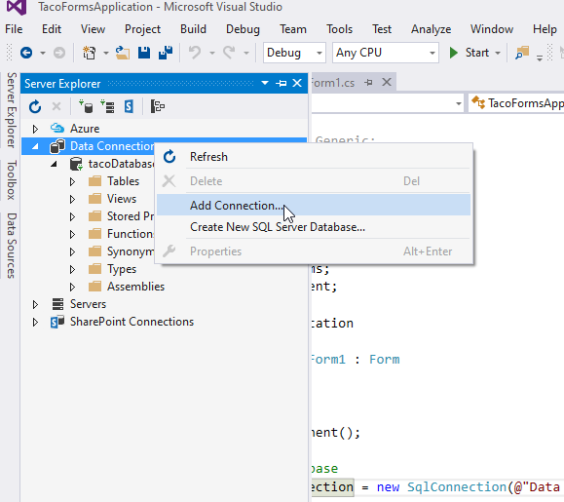

Then it will prompt you to choose your database file.

Click on mircosoft SQL Server Database File, Continue

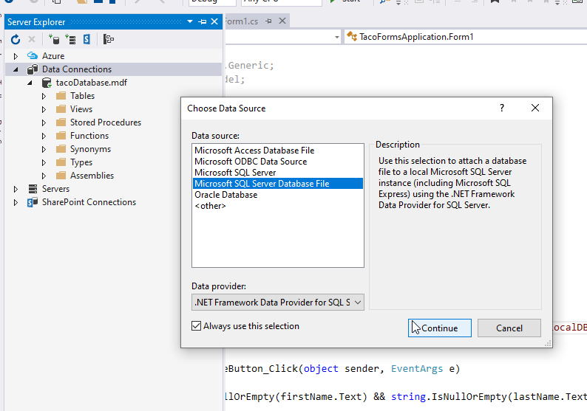

Nagigate to where the .mdf file is and open

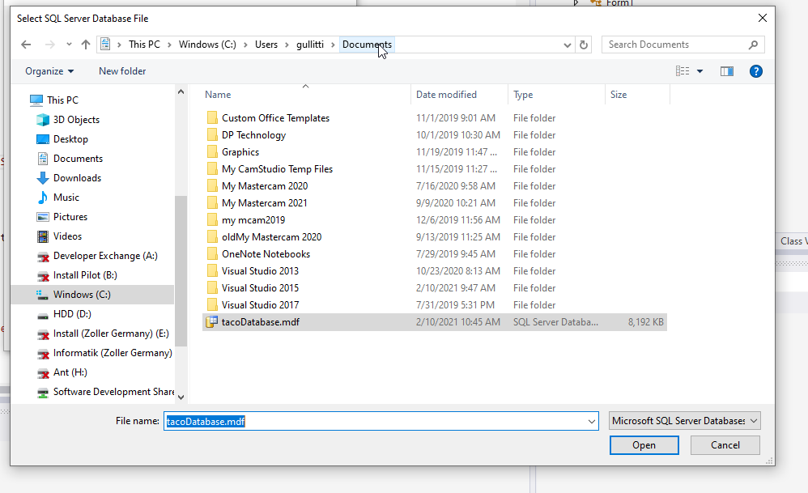

Now hopefully it connected and looks like this in the server explorer window.

Next you will right click and choose properties

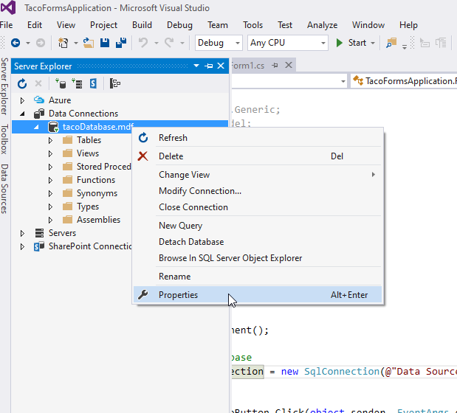

Then you will see the field Connection String, you will copy that full string and…

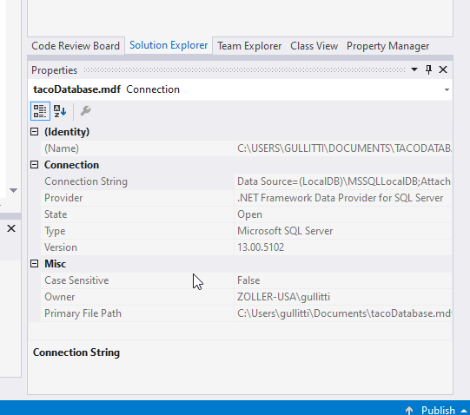

Paste the string in the SqlConnection instance inside the (@”paste string here”). Line 21 in the Form1.cs file.

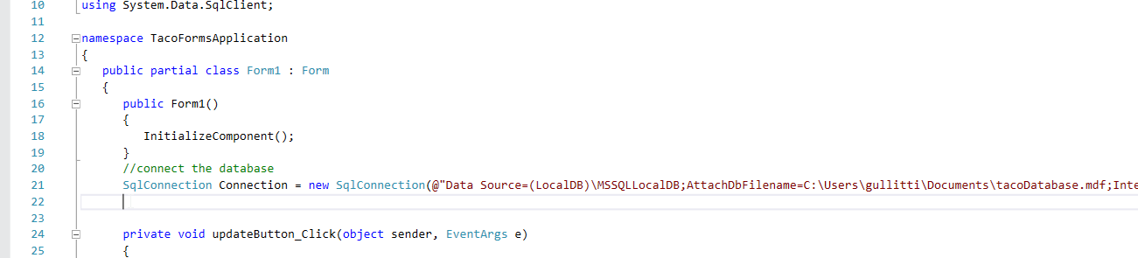

Then you should be good to run!