Alex Mishev and Elian Konedarev


Sprint 1 report
Prof. Vladimir Georgiev

Contents
Angular web-based application 1
Team members contributions 2
User Registration 2
Token Based User Authentication in Web API 4
Token Request from Angular 6
Screenshots 8

Angular web-based application
Our team have chosen to use Angular 9 Web API for our project. Components used in the project:
- Design Login Form in Angular application.
- Web API Token Based Authentication using OWIN and ASP.NET Identity;
- Send Token From Angular HTTP Interceptor.
We used the following tools and modules for this project:
- Angular CLI
- Angular 9
- ASP.NET Web API
- SQL Server
- VS Code and Visual Studio

Team members contributions
Alex Mishev:
- Login Functionality.
- Token Authorization.
- Auth Interceptor
Elian Konedarev:
- Register Functionality.
- DB Creation.
Note: Both members of the team helped each other with the Front-end and Back-end functionality. Sprint 1 was executed successfully! Please refer to the screenshots provided below!
In the following sections are described the detailed descriptions of contributions each to their respective owner.

User Registration
Inside registration form submit event, we have to insert a new user using a Web API request. The project has a web API method with URI ‘/api /Register’ to add new user inside SQL Server. So, we can define a function to consume the Web API method inside the service class.
registerUser(user : User){
const body: User = {
Password: user.Password,
Email: user.Email,
PhoneNumber: user.PhoneNumber,
LastName: user.LastName,
FirstName: user.FirstName,
}
var reqHeader = new HttpHeaders({'No-Auth':'True'});
return this.http.post(this.rootUrl + '/api/Register', body, {headers : reqHeader});
}

We used Asp.Net Identity framework since it provides User Management, Role Management, User Authentication and Authorization, etc. We used Asp. Net Identity to store user details inside Identity tables.
Inside IdentityModels.cs file, we have ApplicationDbContext class which inherits IdentityDbContext class from Asp.Net Identity. With the class constructor, we have configured the DB connection. as part of that we have to add DB connection string in Web.config file with DefaultConnection name as follows.
Database table structure are defined in C# code, in-order to see them as database objects first of all we have to enable migration for that execute following Command.
In the Package Manager Console, we run the following commands
- enable-migrations
- add migration InitialMigration
- update-database
And we have our custom User table in the SQL Server Database.
And this is our model:
public class AccountModel
{
public string UserName { get; set; }
public string Email { get; set; }
public string Password { get; set; }
public string FirstName { get; set; }
public string LastName { get; set; }
public string PhoneNumber { get; set; }

public string LoggedOn { get; set; }
}
Inside the Account Controller we have a Web API method Register to Post registration data from the Angular application.
[Route("api/Register")]
[HttpPost]
[AllowAnonymous]
public IdentityResult Register(AccountModel model)
{
var userStore = new UserStore<ApplicationUser>(new ApplicationDbContext());
var manager = new UserManager<ApplicationUser>(userStore);
var user = new ApplicationUser() { UserName = model.Email, Email = model.Email };
user.FirstName = model.FirstName;
user.LastName = model.LastName;
user.PhoneNumber = model.PhoneNumber;
manager.PasswordValidator = new PasswordValidator
{
RequiredLength = 6
};
IdentityResult result = manager.Create(user, model.Password);
return result;
}

Token Based User Authentication in Web API
The following packages were used in:
- Microsoft ASP.NET Identity Owin
- Microsoft.Owin.Host.SystemWeb
- Microsoft.Owin.Cors
In-order to work with OWIN, we have to create OWIN Startup class. Therefore, the following was used in the Startup.cs file.
namespace WebAPI
{
public class Startup
{
public void Configuration(IAppBuilder app)
{

app.UseCors(CorsOptions.AllowAll);

OAuthAuthorizationServerOptions option = new OAuthAuthorizationServerOptions
{
TokenEndpointPath = new PathString("/token"),
Provider = new ApplicationOAuthProvider(),
AccessTokenExpireTimeSpan = TimeSpan.FromMinutes(60),
AllowInsecureHttp = true
};
app.UseOAuthAuthorizationServer(option);
app.UseOAuthBearerAuthentication(new OAuthBearerAuthenticationOptions());
}
}
}

Next, the ApplicationOAuthProvider class was created to validate email and password.
namespace WebAPI
{
public class ApplicationOAuthProvider : OAuthAuthorizationServerProvider
{

public override async Task ValidateClientAuthentication(OAuthValidateClientAuthenticationContext context)
{
context.Validated();
}

public override async Task GrantResourceOwnerCredentials(OAuthGrantResourceOwnerCredentialsContext context)
{
var userStore = new UserStore<ApplicationUser>(new ApplicationDbContext());
var manager = new UserManager<ApplicationUser>(userStore);
var user = await manager.FindAsync(context.UserName,context.Password);
if (user != null) {
var identity = new ClaimsIdentity(context.Options.AuthenticationType);
identity.AddClaim(new Claim("Username", user.UserName));
identity.AddClaim(new Claim("Email", user.Email));
identity.AddClaim(new Claim("FirstName", user.FirstName));
identity.AddClaim(new Claim("LastName", user.LastName));
identity.AddClaim(new Claim("LoggedOn", DateTime.Now.ToString()));
context.Validated(identity);
}
else
return;
}
}
}

ApplicationOAuthProvider is inherited from OAuthAuthorizationServerProvider class. Inside that we have overridden two functions:
- ValidateClientAuthentication() – used to validate client device based on clientID and secret code but in this project we’ll not authenticate client device.
- GrantResourceOwnerCredentials() – authenticate a user with given username and password. If authentication is successful then we save user details as Claims Identity. It can be used to retrieve user details without DB interaction.

Token Request from Angular
@Injectable()
export class UserService {
readonly rootUrl = 'http://localhost:35257';
constructor(private http: HttpClient) { }

...

userAuthentication(userName, password) {
var data = "username=" + userName + "&password=" + password + "&grant_type=password";
var reqHeader = new HttpHeaders({ 'Content-Type': 'application/x-www-urlencoded','No-Auth':'True' });
return this.http.post(this.rootUrl + '/token', data, { headers: reqHeader });
}
}

Next step is to define the function inside the component ts file.
export class SignInComponent implements OnInit {
isLoginError : boolean = false;
constructor(private userService : UserService,private router : Router) { }

ngOnInit() {
}

OnSubmit(userName,password){
this.userService.userAuthentication(userName,password).subscribe((data : any)=>{
localStorage.setItem('userToken',data.access_token);
this.router.navigate(['/welcome]);
},
(err : HttpErrorResponse)=>{
this.isLoginError = true;
});
}

}

Inside the OnSubmit() function, there are two arrow function, for success and error response. If a user authentication is successful, we save the accessToken in localStorage (in web browser) because we need this token to authenticate the user in the Angular Project. Finally we will navigate the user to home component.
If authentication is fails, isLogin is set to true, based on this property we will show an error message just above the login form.
Note: These are only fragments of the whole code used in this project. Please refer to the ZIP file attached in Canvas for the complete project.

HTTP Interceptor
To consume the Web API method, we have not appended the accessToken. It would be difficult to append accessToken to every Web API call and we have to handle the 401 UnAuthorized Response in each of them( if access token expires).

@Injectable()
export class AuthInterceptor implements HttpInterceptor {

constructor(private router: Router) { }

intercept(req: HttpRequest<any>, next: HttpHandler): Observable<HttpEvent<any>> {
if (req.headers.get('No-Auth') == "True")
return next.handle(req.clone());

if (localStorage.getItem('userToken') != null) {
const clonedreq = req.clone({
headers: req.headers.set("Authorization", "Bearer " + localStorage.getItem('userToken'))
});
return next.handle(clonedreq).pipe(
tap(
succ => { },
err => {
if (err.status === 401)
this.router.navigateByUrl('/login');
}
));
}
else {
this.router.navigateByUrl('/login');
}
}
}

With the first IF statement, we will check the condition No-Auth is True/False. if it is true we don’t need to append the access token. So, you can set No-Auth as true for web API calls which does not need authorization.
Then we check whether the user is authenticated or not. if authenticated then we will append the access token in request header. we must use the prefix Bearer while passing Authorization Access Token in request header. Inside the error function, we handle 401 Unauthorized Status Code – most often it can appear due to token expiration.

Before Running the project, you should:
- Install npm packages using 'npm install' command.
- Change Web API DB Connection String

Screenshots

User Story 1
When users (anonymous and/or registered) visit the main URL (home page) of the app, they should see the welcome page.
The welcome page should contain the following message “Welcome to my e-Library”.
Non-logged-in users should see a “Register” menu link on all pages, which leads them to the registration page
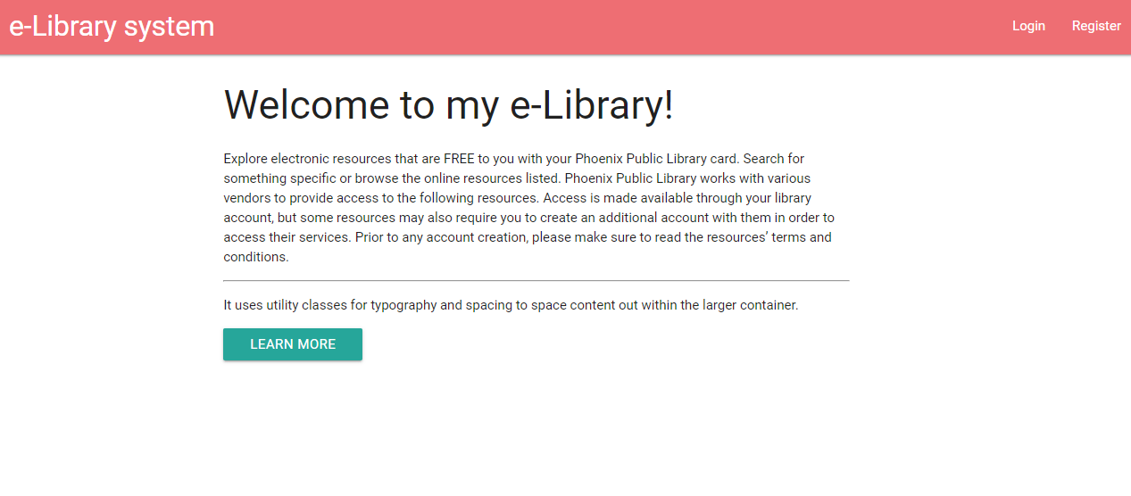

User Story 2
The registration process requires the user’s email, password and phone number
The email should be a valid email address and not exist in the system (two registered users cannot have the same email)
Passwords should be at least 6 characters long and should contain both letters and numbers
Proper validation should be performed by the system, and detailed error messages displayed
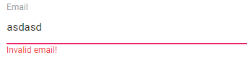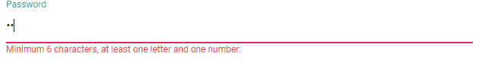
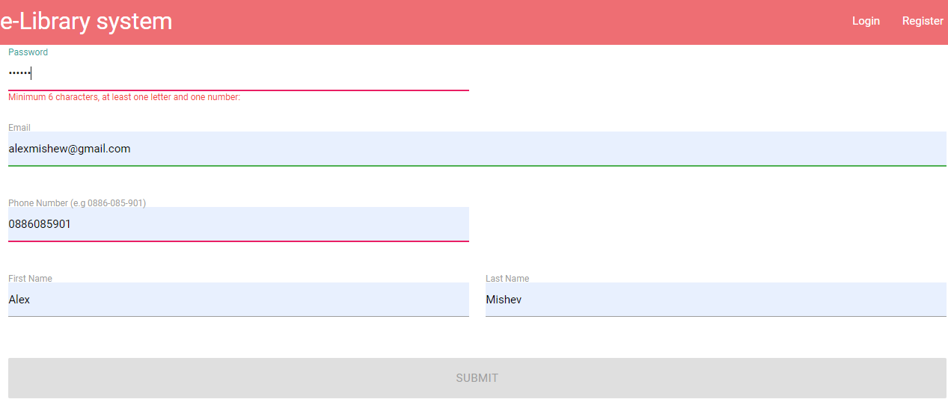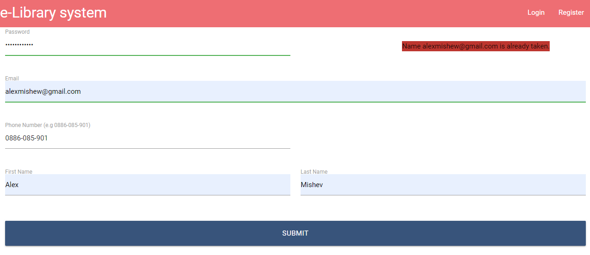
User Story 3 + 4
Non-logged-in users should see a “Login” menu link on all pages, leading to the login page
Login page asks for user email and password
A proper message is displayed if such an email does not exist in the system, password is wrong, or some of the two fields is missing
Upon a successful login, the user is redirected to the application’s home page (the welcome page)
