ExamProject

(A Web Application Design)

1. Introduction

Project theme: Exam.

This project was carried out using the “exam” databasedb”. There are three tables in the database: corrector, student, paper.

What is a corrector?

A corrector is a person qualified and specialized in a particular discipline, usually a teacher, who corrects and grades students' work.

What is a student?

The student is the person taking the exam.it.

What is a work?

The paper represents the physical proof of a student's knowledge. The aptitude exam consists of two papers, one in Romanian Language and Literature and one in Mathematics..

2. Conceptual design

3. Logical level design

Student table:



Correction table:



Work table:



4. Application functionality

4.1 Home Page

The localhost/project connection opens a web page containing the three categories: Student, Paper, and Grader.



4.2 Student

When you click the Student button, the page for student management will open.

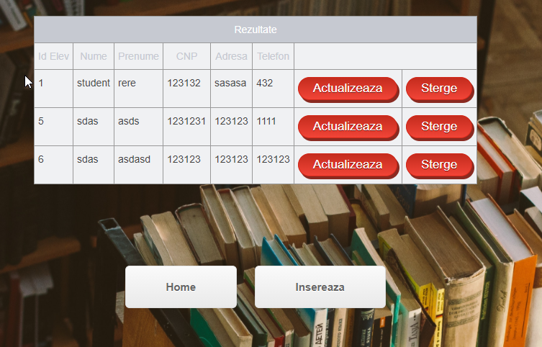

There are two main buttons here: Home and Insert. The Home button returns you to the main page, the Insert button opens a new form for entering data.

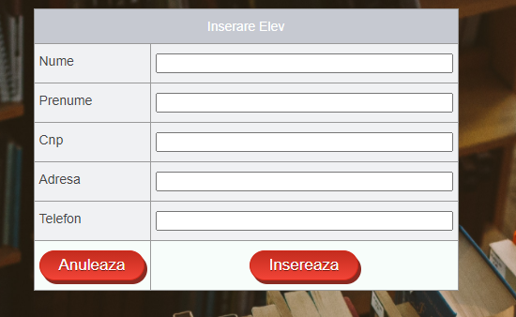

Data entry fieldsin the student table are:

* Name for name
* First name for last name
* Cnp for cnp
* Address for address
* Phone for phone

The Cancel button returns you to the Home page, and the Insert button adds the data to the database. After the data is added, the table with students appears again, next to which there are two buttons: Update and Delete.

When you click the Update button, you will be redirected to the data modification form. The data that you want to update will be changed.

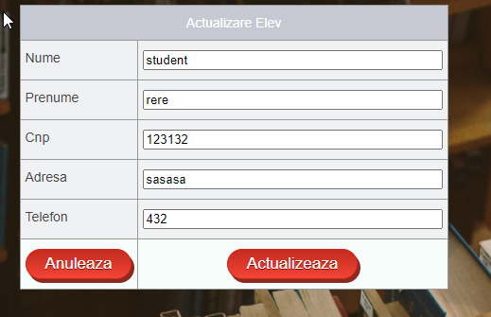

Clicking the Delete button will delete the student from the list.

4.3 Work

When you click the Work button, the page for works will open.

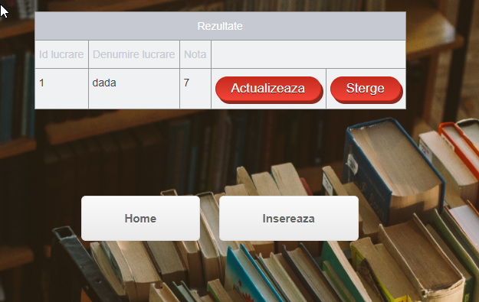

There are two main buttons here: Home and Insert. The Home button returns you to the main page, the Insert button opens a new form for entering data.

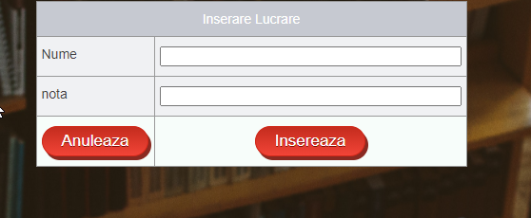

The fields for data entry are:

* Name for name
* Note for note

The Cancel button returns you to the Home page, and the Insert button adds the data to the database. After the data is added, the table with jobs appears again, next to which there are two buttons: Update and Delete.

When you click the Update button, you will be redirected to the data modification form. You will enter the data you wish to update.

Clicking the Delete button will delete the job from the list.

4.4 Corrector

When you click the Proofreader button, the page for proofreaders will open.

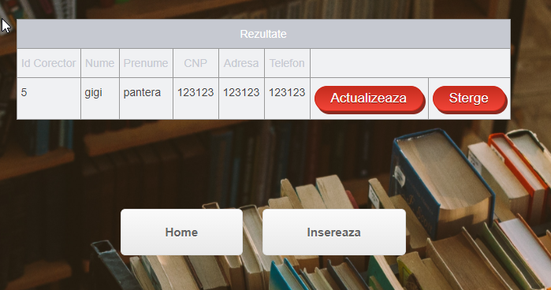

There are two main buttons here: Home and Insert. The Home button returns you to the main page, the Insert button opens a new form for entering data.

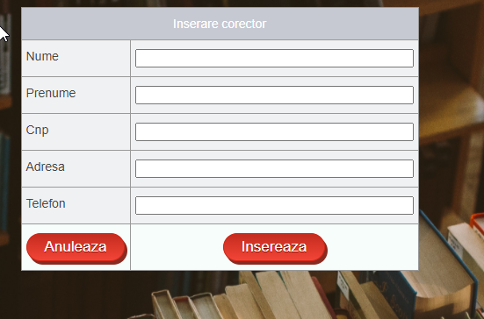

The fields for data entry are:

* Name for name
* First name for last name
* Cnp for cnp
* Address for address
* Phone for phone

The Cancel button returns you to the Home page, and the Insert button adds the data to the database. After the data is added, the table with the list of correctors appears again, next to which there are two buttons: Update and Delete.

When you click the Update button, you will be redirected to the data modification form. The data that you want to update will be changed.

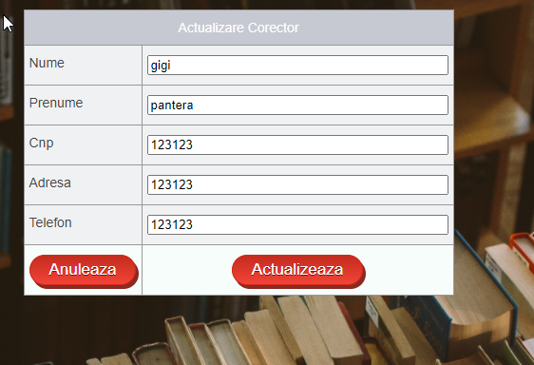

The Delete button deletes the corrector.