Aptitude exam

(Project – Java with Databases)

1. Introduction

Project topic: Aptitude exam.

This project was carried out using the “examencapacitate” database. There are five tables in the database: corrector, student, exam, paper, school.

What is a corrector?

A corrector is a person qualified and specialized in a particular discipline, usually a teacher, who corrects and gradesstudents' works.

What is a student?

The student is the person taking the aptitude test.

What is a work?

The paper represents the physical proof of a student's knowledge. The aptitude exam consists of two papers, one in Romanian Language and Literature and one in Mathematics..

What is a school?

School is a public institution where subjects from a curriculum are studied.

What is an exam?

The exam is the assessment of students' knowledge. In this context, the aptitude exam represents the threshold between middle school and high school.

2. Conceptual design

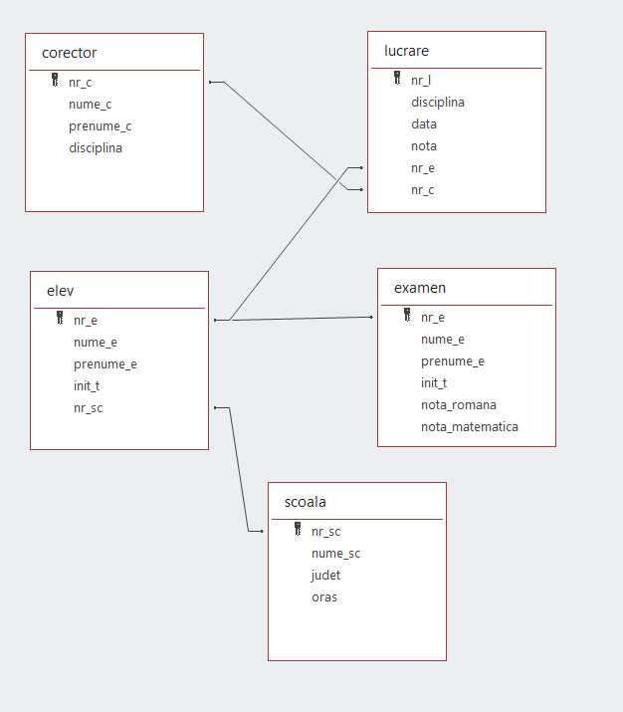

3. Logical level design

Student table:



Correction table:

School table:

Work table:

Exam table:

4. Application functionality

4.1 Home page

To begin, a jFrame called "MainProiectBD.java" will be opened which will contain buttons to all the other categories. Thus, there are five buttons called Student List, Grader List, School List, Paper List and Exam.

4.2 Student

When you click the Student List button in the main menu, the "MainEl.Java" jFrame will open. It contains a data entry section for all table fields, a table showing the contents of the database, and eight buttons that allow you to add, edit, delete, and move between rows of the database for viewing, as well as one for returning to the main menu.

The fields for data entry are:

* Student number for nr_e
* Student name for name_e
* Student first name for first name_e
* Father's initial for init_t
* School number for nr_sc

The buttons are:

* Insert for insertion
* Update for editing
* Delete to delete
* First to show the first row in the database
* Next and Previous to view the next and previous rows, respectively
* Last to show the last row in the database
* Back to return to the main menu

4.3 School

When you click the School List button in the main menu, the jFrame "MainSc.java" will open. It contains a data entry section for all table fields, a table showing the contents of the database, and eight buttons that allow you to add, edit, delete, and move between rows of the database for viewing, as well as one for returning to the main menu.

The fields for data entry are:

* School number for nr_sc
* School name for school_name
* County by county
* City by city

The buttons are:

* Insert for insertion
* Update for editing
* Delete to delete
* First to show the first row in the database
* Next and Previous to view the next and previous rows, respectively
* Last to show the last row in the database
* Back to return to the main menu

4.4 Corrector

When you click the List of correctors button in the main menu, the jFrame "MainC.java" will open. It contains a data entry section for all fields of the corrector table in the database, a table showing the contents of the database, and eight buttons that allow you to add, edit, delete, and move between rows of the database for viewing, as well as one for returning to the main menu.

The fields for data entry are:

* Corrective number for nr_c
* Corrector name for name_c
* Corrector for firstname_c
* Discipline for discipline's sake

The buttons are:

* Insert for insertion
* Update for editing
* Delete to delete
* First to show the first row in the database
* Next and Previous to view the next and previous rows, respectively
* Last to show the last row in the database
* Back to return to the main menu

4.5 Work

When you click the List of works button in the main menu, the jFrame "MainL.java" will open. It contains a data entry section for all fields of the work table in the database, a table showing the contents of the database, and eight buttons that allow you to add, edit, delete, and move between rows of the database for viewing, as well as one for returning to the main menu.

The fields for data entry are:

* Job number for nr_l
* Discipline for discipline's sake
* Date for date
* Note for note
* Student number for nr_e
* Corrective number for nr_c

The buttons are:

* Insert for insertion
* Update for editing
* Delete to delete
* First to show the first row in the database
* Next and Previous to view the next and previous rows, respectively
* Last to show the last row in the database
* Back to return to the main menu

4.6 Exam

When you click the Exam button in the main menu, the jFrame "MainExamen.java" will open. It contains a data entry section for all fields of the exam table in the database, a table showing the contents of the database, and four buttons that allow you to search for the student, check them, view their grades, delete them from the database, and one to return to the main menu.

The fields for data entry are:

* Student number for nr_e
* Student name for name_e
* Student first name for first name_e
* Father's initial for init_t
* Romanian note for romanian_note
* Math grade for math_grade

The buttons are:

* Search to find the desired student
* Verify student for entry into the database
* Show grades to display exam grades
* Delete to prepare the database to display another student's grades
* Back to return to the main menu

When you click the Search button, a window opens with the contents of the student table from which you can select the desired student.

