**AUTO PROJECT**

**(JSP AND MySQL )**

Information on technologies used

1. JSP.

Java Server Pagesis a simple but powerful technology used on the server side to generate dynamic HTML content. JSP is a direct extension ofJava Servletsand provides a way to separate the processing from the presentation. The JSP engine is just anotherServlets, mapped to the extension\*.jsp

A JSP page is a text-based document that describes how to process a request to create a response. It mixes template data with some dynamic actions and mechanisms within the Java platform. The following is a simple JSP file:

<HTML>

<BODY>

<% out.println("HELLO JSP WORLD"); %>

</BODY>

</HTML>

JSP pages are designed to support many types of structured documents, especially HTML and XML. In general, JSPs use some information that they send to the server in an HTTP request that interacts with the data on it and dynamically creates an organized response in a standard format (HTML, DHTML, XML, etc.) or in a text or unorganized format that will be sent back to the client. A Web application is based on:

•Java Runtime Environment, which must run on the server

•JSP page, which takes requests and generates dynamic content

•Java Servlets, with the same role as JSP

•JavaBeans, the server-side component that encapsulates behaviors and states

• static pages HTML, XML, DTM,.

•Java Applets or JavaBeans, client-side components and possibly other Java class files

•Java Runtime Environment to run on the client and which can be loaded via the Java Server Pages plug-in. They inherit from Servlets concepts about Applications, ServletContexts, Sessions, Requests and Responses.

JSP pages are unique in that they can contain both content and presentation code. This provides a multitude of options for designing applications that are easy to maintain and extend. The options available for interweaving content with code include JavaBeans components, custom tags, and scriptlets.

The central point of the technology is represented by the so-called JSP pages which are, practically, text files that combine HTML descriptions with Java code. JSP pages are managed and accessible through an application server. It receives requests coming via HTTP from a Web browser. If a request refers to a JSP page, the server processes the respective page locally and, depending on its content, dynamically generates an HTML page which it sends, as a response, to the browser. It is important to remember that all processing related to JSP pages is done on the server side, these being never transmitted in their original form to the client. In addition, it must be remembered that the application server also includes a Java virtual machine in which both the Java code found in the JSP pages and the objects instantiated by it run. For those interested, we would like to point out that the server-side processing of JSP pages actually involves the creation of Java Servlet classes that follow the rules written in the JSP page and include the Java code from it. The classes thus generated are then compiled and run in the aforementioned virtual machine.

3. Apache Tomcat

Apache Tomcat (or simply Tomcat, formerly known as Jakarta Tomcat) is a[web server](https://ro.wikipedia.org/wiki/Web_server" \t "Web server)[open source](https://ro.wikipedia.org/wiki/Open_source" \t "Open source)and[container](https://ro.wikipedia.org/w/index.php?title=Web_container&action=edit&redlink=1" \t "Web container — pagină inexistentă)[servlet](https://ro.wikipedia.org/w/index.php?title=Java_Servlet&action=edit&redlink=1" \t "Java Servlet — pagină inexistentă)developed by[Apache Software Foundation](https://ro.wikipedia.org/w/index.php?title=Apache_Software_Foundation&action=edit&redlink=1" \t "Apache Software Foundation — pagină inexistentă)(ASF).

Apache Tomcat, also known as "Tomcat", is an open-source web server, developed and maintained by the Apache Software Foundation. It is a software implementation of Java technologies and runs on Java Servlets and JavaServer Pages, known as JSPs.

Compared to Apache HTTP Server, Tomcat provides support for Java Servlets and JSPs for serving dynamic pages. Tomcat also functions as a test server and can run in different modes to guarantee good performance.

Often used in conjunction with Apache HTTP Server, Tomcat can add value to an Apache HTTP Server installation. However, Tomcat can also stand on its own as a web server without Apache HTTP Server.

Finally, what should be remembered is that for users who need to run Java Servlets or JavaServer pages, Tomcat is definitely the best option to implement. However, if many static pages are executed simultaneously or other dynamic techniques are needed, it is more appropriate to opt for Apache HTTP Server and run Tomcat in- or out-of-process.

1. MySQL

MySQL is a[database management system](https://ro.wikipedia.org/wiki/Sistem_de_gestiune_a_bazelor_de_date" \t "Sistem de gestiune a bazelor de date)[related](https://ro.wikipedia.org/w/index.php?title=Baze_de_date_relaționale&action=edit&redlink=1" \t "Baze de date relaționale — pagină inexistentă), produced by the Swedish company[MySQL AB](https://ro.wikipedia.org/wiki/MySQL_AB" \t "MySQL AB)and distributed under[GNU General Public License](https://ro.wikipedia.org/wiki/Licența_Publică_Generală_GNU" \t "Licența Publică Generală GNU)It is the most popular[DBMS](https://ro.wikipedia.org/wiki/SGBD" \t "SGBD)[open source](https://ro.wikipedia.org/wiki/Open-source" \t "Open-source)at the present time[[6]](https://ro.wikipedia.org/wiki/MySQL" \l "cite_note-6), being a key component of the stack[LAMP](https://ro.wikipedia.org/wiki/LAMP" \t "LAMP)([Linux](https://ro.wikipedia.org/wiki/Linux" \t "Linux),[Apache](https://ro.wikipedia.org/wiki/Apache" \t "Apache), MySQL,[PHP](https://ro.wikipedia.org/wiki/PHP" \t "PHP)).

Although it is very often used in conjunction with[programming language](https://ro.wikipedia.org/wiki/Limbaj_de_programare" \t "Limbaj de programare)[PHP](https://ro.wikipedia.org/wiki/PHP" \t "PHP), with MySQL you can build applications in any major language. There are many API schemes available for MySQL that allow applications to be written in many programming languages ​​to access MySQL databases, such as: C, C++, C#, Java,[Pearl](https://ro.wikipedia.org/wiki/Perl" \t "Perl),[PHP](https://ro.wikipedia.org/wiki/PHP" \t "PHP),[Python](https://ro.wikipedia.org/wiki/Python" \t "Python), FreeBasic, etc., each of which uses a specific type of API. An ODBC-type interface called MyODBC allows other programming languages ​​that use this interface to interact with MySQL databases such as[ASP](https://ro.wikipedia.org/wiki/ASP" \t "ASP)or[Visual Basic](https://ro.wikipedia.org/wiki/Visual_Basic" \t "Visual Basic)In support of these programming languages, some companies produce COM/COM+ or .NET (for Windows) components through which these languages ​​can use this[DBMS](https://ro.wikipedia.org/wiki/SGBD" \t "SGBD)much easier than through the ODBC system. These components can be free (such as MyVBQL) or commercial.

[LAMP](https://ro.wikipedia.org/wiki/LAMP" \t "LAMP)also includes MySQL

The GNU GPL license does not allow the incorporation of MySQL into commercial software; those who wish to do so can purchase, for a fee, a commercial license from the producing company, MySQL AB.

MySQL is an integrated component of platforms[LAMP](https://ro.wikipedia.org/wiki/LAMP" \t "LAMP)or WAMP (Linux/Windows-Apache-MySQL-PHP/Perl/Python). Its popularity as a web application is closely linked to that of PHP which is often combined with MySQL and called the Dynamic Duo. In many specialized books it is stated that MySQL is much easier to learn and use than many database management applications, for example the exit command being a simple and obvious one: "exit" or "quit".

To manage MySQL databases, you can use the command line mode or, by downloading from the internet, a graphical interface:[MySQL Administrator](https://ro.wikipedia.org/w/index.php?title=MySQL_Administrator&action=edit&redlink=1" \t "MySQL Administrator — pagină inexistentă)and[MySQL Query Browser](https://ro.wikipedia.org/w/index.php?title=MySQL_Query_Browser&action=edit&redlink=1" \t "MySQL Query Browser — pagină inexistentă)Another tool for managing these databases is the free application, written in PHP,[phpMyAdmin](https://ro.wikipedia.org/wiki/PhpMyAdmin" \t "PhpMyAdmin).

MySQL can run on many existing software platforms: AIX, FreeBSD, GNU/Linux, Mac OS X,[NetBSD](https://ro.wikipedia.org/wiki/NetBSD" \t "NetBSD),[Solaris](https://ro.wikipedia.org/wiki/Solaris" \t "Solaris), SunOS, Windows 9x/NT/2000/XP/Vista.

The MySQL system deals with the databases that form the collection of data organized in such a way that they can be manipulated very easily. This system is delivered without any tools, along with the user environment for manipulating the data.

The MySQL system environment consists of two parts, one of which is the server on which the data is processed, while the second part is the client that asks the server to perform certain tasks. Experts working in the MySQL environment often use integrated consoles, namely the command interface (CLI), as well as other tools with a graphical user environment that comes separately from the system.

Requirements

- add- modify- delete- list- search- reports (presenting data from multiple tables in a selected time period - for example, sales in a time period)- graphs/diagrams (for example, sales by product category in a selected period)- export data to PDF, XLS/X (for example, for invoice, receipt report), import data from XLS/X- application usage log (person, role, date and time, logical action - for example, product modification, SQL command - for example, UPDATE ...)- data validation, error-free operation of the application, general appearance of the application, compliance with Java code conventions

Problem analysis

The bakery web application has magnificent offers of bakery products.

MCD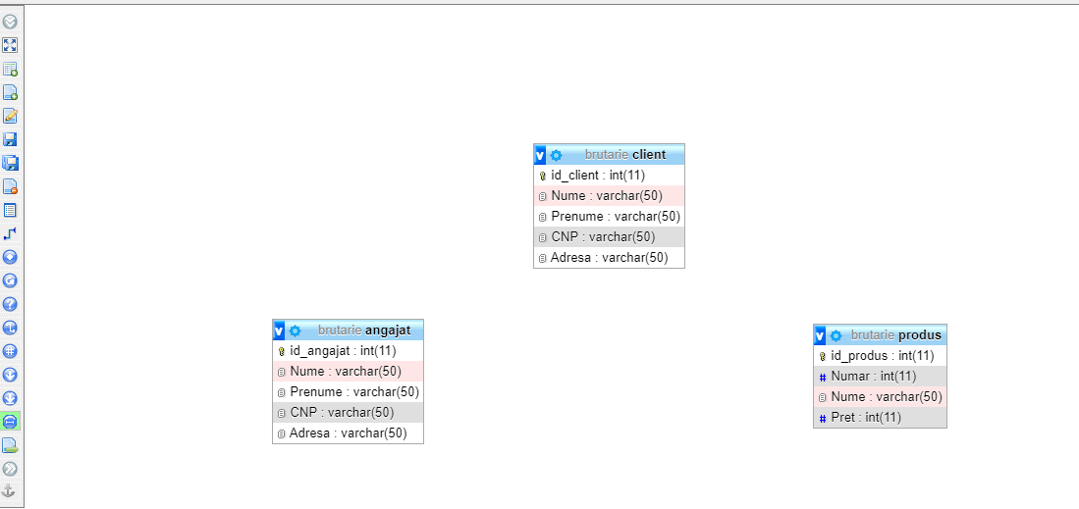

billion

**employee**[employee\_id,last name,first name,number,address]

**Chamber**[Product\_id,number,name,price]

**Customer[customer\_id]**,last name,first name,number,address,phone number]

Program web pages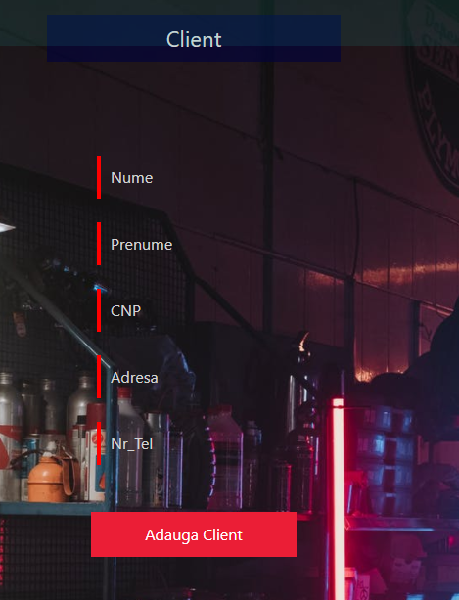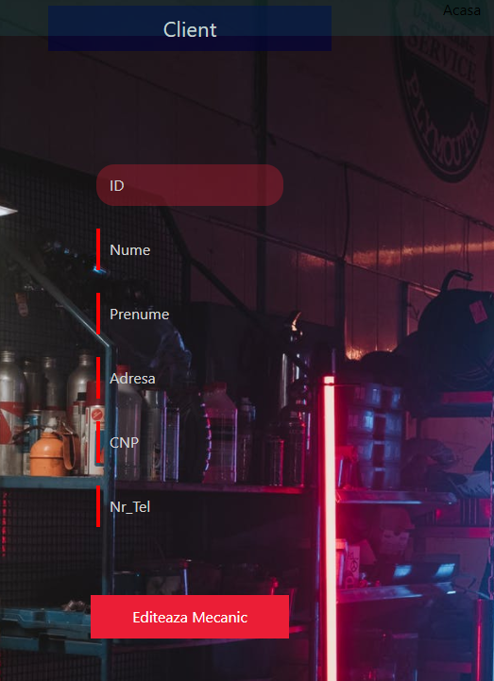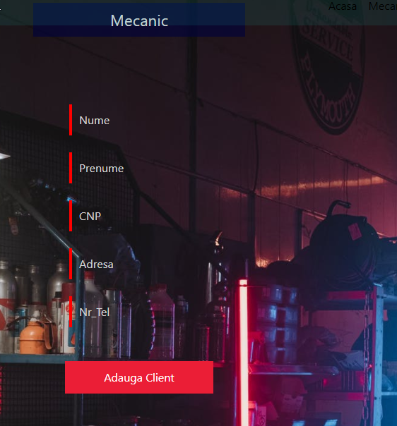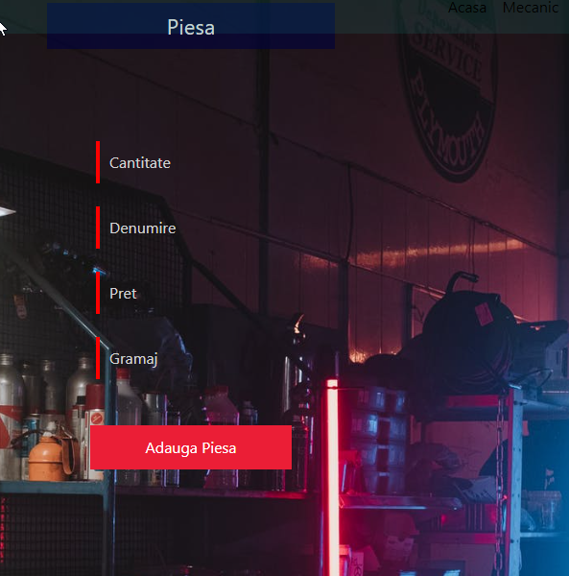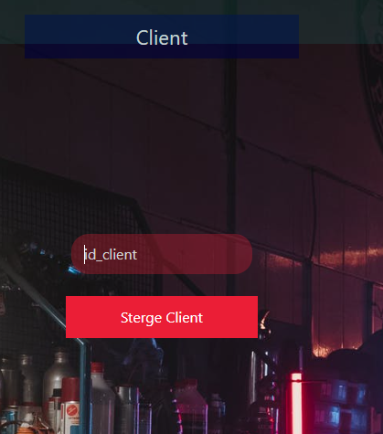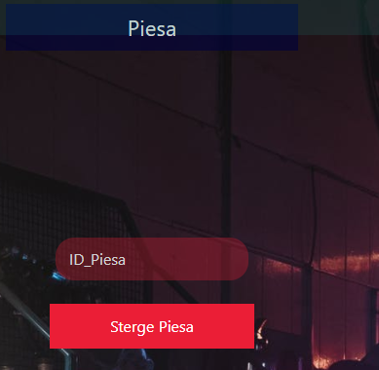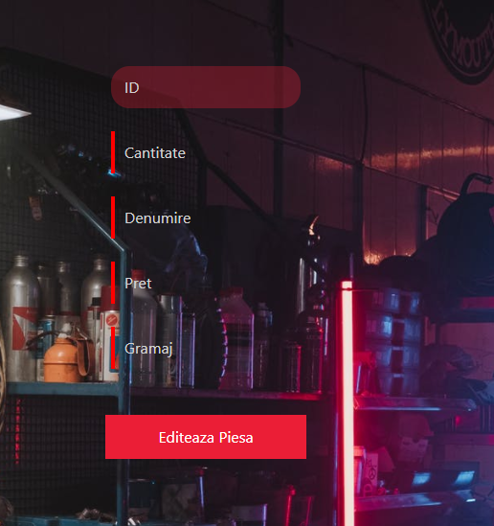

Project goal

Increasing and fixing the notions of java and sql in a dynamic web page.

# Bibliography

<https://www.youtube.com/watch?v=TDpllMVuoeE&ab_channel=OctoGlassCyber>

<https://www.youtube.com/watch?v=-f8N4FEQWyY&ab_channel=edureka%21>

<https://www.youtube.com/watch?v=RAJI9GfPs2g&ab_channel=JavaGuides>

https://www.youtube.com/watch?v=x8GiogC4SdE&t=276s&ab\_channel=CodeJava