**EnergyFIT Philly Seeks Appropriations from City Council**

By: Alexa Monteleone

Advocates for an affordable housing energy program told Philadelphia’s committee on appropriations Tuesday that the program needs more money in order to expand.

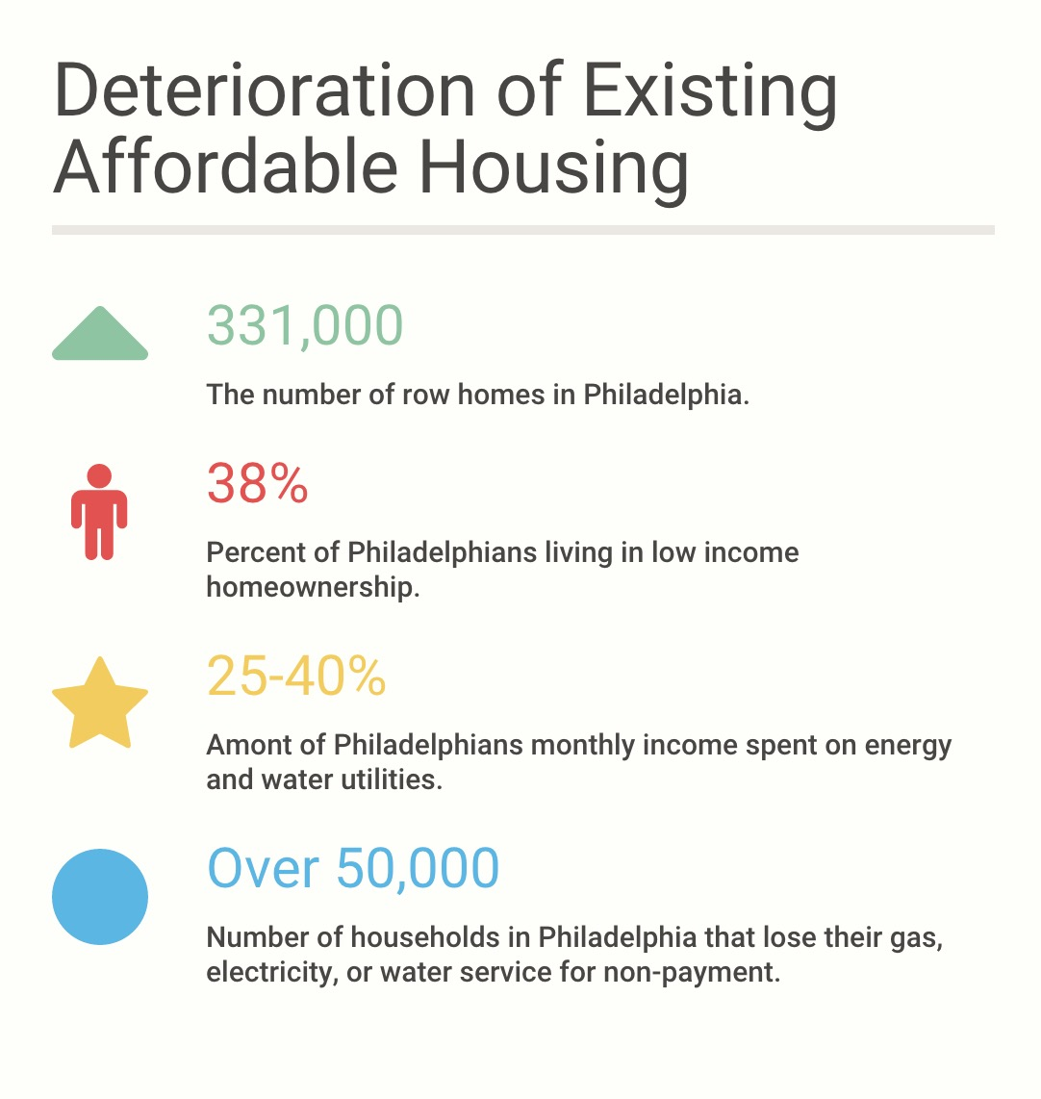Bill no. 150652 would fund the EnergyFIT Philly program, a program run by the non-profit Energy Coordinating Agency that retrofits affordable housing to be more energy efficient.

Liz Robinson, ECA’s executive director, said low-income Philadelphia row homes suffer from roof leaks and lack of resources for home repairs. ECA wants to add services provided by the EnergyFIT Philly program to improve affordable housing.

“Despite the city’s repair program, this problem continues to grow,” Robinson said.

EnergyFIT Philly focuses on restoring health, safety and durability to existing Philadelphia homes in poor conditions. Robinson said the program needs additional funds to begin offering new services including home repairs, case management and occupant engagement.

Beth McConnell, policy director for the Philadelphia Association of Community Development Corporations, said EnergyFIT Philly seeks to reach underserved populations.

The deterioration of Existing Affordable Housing Graph illustrates the data regarding Philadelphia’s struggle to preserve its low income housing stock.

Source: ECA’s testimony

“Investing in home repair is one way Philadelphia can produce equitable development,” McConnell said.

Robinson and McConnell discussed the proposed actions the ECA would take if granted the appropriations funds. The EnergyFIT Philly program plans to replace closed cell roofs with open cell roofs, a new cost and energy efficient roofing technology to fix affordable housing.

|  |  |  |  |  |
| --- | --- | --- | --- | --- |
| Closed Cell vs Open Cell & Mod Bit Roof Replacement, Air Sealing and Insulation | | | | |
| Insulation & Roof Method | Air Sealing Reduction % | Energy Savings Therms | Energy Savings Dollars | Roof Replacement |
| Closed Cell | 32.8% | 127.9 | $170.05 | $10,657.92 |
| Open Cell | 44% | 197.3 | $276.25 | $3,887.75 |

Closed cell roofs insulate many Philadelphia row homes. They contain foams with a high plastic and gas composition. Closed cell roofs produce high levels of humidity, which caused the roof leaks in Philadelphia homes, Robinson said.

Open cell roofs use foams that are lightweight, which allow air to be easily insulated through homes. Robinson said open cell roofs are half the cost of closed cell roofs and provide approximately 25 percent more energy savings from air sealing.

EnergyFIT Philly prefers open cell roofing techniques because it is more energy and cost efficient.

Source: Page 3 of ECA’s testimony.

If ECA is appropriated the funds to administer EnergyFIT Philly’s additions, eligible householders will be brought into the program on a first come, first served basis.

EnergyFIT Philly will concentrate its program in different parts of the city with high concentrations of low income. $6,500 of energy efficient equipment would be serviced in Philadelphia row homes, McConnell said.

“We are convinced that this coordination of housing and energy services yields far greater benefit at the same or reduced cost than technologies and methods currently placed in the city,” McConnell said.

Once the testimony ended, City Council President, Darrell L. Clarke opened discussion to the council members. After a short debate, the committee on appropriations agreed the bill would be put on hold.

“We will convene in the next public hearing on appropriations to determine the future action of this bill,” Clarke said.

**Quoted sources**

Liz Robinson, (215) 609-1033, [lizr@ecasavesenergy.org](mailto:lizr@ecasavesenergy.org)

Beth McConnell, (215) 732-5829, [info@pacdc.org](mailto:info@pacdc.org)

Council President Darrell L. Clarke, (215) 686-2070, [darrell.clarke@phila.gov](mailto:darrell.clarke@phila.gov)

**Invisible sources**

Agenda - <file:///Users/amonteleone/Downloads/Agenda%20(2).pdf>

Copy of Liz Robinson’s testimony

Information on closed vs cell roofs <http://www.energsmart.com/spray-foam-insulation/open-vs-closed-cell-foam.html>