**Decrease in Temple University’s Crime Rates**

By: Alexa Monteleone

Machel Jenkins, a mother of four children ages 1-14, said she refuses to send her four children to Temple because she fears the high crime rates on and around campus.

“I won’t even let my kids apply,” Jenkins said. “I can’t send my kids to a college where I am constantly fearing for their safety.”

The perception that Temple University has high crime rates is not supported by statistics the university gathers. Temple reported lower crime rates than some of the largest Philadelphia colleges due to an increase in campus safety services.

Charles Leone, executive director of campus safety services, said Temple typically has the worst reputation for campus violence.

“There seems to be this stigma about Temple that because of its location, the campus is automatically unsafe,” said Leone.

Other university’s in Philadelphia actually experience and report more crimes. Between 2011 and 2013, St. Joe’s and Villanova have the highest crime rates among Philadelphia colleges— with Penn, Temple, and LaSalle following, in that order. Drexel University was not included in the comparison because their crime statistics were not reported.

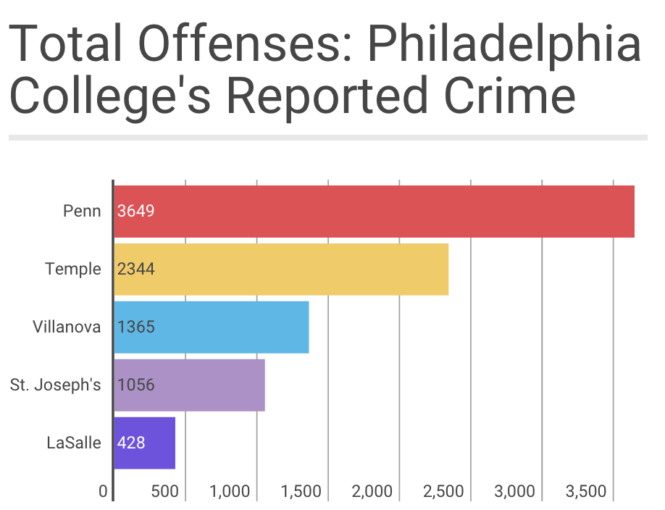

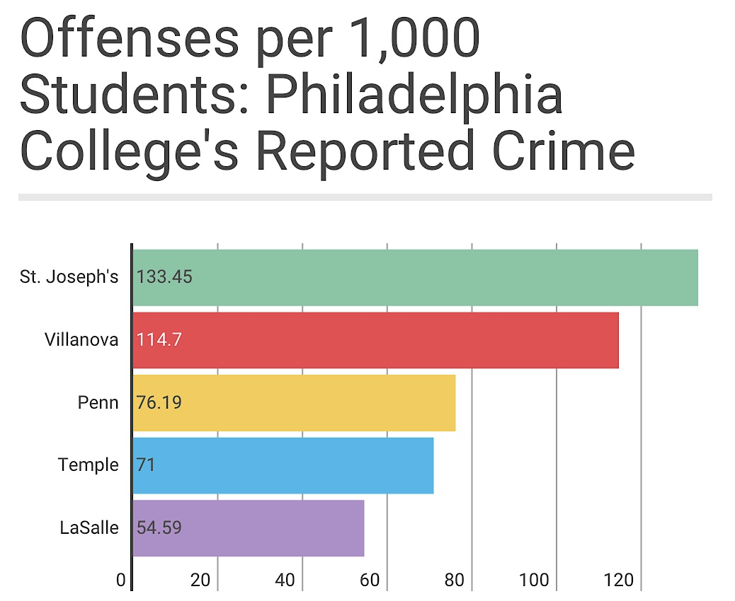

Although Temple and Penn have the highest numbers of reported crime, Temple has a total of 28,408 undergrads and Penn has 9,746 total undergrads. St Joes only has 5,512 total undergrads and LaSalle has 4,322 total undergrads.

*Source: 2011-2013 Annual Security and Fire Safety Report*

To compare them accurately, the rates are calculated by dividing the totals of each university FTE (full-time enrollment of students and faculty), based upon population of 1,000 students.

*Source: 2011-2013 Annual Security and Fire Safety Report*

According to John Gallagher, director of public safety and security at St. Joseph’s University, theft and vandalism are the most commonly reported crimes. People plug their phones in wall outlets around campus and come back later to find it is missing.

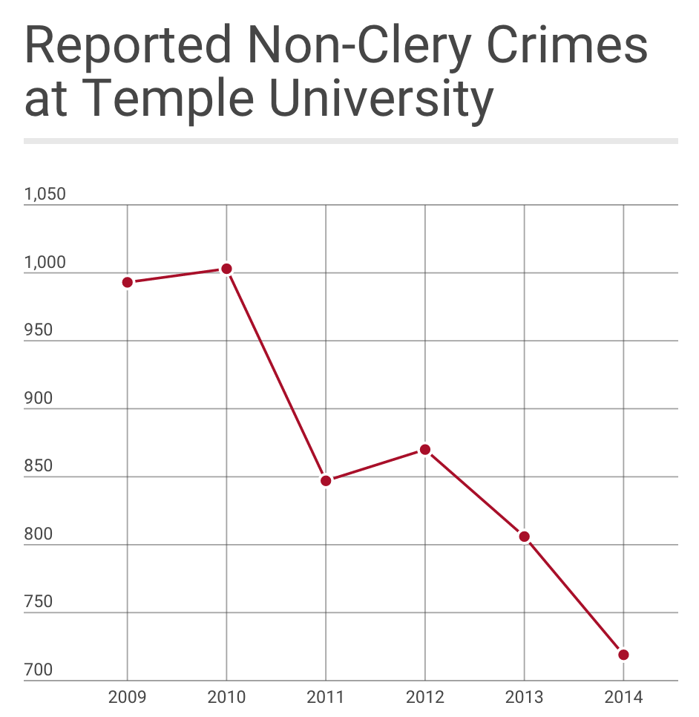“Although the numbers are high, the majority of the reported crimes come from the loss of personal items, not from hate crimes,” Gallagher said.

From 2009-2014, Temple’s non-Clery reported crime rates have decreased significantly. The Clery Act does not require a college or university that receives a report of a campus crime to initiate an investigation, nor does it permit a university to release identifying information about a victim. Clery Act crime reports include only the date of the report, the date of the crime, and the general location.

Denise Wilhelm, captain of patrol operations of Temple’s campus safety services, said the majority of crimes occur on campus. In 2014, 289 crimes occurred on campus and six occurred off campus.

“The majority of Temple students think that most crimes are committed by local residents when most crimes, especially theft, vandalism and harassment are committed by Temple students while on campus,” Wilhelm said.

In comparison to the largest Philadelphia colleges, Temple has the lowest rate of sexual assaults. Sexual assault includes rape, fondling, incest and statutory rape.

The number of crimes reported at Temple decreased by 27.6 percent.

*Source: Temple’s Annual Security and Fire Safety Report*

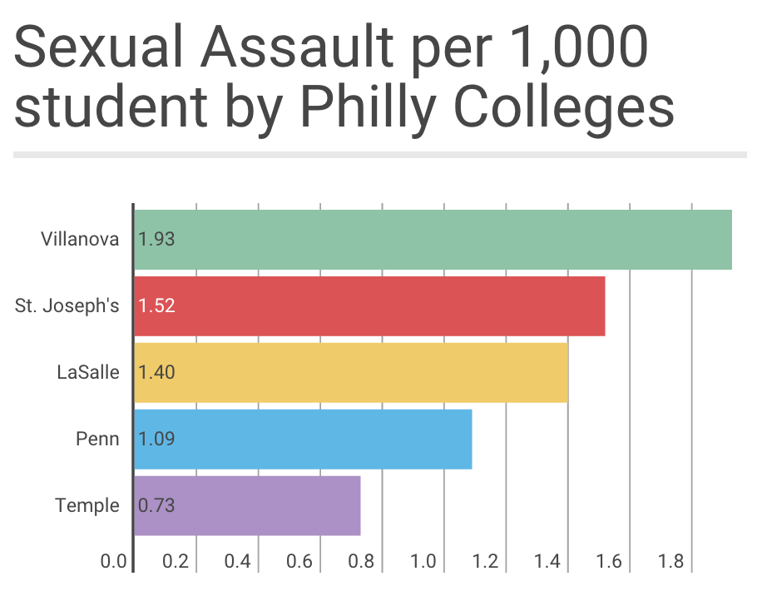Similar to crime rates, Villanova and St. Joseph’s University have reported the highest sexual assault rates.

According to David G. Tedjeske, director of public safety at Villanova University, there are multiple programs and campaigns designed to promote sexual violence awareness.

Tedjeke said in an email, the most popular campaign at Villanova is “Where is the Love?” This campaign provides information on a variety of health-related issues, but focuses largely on alcohol and sexual violence related issues and how to safely and effectively intervene in order to prevent them.

“We believe that love is essential to the life of our community,” Tedjeske said in an email. “We are committed to supporting the rights if a person reporting an incident of sexual assault.”

At Temple, between 2013, 2014 and 2015, there was decrease of 8 percent, 12 percent, and 25 percent in robberies. There was also a 71 percent decrease in sexual assault. The sexual assaults were almost all in residence halls with known accused persons and/or social settings.

To compare them accurately, the rates are calculated by dividing the totals by each university FTE (full-time enrollment of students and faculty), based upon population of 1,000 students.

*Source: 2009-2014 Annual Security and Fire Safety Report*

“Our reduction may be due to the large awareness campaign, collaboration with residential life, student code of conduct and coordinating resources,” Leone said.

Temple University’s campus has several systems to foster crime prevention. Temple instills an integrated computer-aided dispatch system directly linked with the Philadelphia Police Communication Center. Computer-aided dispatch systems assist in the coordination of service in the area of university campuses, Leone said.

Temple’s campus also has code blue emergency phones located throughout campus, which receive and process calls the same way a phone would if someone called 911. Additionally, Temple has high intensity lights to increase visibility on campus, a campus-wide camera system, and shuttle services, Leone said.

There are many services provided to Temple students to ensure their safety. Student can request a police escort by a phone call through Temple’s walking escort program. Services are available daily from 4 p.m. to 6 a.m. where security bike officers maintain communication with Temple police.

According to George Meyer, a safety service officer for bicycle patrols, there have been less than fifty calls made this semester to request a walking escort.

“I’m surprised more students don’t use the walking escort program,” Meyer said. “I hate seeing students walk home alone late at night.”

Among the multiple services provided at Temple to reduce and prevent crime, campus safety services predicts the new library and added green space on main campus will also assist in reducing campus violence, Leone said.

“The more vibrant our campus, the more safe it will be,” Leone said. “With the number of students walking about our well-kept and well-lit campus, the more safe our community will be.”

**Quoted sources**

Machel Jenkins, 973-736-3338

Charles Leone, 215-204-7900, [cleone01@temple.edu](mailto:cleone01@temple.edu)

John Gallagher, 610-660-1164, [jgalla02@sju.edu](mailto:jgalla02@sju.edu)

Denise Wilhelm, 215-204-2122

David G. Tedjeske, 610-519-6982, [david.tedjeske@villanova.edu](mailto:david.tedjeske@villanova.edu)

George Meyer, 215-777-9244

**Invisible sources**

<http://www.temple.edu/safety/asfr/documents/TU_ASFSR2015_FINAL_508_Chartspdf.pdf>

- Temple’s Annual Security and Fire Safety Report

<https://www.publicsafety.upenn.edu/clery/annual-security-fire-safety-report/>

- Penn’s Annual Security and Fire Safety Report

<http://www1.villanova.edu/villanova/publicsafety/securityreport.html>

- Villanova’s Annual Security and Fire Safety Report

<http://www.sju.edu/int/resources/security/annualreport.html>

- St. Joseph’s Annual Security and Fire Safety Report

<http://www.lasalle.edu/financeadmin/security/safety_report.php>

- LaSalle Annual Security and Fire Safety Report

<http://knowyourix.org/the-clery-act-in-detail/>

- Clery versus Non-clery crimes