
Convolutional Neural Network (CNN)
Collected by Alexandra Agranovich


Contents
Convolutional Neural Network (CNN) 3
Convolution 3
Filters(Kernels) 3
Padding 4
Strided Convolutions 5
Pooling Layers 5
Why Convolutions? 5
Variations of CNN 6
A categorized overview 6
1. Standard CNNs 6
2. Modular Architectures 6
3. Efficiency-Oriented CNNs 7
4. Dilated/Deformable CNNs 7
5. Capsule Networks (CapsNet) 8
6. Attention-Augmented CNNs 8
7. Hybrid CNN-Transformer Architectures 8
Summary Table 8
More Info About Networks 9
1. LeNet-5 (1998) 9
2. AlexNet (2012) 9
3. VGGNet (2014) 9
4. GoogLeNet (Inception Network) (2014) 11
5. ResNet (2015) 11
6. MobileNet (2017) 12
7. ShuffleNet (2018) 12
Quick Comparison 12
Q&A 13
What Batch Normalization Does 13
MobileNetV2 bottleneck block 13
Why ReLU after the first 1x1 convolution? 14
Why Linear activation after the last 1x1 convolution? 14
Summary: 15
Detection Algorithms 15
Types 15
YOLO (You Only Look Once) 16
R-CNN Family 17
Segmentation Algorithms 18
U-Net 19
Face Recognition 19
Face Verification vs. Face Recognition 19
Feature Extraction 20
One Shot Learning 20
Siamese Network 21
Triplet Loss Overview 21
Binary Classification Approach 22
Chi-Square Similarity (or Chi-Square Distance) 23
LFW and SOTA 23
Neural Style Transfer 25
Key Idea 25
How It Works (High-Level) 25
Mathematical formulation of Neural Style Transfer (NST) 26
Common Weight Initialization Methods 29
Notes 29

Convolutional Neural Network (CNN)
Definition: a type of deep learning model specifically designed for processing structured grid data, such as images. CNNs utilize convolutional layers to automatically learn spatial hierarchies of features from input images. They are particularly effective for tasks in computer vision, such as image classification, object detection, and image segmentation.
Key Characteristics:
- Convolutional Layers: Apply filters to the input to extract features.
- Pooling Layers: Reduce the dimensionality of feature maps, retaining important information while decreasing computational load.
- Fully Connected Layers: Connect every neuron in one layer to every neuron in the next layer, typically used at the end of the network for classification tasks.

Convolution
Definition - a mathematical operation that combines two functions to produce a third function. In CNNs, it involves sliding a filter (kernel) over an input image to produce feature maps.

Filters(Kernels)
Definition: small matrices used in convolution operations to detect specific features in an image, such as edges, textures, or patterns.
Sobel Filter – operator is used in image processing and computer vision, particularly within edge detection algorithms where it creates an image emphasizing edges.
Horizontal | Vertical
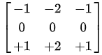 | 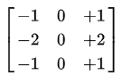

Scharr filter - another method used to detect edges in digital images. It is an improvement over the Sobel operator.
Horizontal | Vertical
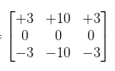 | 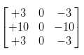

Prewitt filter
Horizontal | Vertical
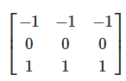 | 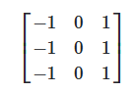

Padding
Padding - the process of adding extra pixels around the border of an image before applying a convolution operation. This helps preserve the spatial dimensions of the image and prevents loss of information at the edges.
Padding types:
- Valid Padding: No padding is added, which reduces the output size.
- Same Padding: Padding is added to ensure the output size is the same as the input size.

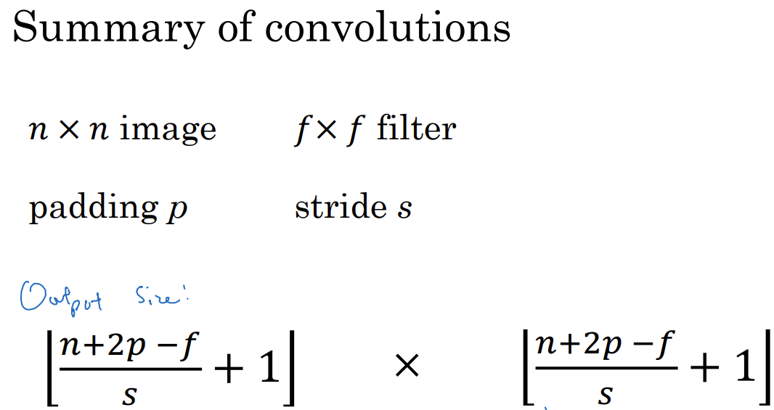
Strided Convolutions
Output Size :
Definition : a technique where the filter moves across
the image with a specified step size (stride). This reduces the spatial dimensions of the output feature map.

Pooling Layers
Definition: Layers that reduce the spatial dimensions of feature maps, helping to decrease computation and control overfitting. Common types include max pooling and average pooling.
- Max Pooling – a pooling operation that selects the maximum value from a feature map within a defined window, effectively down sampling the input.
- Average Pooling - a pooling operation that calculates the average value from a feature map within a defined window, also down sampling the input.

Why Convolutions?
Convolutions are essential in Convolutional Neural Networks (CNNs) for several reasons:
- Feature Extraction:
  - Convolutions allow the model to automatically learn and extract important features from images, such as edges, textures, and shapes, without manual feature engineering.
- Spatial Hierarchy:
  - They help capture spatial hierarchies in data. Lower layers can learn simple features (like edges), while deeper layers can learn more complex features (like objects).
- Parameter Sharing:
  - Convolutions use the same filter (kernel) across the entire image, which reduces the number of parameters compared to fully connected layers. This makes the model more efficient and less prone to overfitting.
- Translation Invariance:
  - Convolutions provide a degree of translation invariance, meaning that the model can recognize objects in different positions within the image.
- Reduced Computational Complexity:
  - By using local connections and pooling, convolutions reduce the amount of computation required, allowing for faster training and inference.

Variations of CNN

A categorized overview

1. Standard CNNs
These include early architectures like:
- LeNet-5: One of the first CNNs, used for digit recognition.
- AlexNet: Popularized deep learning for image classification; introduced ReLU and dropout.
- VGGNet: Used only 3×3 convolutions; very deep but with a simple, uniform structure.

2. Modular Architectures
These CNNs use building blocks or modules instead of simple stacking of layers:
GoogLeNet / Inception
- Introduced Inception modules: multiple convolution filters (1×1, 3×3, 5×5) and pooling in parallel.
- Used 1×1 convolutions for dimensionality reduction.
ResNet (Residual Networks)
- Introduced skip connections (residual connections) to combat vanishing gradients.
- Enabled training of very deep networks (e.g., 50, 101, or 152 layers).
DenseNet
- Each layer receives input from all previous layers (dense connectivity).
- Helps with gradient flow and feature reuse.

3. Efficiency-Oriented CNNs
Designed for mobile devices and low-resource settings:
MobileNet
- Uses Depthwise Separable Convolutions to reduce computation.
- Suitable for mobile and embedded vision applications.
ShuffleNet
- Uses pointwise group convolutions and channel shuffling for speed and efficiency.
SqueezeNet
- Very small model with Fire modules (1×1 and 3×3 convolutions) that achieves AlexNet-level accuracy with fewer parameters.

4. Dilated/Deformable CNNs
For capturing wider context or more flexible spatial features:
Dilated Convolutions (Atrous)
- Adds holes/spaces in the kernel to increase receptive field without increasing parameters.
- Useful in semantic segmentation (e.g., DeepLab).
Deformable Convolutions
- The kernel learns offsets dynamically to adapt to object shapes and positions.
- Enhances object detection and segmentation accuracy.

5. Capsule Networks (CapsNet)
Proposed by Geoffrey Hinton.
- Maintains spatial relationships between features using capsules.
- Uses dynamic routing instead of pooling.

6. Attention-Augmented CNNs
- Integrate attention mechanisms (like in Transformers) into CNNs to help the model focus on relevant regions.
- Example: CBAM (Convolutional Block Attention Module) or Squeeze-and-Excitation Networks.

7. Hybrid CNN-Transformer Architectures
- Combine the local feature learning of CNNs with the global modeling of Transformers.
- Examples: ConvNeXt, CoAtNet, ViT + CNN hybrids.

Summary Table
Type | Key Feature | Example
Standard | Stacked conv/pool/FC layers | LeNet, VGG, AlexNet
Modular | Blocks with diverse paths or skips | Inception, ResNet
Efficient | Lightweight for mobile | MobileNet, SqueezeNet
Context-aware | Enlarged receptive field | Dilated CNNs
Spatially flexible | Adapts to object shape/position | Deformable CNNs
Relationship-aware | Encodes part-whole spatial hierarchy | Capsule Networks
Attention-based | Highlights important features | SE-Net, CBAM
Hybrid | Combines CNNs with Transformers | ConvNeXt, CoAtNet

More Info About Networks

1. LeNet-5 (1998)
• Architecture: 2 CONV layers → 2 Pooling → FC layers
• Use Case: Handwritten digit recognition (MNIST)
• Key Features:
- No padding: spatial dimensions reduce after conv.
- Sigmoid/tanh activations.
- Introduced the idea of local receptive fields and weight sharing.
- Limitation: Too shallow for complex tasks.

2. AlexNet (2012)
- Architecture: 5 CONV layers + 3 FC layers
- Use Case: ImageNet classification
- Key Innovations:
  - ReLU activation (much faster training).
  - Dropout in FC layers to reduce overfitting.
  - GPU training with parallelization.
  - Local response normalization (LRN, now deprecated in modern nets).

3. VGGNet (2014)
- Description:
  - VGG19 is a deep convolutional neural network developed by the Visual Geometry Group (VGG) at Oxford, introduced in the 2014 paper: Very Deep Convolutional Networks for Large-Scale Image Recognition"
by K. Simonyan and A. Zisserman
  - It's called VGG19 because it has 19 layers with learnable weights.

- Architecture:
  - All convolutions are 3×3 with stride 1 and padding = 1 → preserves spatial dimensions.
  - All max-pooling is 2×2 with stride 2 → downsampling.
  - Deep but simple: Only small filters, stacked many times.
  - ReLU activations after each conv and FC layer.

- Why VGG19 Was Important:
  - It showed that depth improves accuracy, even with simple building blocks.
  - It became a popular feature extractor — the convolutional layers learned rich representations useful for other tasks (e.g., style transfer, object detection).

- Pros:
  - Very simple and uniform design (repeating blocks).
  - Excellent baseline for transfer learning.

- Cons:
- Heavy model (millions of parameters): VGG19 has ~143 million parameters, mainly due to the fully connected layers
- Computationally expensive.

- Usage Examples
- Image classification (originally trained on ImageNet)
- Neural Style Transfer (e.g., using conv4_2 for content, and conv1_1, conv2_1, etc., for style)
- Feature extractor in many deep learning tasks (remove FC layers and use conv features)


Next networks move away from plain sequential stacks and use modular blocks to improve learning and gradient flow.

4. GoogLeNet (Inception Network) (2014)
- Inception Module: Parallel branches of:
  - 1×1 conv (bottleneck)
  - 3×3 conv
  - 5×5 conv
  - Max pooling
- Key Concepts:
  - 1×1 convolutions for dimensionality reduction.
  - Factorization of large convolutions into smaller ones (e.g., 5×5 → two 3×3).
  - Efficient and deep with fewer parameters than VGG.
- Very deep, but computationally efficient.

5. ResNet (2015)
- Residual blocks: Output = F(x) + x (skip connections)
- Motivation: Solve vanishing gradient and degradation problem in deep nets.
- Impact:
  - Enabled networks with 100+ layers.
  - Greatly improved training of very deep architectures.

Next networks focused on reducing model size, computations, and inference time, especially for edge devices.

6. MobileNet (2017)
- Core Idea: Depthwise Separable Convolutions
  - Depthwise: One filter per input channel.
  - Pointwise (1×1): Combines outputs across channels.
- Benefit: Reduces parameters and FLOPs by up to 9x.
- Use Case: Mobile vision apps, embedded AI.

7. ShuffleNet (2018)
- Key Techniques:
  - Grouped convolutions: Split channels into groups.
  - Channel shuffle: Mix info across groups.
- Goal: Maintain accuracy while further reducing cost beyond MobileNet.

Quick Comparison
Feature | LeNet / AlexNet / VGG | Inception / ResNet | MobileNet / ShuffleNet
Structure | Sequential | Modular blocks | Lightweight modules
Depth | Low–Medium | Deep (e.g., 50+ layers) | Shallow/Compact
Parameters | High (VGG) | Optimized via modules | Very low
Speed | Slow (VGG) | Faster | Fast (real-time)
Use Cases | Vision classification | Classification + Detection | Edge/mobile inference

Q&A

What Batch Normalization Does
For each feature channel c, it:
- Computes mean and variance:
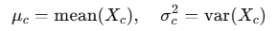
- Normalizes:
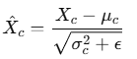
- Scales and shifts (learnable parameters):
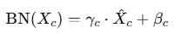

Why Use It?
- Stabilizes training by normalizing activations.
- Helps with faster convergence.
- Reduces sensitivity to weight initialization.
- Acts as a mild regularizer.

MobileNetV2 bottleneck block
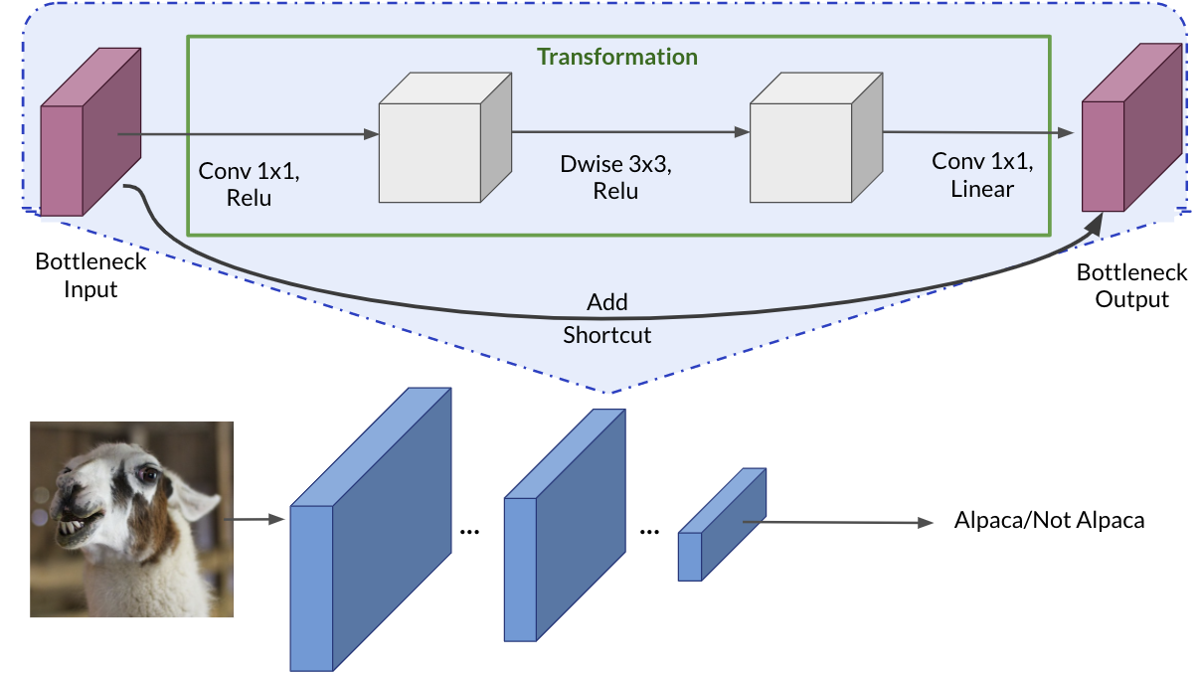

Why ReLU after the first 1x1 convolution?
This first 1x1 convolution is used to expand the number of channels — it's often called the expansion layer.
- It increases the representational power of the network.
- Applying ReLU introduces non-linearity, which is essential for the network to learn complex patterns.
- Without non-linear activation, stacking layers would just be a linear function of the input — not helpful.
So:
ReLU here adds learning capacity after expanding the channel space.

Why Linear activation after the last 1x1 convolution?
The final 1x1 convolution is a projection layer — it reduces the number of channels back to the original input size. This is key for:
- Maintaining dimensional consistency for the shortcut connection (residual addition).
- Ensuring the residual connection adds cleanly without destroying information.
If we apply ReLU here, we risk information loss:
- ReLU zeroes out all negative values — that can block gradient flow or suppress important signals.
- We want to preserve the full range of learned features before adding them to the shortcut.
So:
Linear activation here helps preserve information and makes the residual connection more effective.

Summary
Layer | Purpose | Activation | Why?
Conv 1x1 (expand) | Increase channels, more features | ReLU | Learn non-linear patterns
Dwise 3x3 | Efficient spatial filtering | ReLU | Add non-linearity
Conv 1x1 (project) | Reduce channels, restore input shape | 🚫 Linear only | Preserve information for residual addition

Detection Algorithms

Types

1. Object Localization
- Goal: Find the location of a single object in an image.
- Output: One bounding box and a class label.
- Use case: When the image is guaranteed to contain one object (e.g., face in a passport photo).

2. Landmark Detection
- Goal: Detect specific keypoints or landmarks on an object.
- Examples: Eyes, nose tip, and mouth corners on a face.
- Common in: Face alignment, pose estimation.

3. Object Detection
- Goal: Detect and localize multiple objects in an image.
- Output: Multiple bounding boxes + class labels.
- Examples: YOLO, SSD, R-CNN family.

YOLO (You Only Look Once)

Overview
- A real-time object detection algorithm.
- Approach:
- Divides the image into a grid.
- Each grid cell predicts bounding boxes + class probabilities.
- Fast because it treats detection as a regression problem, doing everything in a single forward pass.
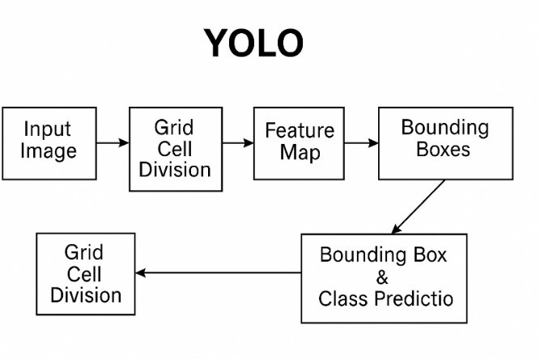

How to construct a training set and make predictions for YOLO like models.

Training Set Construction
- The training set is created to detect objects, including a background class.
- Each grid cell in a grid generates a target vector, with values indicating the presence or absence of objects and their bounding boxes.
Prediction Process
- The neural network outputs a volume for each grid cell, indicating detected objects or noise if none are present.
- Non-max suppression is applied to filter out low-probability predictions and refine the final output for each object class.
Final Output
- The algorithm aims to accurately detect and classify objects in an image, utilizing multiple anchor boxes and grid cells.

Intersection over Union
- A metric to measure the overlap between predicted and ground-truth bounding boxes:
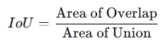
- Used for evaluation and in filtering predictions.

Non-max Suppression (NMS)
Goal: Remove duplicate detections for the same object.
How: Keep the box with highest confidence and suppress others with high IoU (> threshold).

Anchor Boxes
- Pre-defined shapes and sizes used during object detection (especially in YOLO and Faster R-CNN).
- Allow the network to predict multiple objects in a single cell by using multiple anchor boxes.

R-CNN Family
R-CNN (Region-based CNN)
Improves object detection by selecting a few relevant regions to analyze instead of scanning the entire image.
- Uses selective search to generate ~2000 region proposals.
- Each region is resized and passed through a CNN.
- Accurate but very slow.
Fast R-CNN
Enhances the original R-CNN by implementing a convolutional approach to sliding windows, speeding up the classification process.
- Improves R-CNN by:
  - Running the CNN once for the full image.
  - Extracting region proposals from the feature map.
  - Feeding each region into a classification + bounding box regression head.
Faster R-CNN
Further optimizes the region proposal step by using a convolutional neural network for region proposals, making it faster than Fast R-CNN.
- Replaces selective search with a Region Proposal Network (RPN).
- The RPN is a small CNN that shares features with the main detection network, greatly improving speed.

Segmentation Algorithms
🔸 Semantic Segmentation
Goal: Classify every pixel in the image.
Output: A mask with pixel-level class labels.
Example: All pixels of "cat" are labeled as such — but you don’t distinguish between different cats.
🔸 Instance Segmentation
  - Combines object detection + semantic segmentation.
  - Detects objects and assigns a pixel-level mask to each instance.
🔸 Transpose Convolution (a.k.a. Deconvolution or Up-convolution)
- Used to upsample feature maps (i.e., increase spatial resolution).
- Common in segmentation networks like U-Net or SegNet.

U-Net
- Originally developed for biomedical image segmentation.
- Architecture:
  - Contracting path: typical CNN (downsampling).
  - Expanding path: upsampling with transpose convolutions.
  - Skip connections: help preserve spatial information.
- Works well on small datasets, thanks to heavy data augmentation and symmetric design.
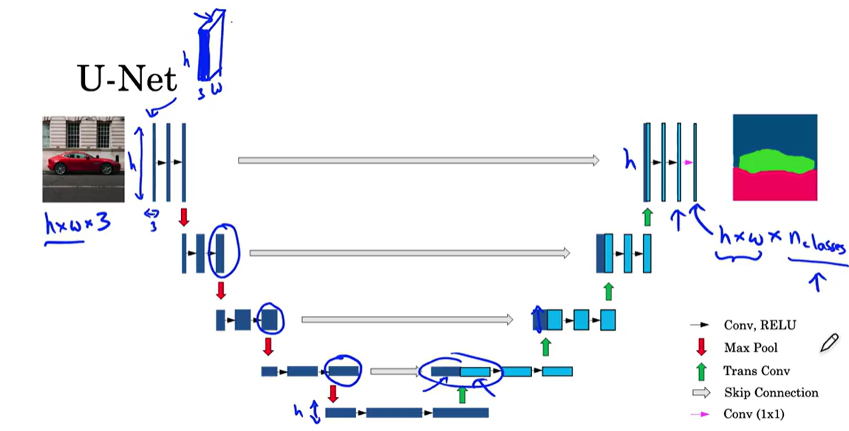

Face Recognition

Face Verification vs. Face Recognition
- Face verification involves confirming if an input image matches a claimed identity, often referred to as a one-to-one problem: Is this person A? → Compare two embeddings using distance (e.g., Euclidean or cosine).
- Face recognition is more complex, as it requires identifying a person from a larger database, necessitating higher accuracy in verification systems to minimize errors: Who is this person? → Compare with a database of known embeddings and pick the closest match.

Feature Extraction
- Goal: Convert a face image into a vector (called an embedding) that represents the face's unique features.
- Popular deep learning models:
- FaceNet (Google)
- DeepFace (Facebook)
- VGGFace (Oxford)
- ArcFace (InsightFace)
- Example: FaceNet maps each face to a 128D vector so that similar faces are close in vector space.

One Shot Learning

One-Shot Learning

A machine learning paradigm where the model learns to recognize or classify new objects or classes from only one (or very few) examples.

Why One-Shot Learning?
In traditional supervised learning, models require hundreds or thousands of labeled examples per class. But in many real-world scenarios (e.g., rare diseases, new users, security), we may only have one sample per class.

Learning a Similarity Function
Instead of classification, a neural network can learn a similarity function that measures the difference between two images.
If the similarity score is below a certain threshold, the images are considered to represent the same person; otherwise, they are different.

Objective
Learn a similarity function f(x1,x2) that determines whether two inputs belong to the same class, even if that class was never seen during training.

Application of the Similarity Function
During recognition, the system compares the new image with existing database images using the learned similarity function.
This approach allows for the addition of new individuals without retraining the entire model, effectively solving the one-shot learning problem.

Siamese Network

Siamese Network Architecture
- A Siamese network consists of two identical neural networks that process two different input images to produce feature vectors.
- Each image is transformed into a 128-dimensional encoding, denoted as f(x1) and f(x2) for the two images.

Distance Measurement
- The similarity between the two images is determined by calculating the distance between their encodings using a norm function.
- A smaller distance indicates that the images likely represent the same person, while a larger distance suggests they are different individuals.

Training the Network
- The goal is to train the network so that encodings of the same person yield small distances, while encodings of different people yield large distances.
- This is achieved through backpropagation, adjusting the network parameters to meet these conditions.

Loss Functions
- Contrastive Loss (used in Siamese Networks)
- Triplet Loss (used in Triplet Networks)

Triplet Loss Overview
- Triplet loss involves comparing three images: an anchor (A), a positive (P), and a negative (N).
- The goal is to ensure that the distance between the anchor and positive images is smaller than the distance between the anchor and negative images.

Formulating the Triplet Loss Function
- The triplet loss function is defined to minimize the difference between the distances, incorporating a margin (α) to prevent trivial solutions.

Training with Hard Triplets
- Selecting "hard" triplets, where the anchor-positive distance is close to the anchor-negative distance, enhances the learning process.
- This approach improves the efficiency of gradient descent, ensuring the neural network learns effectively from challenging examples.

Binary Classification Approach
- Face recognition can be framed as a binary classification problem using a Siamese Network.
- The network computes embeddings for images, which are then used to predict if two images represent the same person (output of 1) or different persons (output of 0).

Logistic Regression and Feature Extraction
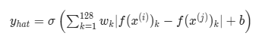
- A logistic regression unit processes the differences between the embeddings of two images.

- Features for the regression can be derived from the absolute differences of the embeddings, which are then used to train the model.

Pre-computation for Efficiency
- To enhance computational efficiency, embeddings can be pre-computed for a database of images.
- This allows for quicker comparisons when new images are introduced, avoiding the need to compute embeddings repeatedly.

Training Process
- The training set consists of pairs of images labeled as either similar or dissimilar.
- The Siamese Network is trained using backpropagation to optimize its parameters for accurate predictions.

Variations and Similarity Measures
- Other methods, such as chi-square similarity, can also be used to compute the relationship between embeddings.

Chi-Square Similarity (or Chi-Square Distance)
A statistical measure used to compare the similarity between two histograms or non-negative vectors, often in image processing, computer vision, or information retrieval.

Formula: Chi-Square Distance
Given two vectors (or histograms) A=[a1,a2,...,an] and B=[b1,b2,...,bn]:
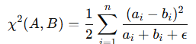
    - The small epsilon (𝜖) is added to avoid division by zero.
    - The factor $\frac{1}{2}$​ makes it symmetric and commonly used in practice.
    - Lower values mean more similarity.

LFW and SOTA
Term | Meaning
LFW | A popular benchmark dataset for face recognition/verification
SOTA | The current best-performing method or model on a specific task or dataset

LWF
LFW (Labeled Faces in the Wild) is a benchmark dataset used for evaluating face verification and recognition algorithms.
• Released by: University of Massachusetts, Amherst.
• Contents: 13,000+ face images of 5,749 people collected from the web.
• Challenge: The images are “in the wild,” meaning they include:
o Unconstrained lighting
o Different facial expressions
o Occlusions (glasses, hats, etc.)
o Varying backgrounds
- Typical Task on LFW:
  - Face verification: Given two images, decide if they belong to the same person.
  - Accuracy metric: Percentage of correct same/not-same predictions.

SOTA
SOTA stands for State Of The Art.
- It refers to the best known performance (highest accuracy, lowest error, etc.) achieved by any method or model at the current time on a given benchmark or task.
- In context of face recognition:
- A method with 99.83% accuracy on LFW is SOTA (as of that publication date).
- New models continually aim to beat SOTA results by improving accuracy, speed, robustness, etc.
Type | Algorithm/Model | Use Case | Key Idea / Methodology | Accuracy (LFW or SOTA) | Similarity Measure | Notes
Traditional | Eigenfaces | Recognition / Verification | PCA-based dimensionality reduction | Low  ~60–70% | Euclidean / Cosine | Sensitive to lighting, pose
Traditional | Fisherfaces | Recognition / Verification | LDA (Linear Discriminant Analysis) | Low–Medium  ~70–80% | Mahalanobis / Euclidean | Better class separation
Traditional | LBPH | Recognition | Local Binary Patterns Histogram | Medium  ~80–85% | Chi-Square | Histogram-based method
Traditional | SIFT / SURF | Verification | Keypoint matching using descriptors | Medium  ~70–85% (varies) | Feature Matching (e.g. FLANN, RANSAC) | Scale-invariant
Deep Learning | DeepFace (Facebook) | Verification / Recognition | CNN-based, trained end-to-end | ~97.35% (LFW) | Euclidean | Early deep learning model
Deep Learning | DeepID | Verification / Recognition | Multiple CNNs + Joint Bayesian modeling | ~97.45% (LFW) | Cosine Similarity | Modular network architecture
Deep Learning | FaceNet (Google) | Embedding + Verification | Triplet Loss, learns 128-D embedding | ~99.63% (LFW) | Euclidean Distance | Embedding-based, scalable
Deep Learning | VGGFace / VGGFace2 | Recognition / Verification | VGG-style CNNs, pretrained on large datasets | ~99.2% (LFW) | Euclidean / Cosine | Pretrained, widely used
Deep Learning | ArcFace | Recognition / Verification | Additive Angular Margin Loss | ~99.83% (LFW) | Cosine Similarity | State-of-the-art margin-based model
Deep Learning | Dlib ResNet | Verification / Recognition | CNN-based, provides 128D embeddings | ~99% (LFW) | Euclidean | Lightweight and fast
Deep Learning | SFace (Huawei) | Verification | Efficient + Accurate for mobile devices | ~99.55%  High | Cosine Similarity | Designed for edge devices

Neural Style Transfer
Neural Style Transfer (NST) is a deep learning technique that reimagines an image by combining the content of one image with the style of another. It was first popularized by the 2015 paper “A Neural Algorithm of Artistic Style” by Gatys et al.

Key Idea
NST takes:
- A content image (e.g., a photo of a cityscape)
- A style image (e.g., a Van Gogh painting)
And produces:
- A stylized image that preserves the content of the first and mimics the artistic style of the second.

How It Works (High-Level)
It uses a pre-trained Convolutional Neural Network (CNN)—typically VGG19—to extract features from images:

Content Representation
- Extracted from deeper layers of the CNN.
- Captures high-level structures (e.g., shapes, objects, layout).

Style Representation
- Extracted from several layers of the CNN.
- Captures textures, colors, and patterns using Gram matrices (which measure correlations between feature maps).

Optimization
- Start with a random or content image.
- Iteratively adjust it using gradient descent to:
- Minimize content loss (difference from content image features).
- Minimize style loss (difference from style image Gram matrices).

Objective Function
The total loss is a weighted sum:
Total Loss=α⋅Content Loss+β⋅Style Loss
Where: α and β - control the trade-off between content and style.

Applications
- Artistic image generation
- Film and game stylization
- Augmented reality filters
- Style-based data augmentation

Example Tools
- TensorFlow and PyTorch both have NST implementations.
- Apps like DeepArt and Prisma use NST for real-time image stylization.

Mathematical formulation of Neural Style Transfer (NST)
Problem Setup
We are given:
- Content image C
- Style image S
- Generated image G (initialized randomly or as a copy of C)
Our goal: Optimize G to minimize a loss function that captures:
- Content similarity to C
- Style similarity to S

1. Content Loss
Let $F^{l}∈R^{N_{l}×M_{l}}$ be the feature map of layer $l$ for the generated image, and $P^{l}$ be the corresponding feature map for the content image.
Where:
- $N_{l}$ is the number of filters (channels) in layer $l$
- $M_{l}=H_{l}×W_{l}$ is the size of each flattened feature map (height × width)

The content loss is:
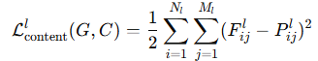
This is the squared error between the activations of G and C in a given layer $l$ (typically a deep layer like conv4_2 in VGG).

2. Style Loss
To represent style, we compute the Gram matrix for the feature maps of layer $l$:
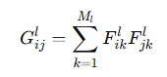
- $G^{l}∈R^{N_{l}×N_{l}}$: style matrix (Gram matrix) of generated image
- $A_{l}$: Gram matrix of the style image at layer $l$
The style loss at layer $l$ is:
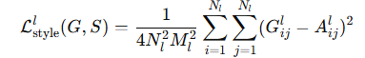
Total style loss across multiple layers:
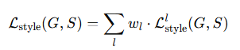
where $w_{l}$ is a weighting factor for each layer’s contribution.

3. Total Loss
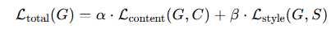
Combining both:

- α : controls importance of content
- β : controls importance of style (often much larger)

4. Optimization
We solve:
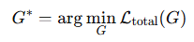
Gradient-based optimization (e.g., L-BFGS or Adam) is used to iteratively update the pixels of G to minimize the total loss.

- L-BFGS (Limited Broyden–Fletcher–Goldfarb–Shanno) is an optimization algorithm used to minimize a loss function. It's a quasi-Newton method : it approximates the Newton-Raphson method and avoids explicitly computing the Hessian matrix (approximating it).
At each step: 1) Approximates the inverse Hessian using past gradients and parameter changes. 2) Computes a search direction. 3) Performs a line search to find the best step size. 4) Updates the parameters.
- Adam (Adaptive Moment Estimation) is an adaptive learning rate optimization algorithm designed for SGD(stochastic gradient descent). It combines the benefits of Momentum (like SGD with momentum) and RMSProp (adaptive learning rates per parameter)

Summary
Component | Role | Equation
Content Loss | Preserve spatial structure
Style Loss | Match textures and color patterns | 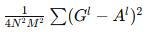
Total Loss | Blend both | 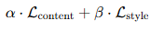
Optimization | Adjust GG to minimize loss | 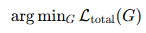

Common Weight Initialization Methods

Notes
- Glorot (aka Xavier) is often a good default choice.
- He is better for ReLU and its variants because it allows for more variance to counteract ReLU’s tendency to kill gradients.
- LeCun is ideal for SELU, which requires self-normalization.
- Orthogonal is useful when preserving long-term dependencies (e.g. in RNNs).
- Zero should not be used for weights because it prevents symmetry breaking.
Initializer | Best For | Distribution / Formula | Short Explanation | Parameters
Glorot Uniform | Tanh,  Sigmoid | $$W∼U\left.\left[-\sqrt{\frac{6}{{fan}_{in}+ {fan}_{out}}}, \sqrt{\frac{6}{{fan}_{in}+ {fan}_{out}}}\right.\right]$$ | Keeps activations/gradients balanced across layers | ${fan}_{in}$ - input units in layer  ${fan}_{out}$ - output units in layer
Glorot Normal | Tanh,  Sigmoid | $$W∼N\left(0,\frac{2}{fan_{in}+fan_{out}}\right)$$ | Same as Glorot, but draws weights from a normal distribution | Same as above
He Uniform | ReLU,  Leaky ReLU | $$W∼U\left[-\sqrt{\frac{6}{fan_{in}}},\sqrt{\frac{6}{fan_{in}}}\right]$$ | Allows for higher variance, ideal for ReLU activations | ${fan}_{in}$ - input units in layer
He Normal | ReLU,  Leaky ReLU | $$W∼N\left(0,\frac{2}{fan_{in}}\right)$$ | Like He Uniform but uses a Gaussian distribution | Same as above
LeCun Uniform | SELU | $$W∼U\left[-\sqrt{\frac{3}{fan_{in}}},\sqrt{\frac{3}{fan_{in}}}\right]$$ | Helps preserve variance for self-normalizing networks | ${fan}_{in}$ - input units
LeCun Normal | SELU | $$W∼N\left(0,\frac{1}{an_{in}​}​\right)$$ | Same as above but Gaussian | Same as above
Zero Initialization | None (avoid!) | W=0 | Leads to symmetry — all neurons learn same features | None (not recommended for weights)
Random Normal | Any (customizable) | $$W∼N\left(μ, σ^{2}\right)$$ | Simple Gaussian — needs tuning for variance | μ: mean  σ: standard deviation
Random Uniform | Any (customizable) | $$W∼U\left(a,b\right)$$ | Uniform over a user-defined range | a,b: lower and upper bounds
Orthogonal | RNNs,  deep linear nets | Initialize weights as orthogonal matrix | Preserves norm, helps gradient flow in RNNs | Shape must be 2D; square matrices preferred
Identity | Residual connections | W=I | Useful in residual/skip connections to preserve information | Only for square weight matrices

