Data Augmentation: PCA color augmentation

PCA color augmentation (also known as PCA lighting or AlexNet-style lighting noise) is a data augmentation technique applied to RGB images to introduce color variation in a way that mimics natural changes in lighting conditions. It was introduced in the AlexNet paper by Krizhevsky et al. (2012) to help improve the generalization of convolutional neural networks.
🔍 Concept
Principal Component Analysis (PCA) is applied to the RGB color values of all pixels in the training dataset to find the major axes of color variation. Then, at training time, small perturbations are added along these principal components to simulate lighting variations.
Why use PCA color augmentation?
- To increase robustness to lighting conditions and color variations.
- Helps prevent overfitting by making the model less sensitive to the specific color distribution in the training set.
- Mimics realistic changes like shadows, illumination shifts, or camera white balance effects.
🧠 How it works (step-by-step)
- Flatten the image dataset:
  - Stack all RGB pixel values from all images into an N×3N \times 3N×3 matrix, where NNN is the total number of pixels across the dataset and 3 corresponds to R, G, B channels.
- Compute the covariance matrix of the RGB values.
- Perform PCA:
  - Get eigenvectors (principal components) and eigenvalues (variance explained).
- Perturb the input image:
  - At runtime, for each image, generate a noise vector α\alphaα of random values drawn from a Gaussian distribution (e.g., N(0,0.1)
  - Compute the color shift:
ΔI=P⋅(α⋅λ)
where:
    - P: matrix of principal components (3×3)
    - λ: eigenvalues
    - α: random scalar coefficients
- Add the color shift to each RGB pixel in the image.

💡 Example (PyTorch-style pseudocode)
def pca_color_augmentation(image, eigvecs, eigvals, alpha_std=0.1):
alpha = np.random.normal(0, alpha_std, size=(3,))
rgb_shift = np.dot(eigvecs, eigvals * alpha)
return np.clip(image + rgb_shift, 0, 255)

⚠️ Things to watch out for
- PCA lighting augmentation can be subtle and shouldn't drastically alter colors — it's meant to simulate lighting, not change image semantics.
- It’s less commonly used today than other augmentations (like random color jitter) but can be beneficial for certain vision tasks.

✅ Step-by-Step PCA Color Augmentation in TensorFlow

1. Precompute PCA on RGB pixel values
Before training, run this once on your dataset:
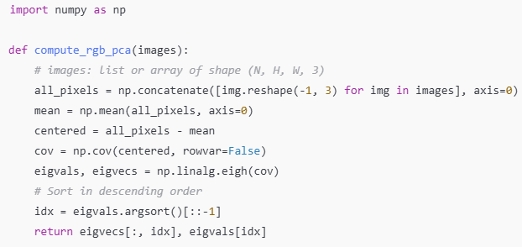
Save eigvecs and eigvals for use during augmentation.

2. PCA Lighting Function
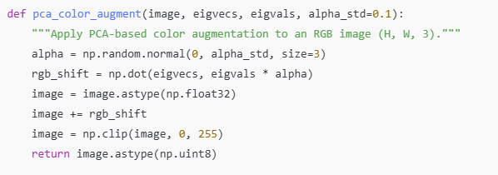

3. Wrap it for use in a TensorFlow pipeline
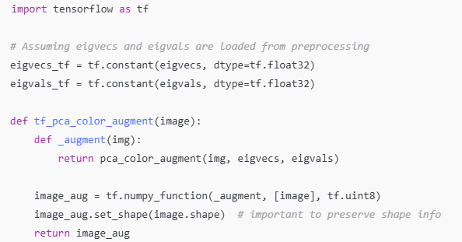

4. Use in a Dataset Pipeline
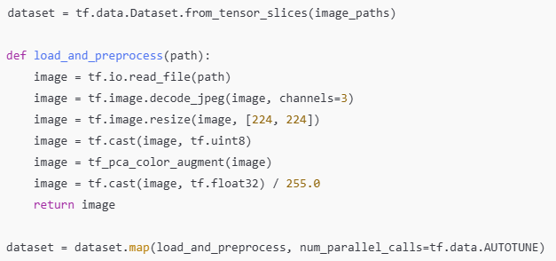

📌 Notes
- PCA color augmentation is more computationally expensive than basic color jittering, so use it when color robustness is critical.
- You can replace .astype(np.uint8) and normalization steps based on your model’s input format.

