Debiasing Word Embeddings – Step-by-Step Visualization

Step 1 Original Vectors
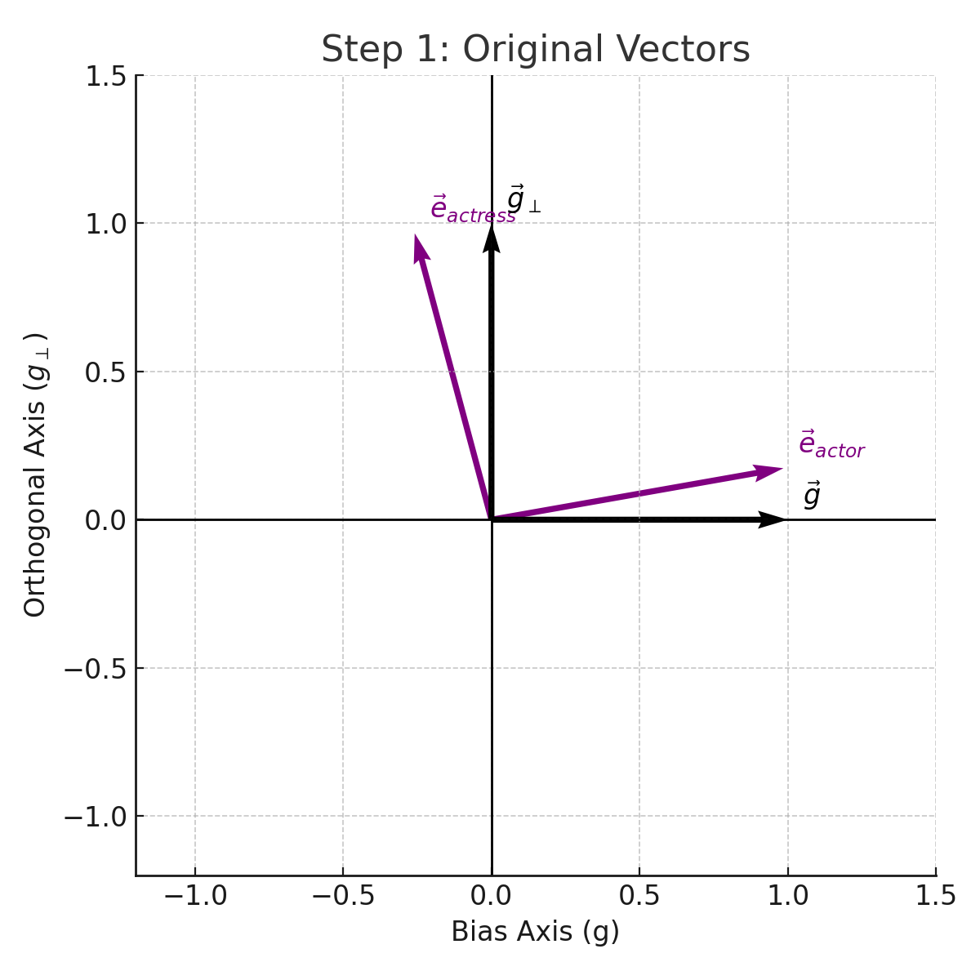

Step 2 Mu
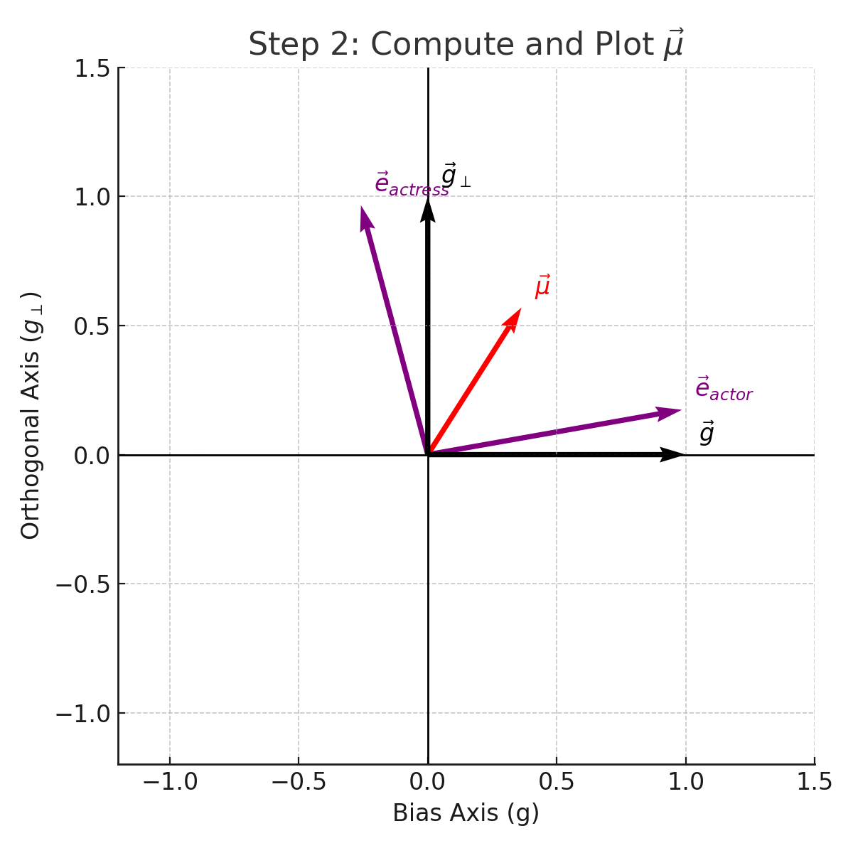

Step 3 Mu B
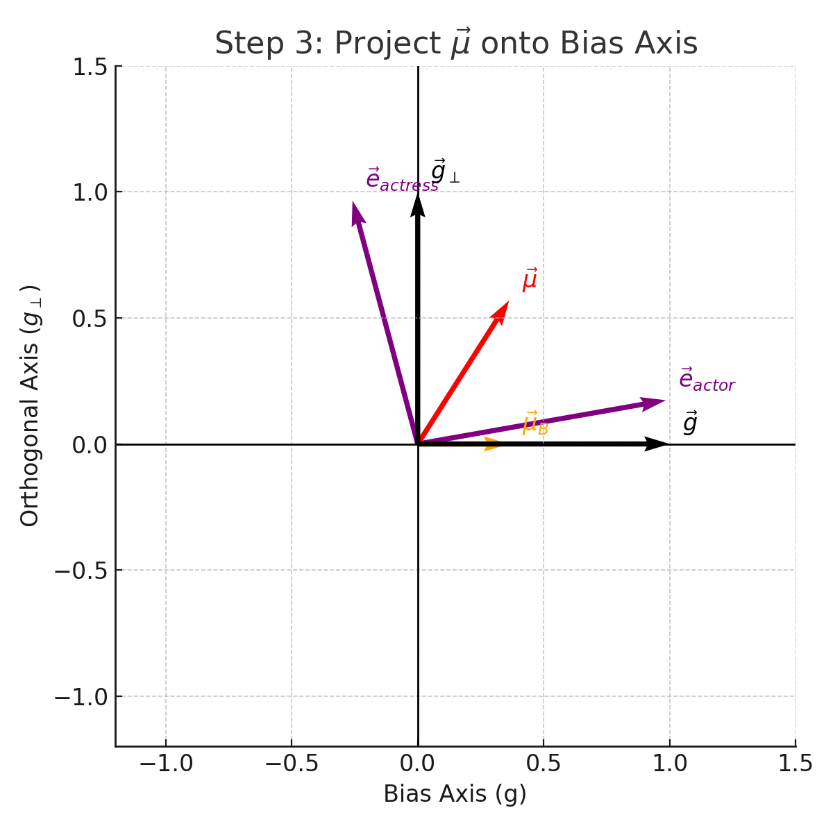

Step 4 Mu Perp
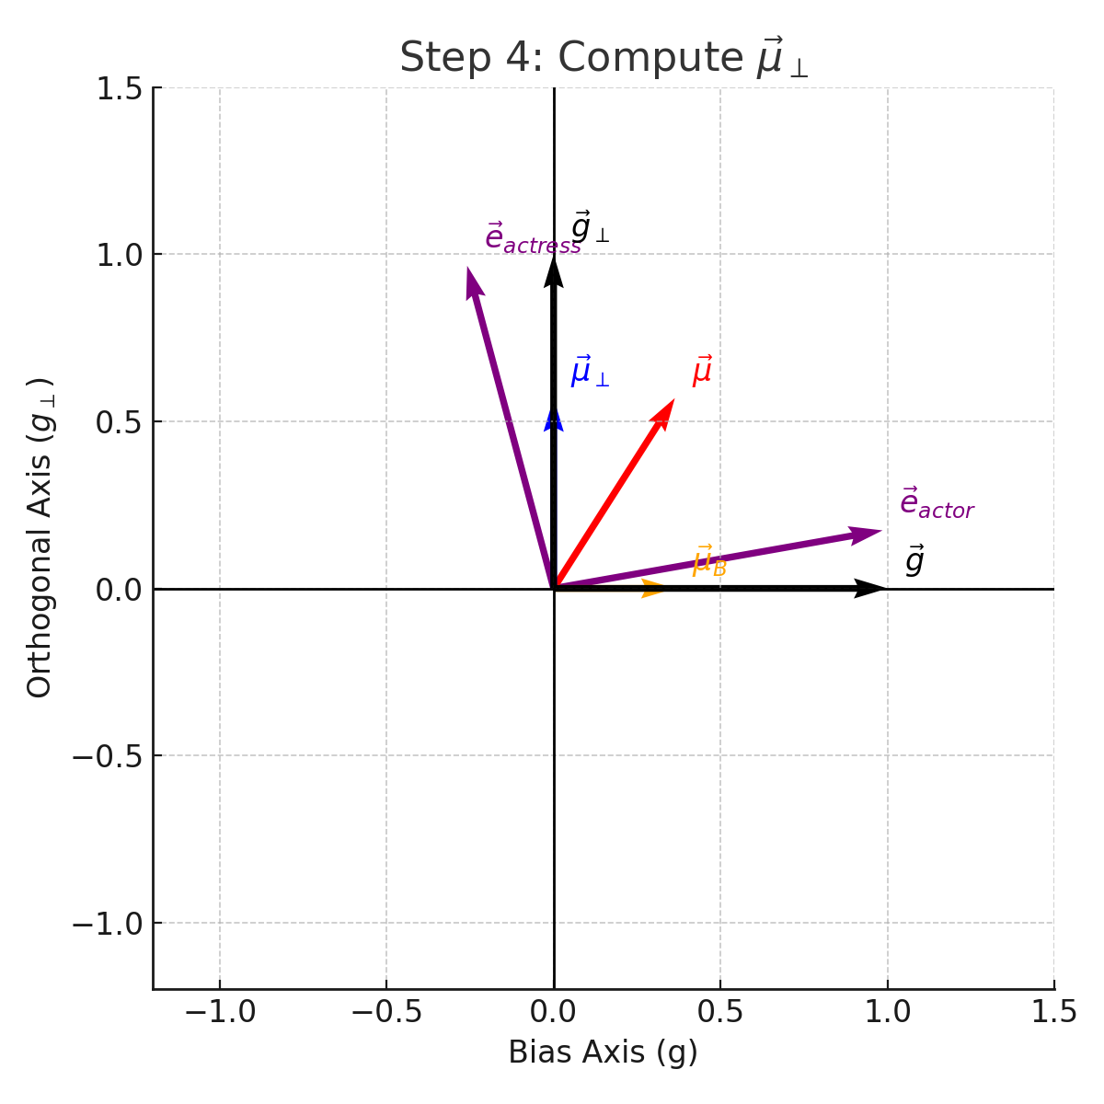

Step 5 Equalized
