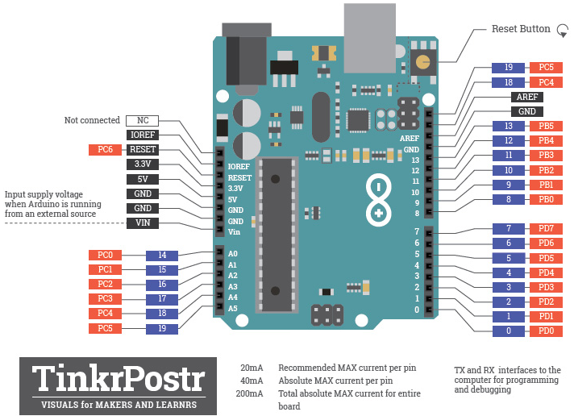

ADC

TWI – I2C: PC4 SDA; PC5 SCL

UART: PD1 TX; PD0 RX

PD3 INT1; PD2 INT0

SPI

PB5 SCK; PB4 MISO;

PB3 MOSI; PB2 SS

PD3 OC2B

PD5 OC0B

PD6 OC0A

PB3 OC2A

PB2 OC1B

PB1 OC1A