App: Price and News aggregator for Cryptocurrency

We will create an iOS app designed to aggregate and display pricing for cryptocurrencies.

The app will use API requests to pull information and display the basic information about the currency. The charting will be in html5 format to display via Tradingview’s cloud database.

Another feature is a news aggregator to pull information about the Crypto market. Will give a basic list of headlines about crypto and links to their full site.

The color scheme is a shade of green, and white. We wanted to utilize green to symbolize money and prosperity. The Main background color is white while the buttons are green. The font design is a the standard Roboto to keep a clean experience.

User Flow Diagram:

We updated the User Flow Diagram – rectangles for screens and rhombus for services.

[user_flow_diagram.drawio - diagrams.net](https://app.diagrams.net/#Halexander-bui%2Fcosc4355_ios_app_project%2Fmain%2Fapp_specifications%2Fuser_flow_diagram.drawio)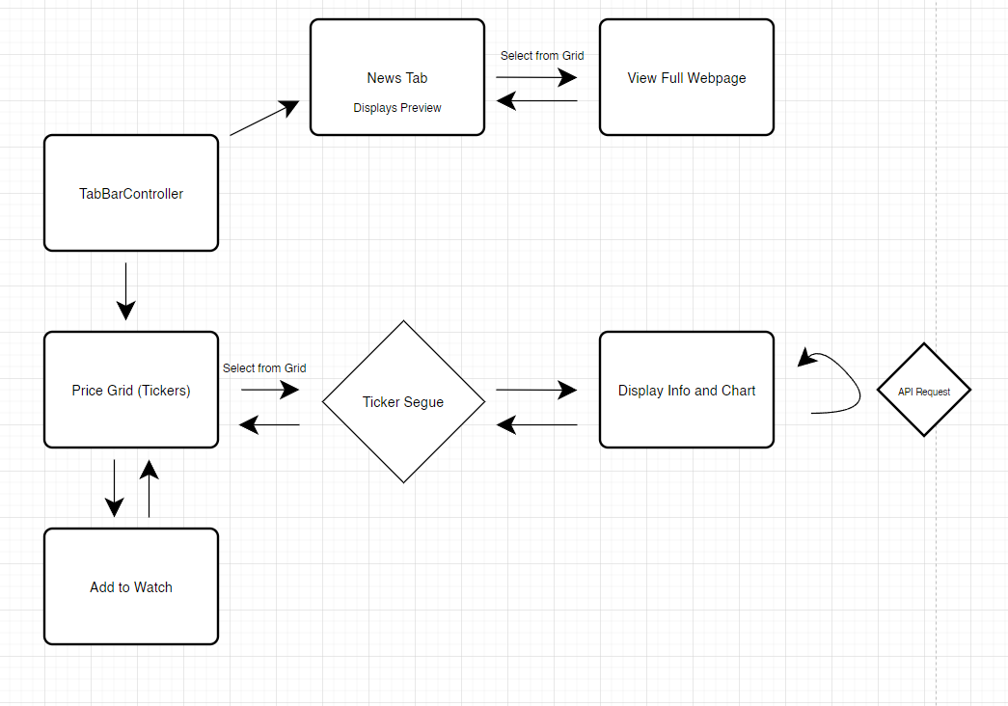

Beta App:

Price Tab:

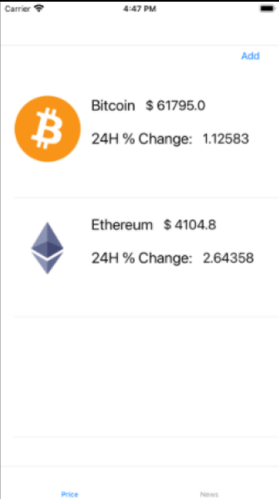

Delete From Price:

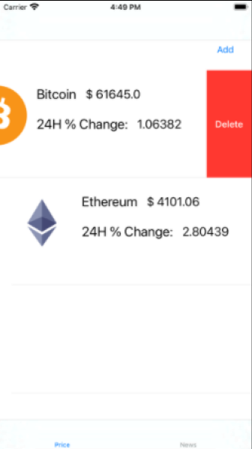

Select Coin:

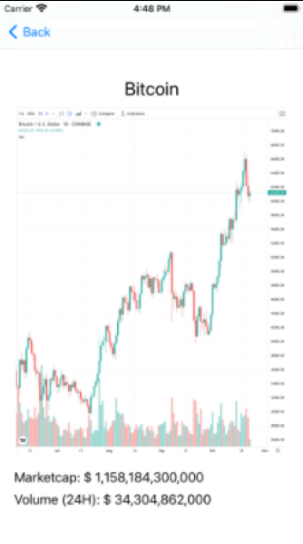

Add To Watch:

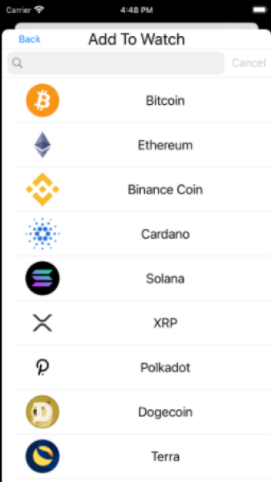

General News:

Personalized News (According to Coins Selected in Price Tab)

Webpage View in after selection of News (For General or Personalized):

Another Possible News Color Format (?):

