App: Price and News aggregator for Cryptocurrency

We will create an iOS app designed to aggregate and display pricing for cryptocurrencies.

The app will use API requests to pull information and display the basic information about the currency. The charting will be in html5 format to display via Tradingview’s cloud database.

Another feature is a news aggregator to pull information about the Crypto market. Will give a basic list of headlines about crypto and links to their full site.

The color scheme is a shade of green, and white. We wanted to utilize green to symbolize money and prosperity. The Main background color is white while the buttons are green. The font design is the standard System font to keep a clean experience.

Notable Change: News tab split into General News and Personalized News tabs. (Explained below with the screenshots)

Note: Both news tabs are ordered not by date, but by using the API's rank score algorithm for the news from the last 7 days (so that the news is current).

Final Stage – Reflections

After getting feedback about the Beta submission, I made a few changes to the Price tabs. First was changing the color to a black tone to match the existing Tabs color scheme. Another big change that you can see is the moving of the ‘Add’ button to the bottom near the Tabs and changing to a + symbol. This creates more screen space without compromising the existing layout. The result is a cleaner user experience. I also fixed the uneven table size each ticker, cleaner visual presentation.

User Flow Diagram (of previous submission) Correction:

We updated the User Flow Diagram – rectangles for screens and rhombus for services.

[user_flow_diagram.drawio - diagrams.net](https://app.diagrams.net/#Halexander-bui%2Fcosc4355_ios_app_project%2Fmain%2Fapp_specifications%2Fuser_flow_diagram.drawio)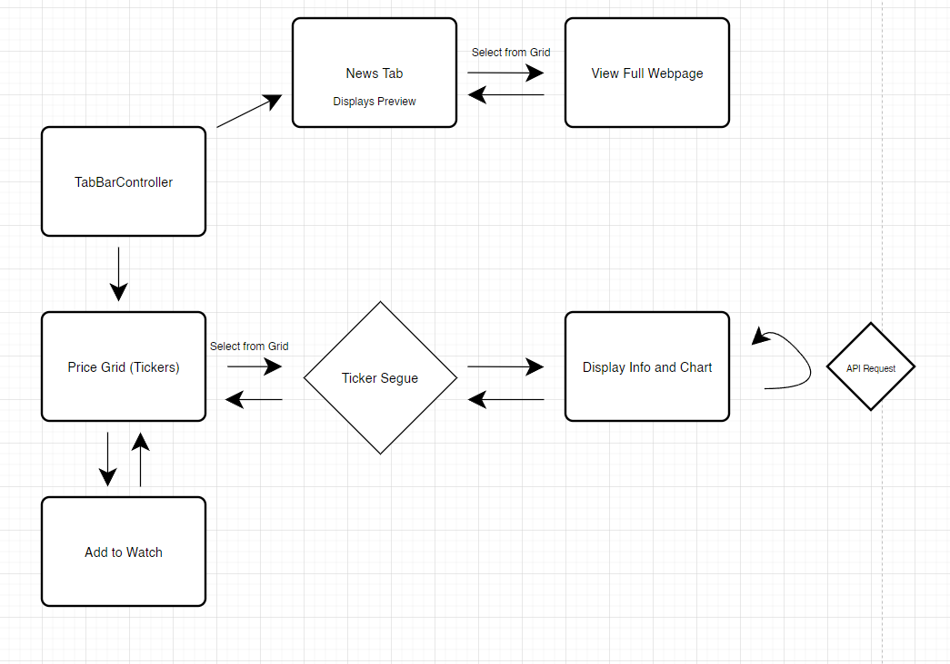

Launch Screen (We decided to use a logo name with some fun word play):

Price Tab:

BEFORE AFTER

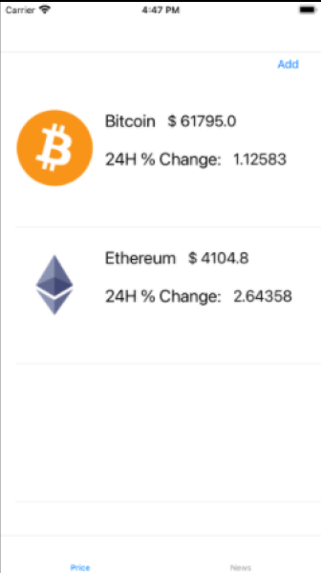

Delete From Price:

BEFORE AFTER

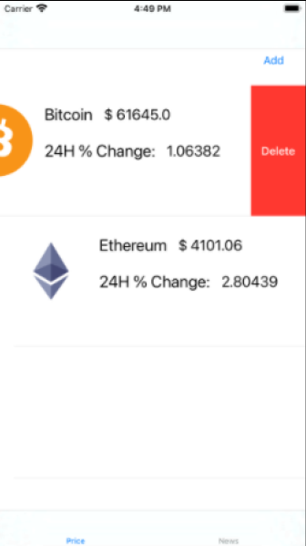

After Selecting a Coin:

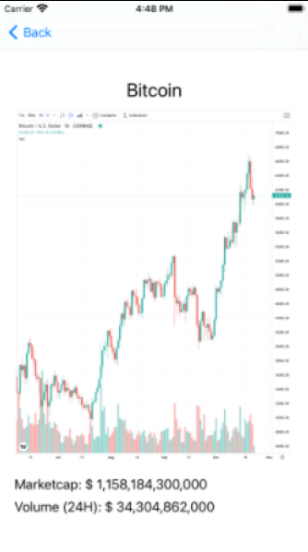

Add To Watch:

General News (General cryptocurrency related news):

Personalized News (News according to Coins Selected in the Price Tab):

Webpage View in after selection of News (For General or Personalized):

