# Design

Here we describe technical diagrams on how the ADMC (Australian Dog Matching Company) website interacts.

## Hierarchy Chart

The ADMC website has a homepage which links to various dog services, Info page, Search page, Adopt page, Surrender page, Statistics of dog rehoming page, Donate page accepting Credit Card and PayPal and a Contact Us page with social media plugins as shown in Figure 1, also available at

<https://drive.google.com/file/d/1jKM1PmlkaVlj39y7T1aUslVcOesqy4VZ/view?usp=sharing>.

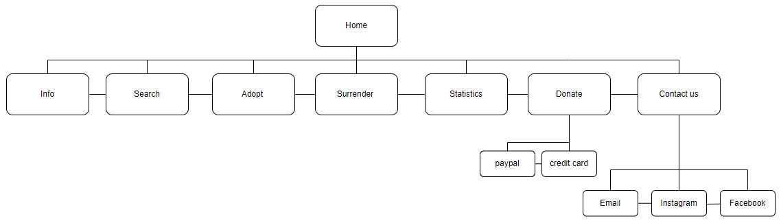

Figure 1 – ADMC Hierarchy Chart (from <https://drive.google.com/file/d/1jKM1PmlkaVlj39y7T1aUslVcOesqy4VZ/view?usp=sharing> )

## Wireframes

### We adopt a “mobile first” design principal and primarily have desktop and tablet versions to save screen space on larger screens. Wireframes are traced to Table 2 Requirements in Part A.

### Requirements in Part A are traced to Wireframes in Table 4 and most pages have 2 versions to accommodate all devices. We believe all requirements are met except Req10 Quality of Service which is not addressable now. All wireframes are also available at <https://wireframe.cc/pro/pp/c0ddee9ab649849> .

|  |  |  |  |
| --- | --- | --- | --- |
| ReqId | Requirement | Wireframe | Req Type |
| 1 | Info | Figure 2,3 | User |
| 2 | Surrender form | Figure 4,5 | User |
| 3 | Adopt form | Figure 9,10 | User |
| 4 | Search form | Figure 11,12 | User |
| 5 | Donate page | Figure 13 | User |
| 6 | View Statistic page | Figure 8 | User |
| 7 | Device Support | Figures 2-13 | Functional |
| 8 | Interaction Support | Figures 2-13 | Functional |
| 9 | Accessibility for service | Figures 2-13 | Functional |
| 10 | Quality of Service | N/A | Non functional |
| 11 | Free service | Figures 2-13 | Non functional |
| 12 | Implementation | Figures 2-13 | Non functional |
| 13 | Social Media | Figure 6,7 | Business  Requirements |
| 14 | Inclusivity | Figures 2-13 | Business  Requirements |
| 15 | Language | Figures 2-13 | Business  Requirements |

Table 4 – Traceability of wireframes to requirements

### Info Page

About the matching process and ADMC.

Figure 2 – Mobile Info Page (from https://wireframe.cc/pro/pp/c0ddee9ab649849)

Figure 3 – Desktop/Tablet Info Page

### Surrender Page

A page to surrender a Dog

Figure 4 – Mobile Surrender Page

Figure 5 – Desktop/Tablet Surrender Page

Contact Us Information

Pages to contact ADMC

Figure 6 – Mobile Contact Us Page

Figure 7 – Desktop/Tablet Contact Us Page

Statistics Page

Pages to retrieve dog rehoming information.

Figure 8 – Mobile/ Desktop/Tablet Statistics Page

Adopt Page

Page to Adopt or register for adoption of a dog.

Figure 9 – Mobile Adopt Page

Figure 10 – Desktop/Tablet Adopt Page

Search Page

Find available dogs to adopt.

Figure 11 – Mobile Search Page

Figure 12 – Desktop/Tablet Search Page

Figure 13 – Mobile/ Desktop/Tablet Donate Page

## Colour Palette

The following colour palette is used to Satisfy “ReqId 7” we use web-safe colours with good contrast.

|  |  |  |  |
| --- | --- | --- | --- |
| Area | Elements | Colour (Hex) | Sample |
| Page Background | background-color | #2F4F4F |  |
| Headings | h1 | #808080 |  |
| Sub-headings | c2,h3 | #000000 |  |
| Text | article, p | #FFFFFF |  |
| Section | section | #000099 |  |
| Unvisited Link | a:link | #6666FF |  |
| Visited Link | a:visited | #9933CC |  |
| Active Link | a:active | #00FF00 |  |
| Hover Link | a:hover | #6699FF |  |

Table 4 – Colour Palette