DSO 545 George Zhou, Martin Wu, Shihua(Sylvia) Lu, Jiaxin Huang, Silu(Lucia) Liu, Loukya Garlapati

**Final Project: 311 Call Center Tracking Data for City of Los Angeles**

**Executive Summary**

This report provides an analysis, insights and recommendations based on My LA 311 call center data. We analyzed Call Center data, Service Requests data and demographical information and we were able to find the time, day of the week, and month that the call center received the most traffic and we were also able to pinpoint the most popular service request types and the departments. In addition, we identified the specific zip codes in LA that had the most certain type of requests and also relation between requests and income and education level.

Our main findings from the report tell us that seasonality is related to the number of requests. We also found out that requests for Bulky items and Graffiti Removal are the highest along with the findings that the departments BOS and OCB have high requests. Further research indicate the service requests are generally high on weekdays through phone calls. Moreover, we found that high income and education areas are negatively correlated to requests such as Graffiti Removal.

The report also delves deeper into recommendations based on each insight. Some of the recommendations are:

* Allocate more staff during weekdays and the summer.
* Implement IVR or automated answering service for popular requests and departments.
* Promote other request channels such as apps and websites.
* Allocate resources based on the popular service requests in different areas.
* Implement targeted awareness campaigns to specific segmentations of residents.

**Introduction**

Launched in December 1, 2007, 311 Call Center is a “one call to city hall” program for non-emergency city services. By analyzing numerous service request and call center datasets, our aim is to

* provide meaningful suggestions to the government of Los Angeles to better allocate resources to serve tenants.
* Optimize personnel assignment across workdays and months, so as to improve the working efficiency of 311 call center.

**Data Source**

We collected our data from two resources:

* data.lacity.org

Call Center: <https://data.lacity.org/dataset/311-Call-Center-Tracking-Data/vmc3-stgb>

Service Requests: <https://data.lacity.org/A-Well-Run-City/MyLA311-Service-Request-Data-2016/ndkd-k878>

* censusreporter.org

The censusreporter.org provides demographical information for each regions, such as income level, education level, which will help us to comdpare the relationship between requests and different region.

**Github**

You can access our data, code, this report and presentation through Github: <https://github.com/DSOGroup7/311-LA>

**Insights/Analysis**

**1. Service Requests and Departments**

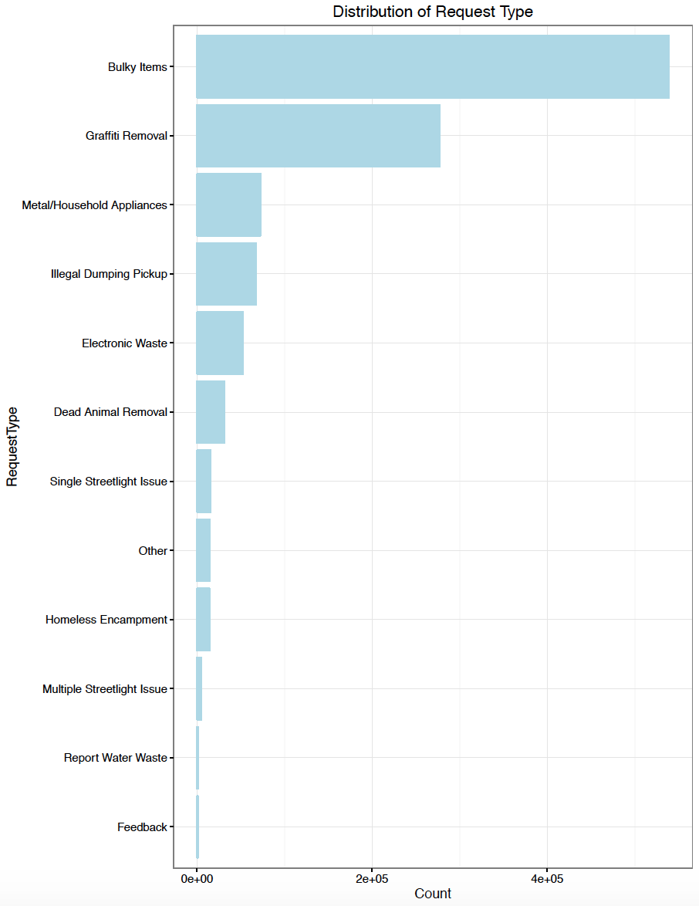

Majority of the request are bulky items and graffiti removal. Call center representatives can be trained to process these two specific requests more quickly and efficiently since these are the most common type of requests. Another solution might be to transfer these specific calls to an automated system where the system will ask the caller for the address of the bulky item or the graffiti and it can automatically dispatch teams to resolve the request.

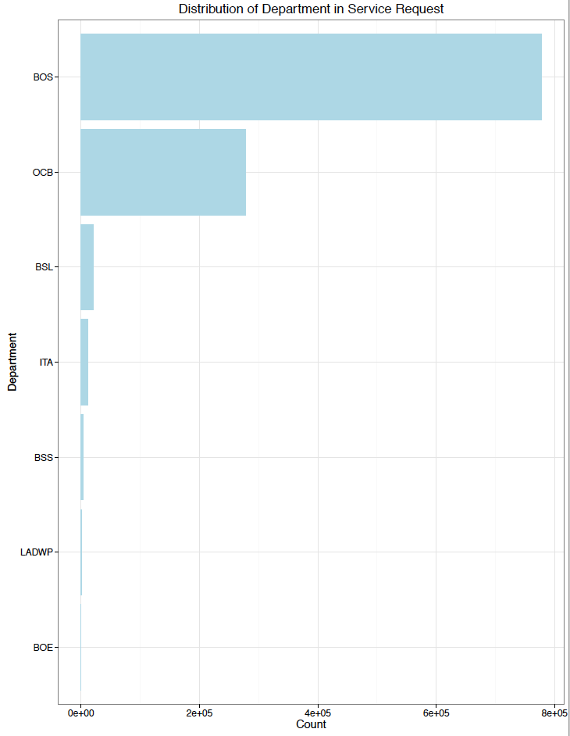

Departments that receive the most requests are Bureau of Sanitation (BOS) and Office of Community Beautification (OCB). These two departments perhaps could implement more channels such as online applications, emails, and apps to process the requests from residents and reduce the load on call center.

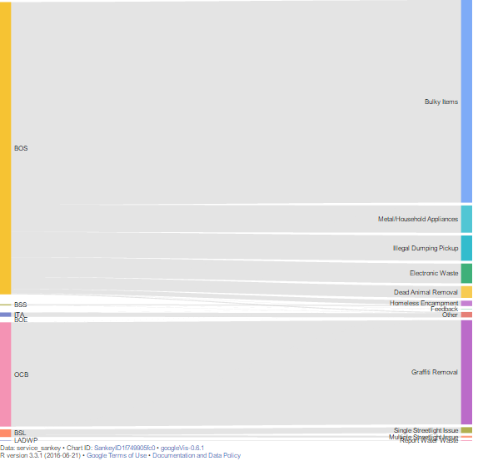

Here is a Sankey diagram which visualizes the proportion of requests by department and request type. It’s a combination of the previous two graphs. We can see that Bureau of Sanitation (BOS) processed requests on Bulky items, Metal/Household/Application, Illegal Dumping Pickup, Electronic Waste, Dead Animal Removal, and Homeless Encampment. OCB corresponds to Graffiti Removal, etc.

**2. Seasonality**

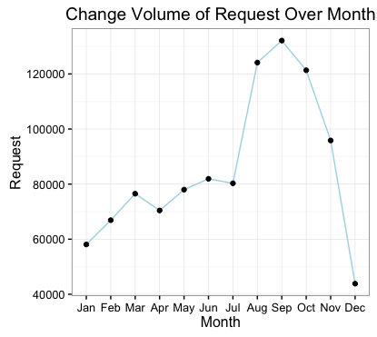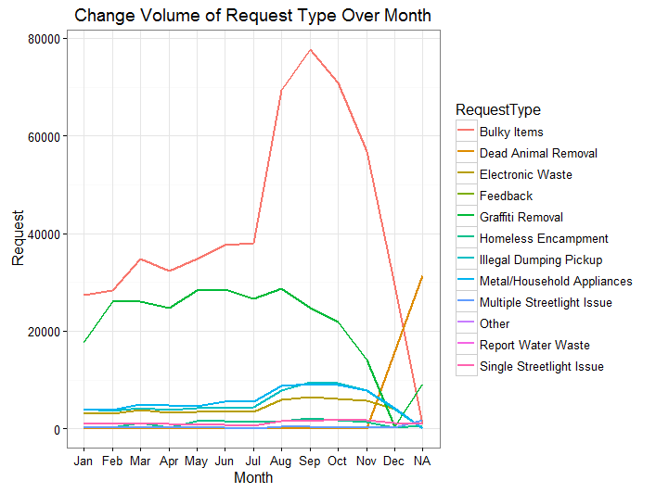

It is interesting to note that in any given year, significantly more calls occur during the summer months than any other months. This is perhaps due to the fact that during summer, children are more likely to have more free time and the parents are therefore more concerned about the safety of residential surroundings. August, September, and October are usually the warmest months in LA and more people are likely to venture outdoors and be more aware of the environment around them. From this data, we think it would be helpful for the call center to hire more temporarily call representatives during this period.

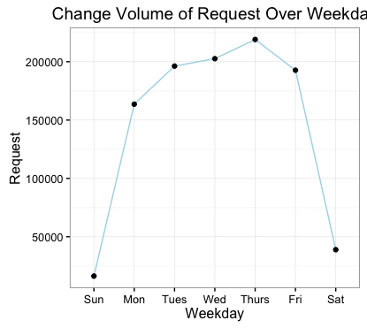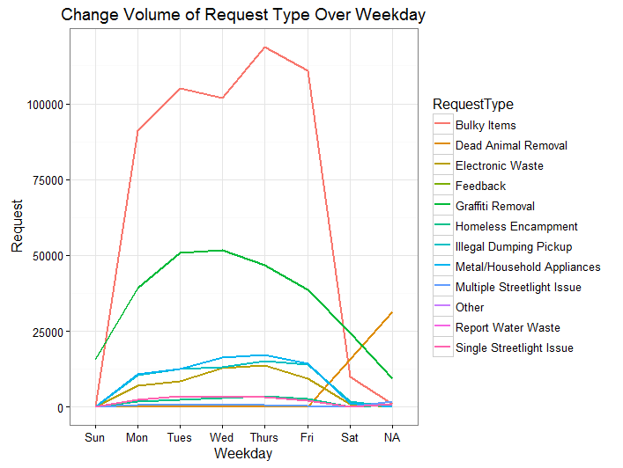

In analyzing the total volume of all requests received by all the city departments, we found that in a given any week, the city departments seemed to receive the most number of requests on Thursdays followed by Wednesdays. Individual Request Types follow similar patterns as the overall trends-- most requests are placed over the weekdays., especially Tuesday through Thursday. To achieve better resident satisfaction and reduce waiting time, the departments can have more staffs during mid-week to process the requests.

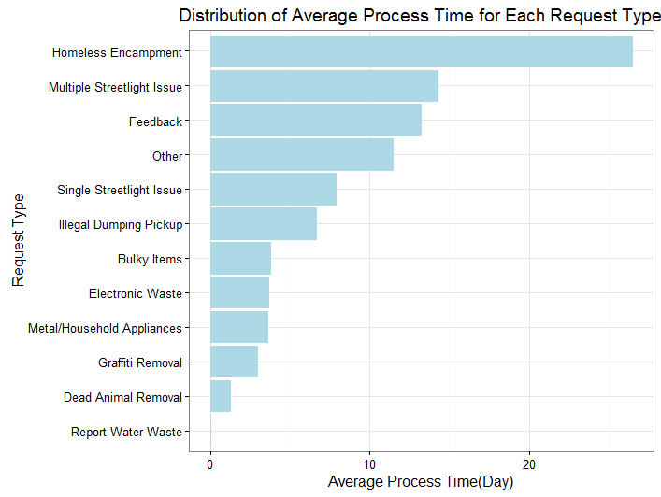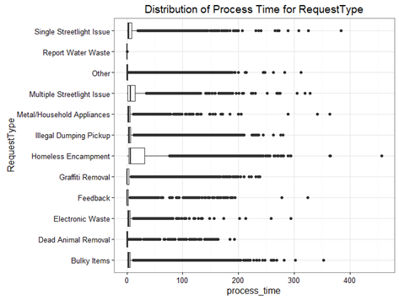

Average Process Time for Homeless Encampment is the longest ( around 28 days), and Dead Animal Removal and Report Water Waste the shortest（0-2 days) It is worth noting that there is a substantial number of outliers for Process Time in each Request Type that needs to be address. These might potentially exist due to reporting error. Average Process Time is calculated by UpdatedTime minus CreatedTime, which might not reflect the true value of process time.

**3. Request Channels**

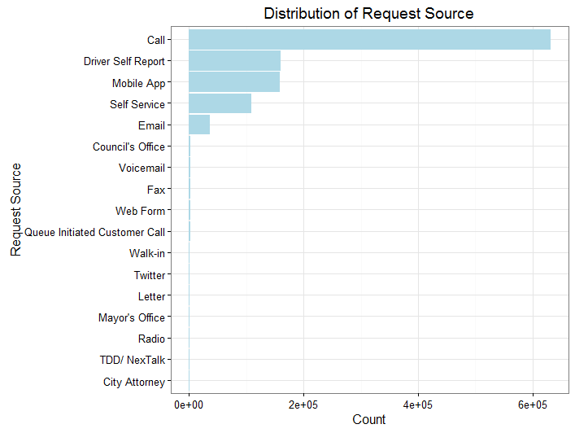

Most of the requests came in through calls. Phones seem to be the most convenient way for people to request service. Given more promotion and awareness on other possible channels such as mobile app, email, and self-service, perhaps more frequent users would switch from calls to these other alternatives.

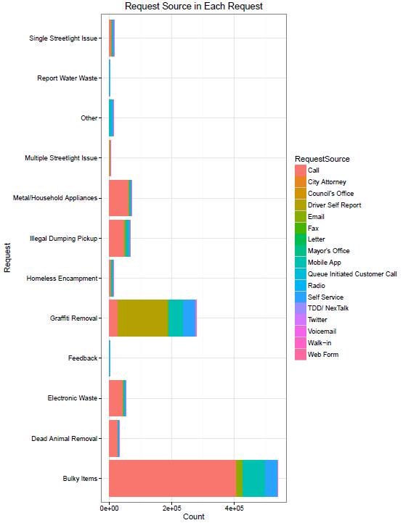

Take a deeper dive into Request Source by different service request types, we can see that about half of the all services processed are through phone calls for bulky item removal. There is also a great volume for graffiti removal requests generated from Driver Self Report. For high volume request types such as Bulky Items, Grafitti Removal, Metal/Household Appliances, how to entice users to switch from phone to web form or app to place service requests would be an area that the City should aim to tackle.

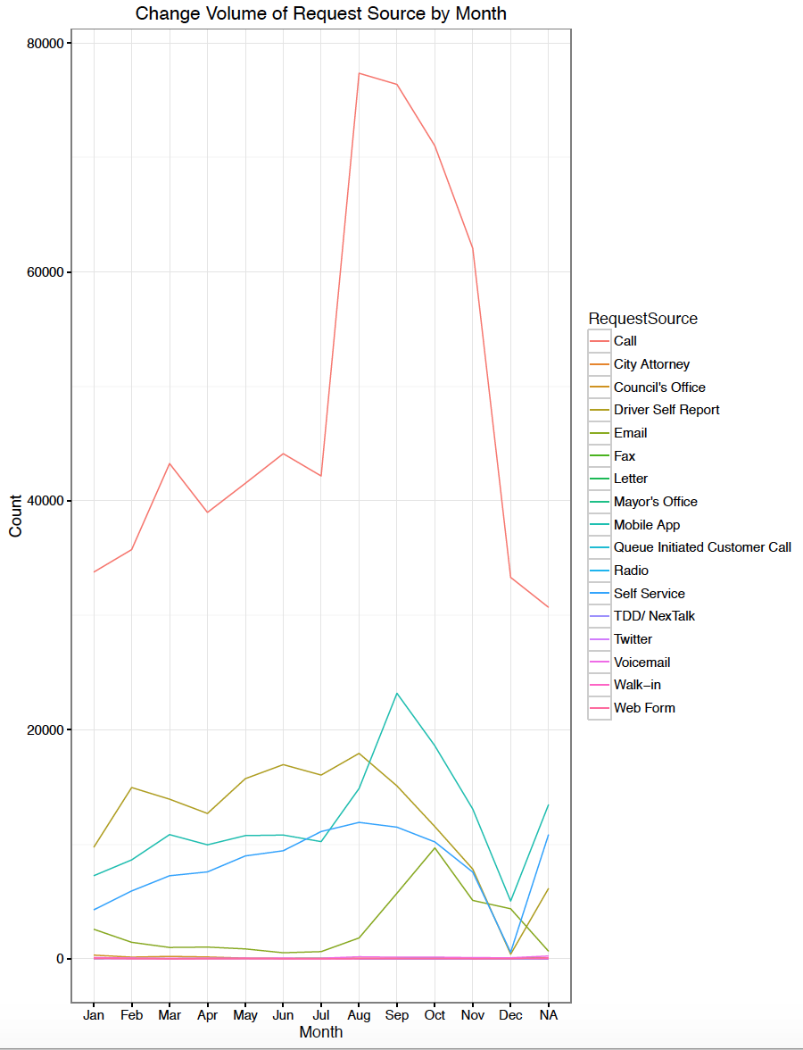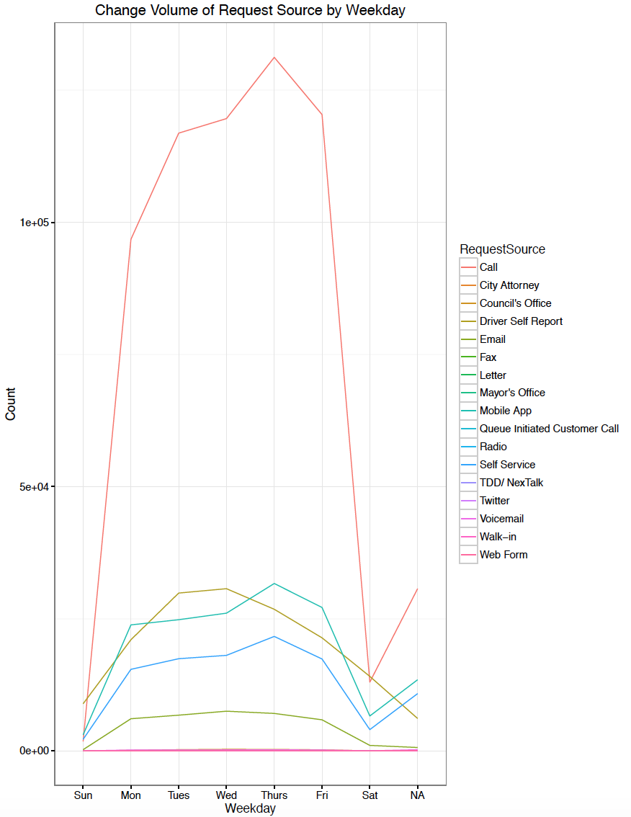

It can be observed that there is similar patterns of service request volume through various request sources.

**4. Demographic Level**

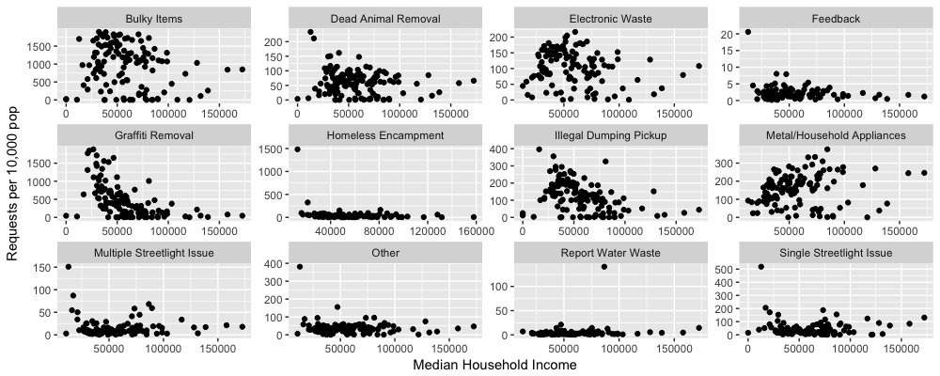

By using the data from censusreporter.org, we can find the median household income for each area (by zip code). The total requests number for each area is obviously related to the number of population in that area, thus we use requests per 10,000 people as a normalized metric to better compare the number of requests across regions. In the graph above, we can see the pattern of requests type vs household income varies. For example, the total number of Graffiti removal and illegal dumping pickup requests are clearly negatively correlated with median household income. This is probably because the area with high household income are more likely to be good neighbourhood and less likely to have problems with graffiti and illegal dumping. For requests such as multiple streetlight issue, water waste, homeless encampment, they seems to be uncorrelated with median household income.

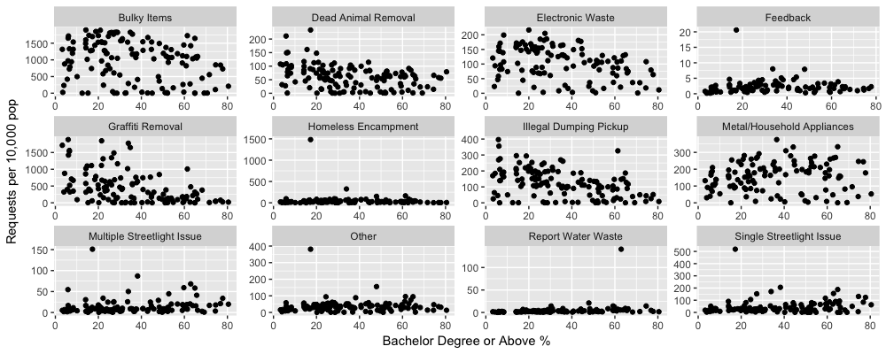

Similar to household income, we also analyzed the relationship between education level and request number. We have calculated the percentage of people who have bachelor’s degree or above in certain area as proxy for the education level. We have similar results as household income. Graffiti removal and illegal dumping pickup are negatively correlated with education level too. Bulky items and electronic waste have weak negative relationship with education level. The rest are unclear.

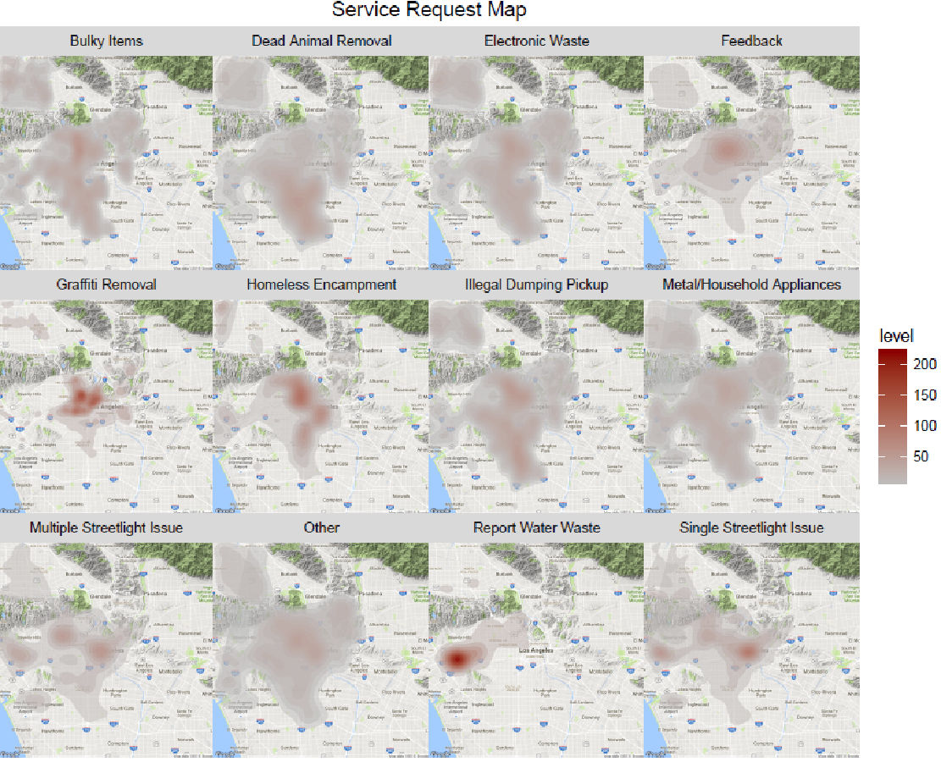

**Median Household income map of Los Angeles**

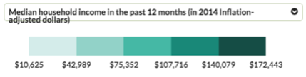

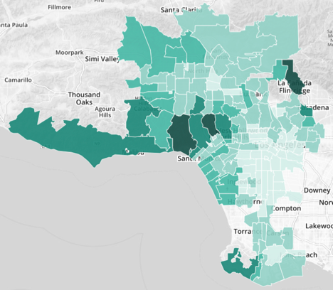

**Bachelor’s degree percentage in Los Angeles**

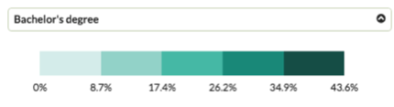

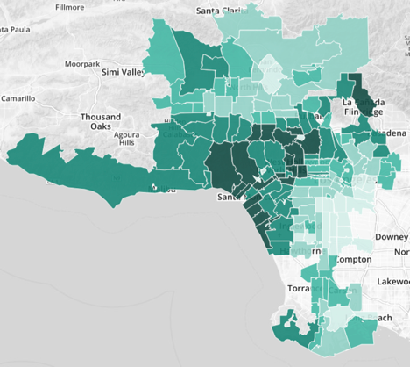

By comparing the heatmap of median household income, bachelor’s degree % and request type, we can further confirm our previous observation. Graffiti removals are mostly concentrated in downtown area, and illegal dumping are mostly concentrated in downtown/south los angeles area. Those areas have lower median household income. Another interesting observation is water waste are concentrated in Beverly Hill area, where water fountain, irrigation are very common for wealthy families. We suggest the government to campaign the importance of water in Beverly Hill area to educate residents.

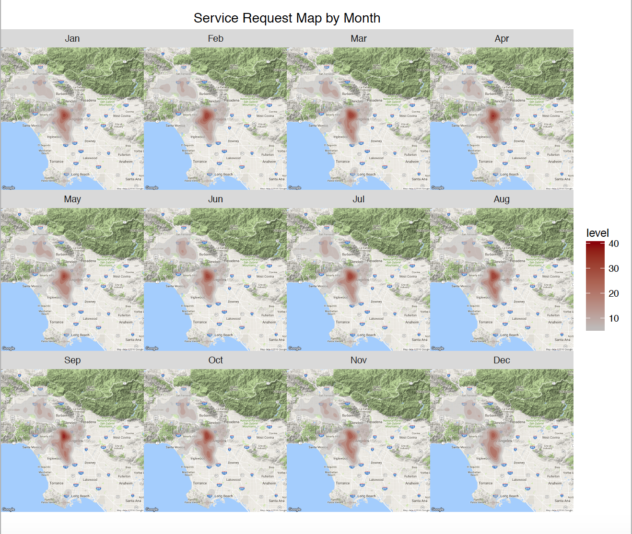

From the graph above, we can see service request center have slightly difference among different months. During the summer (July, Aug and Sep), total requests number are higher than other months. But generally speaking, the shape and area covered are very similar across different months.

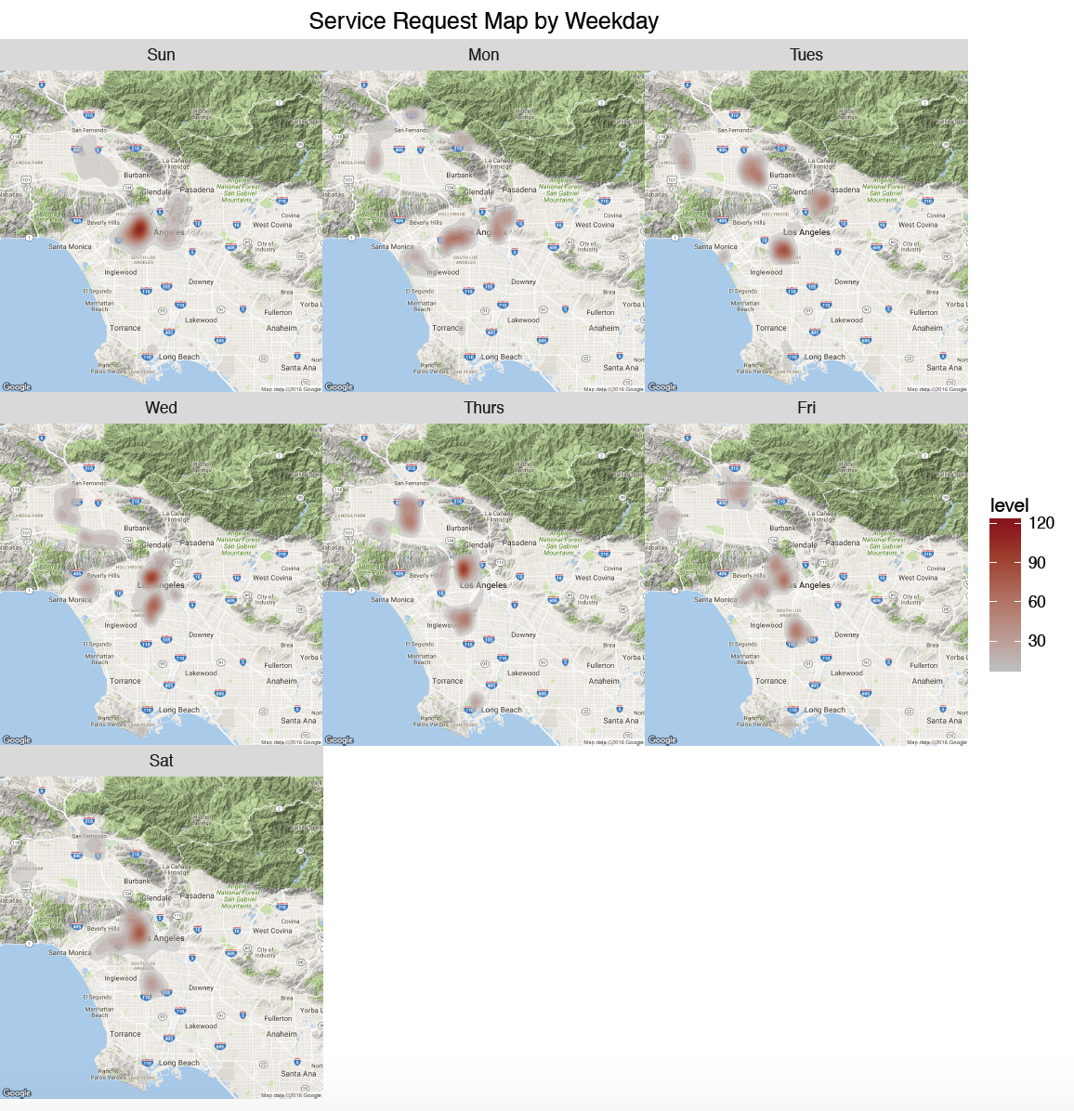

The graph above have some interesting results. Sundays seem to have the highest requests level followed by Wednesday and Thursday.

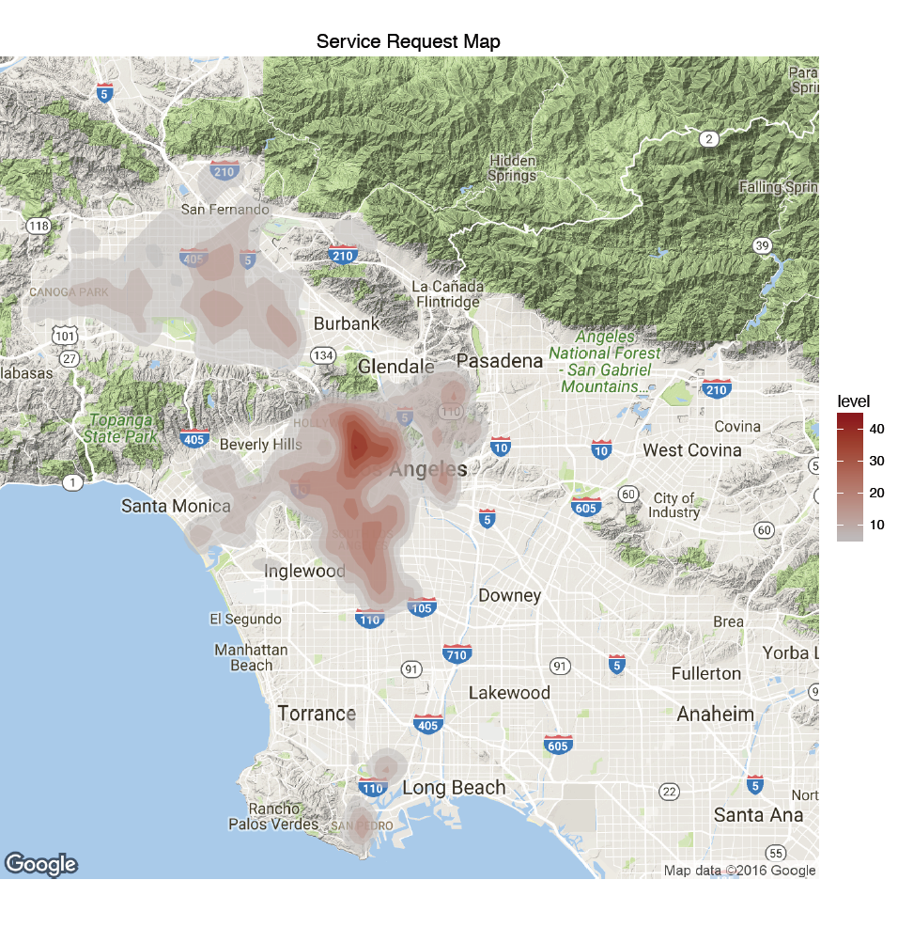

Most requests are concentrated in the north-west Los Angeles area, we suggest the government to allocate more resources in those area to prevent future requests.

**Call Center**

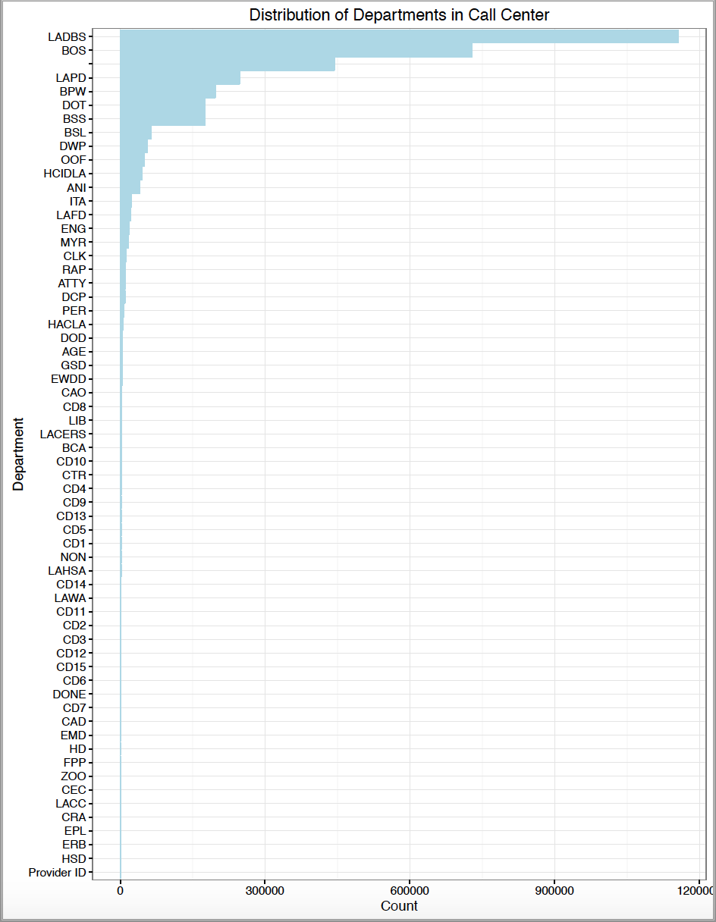

Most of the requests are distributed to LADBS (Los Angeles Department of Building and Safety) and BOS (Bureau of Sanitation) has the second most number of requests. In analyzing the service types within these departments, we discovered that most of the calls to LADBS are related to different types of permit services. These permit applications, reviews, and requests can be easily set up online for people to use instead of calling the call center. We believe that making the LADBS website more accessible and user friendly regarding permits will help reduce the number of calls to the call center significantly.

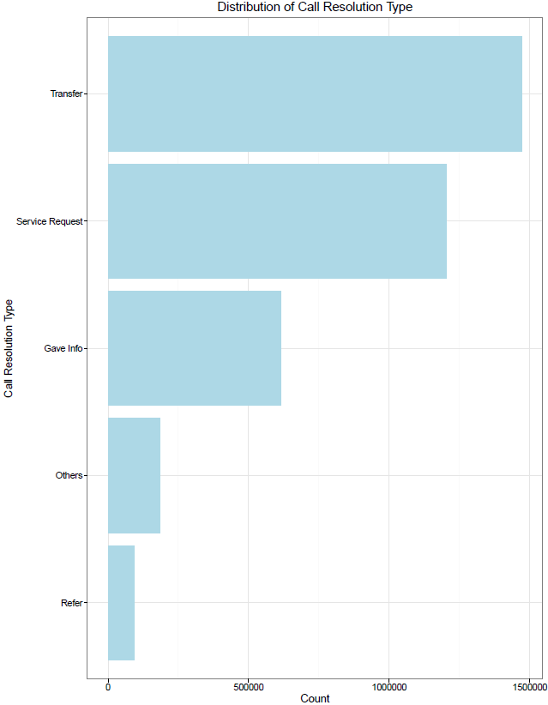

From the chart above, it is apparent that the most frequent call resolution is Transfer followed by Service Request Processed and Gave Caller Information. We recommend that the call center can implement an automated answering service with different options that the incoming caller can select to be transferred to. The automated service will provide a brief description of the department name and the type of services it can process to assist the callers in selecting their transfers. One of the options will be to stay on the line and speak with the representative who will provide other information such as Service Request and Giving Caller Information. We believe this will help the call center save money on operation cost.

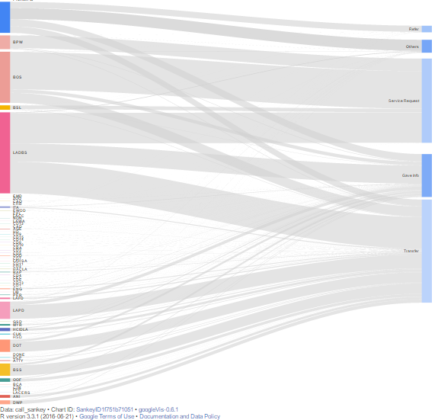

This Sankey Diagram summarizes the the proportion of service request by department and by call resolution types. It shows the relationship between the departments and the resolution types.

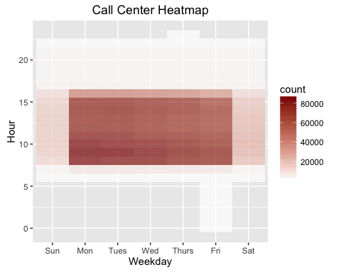

The heatmap shows that calls occur primarily during weekdays between 7:00AM and 4:00PM with some occurring during weekends. Monday and Tuesday mornings from 8:00AM – 10:00AM are the busiest. We, therefore, recommend the call center to have more staffs during early weekdays and mornings, and less staff during the weekends to maximize the efficiency and minimize the cost of the call center.

**Conclusion/Recommendations**

In analyzing both sets of data, we discovered several insights which we believe can help Los Angeles’s 311 call center reduce costs, increase efficiency, and improve user experience. We hope the analysis and recommendations will help the management team strategically allocate resources and delegate tasks to other departments. From the call center data, we were able to find the time, day of the week, and month that the call center received the most traffic and we were also able to pinpoint the most popular service request types and the departments. In addition, we identified the specific zip codes in LA that had the most certain type of requests. We segmented the residents based on income and education level and found that there was correlation between the service types and the segmentations.

Some of our main recommendations from the above analysis are as follow:

1. There is seasonality to the requests with more residents calling in during the summer. User experience can be improved if the call center and the city departments allocate more staffs during weekdays and the summer.
2. By identifying the most popular requests and most common call resolutions, we recommend the call center to implement an automated answering service with several of the most popular requests and departments for callers to pick from. This will help the call center reduce staffing costs and improve work efficiency.
3. Implement promotional messages for other request channels such as apps and websites during the calls. In addition to the automated greeting from the mayor in the beginning of the call, the call center can add another automated sentence reminding callers that they can get the same requests processed via other channels. This will help reduce cost and staffing for the call center.
4. Some request types are more popular within certain cities as identified by our geographical analysis. The call center can inform the responsible departments to better allocate resources on these specific types of services in specific cities.
5. Income and education are negatively correlated with the number of requests for certain services. By implementing targeted awareness campaigns to specific segmentations of residents, the city might be able to reduce the number of calls and requests.