**311 Call Center Tracking Data for City of Los Angeles**

**Part I. Background information and introduction**

What is 311?

MyLA 311 is a department of the City of Los Angeles that serves its community by providing citizens a way to connect with city to help beautify the community. LA residents can request a number of services via the Submit Service Request Form through a number of different channels, such as phone, email, or the newly developed MyLA 311 mobile app. The most common service type requests include graffiti removal, bulky-item pickup, and illegal dumping.

Through data visualization methodologies and techniques, how can we uncover potential problems for MyLA 311 and improve the department’s efficiency in servicing the residents of Los Angeles.

**Part II. Methodology**

**Data Preparation:**

Base on the nature of the course, all of our analysis and visualization were performed under R. The sources of our datasets were provided by Professor Sharif and retrieved from City of Los Angeles’ website: “311_Call_Center_Tracking_Data” and “MyLA311_Service_Request_Data_2016”.

The first dataset contains all historical records of 311 requests from 2011 to partial 2015 including the request date, time, service type, department responsible for the type of service, department abbreviation, call resolution (outcome), and the zip code of the caller. The 2016 dataset, covers all variables mentioned except “call resolution”, but also includes other useful parameters such as the exact location of the call (latitudes and longitudes), and an efficiency measurement, which is calculated with the subtraction of “CreatedDate” by “UpdateDate”. This measurement essentially indicates how long it took the representative to process each request.

What’s more, to visualize the data, we find the location of each zip code. We just select the LA zip code, so we can see the trend of these 6 years in the project. The zipcode data can be combined with the 2011 to 2015 data and 2016 data easily.

**Difficulty with inconsistencies in reporting system 2011 to now**

Due to the changes in the reporting system of MyLA 311 in mid 2015, our datasets did not share many common variables to analyze in aggregate. In addition, we have noticed some overlaps of the two datasets, but notably have any effects on the overall visuals and calculations. Therefore. we chose to analyze the datasets separately to identify any trends, as well as deviations from one dataset to the other.

**Part III. Data Visualization**

**Exploratory Analysis:**

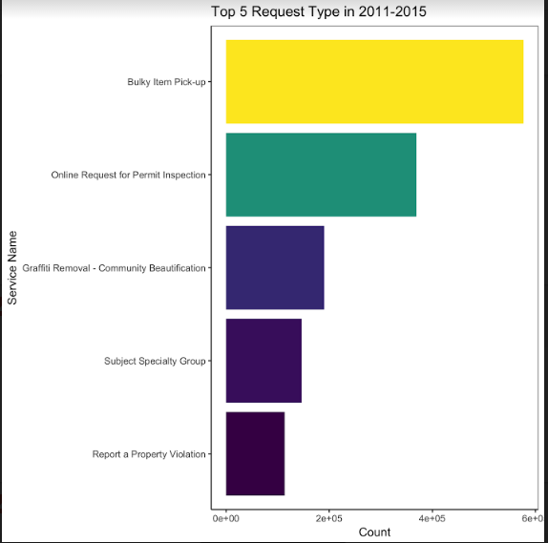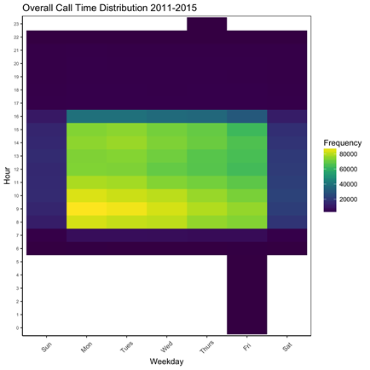

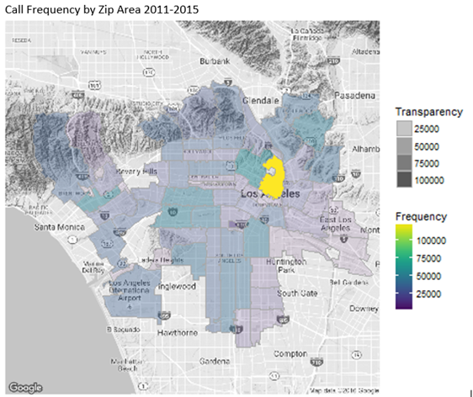

As shown by this bar chart, bulky pick removal is by far the most common service request type from our first dataset (2011-mid2015). This gives us an indication of how MyLA should be staffed to deal with such requests. In addition, this can give us further insight into any deviations we may see based on zip code or other variables.

Regarding the time distribution of calls, we can observe that the department receives its heaviest influx of calls between 7:30am and 10:30am, with the majority of the service requests coming in the beginning of the week. This intuitively makes sense to us, but this again can provide us with standard of time distribution to compare any deviations in data subsets.

As seen in the map of Los Angeles above, there is a significant, disproportionately large number of calls coming from an area of LA just north of downtown. We have identified this zip code as 90012. To further explore how MyLA 311 can better service the city, we have decided to dive deeper into the 90012 zip code to determine what is going on in this particular area.

**Zip Code – 90012:**

We wanted to dive deeper into the 90012 zip code to see if there were any unusual deviations from the overall dataset. As seen by the bar chart below, bulky item removal remains the most common service request call from the area. However, we notice that there are a disproportionate amount of property violation reports than in the overall dataset. This would indicate a greater staffing and service need for the City of Los Angeles to serve this area.

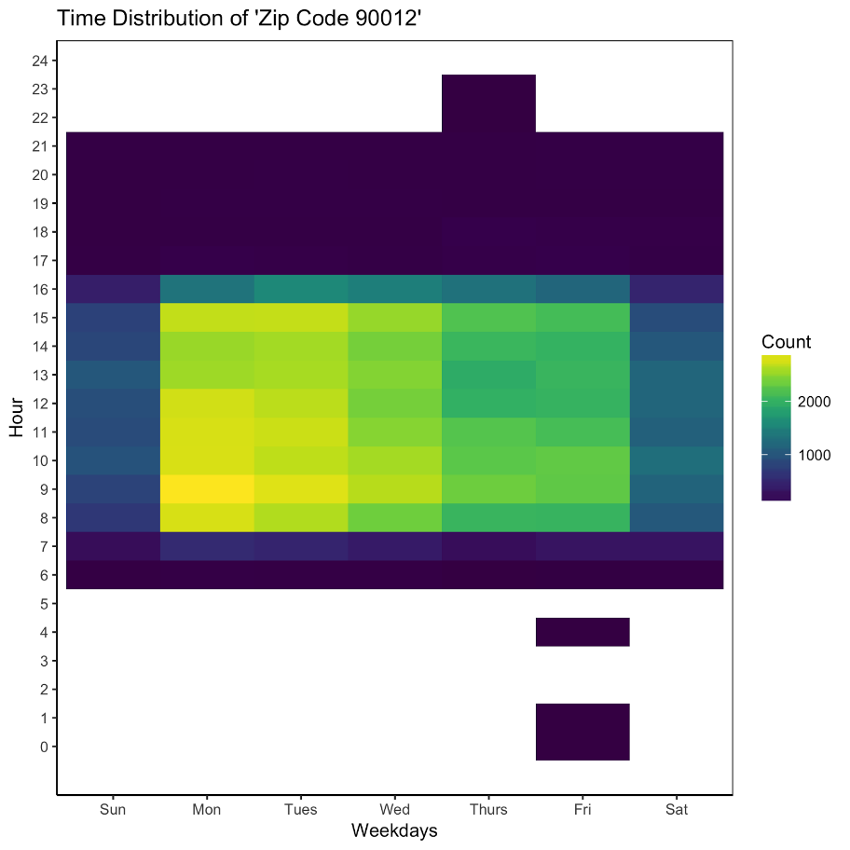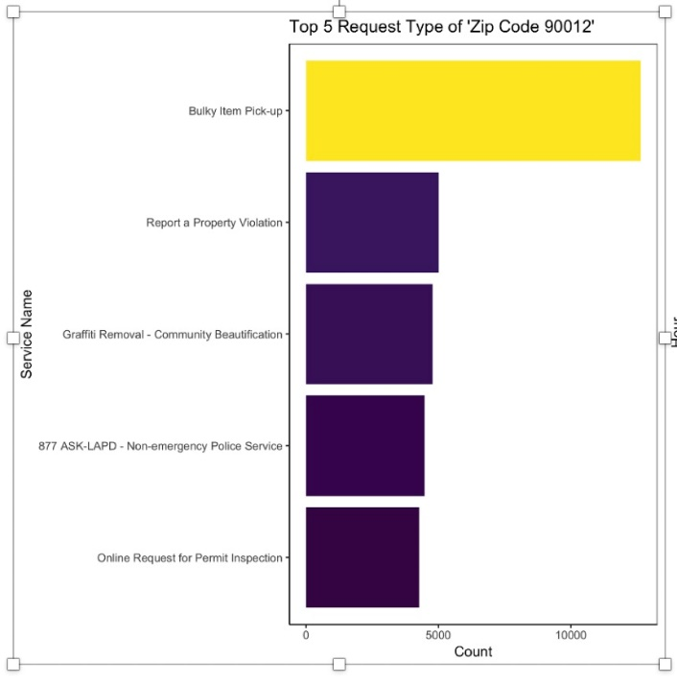

In addition, the time distribution of service calls to zip 90012 does not appear to deviate from the dataset as a whole. This indicates a normal call distribution and does not indicate any action required to investigate call distribution.

**Second Dataset 2015-2016:**

When analyzing the second dataset of calls from mid 2015-2016, bulky item pickup remains the main request type as in the previous dataset. However, there is a noticeable jump in the proportion of graffiti removal calls than in the previous dataset. This may be due to how requests are reported in the database, but we feel this deserves further investigation.

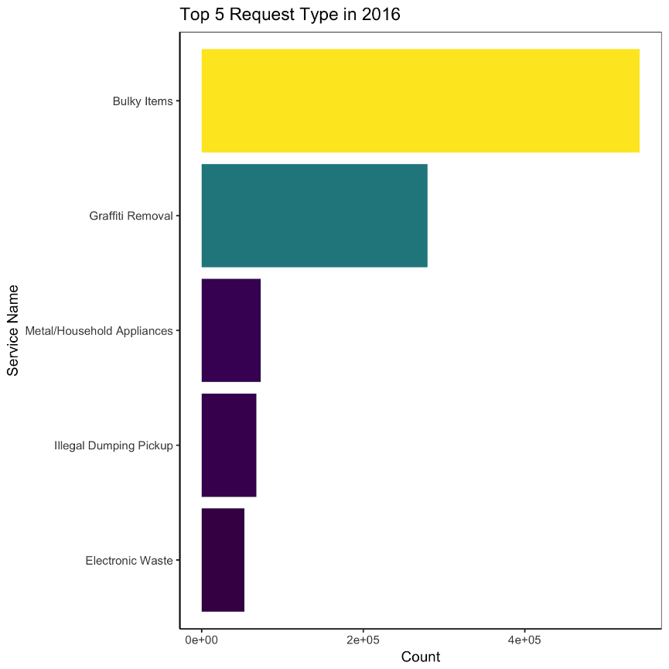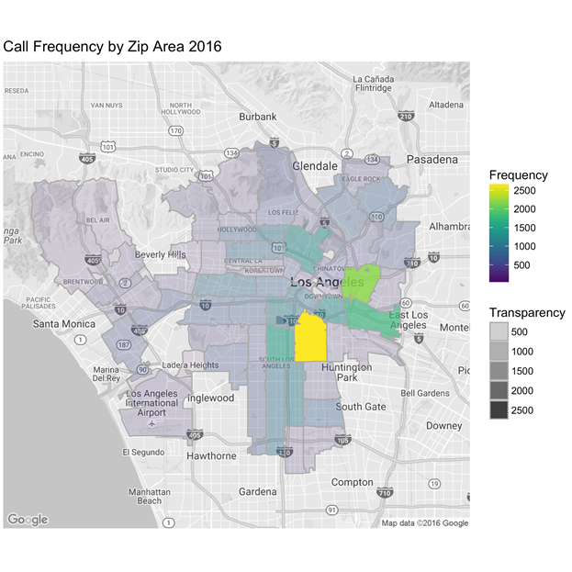

The spatial map indicates that whatever problems there may have been in the 90012 zip code in the prior dataset have been resolved; however, the new sample size is small in comparison so we cannot say this with certainty. In 2016, we have noticed a heavy shift from frequency of calls to the 90011 zip code. Similar to the 90012 zip code from the previous dataset, we will investigate this area further.

**Zip Code – 90011:**

As we can see by the frequency of request type to the 90011 zip code, we can see that graffiti removal is the most common request type from the area. This may be part of the explanation for the jump in this service type request for the overall dataset. In addition, the call time distribution shows a deviation in that there is a heavy influx of calls in the late morning on Tuesdays. This may indicate that something odd may be happening in this neighborhood during this time.

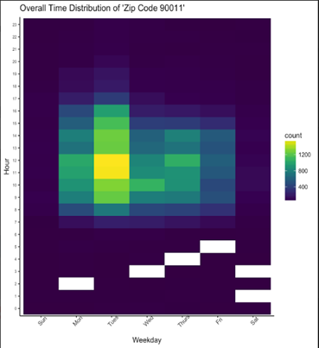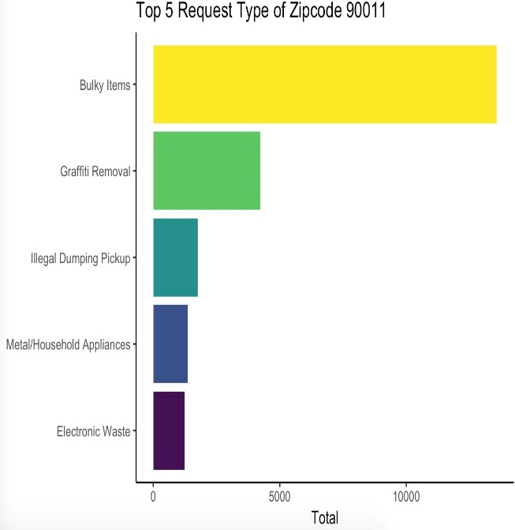

**Call Resolution:**

From the 2011 to 2015 dataset, we have come across one of the only outcome variables, “Call Resolution”, which indicates the results of each individual requests. Due to the fact that effectively servicing calls is a major priority of MyLA 311, we plotted first a barchart to observe the ratio of all call resolution types. Categories are grouped generally including transferred, referred, processed, and invalid as shown below. What we considered to be an unsuccessful service call are defined as: Voicemail, Line Busy, Hung-up, and Information Not Available. Among 3.5 million requests, only approximately 5 percent of the calls were considered “unsuccessful” according to our definition.

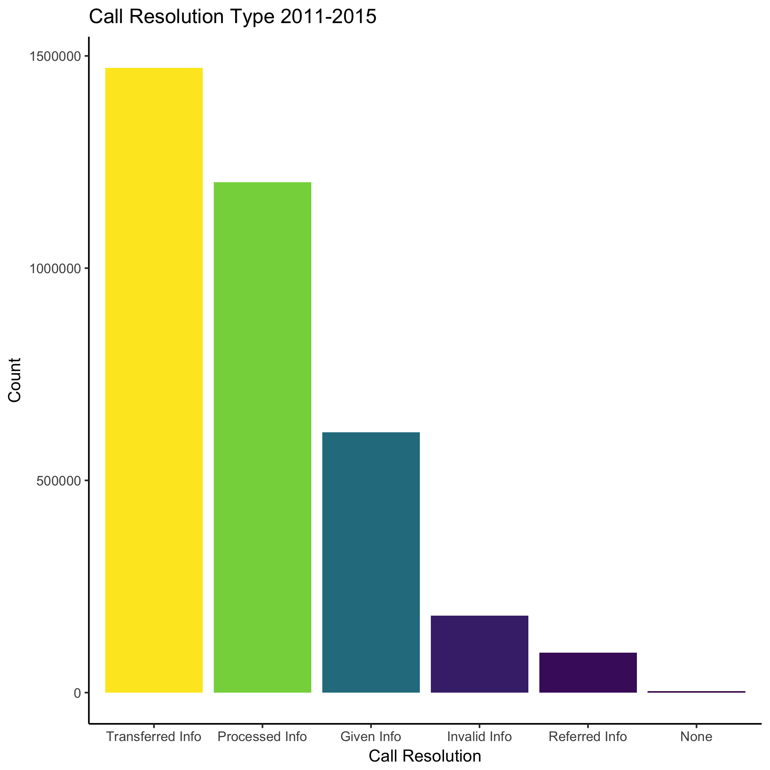

Looking further into efficiency, we used the time distributions heat maps of overall calls from 2011 to 2015 as a basis, and compared with the time distribution of specific unsuccessful outcomes throughout the week in 2011 to 2015. We have observed that there are a clear aggregation of unsuccessful service calls from the period of approximately 11am-1pm during the week. However, the time distribution of all calls shows heavy frequency around 8am-10am. This discrepancy leads us to assume that there may be staffing issues, perhaps due to standardized lunch hours, which led to the large number of unsuccessfully serviced calls during this time period.

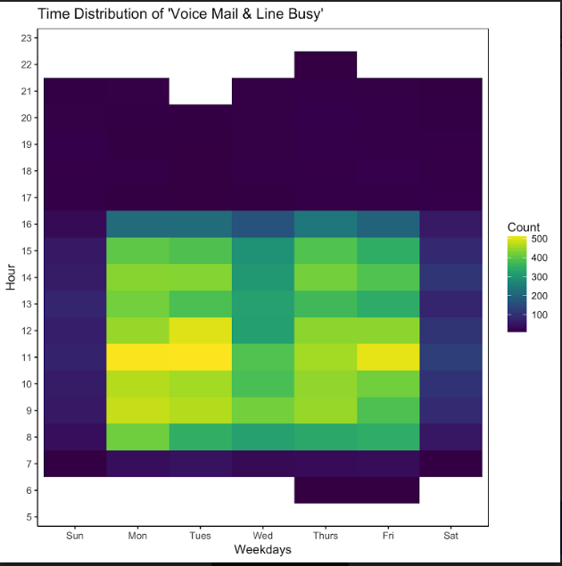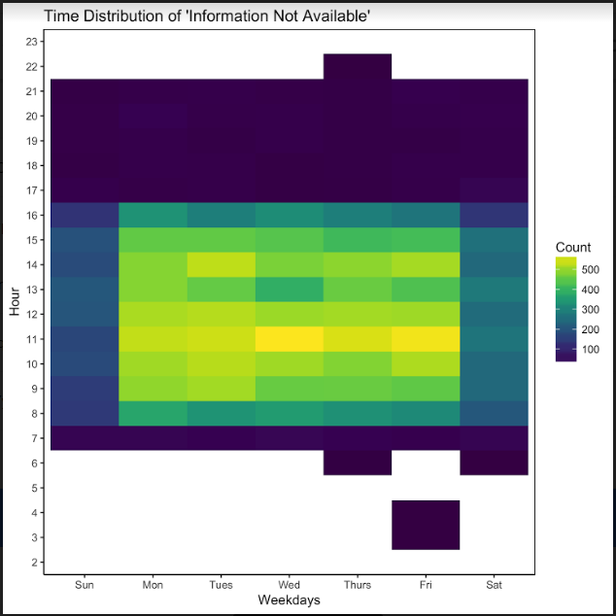

**Mobile App:**

As innovations in mobile technology continues to impact every business and social applications, our group thought it would be interesting to investigate the effects of digitalization trends within our data. Though majority (58%) was dominated by phone calls, 14% of the service inquiries came from 311’s mobile app. Our group then plotted a barchart, ranking services types by counts, and noticed that the mobile app is prospectively capable of requesting many popular tasks, such as bulky item pickup, graffiti and dead animal removal.

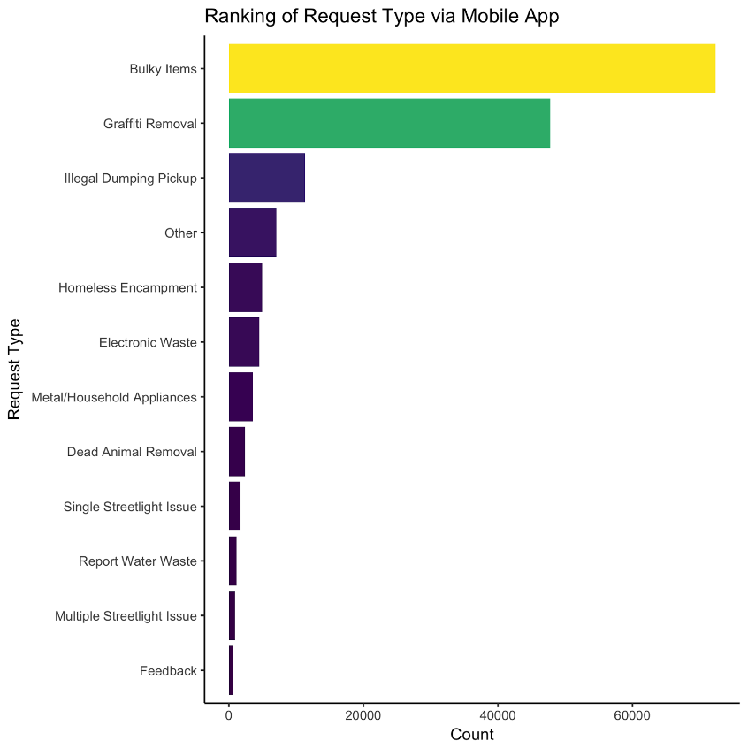

We then analyzed into the average procedure time (in days) of each request source throughout a day, and noticed that mobile app services have not only the most consistent process duration, but also contain an even distribution of efficiency around 24-hour spam. As people move more towards a mobile adaptation of services, our group can only predict the percentage of mobile service requests to ramp up continuously.

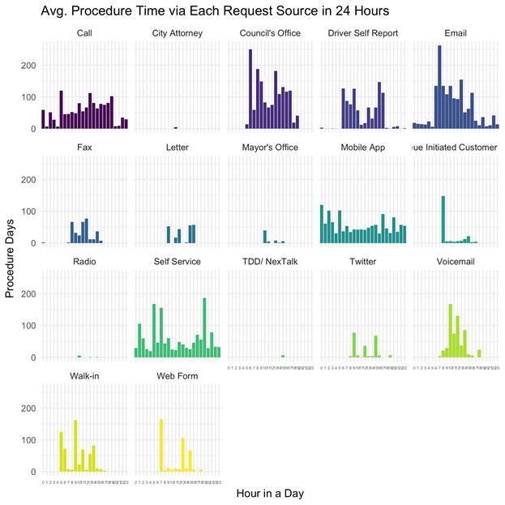

**Shiny:**

To make our data visualization more interactive, we create shiny.

We create 3 tabs. The first tab is overview of 2011-2015 and 2016 data. Users can check different data range data by changing data at the left part tab. The second tab is zipmap and heatmap of call resolution. We divided call resolution into 5 kinds. Users can choose different kind of call to check the distribution of zipcode and time. The third tab displays the efficiency of 311 project.

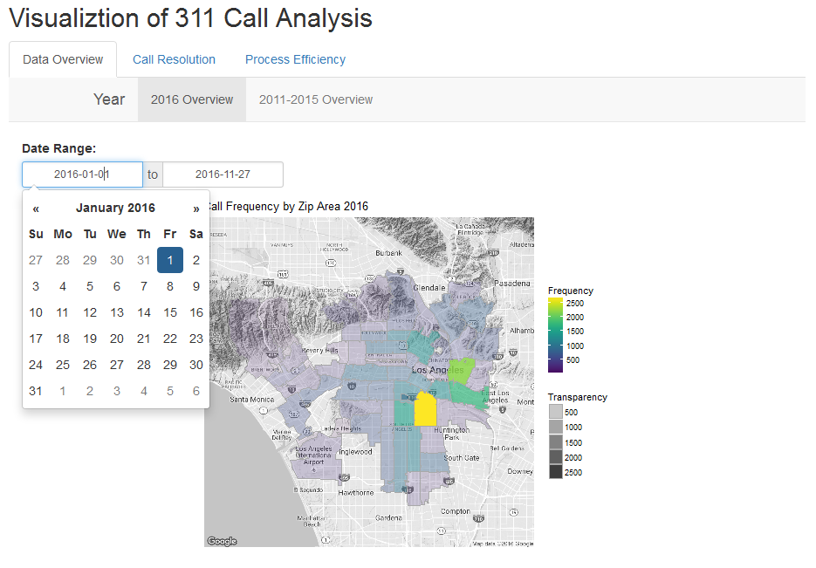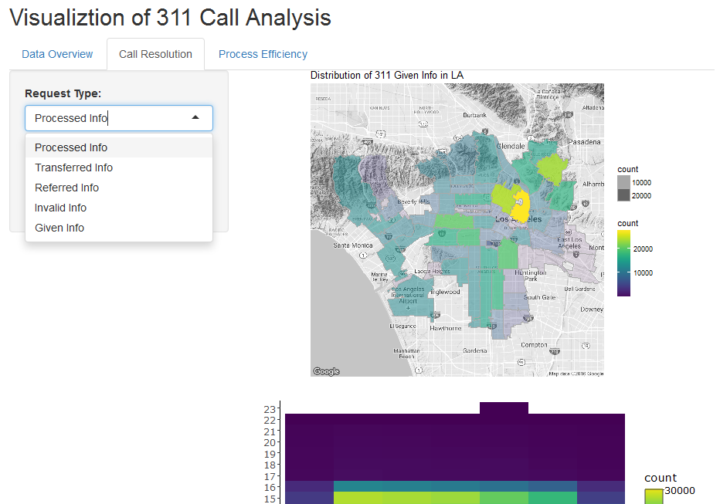

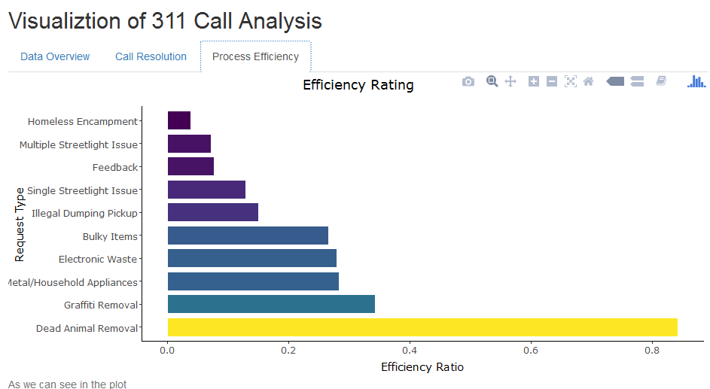

**Part IV. Conclusion**

**Insights and Recommendations:**

Based on our analysis, our recommendations are threefold:

1. 311 call center should acknowledge the frequency spike in the area 90011 zip code and extensively monitor of the changes. Focus servicing the area from 11AM to 1PM on Tuesdays, and communicate closely with the city departments responsible in handling top ranked inquiries, specially graffiti removal, and bulky item pickups.
2. Few respondents are available during 11am-1pm. 311 call center should look into the cause and property assign or reallocate human resources minimizing any unsatisfactory outcomes.
3. Mobile app appears to be successful. The continuation of platform improvement and promotion should definitely be emphasized as it increases operational efficiency as the trend of mobile usage grows.