**CHIEF ADMINISTRATIVE OFFICE**

**MEMORANDUM**

**To:** Gilbert Montaño, *Chief Administrative Officer*

**From:** Alex Bauer

**CC:** Cameron MacPhee, Rebecca Houtman

**Date:** February 2, 2024

**Re: FOR REVIEW:** NOPD Citation Revenue Analysis

**BACKGROUND**

New Orleans has a unique approach to handling traffic citations, providing its Police Department (NOPD) the option to cite drivers based on either local city ordinances or state traffic laws. This flexibility aims to address traffic violations effectively; however, it also has financial implications for the city. The distinction between the fines for local ordinances and state codes is significant, with state-imposed fines usually being higher. Given the potential impact on the city's annual budget, understanding the revenue implications of NOPD's choice between citing under city ordinance versus state code is of paramount importance. This analysis seeks to offer insight into how these decisions affect financial outcomes for New Orleans, exploring the balance between law enforcement practices and fiscal health.

**ANALYSIS**

In our analysis of the New Orleans Police Department's (NOPD) traffic citation practices, a primary focus was placed on comparing the revenue generated from citations under the City's local traffic ordinances versus those under state traffic laws. It's noteworthy that the state code mandates higher fines for these violations. This discrepancy prompted an investigation into the theoretical financial outcome had NOPD opted exclusively for state citations over local ones. Our definition of "lost revenue" pivots on this comparison, highlighting the gap between the actual funds collected through NOPD's enforcement actions and the augmented figures that could have been achieved under state violation citations.   
  
To ground this investigation, several key assumptions were made. First, we assume that all drivers cited under New Orleans' local ordinances could have been cited for the equivalent state violations. This supposition disregards the potential legal or procedural barriers that might favor local over state citations in certain contexts. Furthermore, we operate under the premise that the citation behavior, in terms of volume and violation type, would remain constant. This means we did not account for possible changes in driver behavior that higher state fines could induce nor the administrative feasibility of implementing such a shift. By adhering strictly to these assumptions, our analysis seeks to isolate the financial impact of this sole procedural change, providing a clear picture of the potential revenue gains from aligning NOPD's citation practices with more financially stringent state laws.

**KEY FINDINGS**

|  |  |  |  |  |  |
| --- | --- | --- | --- | --- | --- |
| **Citations by Violation Type** | | | | | |
| **Violation** | **NOPD Local Citations** | | **NOPD State Citations** | | **NOPD Total Citations** |
| Careless operation of a vehicle | 1982 | | 1857 | | 3839 |
| D/L not on person | 940 | | 560 | | 1500 |
| Disregard red light | 1024 | | 440 | | 1464 |
| Drivers to use reasonable vigilance | 1943 | | 0 | | 1943 |
| Following too closely | 1943 | | 388 | | 2331 |
| Improper lane use | 1164 | | 285 | | 1449 |
| Improper turn | 738 | | 221 | | 959 |
| License plates | 2717 | | 4 | | 2721 |
| No/expired brake tag | 18 | | 731 | | 749 |
| Unlawful use of license | 1631 | | 164 | | 1795 |
| Yield right of way | 1446 | | 599 | | 2045 |
| Total NOPD Citations | 15546 | | 5249 | | 20795 |
| **Total Citations** | | | | | |
| **NOPD Local Citations** | | **NOPD State Citations** | | **NOPD Total Citations** | |
| 15546 | | 5249 | | 20795 | |

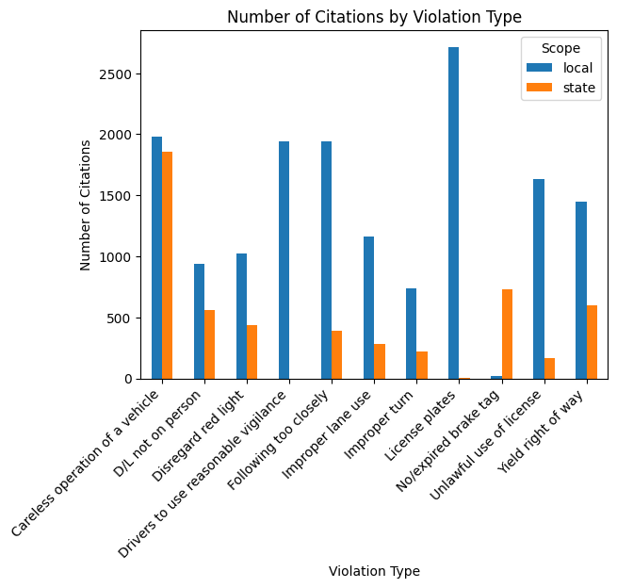

The citation data reveals a clear pattern where the majority of traffic citations issued by the New Orleans Police Department (NOPD) are for local violations, apart from brake tag violations which predominantly fall under state citations. This trend highlights a discretionary aspect in the enforcement of traffic laws, especially in cases of careless operation of a vehicle, drivers required to use reasonable vigilance, and following too closely. These specific violations, which top the list of local citations, inherently possess a degree of subjectivity in their interpretation and enforcement by NOPD officers. This discretion underscores the human element in law enforcement, suggesting that officers' personal judgments play a significant role in determining whether a driver's behavior warrants a citation under local ordinances versus state laws. The exception of brake tag violations being mostly cited under state laws could indicate a stricter adherence to or a specific mandate for enforcement in this category, contrasting with the more interpretive nature of the aforementioned violations.

|  |  |  |  |  |  |  |  |  |  |  |  |
| --- | --- | --- | --- | --- | --- | --- | --- | --- | --- | --- | --- |
| **Revenue by Violation Type** | | | | | | | | | | | |
| **Violation** | **NOPD Local Revenue** | | **NOPD State Revenue** | | **NOPD Total Revenue** | | **NOPD Revenue Local as State** | | **Total NOPD Revenue Local as State** | | **NOPD Lost Revenue** |
| Careless operation of a vehicle | $510,365.00 | | $561,742.50 | | $1,072,107.50 | | $599,555.00 | | $1,161,297.50 | | $89,190.00 |
| D/L not on person | $195,050.00 | | $169,400.00 | | $364,450.00 | | $284,350.00 | | $453,750.00 | | $89,300.00 |
| Disregard red light | $232,960.00 | | $133,100.00 | | $366,060.00 | | $309,760.00 | | $442,860.00 | | $76,800.00 |
| Drivers to use reasonable vigilance | $403,172.50 | | $0.00 | | $403,172.50 | | $587,757.50 | | $587,757.50 | | $184,585.00 |
| Following too closely | $442,032.50 | | $117,370.00 | | $559,402.50 | | $587,757.50 | | $705,127.50 | | $145,725.00 |
| Improper lane use | $183,330.00 | | $86,212.50 | | $269,542.50 | | $352,110.00 | | $438,322.50 | | $168,780.00 |
| Improper turn | $116,235.00 | | $66,852.50 | | $183,087.50 | | $223,245.00 | | $290,097.50 | | $107,010.00 |
| License plates | $427,927.50 | | $1,210.00 | | $429,137.50 | | $821,892.50 | | $823,102.50 | | $393,965.00 |
| No/expired brake tag | $3,735.00 | | $221,127.50 | | $224,862.50 | | $5,445.00 | | $226,572.50 | | $1,710.00 |
| Unlawful use of license | $990,832.50 | | $102,910.00 | | $1,093,742.50 | | $1,023,452.50 | | $1,126,362.50 | | $32,620.00 |
| Yield right of way | $328,965.00 | | $181,197.50 | | $510,162.50 | | $437,415.00 | | $618,612.50 | | $108,450.00 |
| Total NOPD Revenue | $3,834,605.00 | | $1,641,122.50 | | $5,475,727.50 | | $5,232,740.00 | | $6,873,862.50 | | $1,398,135.00 |
| **Total Revenue** | | | | | | | | | | | |
| **NOPD Local Revenue** | | **NOPD State Revenue** | | **NOPD Total Revenue** | | **NOPD Revenue Local as State** | | **Total NOPD Revenue Local as State** | | **NOPD Lost Revenue** | |
| $3,834,605.00 | | $1,641,122.50 | | $5,475,727.50 | | $5,232,740.00 | | $6,873,862.50 | | $1,398,135.00 | |

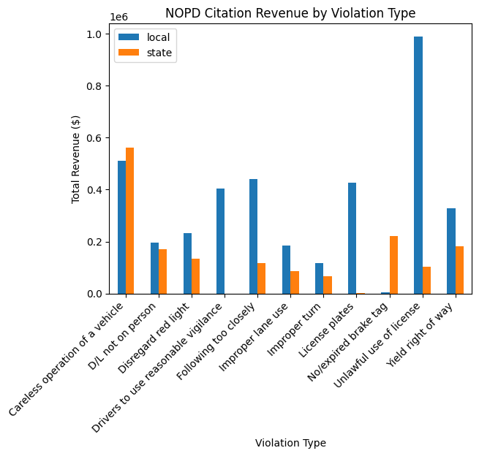

Analyzing the citation data, it’s clear that the majority of revenue generated comes from citations for unlawful use of a license, which stands as one of the most costly violations at a local fine of $607.5, resulting in nearly $993,262.5 in revenue. This violation alone significantly contributes to the total revenue, highlighting its critical role in revenue generation from traffic citations. On the other hand, while license plate violations predominantly result in local citations, with a total revenue of $429,187.5, there exists a substantial opportunity for increased revenue in this category. This is due to the stark contrast in fines between local and state citations; the state fine for license plate violations is almost double the local fine, indicating a potential increase in revenue if citations are issued under state laws. With the state fine for license plate violations being $302.5 compared to the local fine of $157.5, migrating toward state citations for these violations could significantly enhance the overall revenue, demonstrating a notable area for financial growth in citation management.

|  |  |
| --- | --- |
| **Financial Impact Analysis** | |
| **Description** | **Value** |
| Average Monthly Lost Revenue | $116,511.25 |
| Annualized Lost Revenue | $1,398,135.00 |
| Collection Rate | $0.21 |
| Estimated Annual Revenue Impact | $293,608.35 |

Diving into the financial impact of the New Orleans Police Department's (NOPD) current practices for issuing traffic citations, we've uncovered some eye-opening figures. Our analysis reveals an average monthly lost revenue of $116,511.25, due to the choice between citing drivers under local ordinances versus state codes, which carry higher fines. This misstep amounts to an annualized lost revenue potential of $1,398,135.00. This substantial leakage represents a missed opportunity in strengthening the city's financial standing, especially when considering the challenging budgetary constraints many city departments face.  
  
Moreover, when estimating the potential revenue impact of adjusting NOPD’s citation practices to favor state codes, we discern a possible enhancement to the annual budget by approximately $293,608.35. This adjustment not only demonstrates the significant impact of optimal citation practices on the city’s budget but also underscores the importance of strategic decisions in law enforcement practices. The variance between local and state citation revenues brings to light the critical role of policy and procedure alignment with financial sustainability goals.  
  
To plug this revenue leak and capitalize on the untapped financial resource, the NOPD could adopt a more strategic approach to issuing traffic citations. Focusing efforts on maximizing revenues through the adoption of state codes for traffic violations could not only recover the over $1.39 million lost annually but could also bolster the city's budget to a notable extent. This strategy not only offers a financial uplift but could also foster a closer adherence to state-level legal standards, ensuring a more robust alignment between local law enforcement practices and state laws. The implications of our findings suggest a pivotal opportunity for the NOPD to refine its operational practices, thereby significantly enhancing fiscal health and compliance.

**RECOMMENDATION**

Upon detailed analysis of the New Orleans Police Department's (NOPD) traffic citation practices and their impacts on the city's budget, it is evident that the choice between citing drivers for violations of local traffic ordinances versus state traffic laws has significant revenue implications. Our findings show a substantial annual lost revenue of approximately $1,398,135 due to NOPD opting more frequently for local citations over state citations, even though state code violations impose higher fines. The analysis revealed an average monthly lost revenue of $116,511.25, underscoring the potential financial benefit of adjusting citation practices. Furthermore, with a collection rate of just 21%, there's an estimated annual revenue impact of $293,608.35 that could be realized through optimizing citation strategies to favor state code violations where applicable.  
  
During discussions, a NOPD traffic citation investigator shed light on the rationale behind the choice of citation type. According to them, NOPD personnel use state statutes to issue citations for more serious violations as a means of imposing stiffer penalties on more egregious offenders. This discretionary practice denotes NOPD's approach towards balancing public safety concerns with punitive measures. However, this approach, while possibly effective for law enforcement purposes, poses challenges for maximizing revenue without compromising the principle of fairness in enforcement.  
  
Given these findings, it is recommended that the NOPD and city administration collaborate to review and potentially recalibrate the current citation practices. A balanced approach could involve developing a clear guideline that considers both the severity of the violation and the revenue implications of choosing between local and state citations. Such guidelines should aim to maximize revenue without undermining NOPD's discretion to address serious traffic violations more stringently.  
  
To leverage the potential revenue increase, further steps could include targeted training for officers on the new guidelines, coupled with periodic reviews to assess compliance and effectiveness. Additionally, increasing public awareness about the consequences of traffic violations under both local and state laws might serve as a deterrent, thereby enhancing overall traffic safety.  
  
Implementing these recommendations could enable the NOPD to maintain its operational integrity while also contributing to a significant boost in annual revenue for the city. Ultimately, the goal is to strike an optimal balance between law enforcement efficacy and revenue generation, without compromising public safety or the equitable application of traffic laws.