

OCTO-DE Benefit Tools Crew | Accredited Representation Management

February 26, 2024 | Find a Representative

Version 2.0

Revision History

| Date | Version | Description | Author |
| --- | --- | --- | --- |
| 12/5/2023 | 1.0 | MVP: Minimum Viable Product | Lindsay Li-Smith |
| 2/26/2024 | 2.0 | Adjustments and enhancements based on UX research findings | Lindsay Li-Smith |

Table of Contents

1. Product Overview 4

2. User Access 4

3. Navigation 4

4. Functionality 5

5. Major Issues and Error Messages 11

6. Frequently Asked Questions 13

7. Table of Figures 14

## 1. Product Overview

The Find a Representative product is a user-friendly, accessible tool for Veterans to search for an accredited representative on VA.gov, intended to mirror the representative search functionality of older tools: [OGC](https://www.va.gov/ogc/apps/accreditation/index.asp) and [eBenefits](https://www.ebenefits.va.gov/ebenefits/vso-search).

Users will be able to search for representatives based on:

1. Type of accredited representative (*Required)
   1. Veteran Service Officer (VSO), attorney, claims agent
2. Location (*Required)
   1. Address, city, state, or postal code
   2. “Use my location”
3. Search area
   1. Defaults to 50 miles
   2. Other options: 5 miles, 10 miles, 25 miles, 100 miles, 200 miles, Show all
4. Name of accredited representative
   1. Open text input field

## 2. User Access

All users will have access to the Find a Representative product; authentication is not required for this experience.

## 3. Navigation

Landing Page

Most of the benefits pages on VA.gov will have a link that points to our landing page “Get help from a VA accredited representative”, often in the “What if I need help?” (or similar) section towards the bottom of the page.

The URL for this landing page will be <https://va.gov/get-help-from-accredited-representative>.

Product Page

The landing page mentioned above will link to our Find a Representative product page, which will have a URL of <https://va.gov/get-help-from-accredited-representative/find-rep>.

Search

Users will also be able to find our Find a Representative tool through the VA.gov search in the “Our top recommendations for you” section.

The landing page and product page will appear in this sectionof search results, for any searches on VA.gov that match key words in the page title or description.

## 4. Functionality

Search for an Accredited Representative

Users will be able to search for accredited representatives based on the following parameters:

1. Type of accredited representative (*Required)
   1. Veteran Service Officer (VSO), attorney, claims agent
2. Location (*Required)
   1. Address, city, state, or postal code
   2. “Use my location”
3. Search area
   1. Defaults to 50 miles
   2. Other options: 5 miles, 10 miles, 25 miles, 100 miles, 200 miles, Show all
4. Name of accredited representative
   1. Open text input field

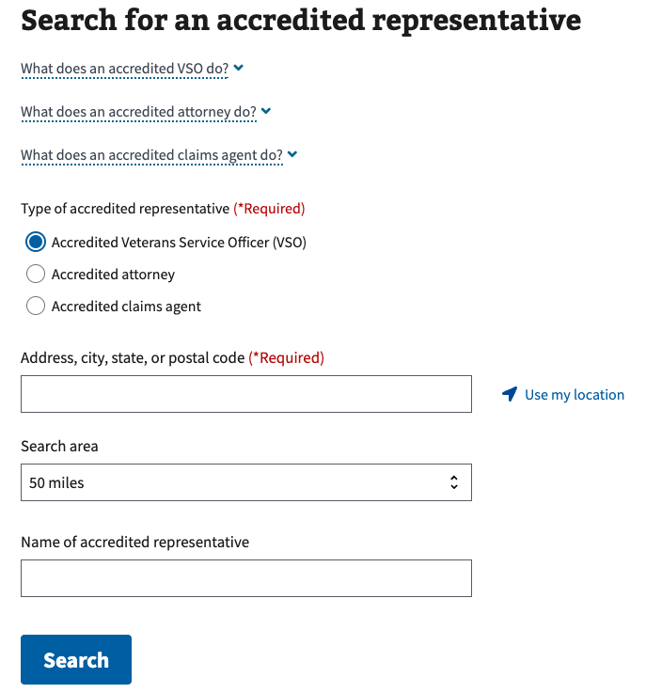

Figure 1. Search criteria for Find a Representative.

Search Results

A list of representatives matching the user’s search parameters will be displayed, with 10 results per page.

The search results will include the following representative details:

1. Distance in miles
2. Full name
3. Associated organization(s)
4. Address (clickable, opens Google Maps in a new tab)
5. Phone number (clickable, initiates a phone application)
6. Email (clickable, initiates an email application)

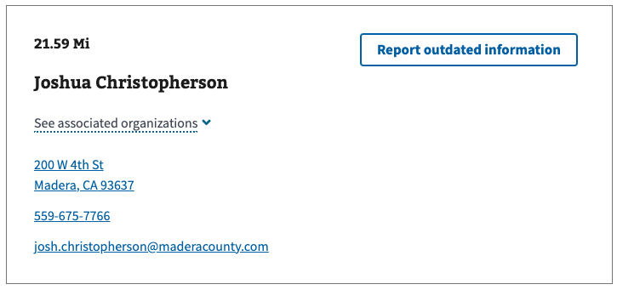

Figure 2. Example of a representative in search results.

The search results allow the following “Sort by” options:

1. Distance (closest to farthest) - default
2. First name (A - Z)
3. First name (Z - A)
4. Last name (A - Z)
5. Last name (Z - A)

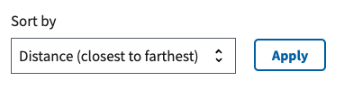

Figure 3. Default sort.

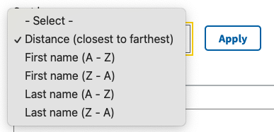

Figure 4. All sort options.

Reporting Outdated Information

Findings from user research indicate the contact information for accredited representatives are not always accurate. While we cannot control the contact information in the accredited representative database, we have implemented:

1. A banner at the top of the search results, to inform users of data quality
2. A way to report outdated information of representatives returned in search results

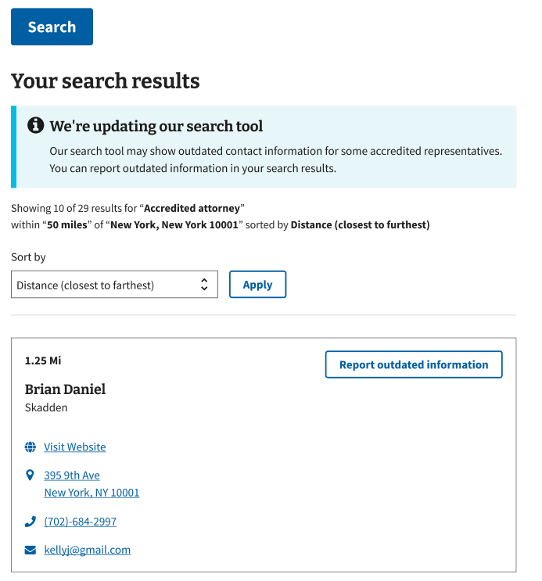

Figure 5. A banner above the search results informs users that some contact information may be out of date.

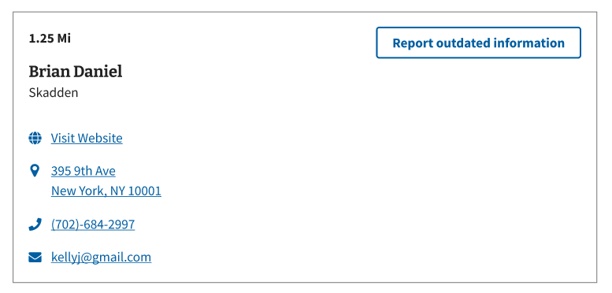

Figure 6. The option to report outdated information is in the upper right of a search result.

Users will be able to report a representative’s address, email, phone number, or “other”:

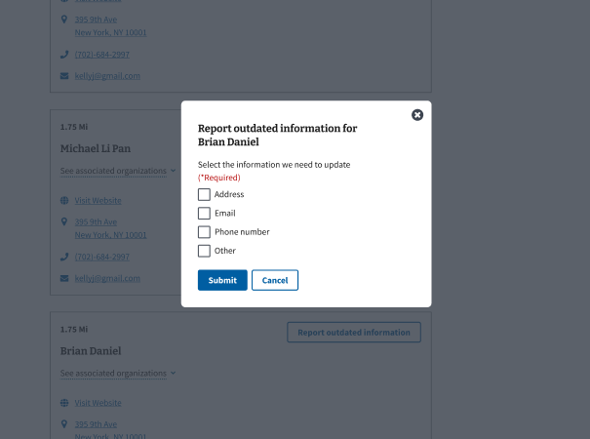

Figure 7. The report modal, with options to report address, email, phone number, and “other”.

Selecting “Other” reveals a text input field, where the user can “Describe the other information we need to update”:

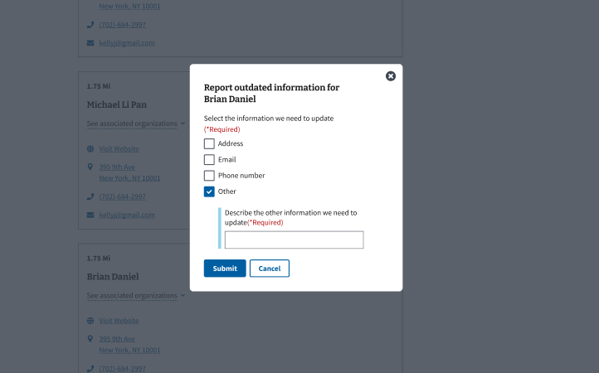

Figure 8. The report modal reveals a text input when “other” is selected.

After a user submits a report, they will receive a “Thanks for reporting outdated information” message on the search result:

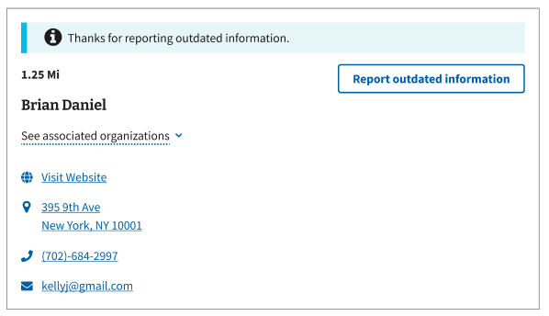

Figure 9. The search result provides feedback at the top, when a user reports outdated information.

A user can come back and submit more information:

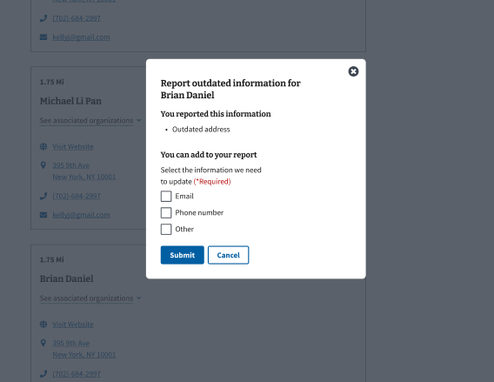

Figure 10. The report modal will provide feedback to information that has been reported (address) and allow the user to report additional information (email, phone number, other).

After all information is submitted for a certain representative, no further reporting is available to the user.

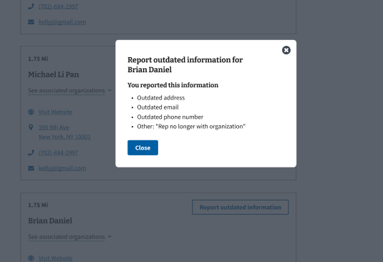

Figure 11. The report modal confirms that all information has been reported, there are no further actions for the user.

## 5. Major Issues and Error Messages

If a user tries to search without entering a location, the location input field will become highlighted in red with an error message “Please **enter a valid location**.”:

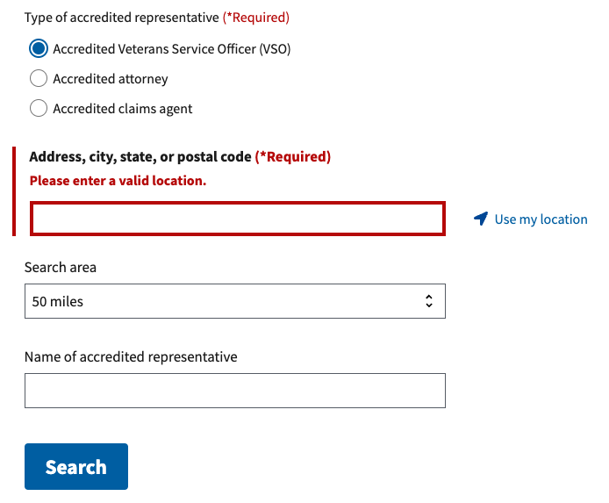

Figure 12.. Error message when a location has not been specified.

If a user has not enabled location sharing in their browser and tries to “Use my location”, a “We need to use your location**. Please enable location sharing in your browser to use this feature.**” alert will appear:

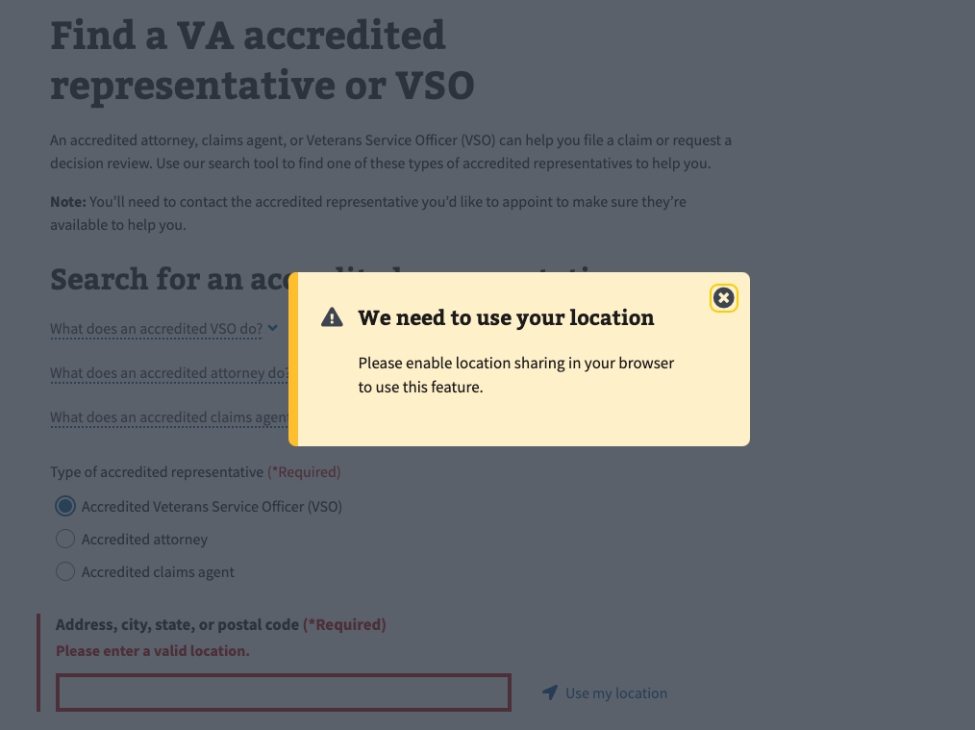

Figure 13. Alert when location sharing is disabled.

If there is an issue retrieving search results, whether that’s with the VA network or our connected location service (Mapbox), a general “We’re sorry, something went wrong. Please try again soon.” alert will appear below the Search button:

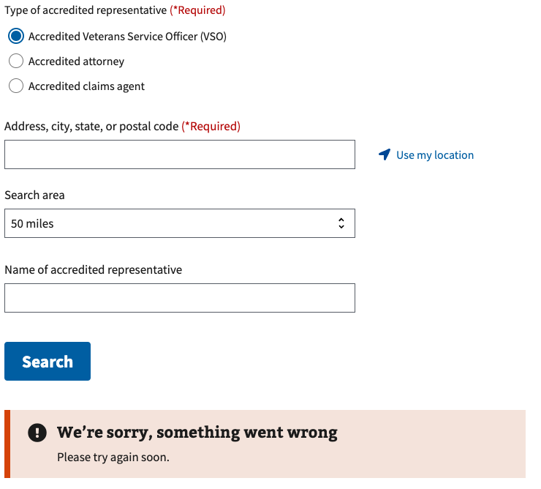

Figure 14. General alert when there is an issue with retrieving search results.

If there is an issue reporting outdated information **for a representative in the search results**, a **modal will appear with an alert** “We’re sorry, something went wrong. Please try again soon.”:

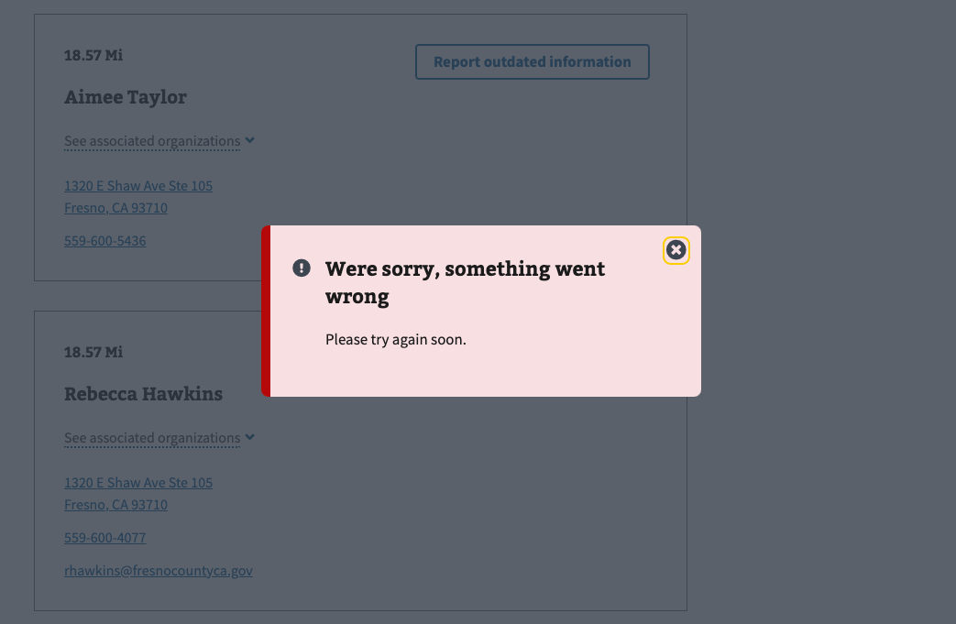

Figure 15. General alert when there is an issue reporting outdated information for a representative in the search results.

## 6. Frequently Asked Questions

Users may have the following questions, when using this product:

1. What's the differences between accredited representatives (VSOs, attorneys, claims agents)?
2. What makes a representative accredited?
3. Do accredited representatives charge fees?
4. How do I appoint an accredited representative?
5. How can an accredited representative help me?
6. Does an accredited representative have to help me?
7. Can I work with more than one accredited representative at a time?
8. Can I work with an accredited representative online or over the phone?
9. How do I cancel my representation?

Answers to these questions, and additional information about accredited representatives can be found on:

1. The top of the “Find a Representative” product page includes definitions of each type of accredited representative: <https://va.gov/get-help-from-accredited-representative/find-rep>
2. The “Get help from an accredited representative” landing page includes information on how to find and appoint an accredited representative: <https://va.gov/get-help-from-accredited-representative>.
3. The “FAQ” page includes additional information about accredited representatives: <https://www.va.gov/va-accredited-representative-faqs>

## 7. Table of Figures

Figure 1. Search criteria for Find a Representative. 5

Figure 2. Example of a representative in search results. 6

Figure 3. Default sort. 6

Figure 4. All sort options. 6

Figure 5. A banner above the search results informs users that some contact information may be out of date. 7

Figure 6. The option to report outdated information is in the upper right of a search result. 7

Figure 7. The report modal, with options to report address, email, phone number, and “other”. 8

Figure 8. The report modal reveals a text input when “other” is selected. 8

Figure 9. The search result provides feedback at the top, when a user reports outdated information. 9

Figure 10. The report modal will provide feedback to information that has been reported (address) and allow the user to report additional information (email, phone number, other). 9

Figure 11. The report modal confirms that all information has been reported, there are no further actions for the user. 10

Figure 12.. Error message when a location has not been specified. 11

Figure 13. Alert when location sharing is disabled. 11

Figure 14. General alert when there is an issue with retrieving search results. 12

Figure 15. General alert when there is an issue reporting outdated information for a representative in the search results. 12