ECE 461/561 –   
Embedded System Design  
Project: White Noise Generation   
with Pulse-Width Modulation

# Overview

In this project you will develop code to implement a white noise generator using two SAU channels to create a PWM signal. An overview appears in Figure 1.



Figure . White Noise Generator System Overview

You will write code to create a pseudorandom number generator built around a linear feedback shift register. These pseudorandom numbers will be used to set the duty cycle of the PWM output AUD-R once per cycle, as shown in Figure 2. We are using the PWM output and low-pass filter as a digital-to-analog converter, as the RL78/G13 does not include a DAC.

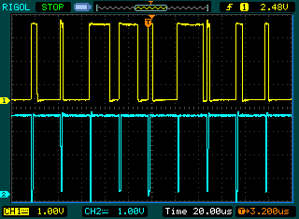

Figure . Yellow: PWM output signal driven with pseudorandom number sequence. Blue: Low indicates master channel ISR is active.

As shown in Figure 3, the PWM output (yellow trace) for Timer 0 Channel 1 (TO01, P16, U1 pin 40, signal AUD-R) is converted to an analog output by the band-pass filter at the input of the audio output circuit (in Figure 4). The blue trace indicates the beginning of the PWM output cycle.

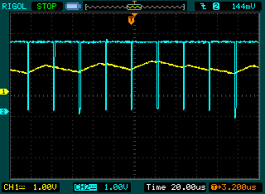

Figure . Yellow: Filtered PWM output signal. Blue: Master channel ISR active.

# 

Figure . YRDKRL78 Stereo audio output circuit.

The resulting audio output signal should be similar to the noisy trace of Figure 5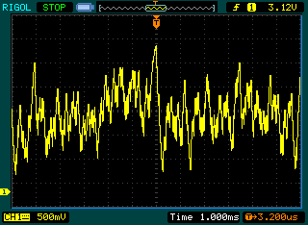

Figure . White noise audio output signal.

# Details

Requirements:

* Use a PWM signal frequency of 40 kHz. This frequency is high enough above the upper corner frequency of the band–pass filter formed by R55, R56 and C36 that sampling noise will be negligible.
* Use SAU0 Channel 0 as the master PWM channel and Channel 1 as the slave channel.

Suggestions:

* Note that the duty cycle of the output signal depends on the master channel’s period. The master channel will not be counting to 0xffff in order to generate a 40 kHz signal.

Extra Credit:

* Create stereo audio by driving both the left and the right audio channels with different white noise sources.
* Add a digital filter to change the spectrum of your white noise to emphasize the low frequencies.
* Performance analysis – what fraction of the CPU’s time is left after generating the audio signal?

Resources:

* RDK Manual
* RL78/G13 User’s Manual: Hardware
  + Chapter 6, especially Section 6.8.2 and 6.8.3
* Textbook
  + Chapter 2, 9
* Web Resources
  + <http://en.wikipedia.org/wiki/Linear_feedback_shift_register>

# Demonstration Requirements

You must demonstrate your program to the instructor or a TA by plugging headphones or a speaker into the headphone jack (J13).