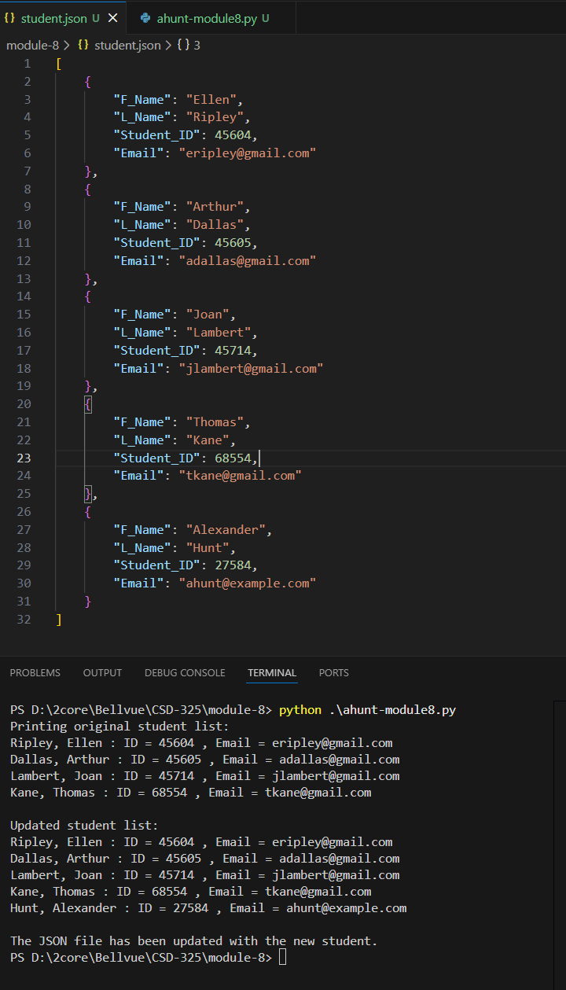
  - Once the program runs, you should also see a notification that the student.json file has changed, with a choice to save or not. Take a screen shot of the notification and paste into your Word document. Should look similar to :
VSCode has an “autosave feature” that automatically dismisses all pop-ups and automatically saves all changes to all files and folders under the root directory. Here’s a reference to the auto save feature.
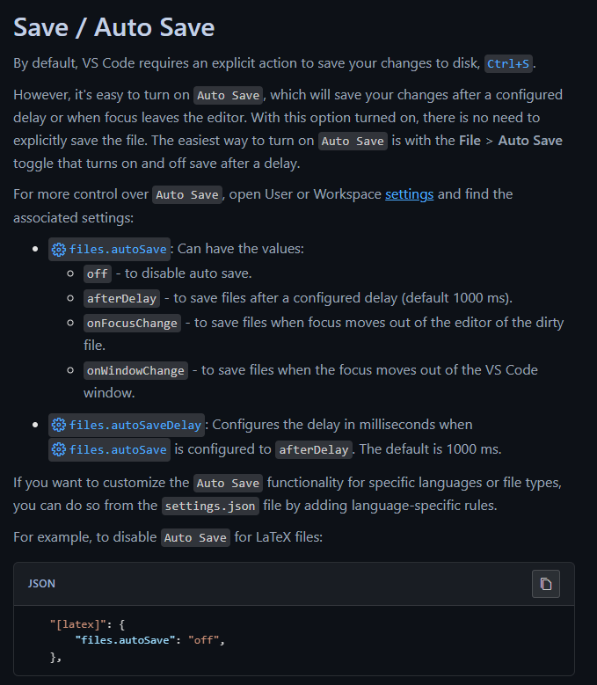
Refence:
Microsoft. (2021, November 3). Visual Studio Code. Visualstudio.com; Microsoft. https://code.visualstudio.com/docs/editing/codebasics

[
{
"F_Name": "Ellen",
"L_Name": "Ripley",
"Student_ID": 45604,
"Email": "eripley@gmail.com"
},
{
"F_Name": "Arthur",
"L_Name": "Dallas",
"Student_ID": 45605,
"Email": "adallas@gmail.com"
},
{
"F_Name": "Joan",
"L_Name": "Lambert",
"Student_ID": 45714,
"Email": "jlambert@gmail.com"
},
{
"F_Name": "Thomas",
"L_Name": "Kane",
"Student_ID": 68554,
"Email": "tkane@gmail.com"
},
{
"F_Name": "Alexander",
"L_Name": "Hunt",
"Student_ID": 27584,
"Email": "ahunt@example.com"
}
]

