Test legacy USPS custom approval workflow on usps15.
- Alex test RR -- test Reviewer Rejects
- Alex test PR -- test Publisher Rejects
- Alex test PA -- test Publisher Approves to publish
- Alex test PGA -- test Publishing Group member Approves to publish

- Alex test RR -- test Reviewer Rejects
Kb_knowledge_base.list
IT Knowledge
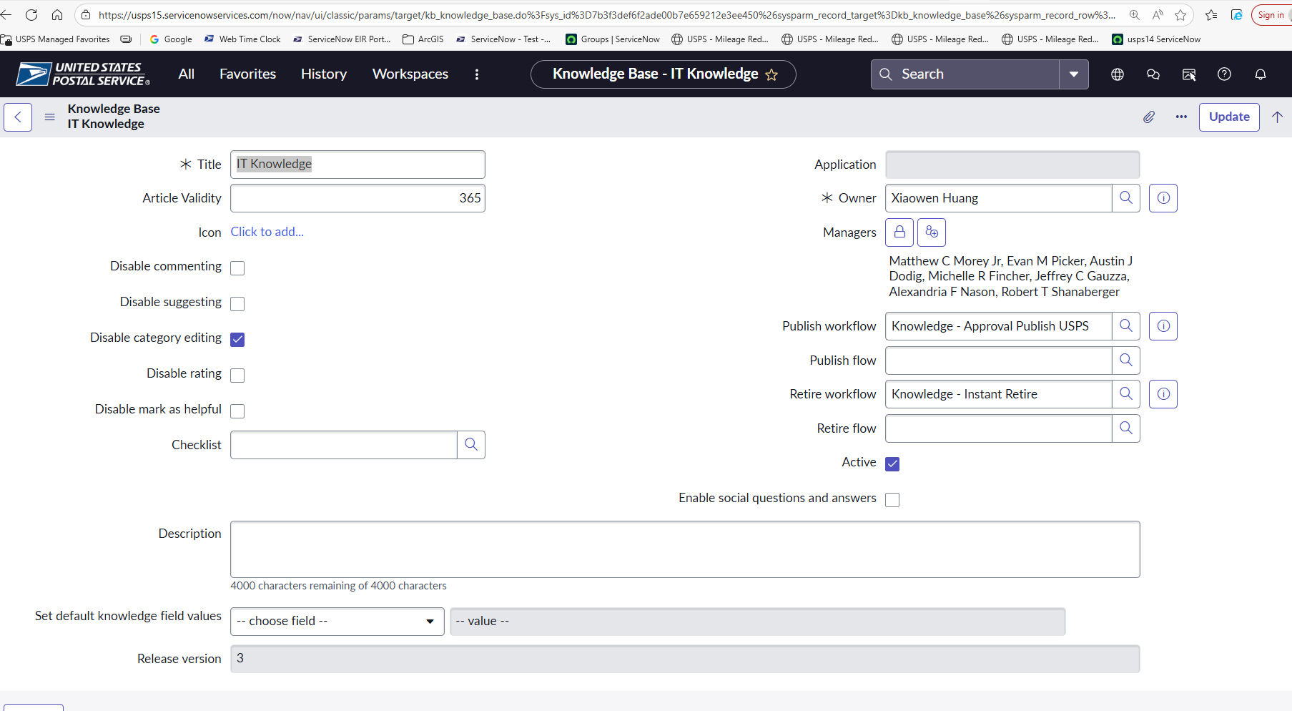

[New]
Title/Short Description / Article Body: “Alex test RR -- test Reviewer Rejects“
Category/Business Service: Pick one related to “ServiceNow”
Owner Group: “ServiceNow Support”
Author: (self)
Reviewer: Jini J Thokalath
Publishing Group: IT Service Desk Kbase Admin
Will this Entire Article be Restricted? No
Meta: test
KB0242932
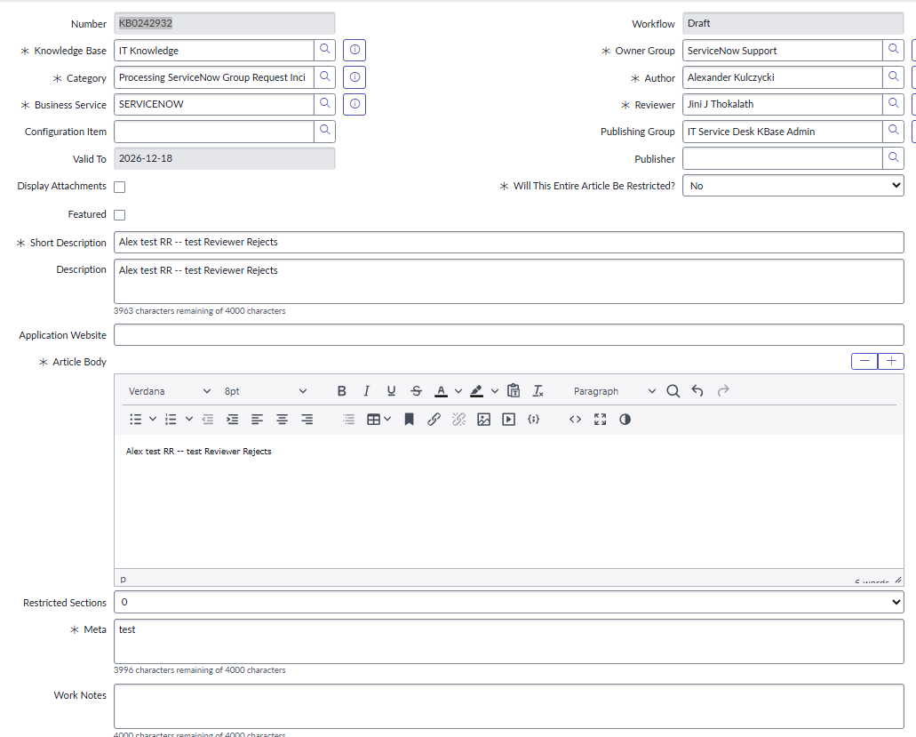

[Save]
[Publish]
Info Message: “This knowledge item is in review”


Go to KBA
Approvals Tab
Select “Requested” Approval

[Reject]
State is “Draft”
Sys_email.list
Search *[KB#] in subject:
*KB0242932
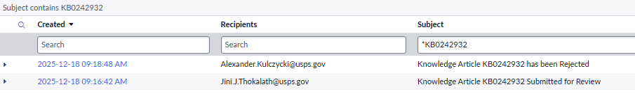
“Submitted for Review” notification was sent to Reviewer.
“Article has been Rejected” notification was sent to Author.

Alex test PR -- test Publisher Rejects
Title/Short Description / Article Body: “Alex test PR -- test Publisher Rejects“
Category/Business Service: Pick one related to “ServiceNow”
Owner Group: “ServiceNow Support”
Author: (self)
Reviewer: Jini J Thokalath
Publishing Group: IT Service Desk Kbase Admin
Will this Entire Article be Restricted? No
Meta: test
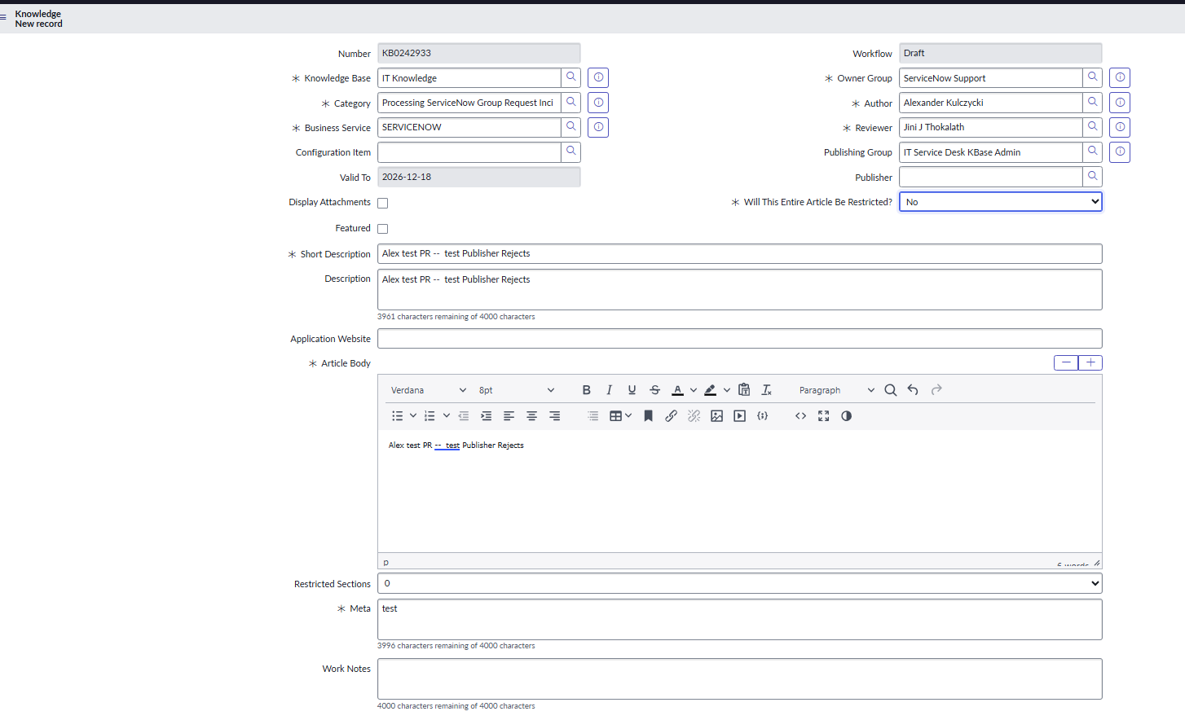[Save]
KB0242933
[Publish]

[Publish]
Info Message: “AThis knowledge item is in review”
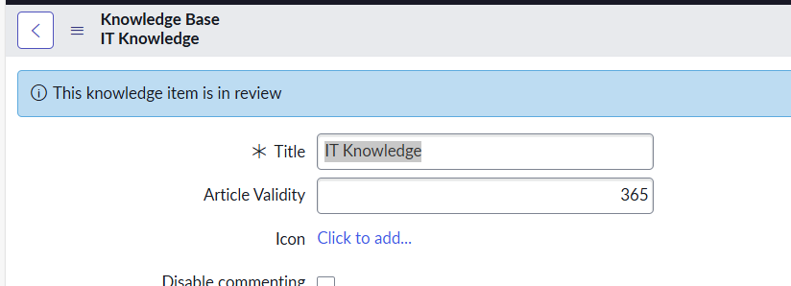

Go to KBA
Approvals Tab
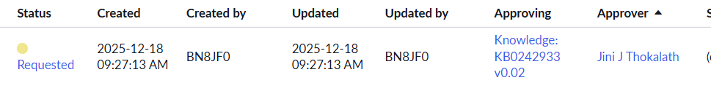
Select “Requested” Approval

[Approve]

State is “Review”
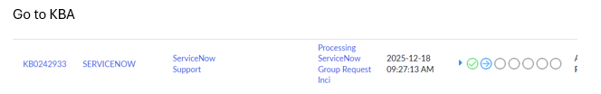
On the approvals tab, select a “Publisher Group” approval request.
Hit [Reject].

Status is “Draft”.
Search sys_emails.list for related emails: “KB0242933”
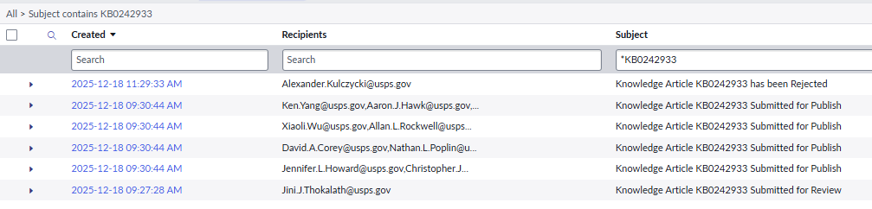

We see notification to reviewer: “Submitted for Review”.
Notifications to publisher group: “Submitted for Publish”,
And notification to Author: “KBA Rejected”.

Alex test PA -- test Publisher Approves to publish

