Test reverted to OOB approval workflow on usps14.
(After running copy script and applying all changes from my update set.)
- Alex test KBA OG R – test KB article – ownership group member - Rejects
- Alex test KBA OG A – test KB article – ownership group member - Approves
- Alex test KBB OR -- test Knowledge Base – Owner - Rejects
- Alex test KBB OA -- test Knowledge Base – Owner – Approves

- Alex test KBA OG R – test KB article – ownership group member - Rejects
All > sys_user.list
Identify an Inactive user

J50KC0
All > Knowledge > Ownership Groups > All Groups
All> sys_user_group.list
[New] name: “Empty Inactive Knowledge Ownership Group”
Manager: the inactive user
Type: Knowledge
[Save]
Group members tab -> Edit
Add member: the inactive user
Group email: the inactive user’s email address
Check “Support Group Org”
Add the group to “Itil”
(Make the group similar to an existing one such as “SDS HR Knowledge Mgmt”)
--
Examine existing group: “ServiceNow Support”
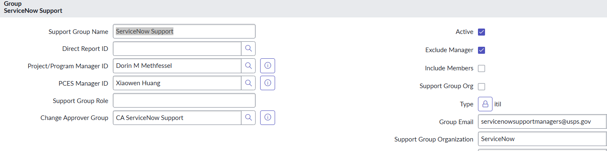
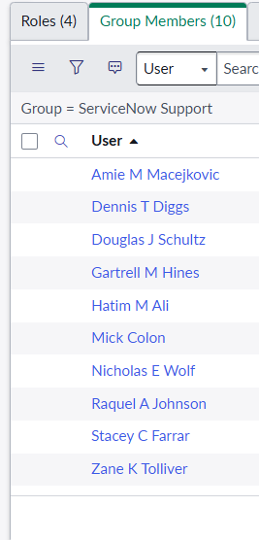
Browse to KBB: “IT Knowledge”
[New] New KBA article:

- Title: “Alex test KBA OG R – test KB article – ownership group member - Rejects“
Ownership Group: “ServiceNow Support”
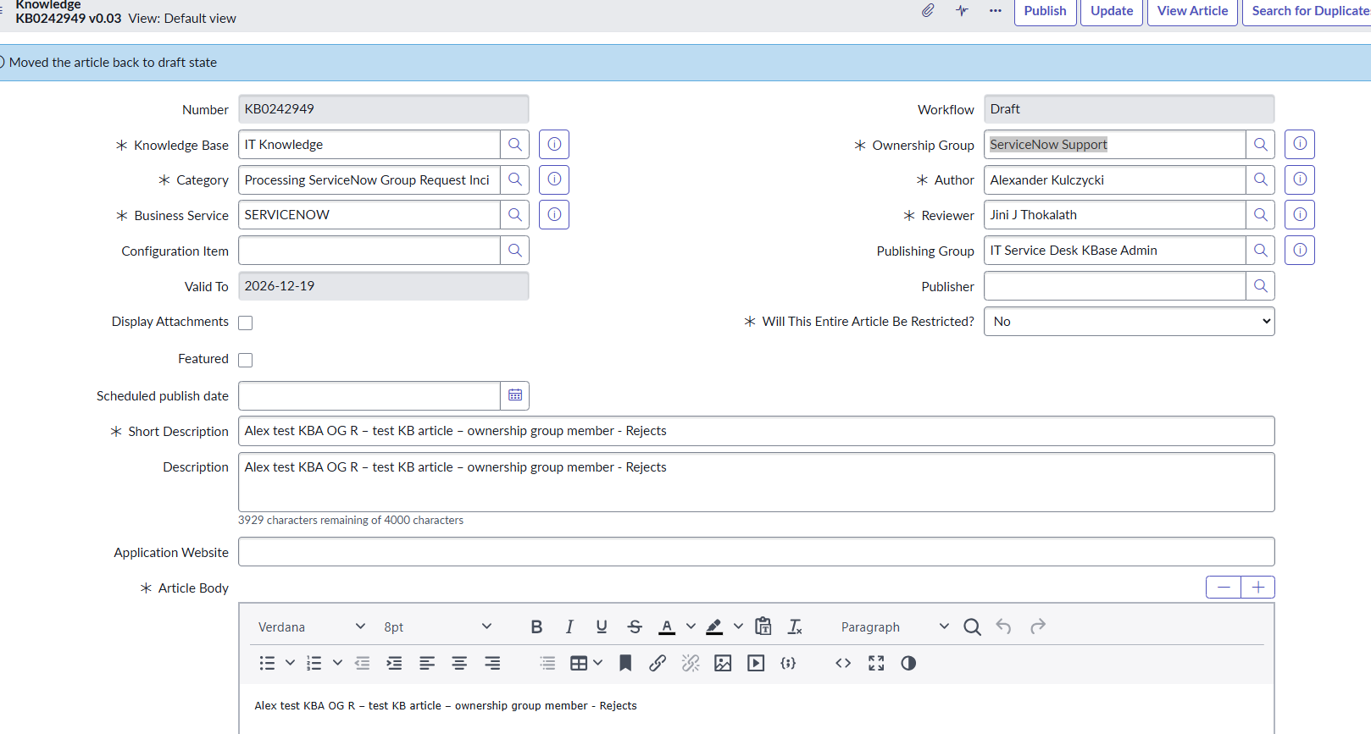
KB0242949
[Publish]
Select an Ownership Group member’s approval and hit “Reject”

Note that the case is back in “Draft” status.
- Alex test KBA OG A – test KB article – ownership group member – Approves
Ownership Group: “ServiceNow Support”
[Publish]
Select an Ownership Group member’s approval and hit “Approve”
KB0242951

Status is now “Published”

Browse to the KBB “IT Knowledge”. Verify the name of the Owner and Managers:
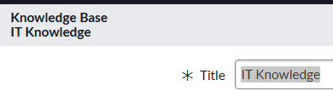
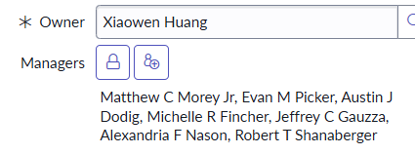

- Alex test KBB OR -- test Knowledge Base – Owner – Rejects
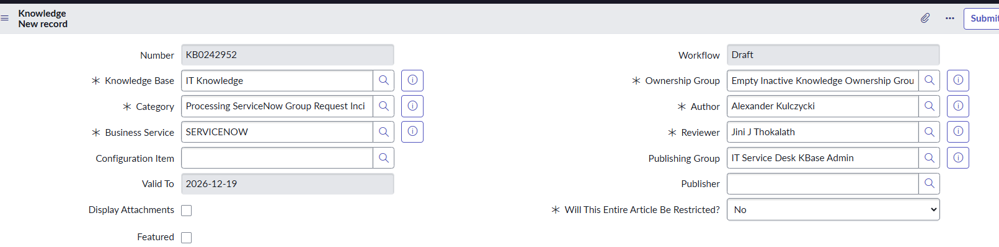
Enter an Ownership Group of “Empty Inactive Knowledge Ownership Group”
[Publish]
KB0242952
Lookup the KBA in review. Note that the approvers are the KBB owner and managers:
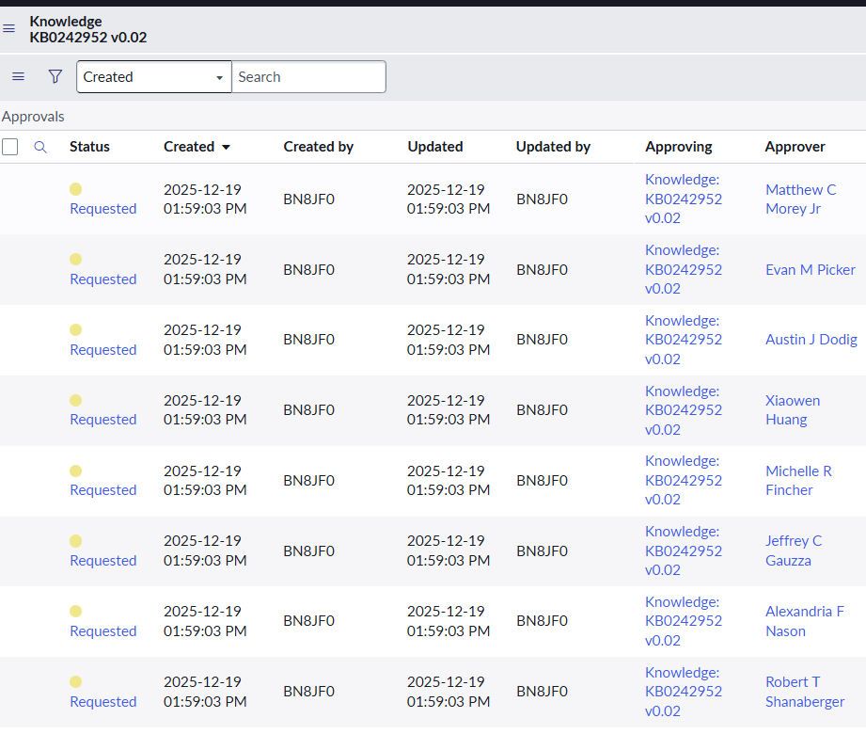

As one of the Approvers, “Reject” approval.
[Reject]

Note that te article is back in “Draft” state.

- Alex test KBB OA -- test Knowledge Base – Owner – Approves
New KBA Article
KB0242953
Ownership Group is the “Empty Inactive Knowledge Ownership Group”.
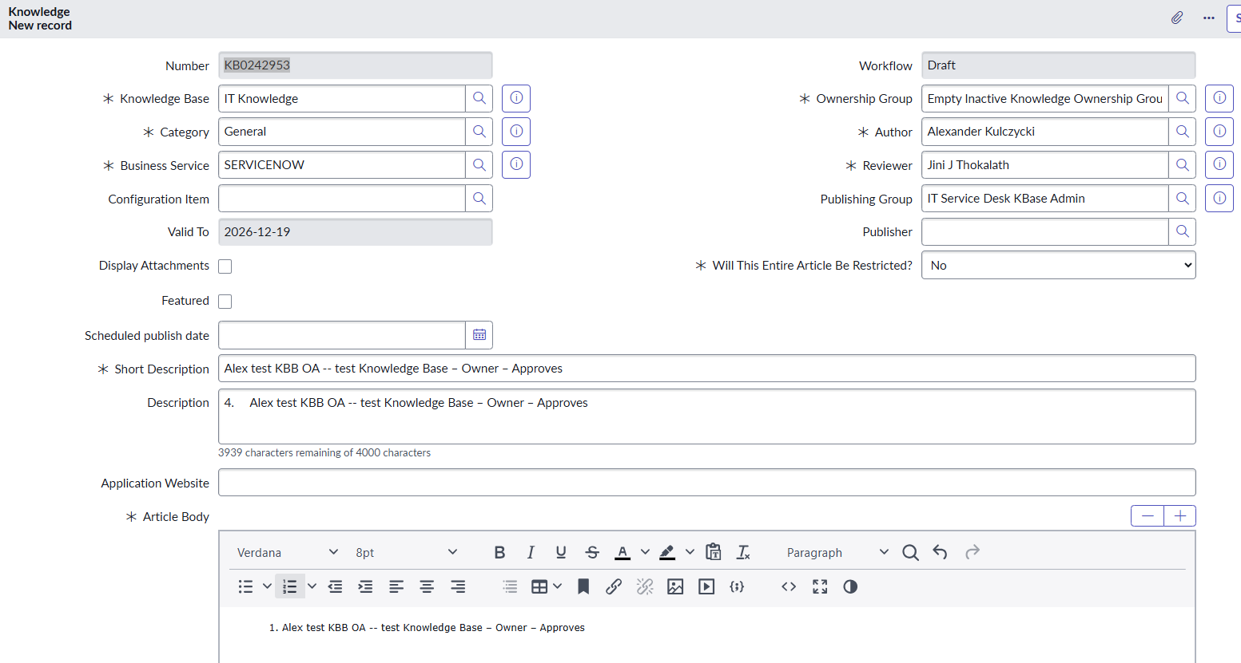
[Publish]
Select the article
Lookup the KBA in review. Note that the approvers are the KBB owner and managers:
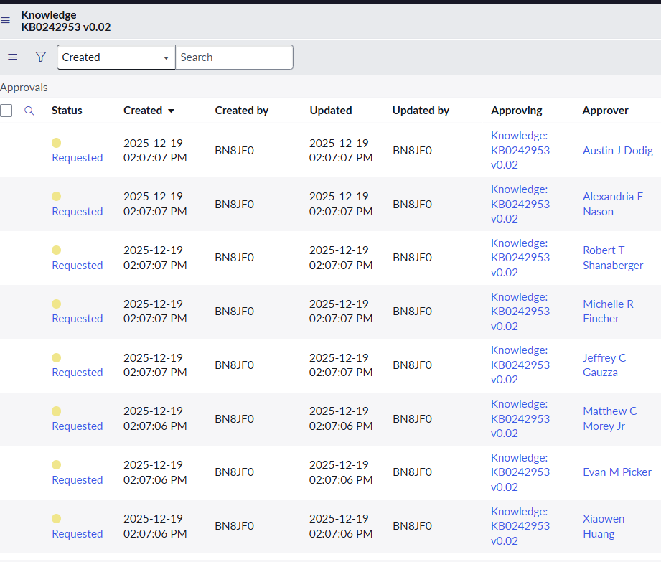

As one of the approvers, “Approve”

[Approve]
Note the article workflow state is “Published” 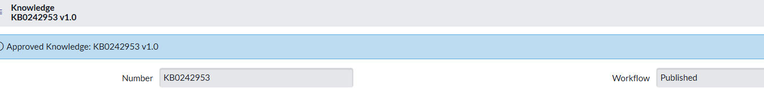

From the sys_email.list screen, note the Notifications that have been sent that the article has been published:
