## Davidson County District Performance

**Introduction**

Davidson County is a school district serving 79934 students. Its expenditures in 2015 were $11496.30 per student.

**Demographic Information**

Here is a table with student demographic information for Davidson County:

|  |  |
| --- | --- |
| Subgroup | Percentage of Students |
| Black/Hispanic/Native American | 65.2 |
| Economically Disadvantaged | 75.3 |
| Students with Disabilities | 12.4 |
| English Learners | 16.2 |

**3-8 Achievement Data**

Here is a graph with some achievement data for 3-8 subjects:

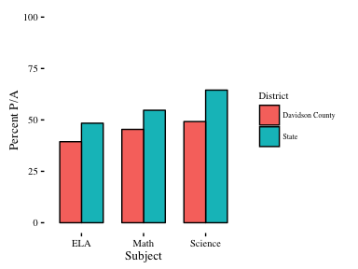

**High School Achievement Data**

Here is a graph with some achievement data for EOC subjects:

