Dastan Abdildin

Project report

At first, LA5 dataset was downloaded and for introduction visualization of several patients (10159, 10171, and 10189) MRI was performed in depiction.ipynb at google drive using Pérez-García torchio pipeline that was recommended for the previous homework and the top one model from it:

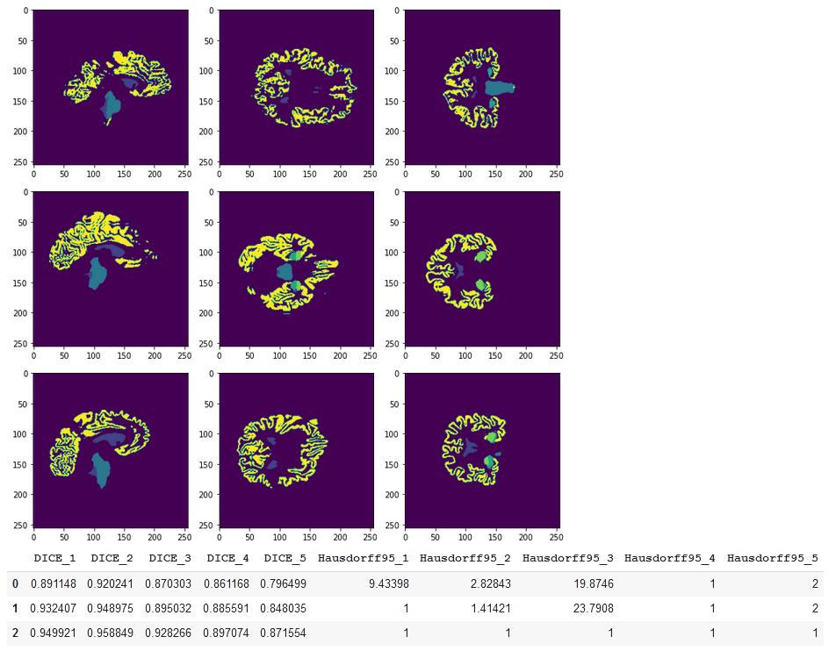

After that, there was an attempt to run autoencoder training of model for LA5 dataset, however it was halting at the final stage, no matter what software was being used (Google Colab, Jupyter Notebook, Jupyter Notebook with CUDA enabled), since training of model under any parameters of model_kwargs was resulting in memory overfilling and death of kernel.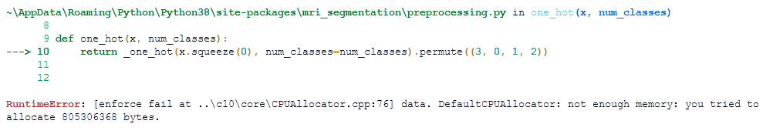

Later, the train.ipynb notebook was used to try making own model, there are some Comet ML graphs to illustrate the process of training:

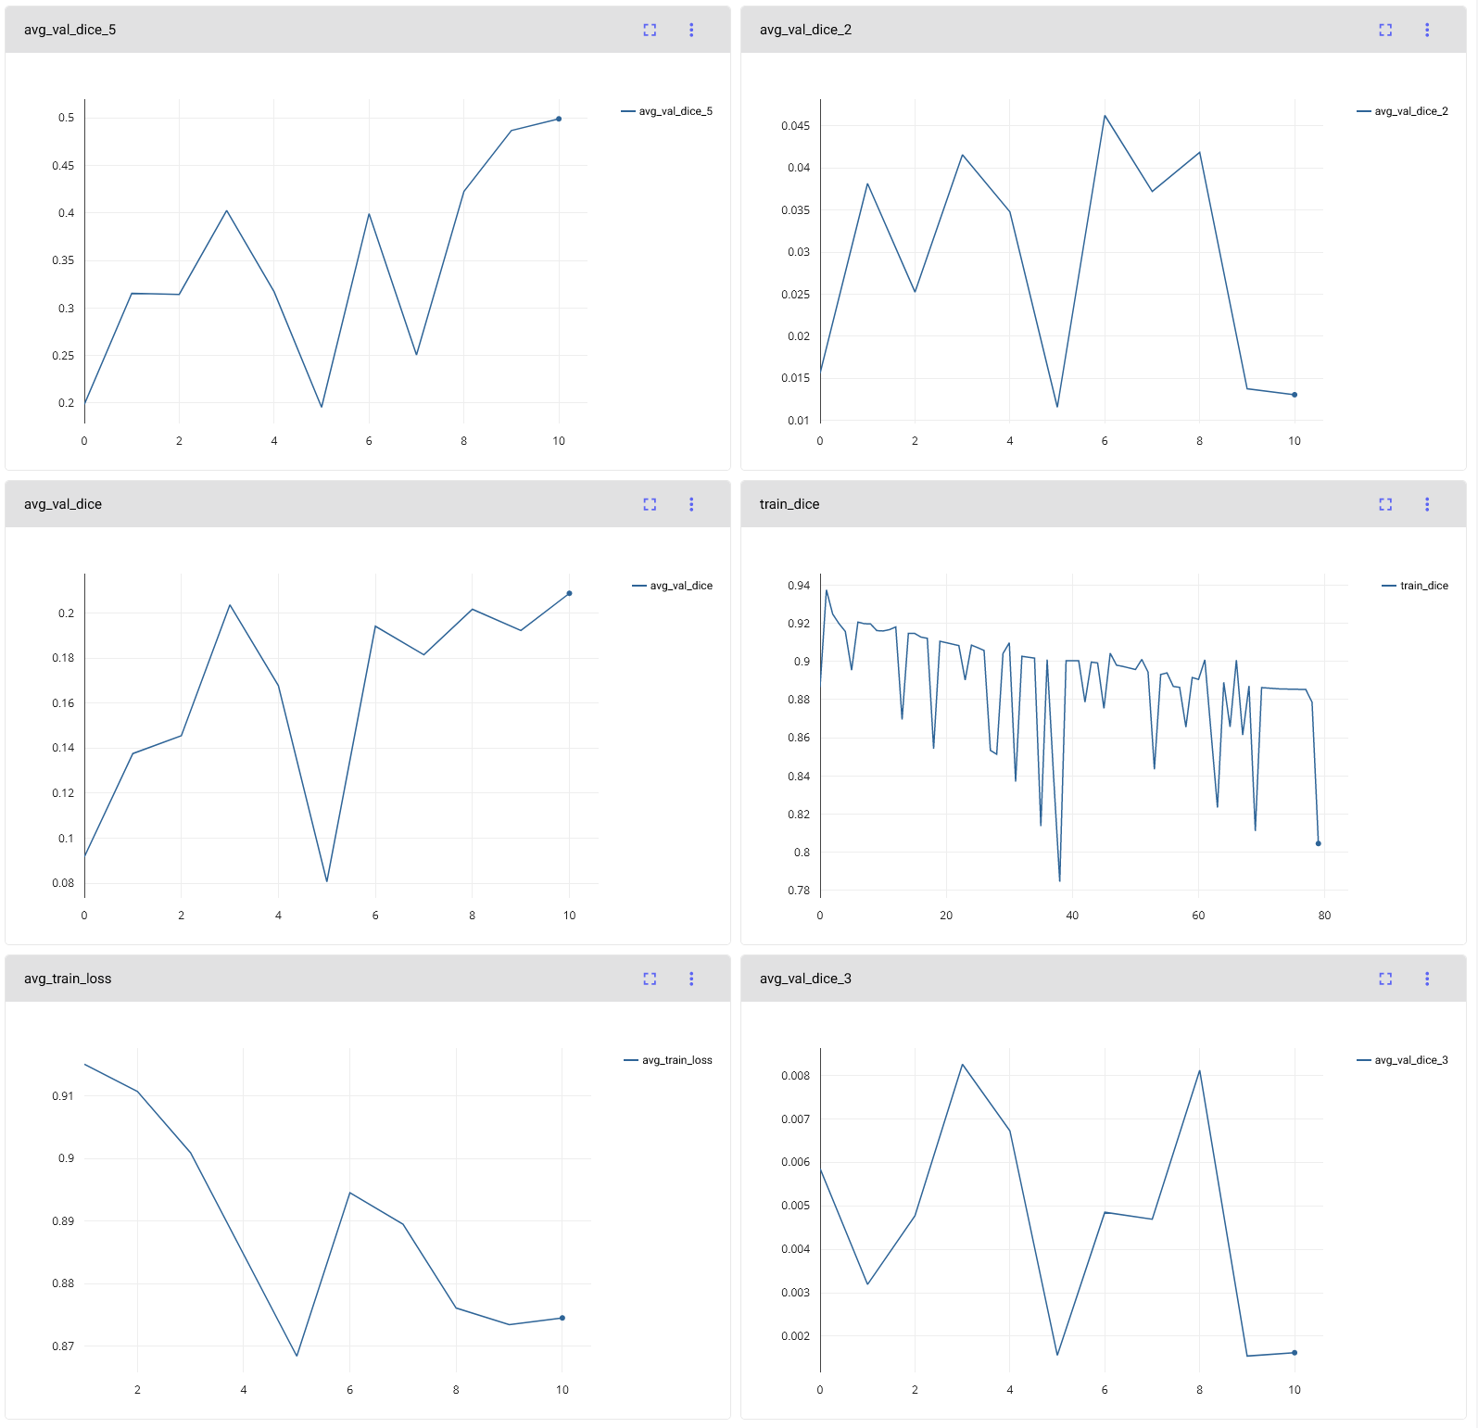

(<https://www.comet.ml/d45t4n/project-2/bb6bdbce9be74a569bc61a0cf743d94b?experiment-tab=chart&showOutliers=true&smoothing=0&transformY=smoothing&xAxis=step>)

After it, attempt to perform segmentation analysis was made. The dataset of unrestricted_hcp_freesurfer from the previous seminars was used as non-pathological brain example. The pipeline has stopped at computing volume, since Colab wasn’t able to process it at all, and Jupyter with CUDA was running out of memory.

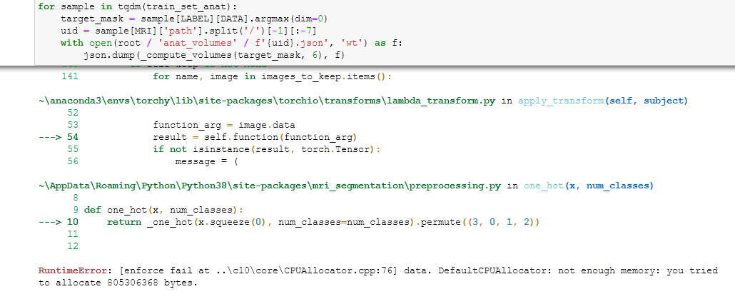

Afterwards, the LA5 dataset was processed to visualize its normalized orthogonal slices:

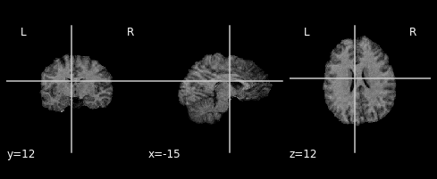

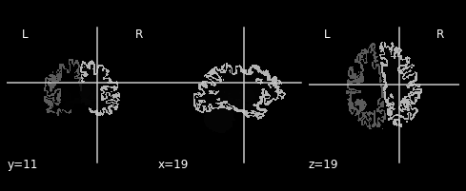

After that, building of segmentation model was started:

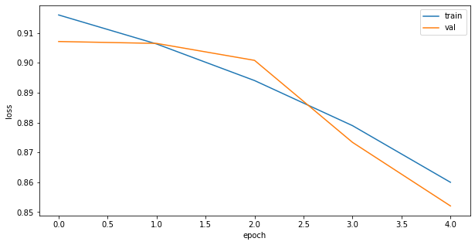

The overall training loss is 0.851272, while validation loss is 0.872469. During the seminar it was stated that DICE > 0.9 is expected for 40 epochs (the same as here), so we can see that the real output got even slightly better, and there is the Comet ML for the notebook:

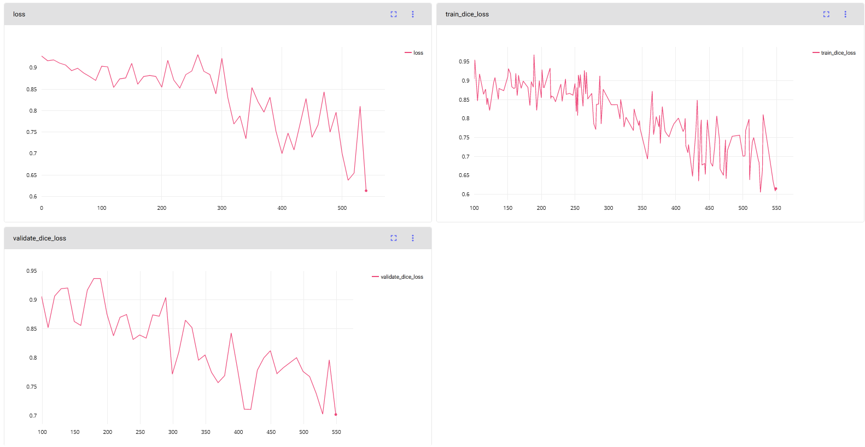

(<https://www.comet.ml/d45t4n/project-2/c7c249cb54ae44b59acb9faad13c2a8f?experiment-tab=chart&showOutliers=true&smoothing=0&transformY=smoothing&xAxis=step>)

When looking at visualization of central cuts of the brain, we already can see the abnormalities, since even for the foreground plots, we can observe gaps in the brain mass that are not present in the healthy patients.

Healthy patients plot from the seminar:

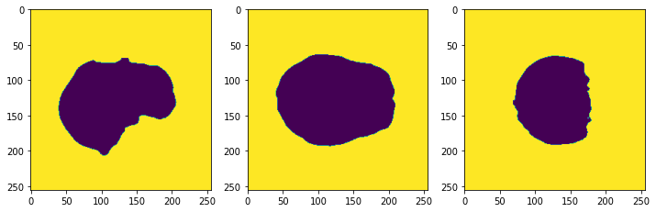

LA5 dataset of sick patients:

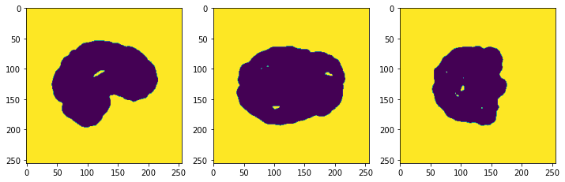

Other perspectives of LA5 patientss in the same way present abnormal brain structure:

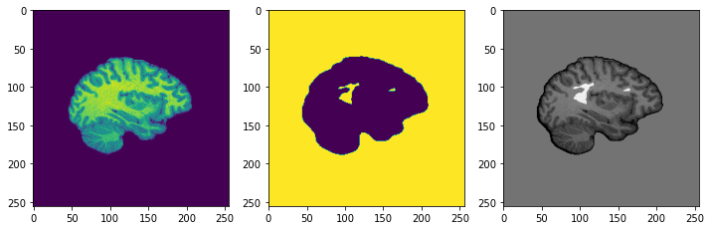

Performance of patch-based segmentation produces the similar observations:

Healthy patients:

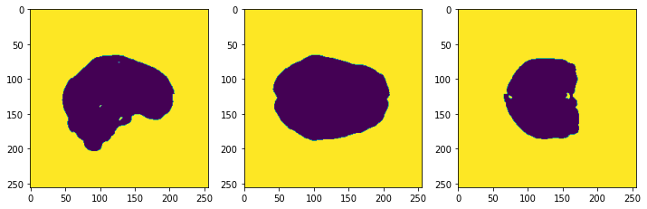

LA5 dataset patients:

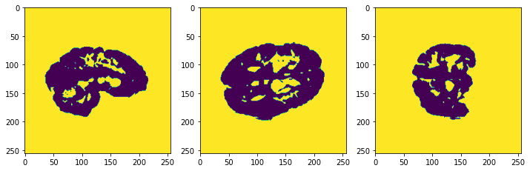

After running optimization and training, the output images become less different, yet it is still visible that walls on the images are thinner, and fewer contours have closed outline, implying that patients of LA5 dataset suffer from reduction of brain mass.

Healthy patients:

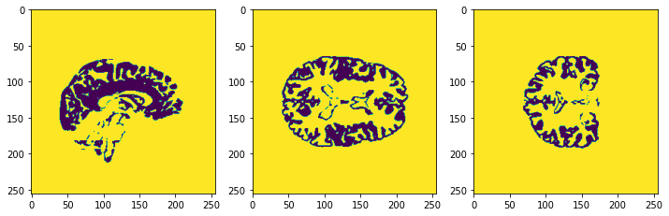

LA5 dataset patients:

