# DAD 220 Database Documentation Template

Complete these steps as you work through the directions for Project One. Replace the bracketed text with your screenshots and brief explanations of the work they capture. Each screenshot and its explanation should be sized to approximately one quarter of the page, with the description written below the screenshot. Follow these rules for each of the prompts and questions below. Review the example document located in the Project One Supporting Materials for assistance.

## Step One: Create a Database

1. Navigate to your online integrated development environment (IDE). Here, you will need to write the proper SQL commands in command line to create tables that demonstrate relationships based on the entity relationship diagram. List and record the SQL commands that you used to complete this step here:

[Insert screenshot and brief explanation here.]

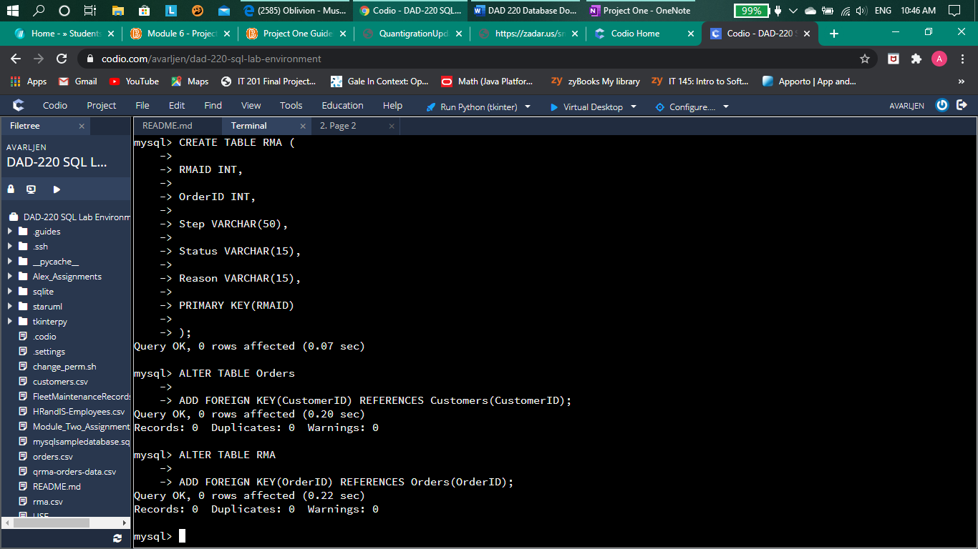

Code used:

ALTER TABLE Orders

ADD FOREIGN KEY(CustomerID) REFERENCES Customers(CustomerID);

ALTER TABLE RMA

ADD FOREIGN KEY(OrderID) REFERENCES Orders(OrderID);

The SQL commands used here where implemented after I had already created the three new tables for the “QunatigrationUpdates” database. These two commands create the relationship between the three tables with the “Orders” table using the “CustomerID” attribute from the “Customers” table as it’s foreign key and the “RMA” table using the “OrderID” attribute from the “Orders” table as it’s foreign key, thus connecting the three tables via foreign keys and creating the relationship.

1. Create a database schema called *QuantigrationUpdates*. List out the database name. Provide the SQL commands you ran against MySQL to successfully complete this in your answer:

[Insert screenshot and brief explanation here.]

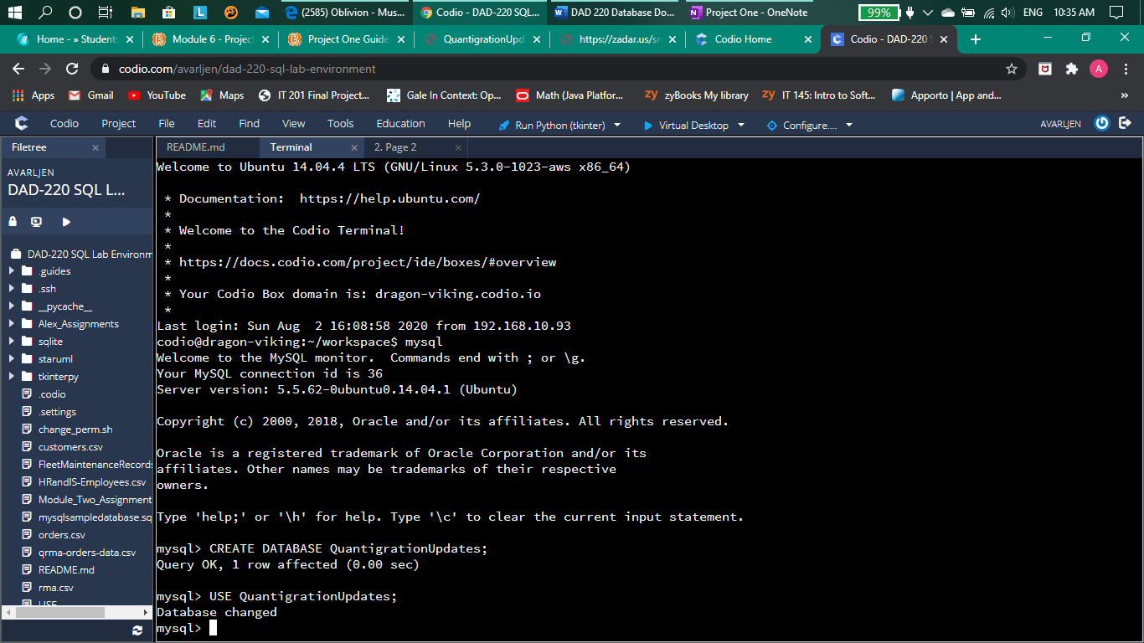

Code used:

CREATE DATABASE QuantigrationUpdates;

USE QuantigrationUpdates;

These two SQL commands where used to create the new database “QuantigrationUpdates” and to use the newly created database for the queries that will follow in this project.

1. Using the ERD as a reference, **create the following tables with the appropriate attributes and keys**:
   1. A table named **customers** in the *QuantigrationUpdates* database as defined on the project ERD. Provide the SQL commands you ran against MySQL to complete this successfully in your answer:

[Insert screenshot and brief explanation here.]

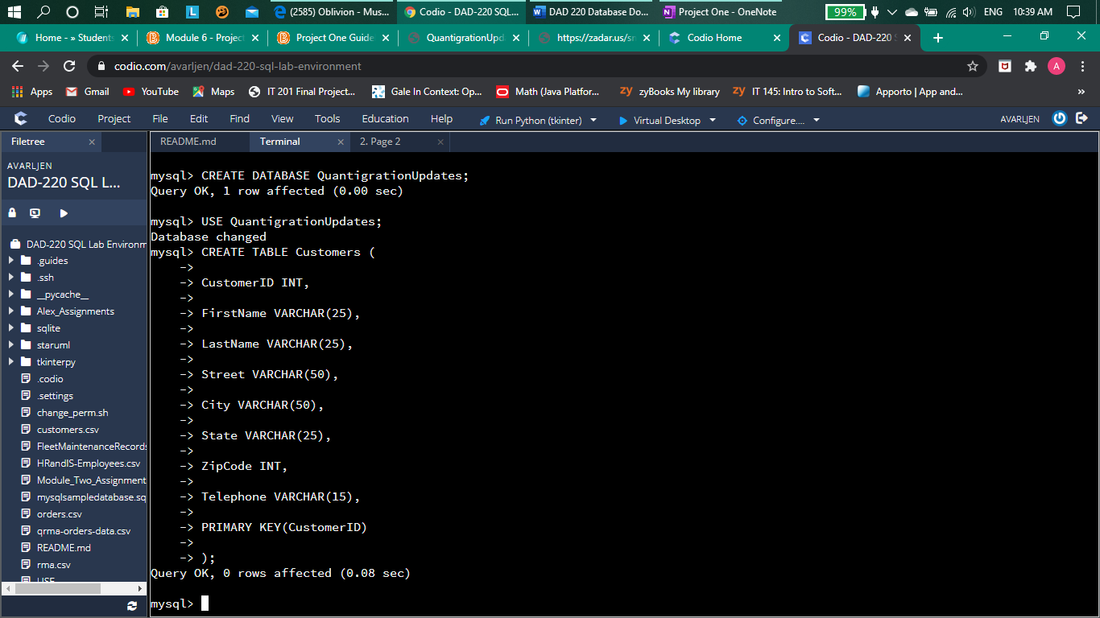

Code used:

CREATE TABLE Customers (

CustomerID INT,

FirstName VARCHAR(25),

LastName VARCHAR(25),

Street VARCHAR(50),

City VARCHAR(50),

State VARCHAR(25),

ZipCode INT,

Telephone VARCHAR(15),

PRIMARY KEY(CustomerID)

);

This SQL command was used to create the new table named “Customers” for the “QuantigrationUpdates” database and contains all the necessary attributes involved in this table.

* 1. A table named **orders** in the *QuantigrationUpdates* database as defined on the project ERD. Provide the SQL commands you ran against MySQL to complete this successfully in your answer:

[Insert screenshot and brief explanation here.]

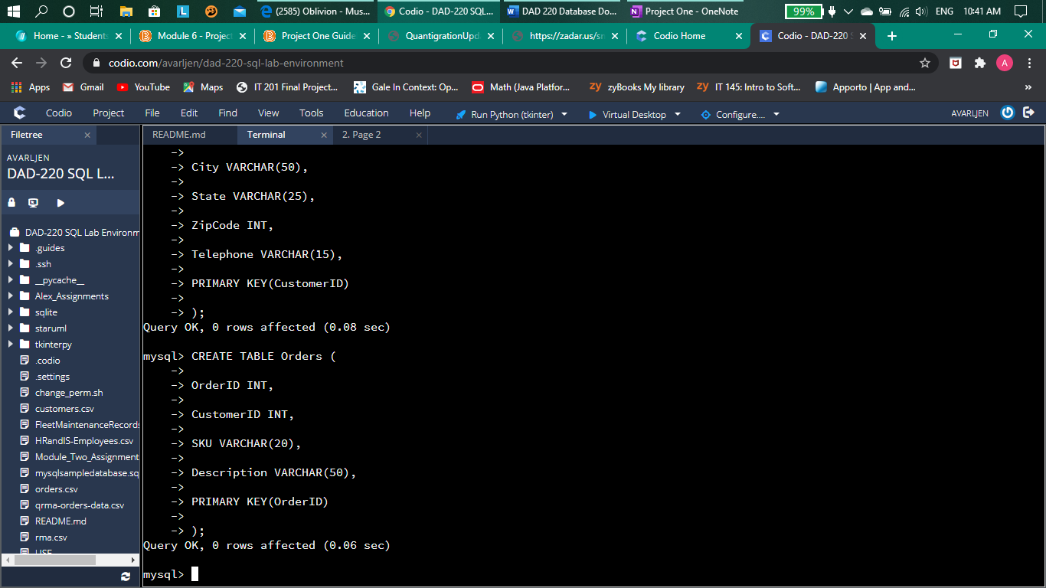

Code used:

CREATE TABLE Orders (

OrderID INT,

CustomerID INT,

SKU VARCHAR(20),

Description VARCHAR(50),

PRIMARY KEY(OrderID)

);

This SQL command was used to create the new table called “Orders” for the “QuantigrationUpdate” database and contains all the necessary attributes.

* 1. A table named **rma** in the *QuantigrationUpdates* database as defined on the project ERD. Provide the SQL commands you ran against MySQL to complete this successfully in your answer:

[Insert screenshot and brief explanation here.]

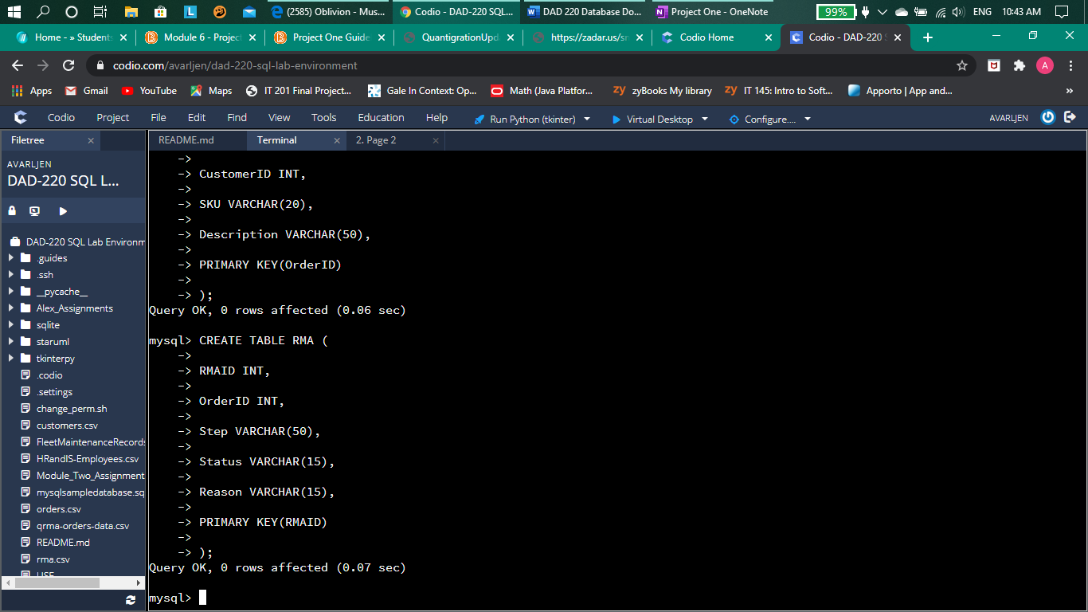

Code used:

CREATE TABLE RMA (

RMAID INT,

OrderID INT,

Step VARCHAR(50),

Status VARCHAR(15),

Reason VARCHAR(15),

PRIMARY KEY(RMAID)

);

This SQL command was used to create the new table named “RMA” for the “QuantigrationUpdate” database with all of the necessary attributes.

1. **Update your existing table** from “Customer” to “Collaborator” using SQL based on this change in requirements. Provide the SQL commands you ran against MySQL to complete this successfully in your answer:

[Insert screenshot and brief explanation here.]

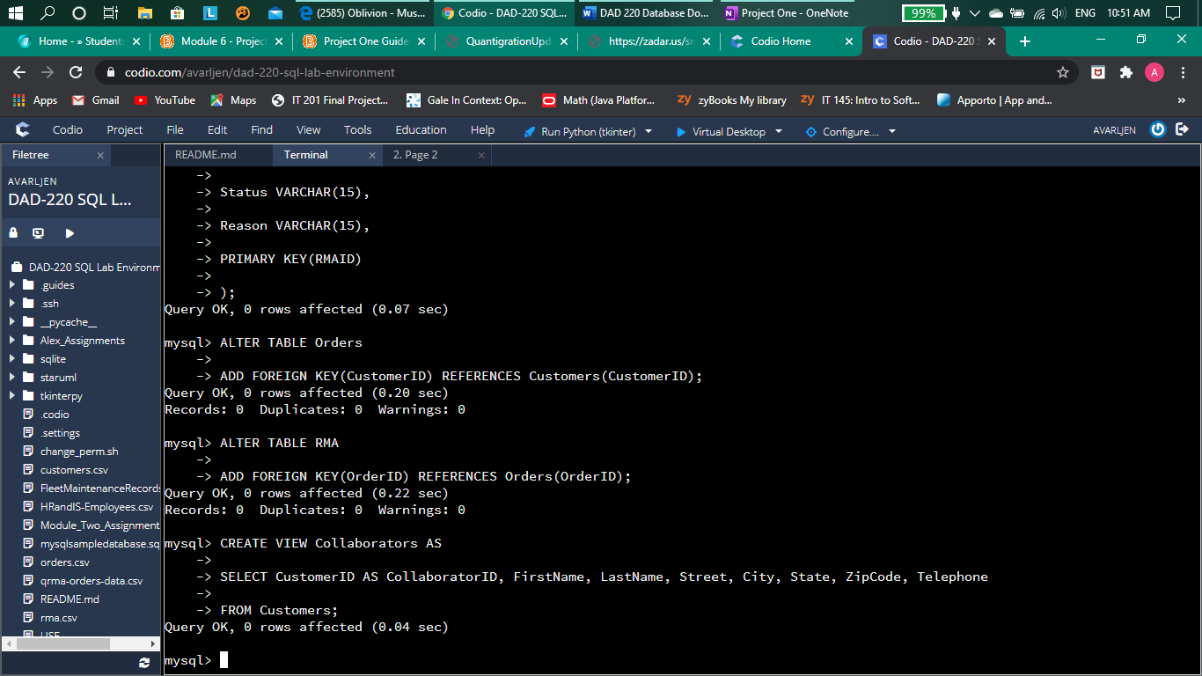

Code used:

CREATE VIEW Collaborators AS

SELECT CustomerID AS CollaboratorID, FirstName, LastName, Street, City, State, ZipCode, Telephone

FROM Customers;

This SQL command was used to create a new “view” of the “Customers” table, which contains all the same attributes as the “Customers” table, relabeled as “Collaborators”.

## Step Two: Load and Query the Data

1. **Import the data from each file into tables**.
   * Use the *QuantigrationUpdates* database, the three tables you created, and the three CSV files preloaded into Codio.
   * Use the import utility of your database program to load the data from each file into the table of the same name. You will perform this step three times, once for each table.
2. **Write basic queries against imported tables to organize and analyze targeted data.** For each query, replace the bracketed text with a screenshot of the query and its output. You should also include a brief, 1- to 3-sentence description of the output.
   * Write an SQL query that returns the count of orders for customers located only in the city of Framingham, Massachusetts.
     1. How many records were returned?

[Insert screenshot and brief explanation here.]

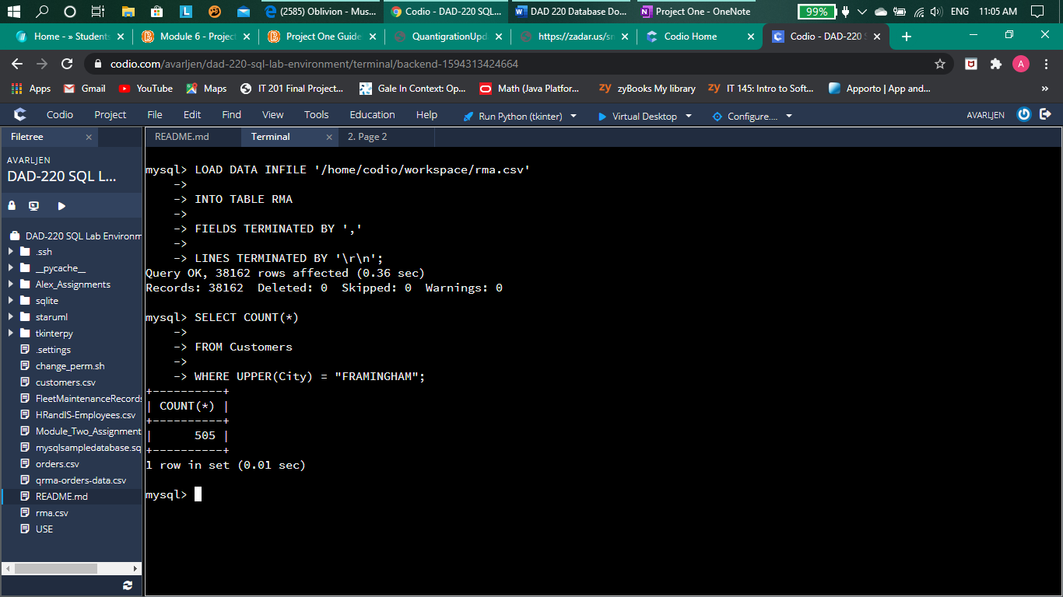

Code used:

SELECT COUNT(*)

FROM Customers

WHERE UPPER(City) = "FRAMINGHAM"

This SQL command was used to count the number of records from the customers located in Framingham. The number of records returned was 505.

* + Write an SQL query to select all of the customers located in the state of Massachusetts.
    1. Use a WHERE clause to limit the number of records in the customers table to only those who are located in Massachusetts.
    2. Record an answer to the following question: How many records were returned?

[Insert screenshot and brief explanation here.]

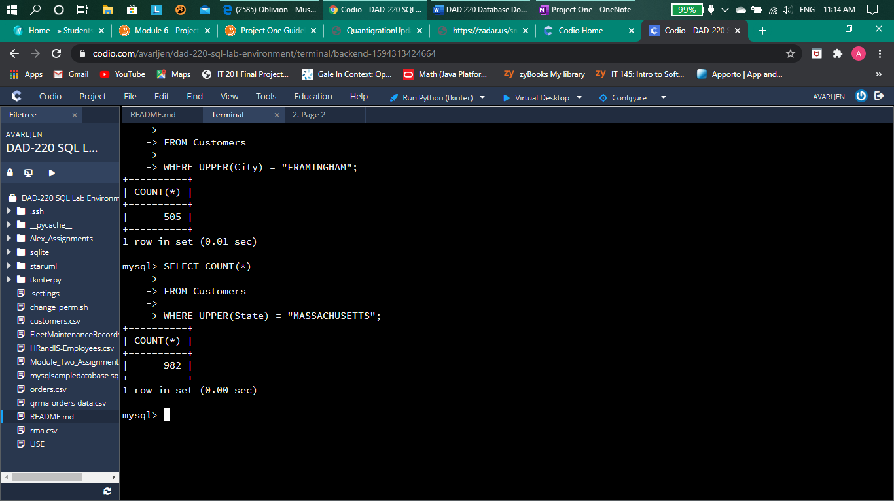

Code used:

SELECT COUNT(*)

FROM Customers

WHERE UPPER(State) = "MASSACHUSETTS";

This SQL statement was used to count the number of records from customers who are in the state of Massachusetts. The number of records returned is 982.

* + Write a SQL query to insert four new records into the orders and customers tables using the following data:
    1. Customers Table

|  |  |  |  |  |  |  |  |
| --- | --- | --- | --- | --- | --- | --- | --- |
| **CustomerID** | **FirstName** | **LastName** | **StreetAddress** | **City** | **State** | **ZipCode** | **Telephone** |
| 100004 | Luke | Skywalker | 15 Maiden Lane | New York | NY | 10222 | 212-555-1234 |
| 100005 | Winston | Smith | 123 Sycamore Street | Greensboro | NC | 27401 | 919-555-6623 |
| 100006 | MaryAnne | Jenkins | 1 Coconut Way | Jupiter | FL | 33458 | 321-555-8907 |
| 100007 | Janet | Williams | 55 Redondo Beach Blvd | Torrence | CA | 90501 | 310-555-5678 |

[Insert screenshot and brief explanation here.]

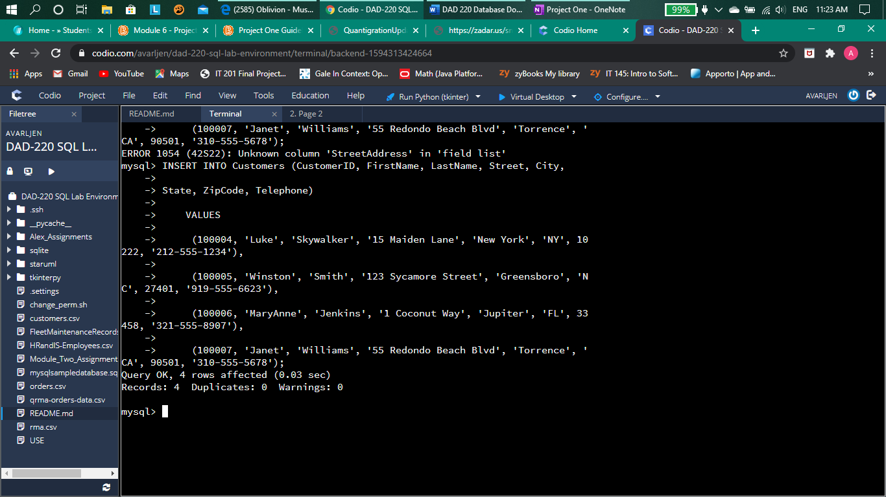

Code used:

INSERT INTO Customers (CustomerID, FirstName, LastName, Street, City,

State, ZipCode, Telephone)

VALUES

(100004, 'Luke', 'Skywalker', '15 Maiden Lane', 'New York', 'NY', 10222, '212-555-1234'),

(100005, 'Winston', 'Smith', '123 Sycamore Street', 'Greensboro', 'NC', 27401, '919-555-6623'),

(100006, 'MaryAnne', 'Jenkins', '1 Coconut Way', 'Jupiter', 'FL', 33458, '321-555-8907'),

(100007, 'Janet', 'Williams', '55 Redondo Beach Blvd', 'Torrence', 'CA', 90501, '310-555-5678');

This SQL command was used to insert the four new records from the table above into the “Customers” table. All the four new records place the relevant data into all of the relevant attributes of the “Customers” table.

* + 1. Orders Table

|  |  |  |  |
| --- | --- | --- | --- |
| **OrderID** | **CustomerID** | **SKU** | **Description** |
| 1204305 | 100004 | ADV-24-10C | Advanced Switch 10GigE Copper 24 port |
| 1204306 | 100005 | ADV-48-10F | Advanced Switch 10 GigE Copper/Fiber 44 port copper 4 port fiber |
| 1204307 | 100006 | ENT-24-10F | Enterprise Switch 10GigE SFP+ 24 Port |
| 1204308 | 100007 | ENT-48-10F | Enterprise Switch 10GigE SFP+ 48 port |

[Insert screenshot and brief explanation here.]

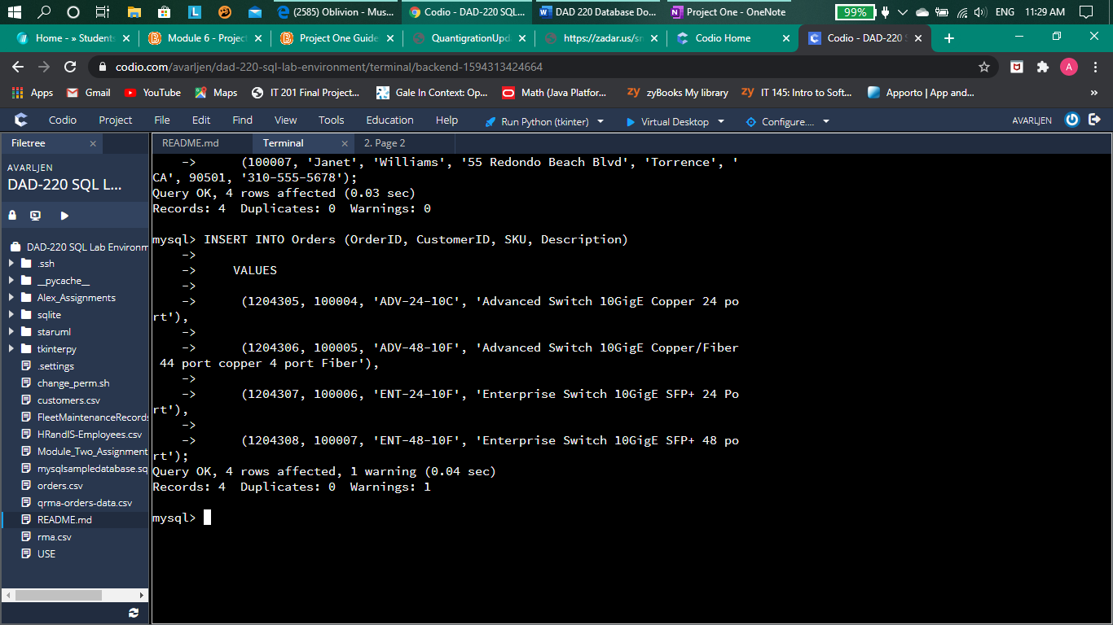

Code used:

INSERT INTO Orders (OrderID, CustomerID, SKU, Description)

VALUES

(1204305, 100004, 'ADV-24-10C', 'Advanced Switch 10GigE Copper 24 port'),

(1204306, 100005, 'ADV-48-10F', 'Advanced Switch 10GigE Copper/Fiber 44 port copper 4 port Fiber'),

(1204307, 100006, 'ENT-24-10F', 'Enterprise Switch 10GigE SFP+ 24 Port'),

(1204308, 100007, 'ENT-48-10F', 'Enterprise Switch 10GigE SFP+ 48 port');

This SQL command was used to insert the four new records, outlined in the above table, into the “Orders” table. The four new records each contain new data for each attribute in the “Orders” table.

* + In the customers table, perform a query to count all records where the city is Woonsocket, Rhode Island.
    1. How many records are in the customers table where the field “city” equals “Woonsocket”?

[Insert screenshot and brief explanation here.]

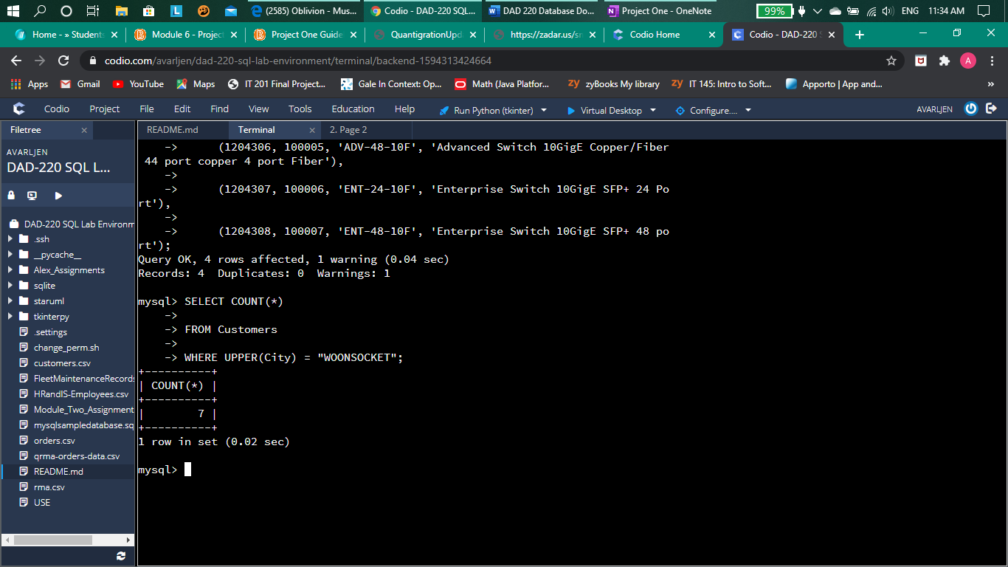

Code used:

SELECT COUNT(*)

FROM Customers

WHERE UPPER(City) = "WOONSOCKET";

This SQL command was used to count the number of records in the “Customers” table where the customers ordered from the city of Woonsocket.

* + In the rma database, update a customer’s records.
    1. Write an SQL statement to select the current fields of *status* and *step* for the record in the *rma* table with an *orderid* value of “5175.”
       1. What are the current status and step?

[Insert screenshot and brief explanation here.]

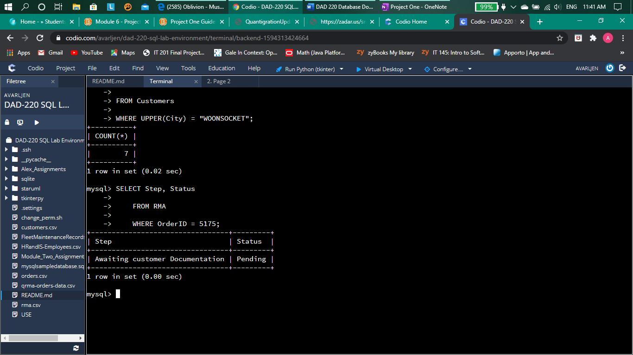

Code used:

SELECT Step, Status

FROM RMA

WHERE OrderID = 5175;

This SQL command was used to find the “Step” and “Status” of order number 5175 in the “RMA” table. The “step” is “Awaiting customer Documentation” and the “Status” is “Pending”.

* + 1. Write an SQL statement to update the *status* and *step* for the *orderid*, 5175 to *status* = “Complete” and *step* = “Credit Customer Account.”
       1. What are the updated *status* and *step* values for this record?

[Insert screenshot and brief explanation here.]

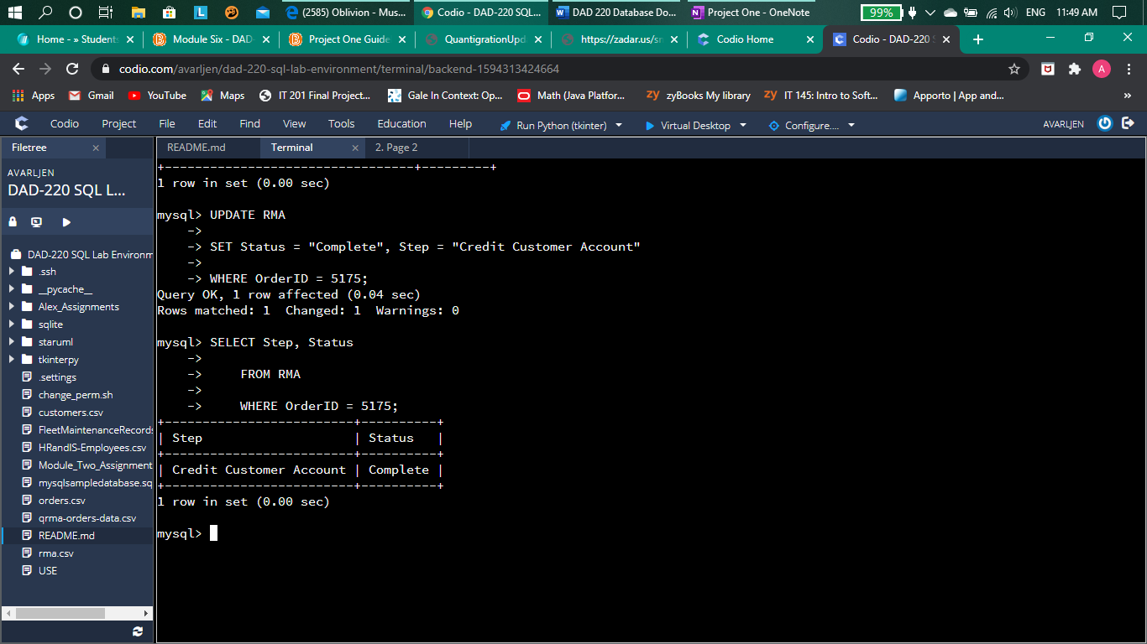

Code used:

UPDATE RMA

SET Status = "Complete", Step = "Credit Customer Account"

WHERE OrderID = 5175;

SELECT Step, Status

FROM RMA

WHERE OrderID = 5175;

The first SQL command was used to update the “Status” and “Step” of order number 5175 from the “RMA” table to “Complete” and “Credit Customer Account” The second SQL command was used to check the new “Step” and “Status” of order number 5175 from the “RMA” table. The new “Step” is “Credit Customer Account” and the new “Status” is “Complete”.

* + Delete rma records.
    1. Write an SQL statement to delete all records with a reason of “Rejected.”
       1. How many records were deleted?

[Insert screenshot and brief explanation here.]

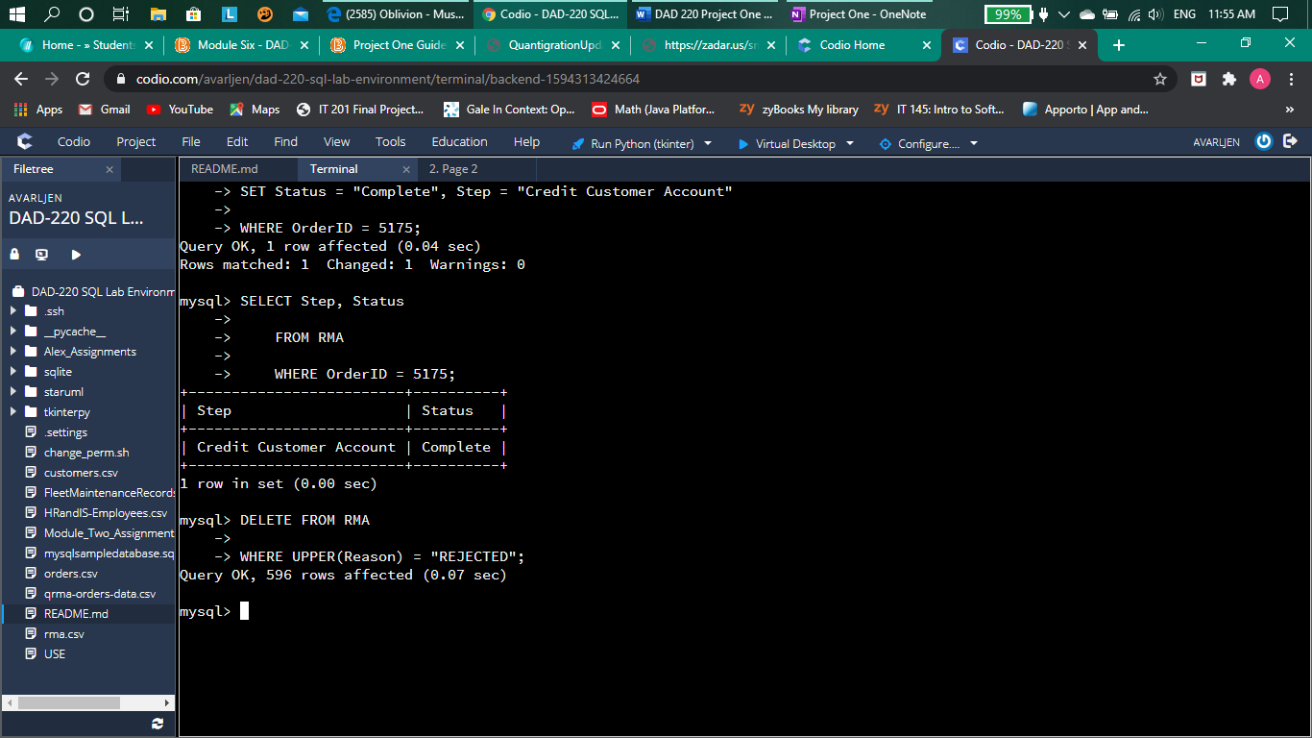

Code used:

DELETE FROM RMA

WHERE UPPER(Reason) = "REJECTED";

This SQL command was used to delete any record where the “Reason” attribute was filled with the string “Rejected” from the “RMA” table. The number of rows affected, and therefor the number of records deleted, was 596.

1. **Create an output file of the required query results.** Write an SQL statement to list the contents of the *orders* table and send the output to a file that has a .csv extension.

[Insert screenshot and brief explanation here.]

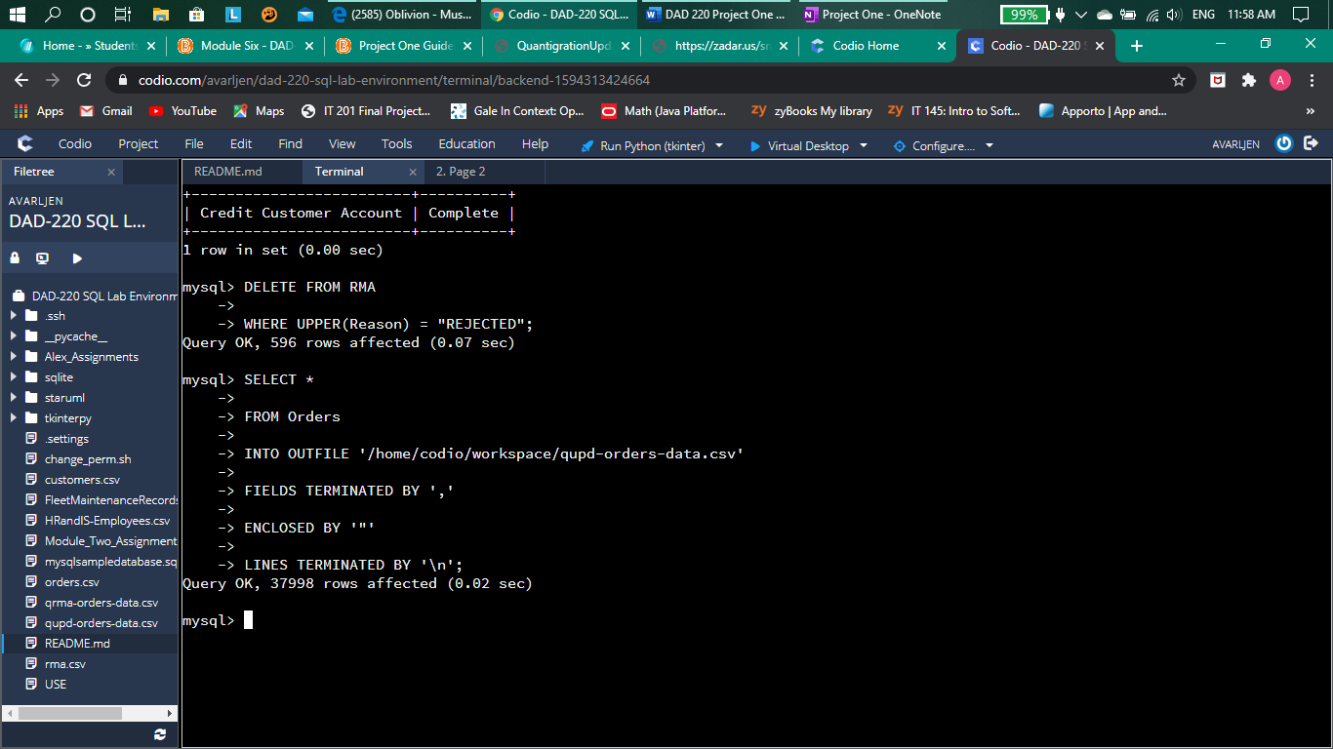

Code used:

SELECT *

FROM Orders

INTO OUTFILE '/home/codio/workspace/qupd-orders-data.csv'

FIELDS TERMINATED BY ','

ENCLOSED BY '"'

LINES TERMINATED BY '\n';

This SQL command was used to put all of the data from the “Orders” table into a csv file labeled “qupd-orders-data.csv”