# Setting up and opening the programmes

1. Open Matlab and let it load (so PC does not freeze)
2. Open MC Data Tool
3. Ensure that Dropbox sync is turned **on**

Both programs are on the desktop.

# First file conversion—.mcd to .raw (MC Data Tool)

1. Click File, Open Multiple
2. Select the .mcd files that you want to convert

These .mcd files will all need to be in the same folder.

In addition, they need to be saved locally on the PC—so **load them in from** where they are saved on the **D drive** and please **set them as ‘online only’ on the Dropbox** (right-click on the folder or file, hover over Smart Sync and click Online Only)

1. Click ‘bin’ (under Tools/View tab)
2. Select all channels (click All button)
3. Ensure Writer Header and Signed 16Bit boxes are ticked (bottom right)
4. Check the output folder is set to

*Dropbox>NOG MEA Data>MEA Data Mecp2Project Jan 2019>RAW*

1. Hit Save—the files will start converting. Now we switch to Matlab.

# Second file conversion—.raw to .mat (Matlab)

1. Open .*Mat_convert_with_delay.m* from *Dropbox>meaHeatMapOvrelay>MatlabAnalysisScriptsAD*
2. Estimate the time that it will take to convert all the .mcd files to .raw.

This is done by **estimating the time it is taking the MC Data Tool to convert the files to .raw** but also bear in mind a) the number of files and b) if the rest of the files are the same size. If there are larger files to be converted, use this for estimation. We need to make sure all .mcd files are finished converting to .raw before we run the conversion of .raw to .mat else the PC will run out of memory and crash. Therefore, overestimate this time and run the conversion overnight.

1. Round up the number of hours the first conversion will take and type this into the Matlab script
2. Type this into the script (line 2)
3. Hit Run and you can see the timer variable in the workspace (to the right) but the pause button will not appear. The files are now converting and will start appearing in *Dropbox>NOG MEA Data>MEA Data Mecp2Project Jan 2019>MAT*

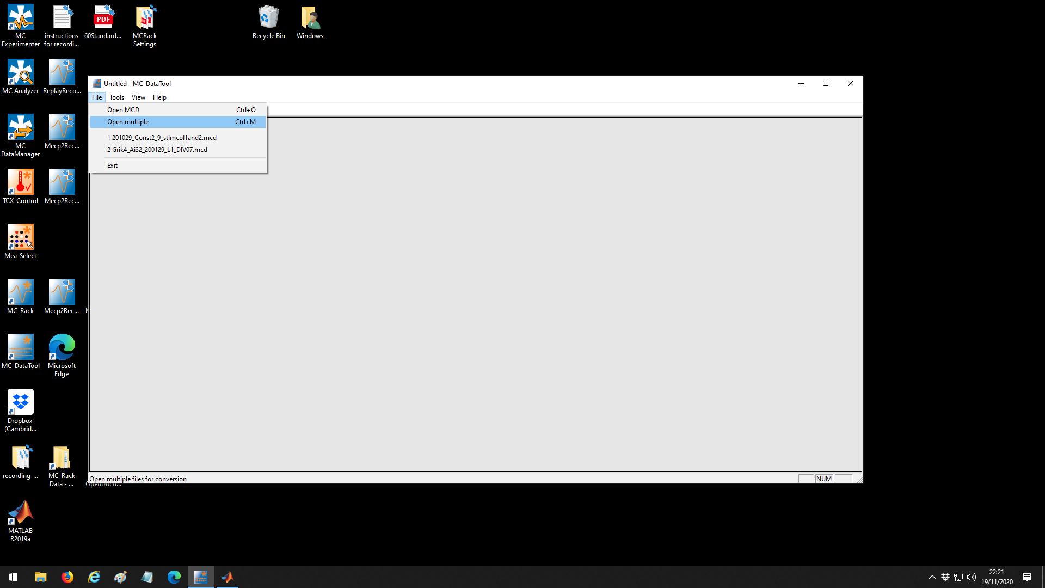

Image 1: MC Data Tool. Icon in bottom left of image.

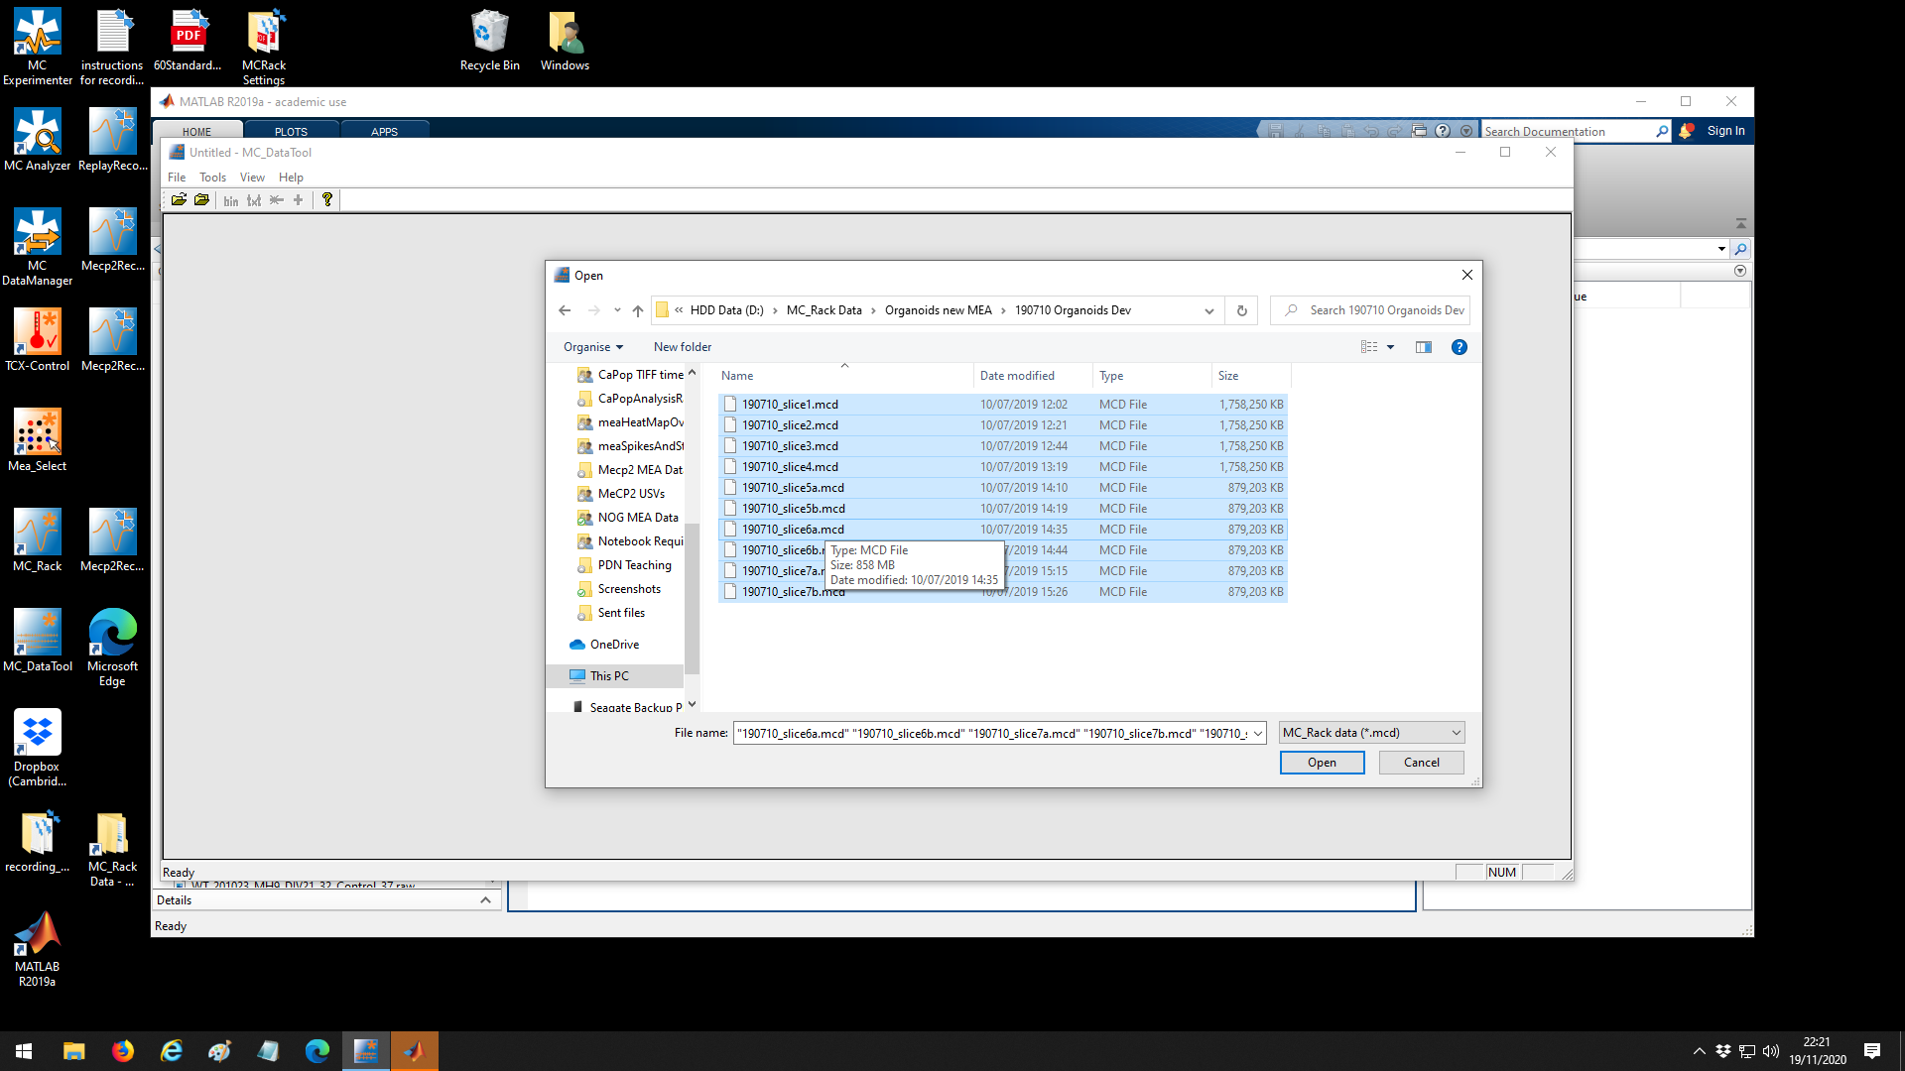

Image 2: Selecting files.

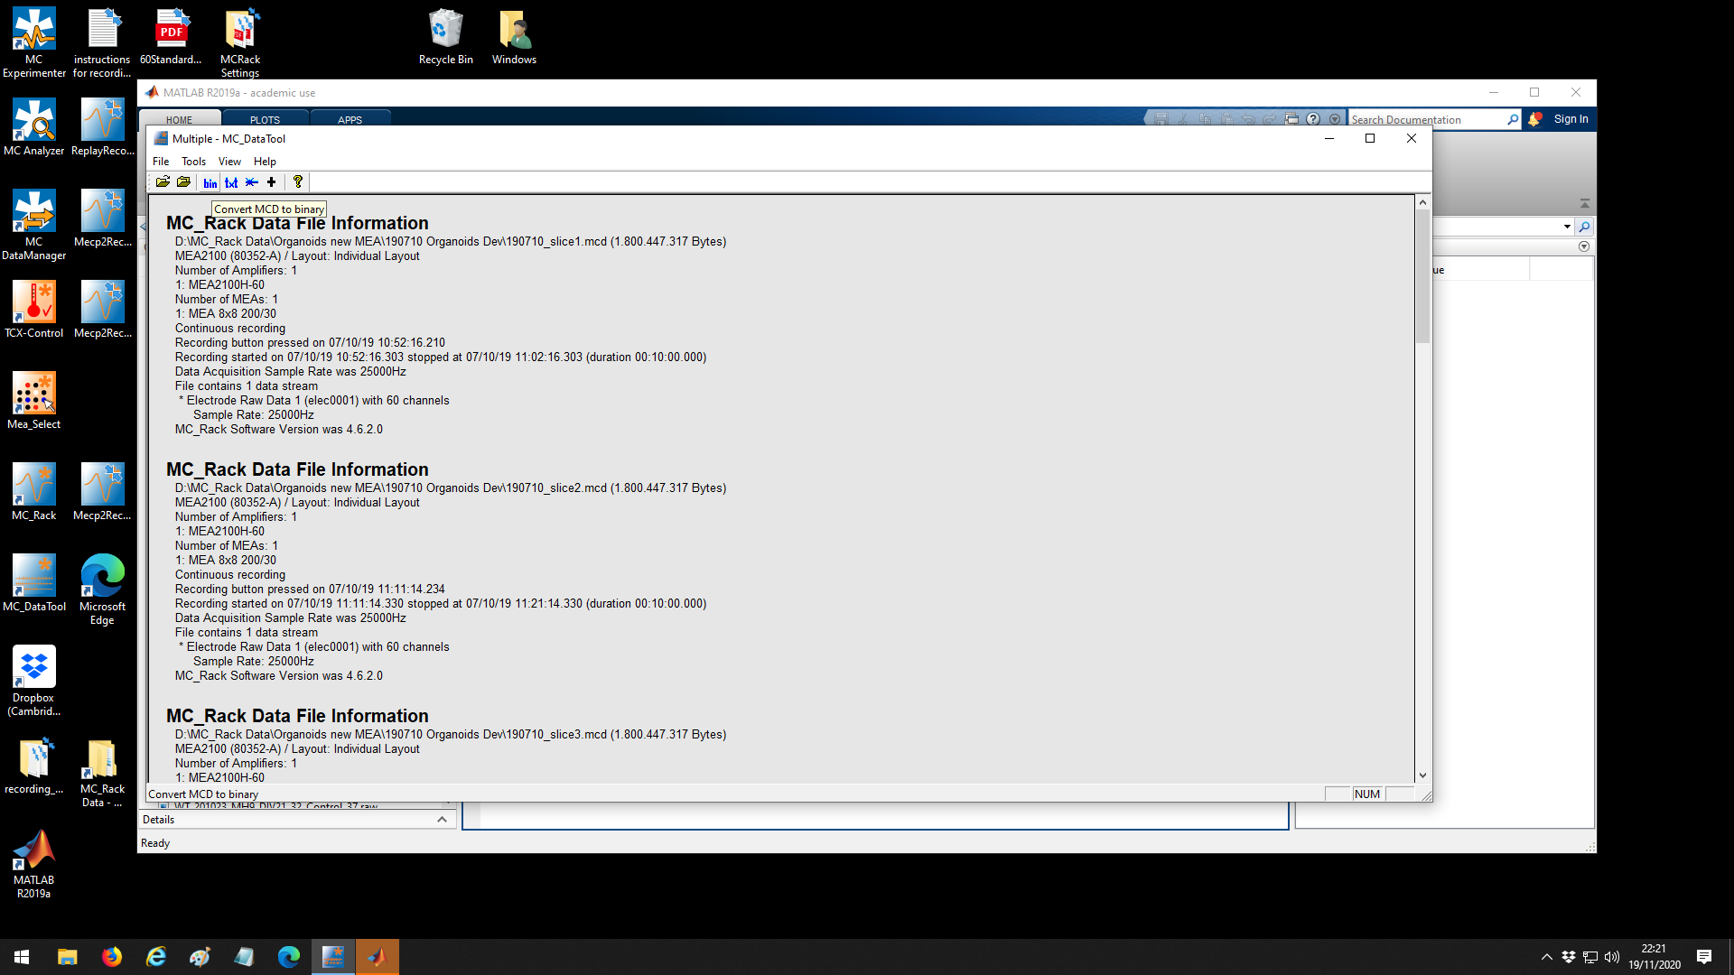

Image 3: The ‘bin’ button is under the Tools/View tab.

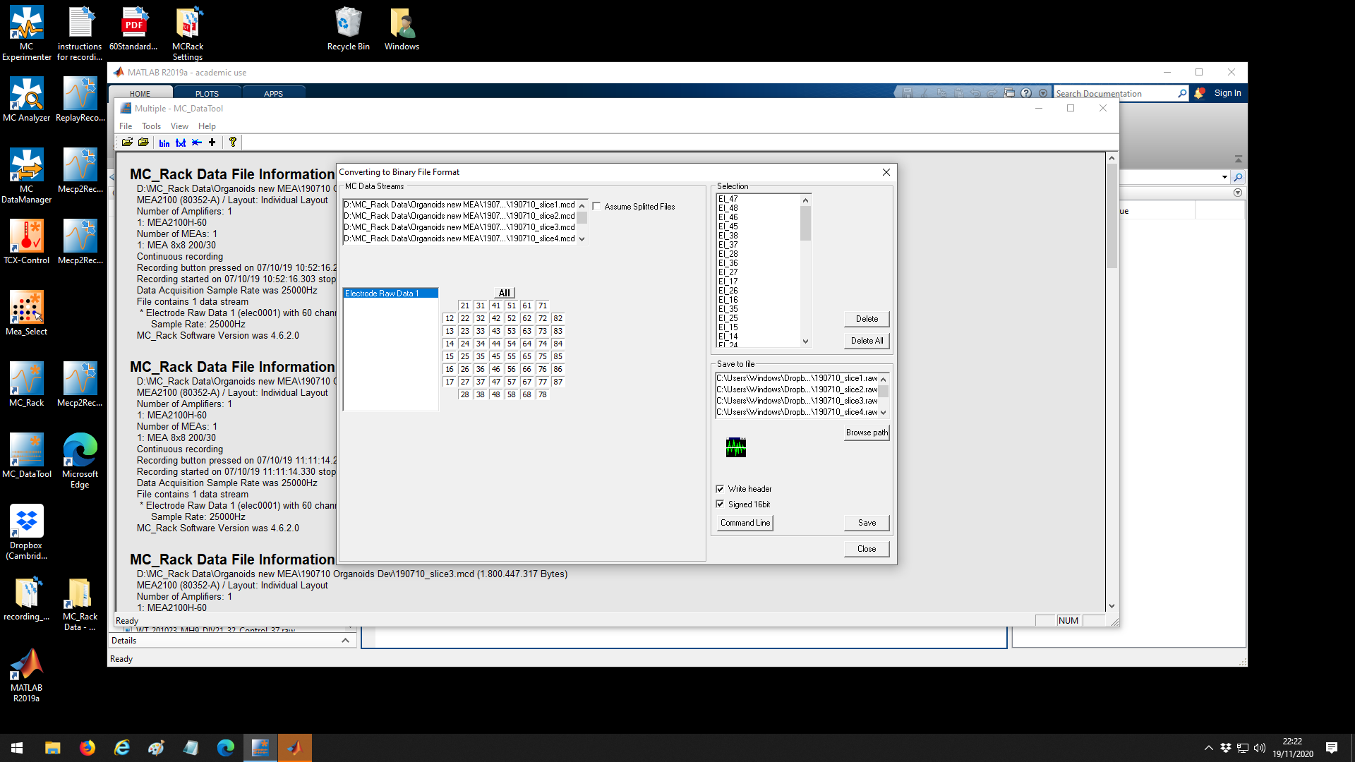Image 4: Click the All button to select all channels and check Write Header and Signed 16bit

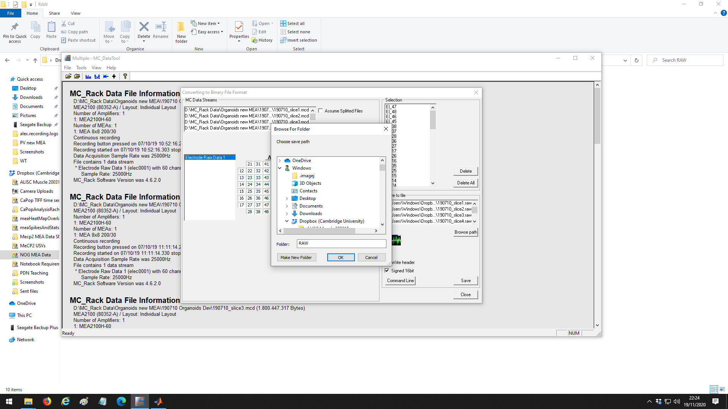

Image 5: Check that the output folder is

*Dropbox>NOG MEA Data>MEA Data Mecp2Project Jan 2019>RAW*

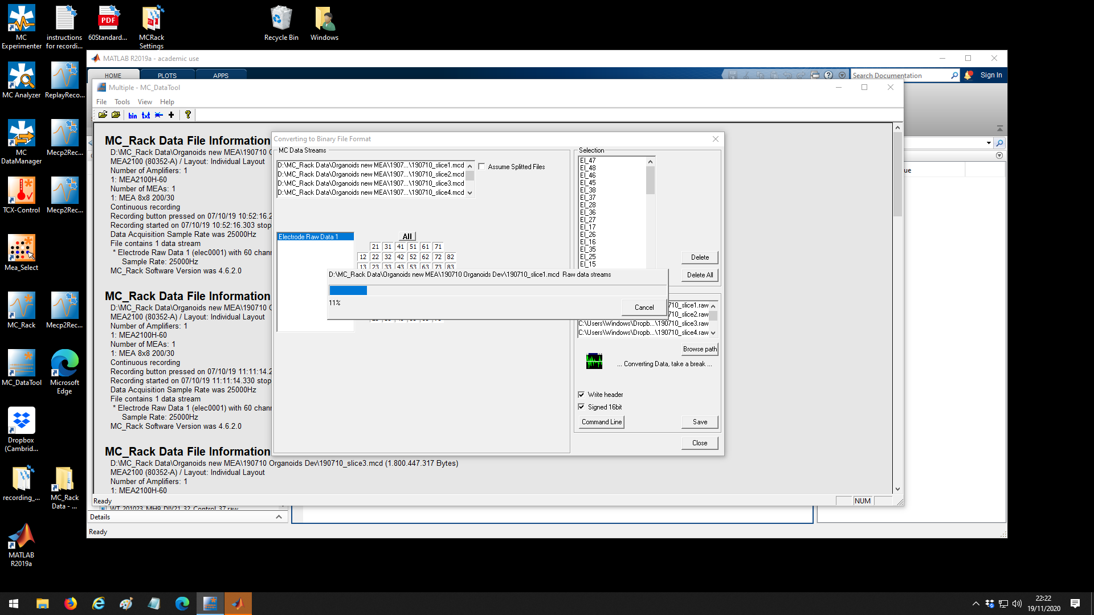

Image 6: Click Save and the files will start converting. Use this progressbar to estimate the time it will take to convert all the selected files based on the quantity and size of said files.

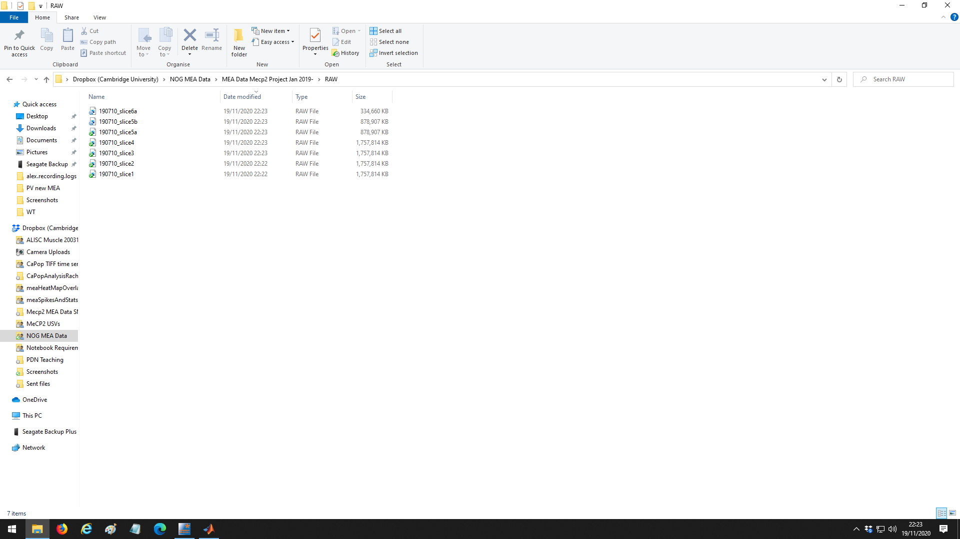

Image 7: You can see the .raw files appearing in

*Dropbox>NOG MEA Data>MEA Data Mecp2Project Jan 2019>RAW.*

The Matlab script will take files from here.

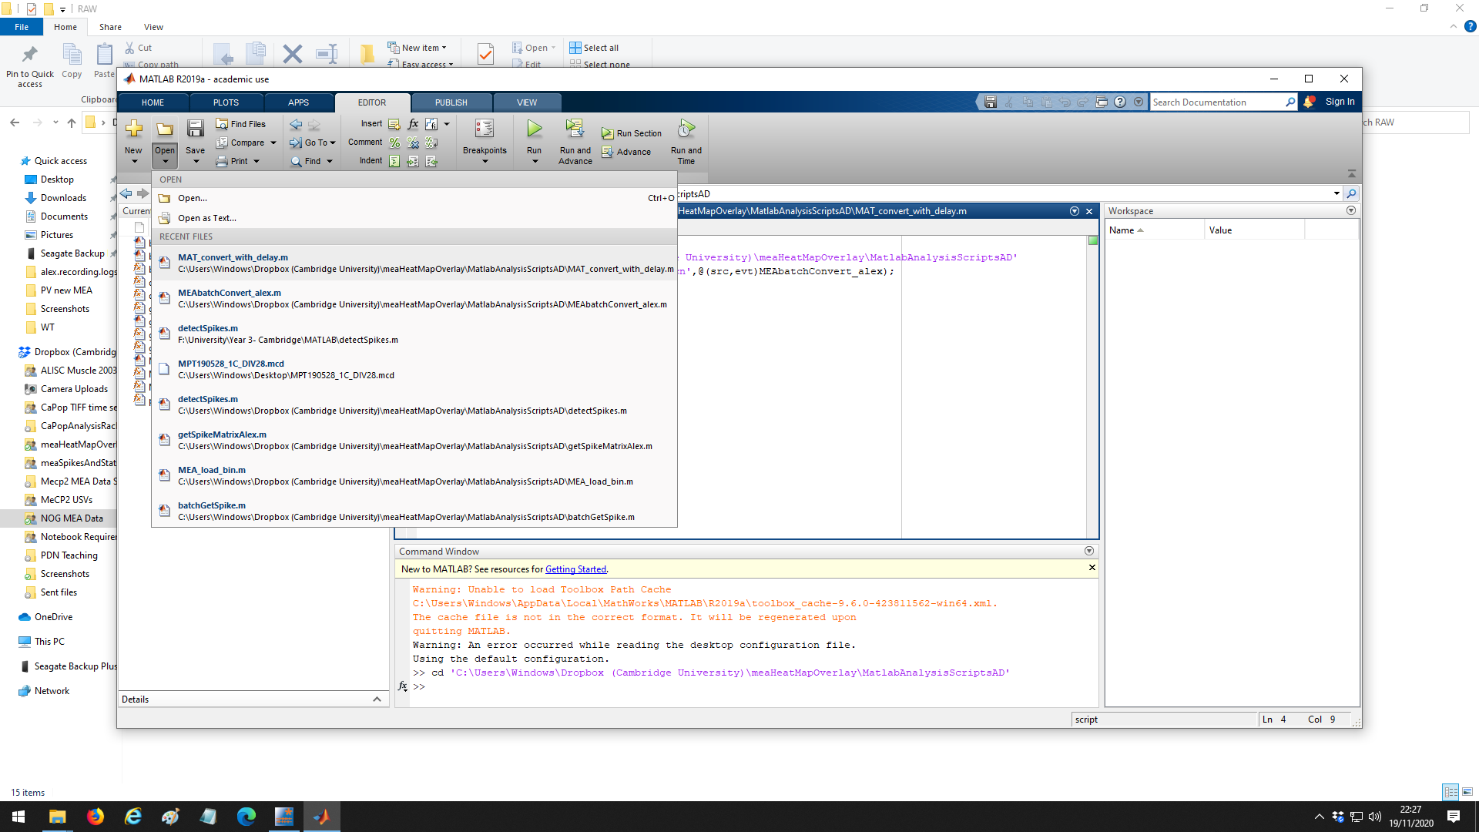

Image 8: Open .*Mat_convert_with_delay.m* from *Dropbox>meaHeatMapOvrelay>MatlabAnalysisScriptsAD*

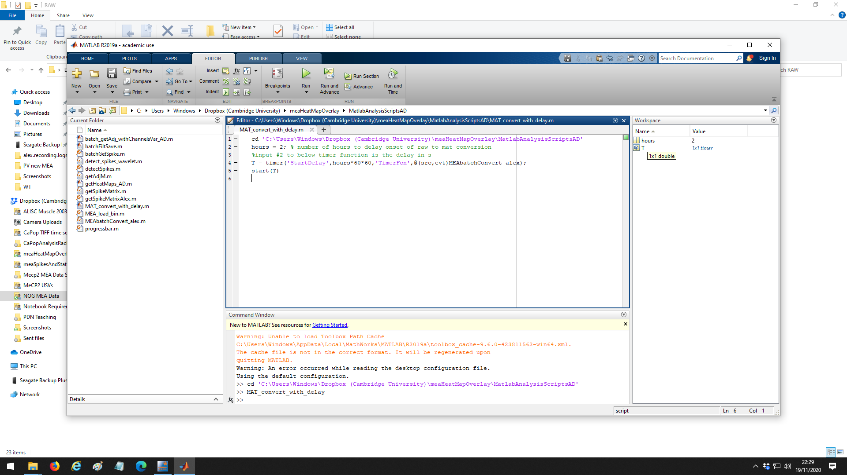

Image 9: Input (to line 2) the maximum number of hours that you think it could take for all the files to convert to .raw. Matlab will wait for this amount of time before starting the second conversion. It is best to overestimate this as the PC will crash if it tries to run both conversion steps at the same time.

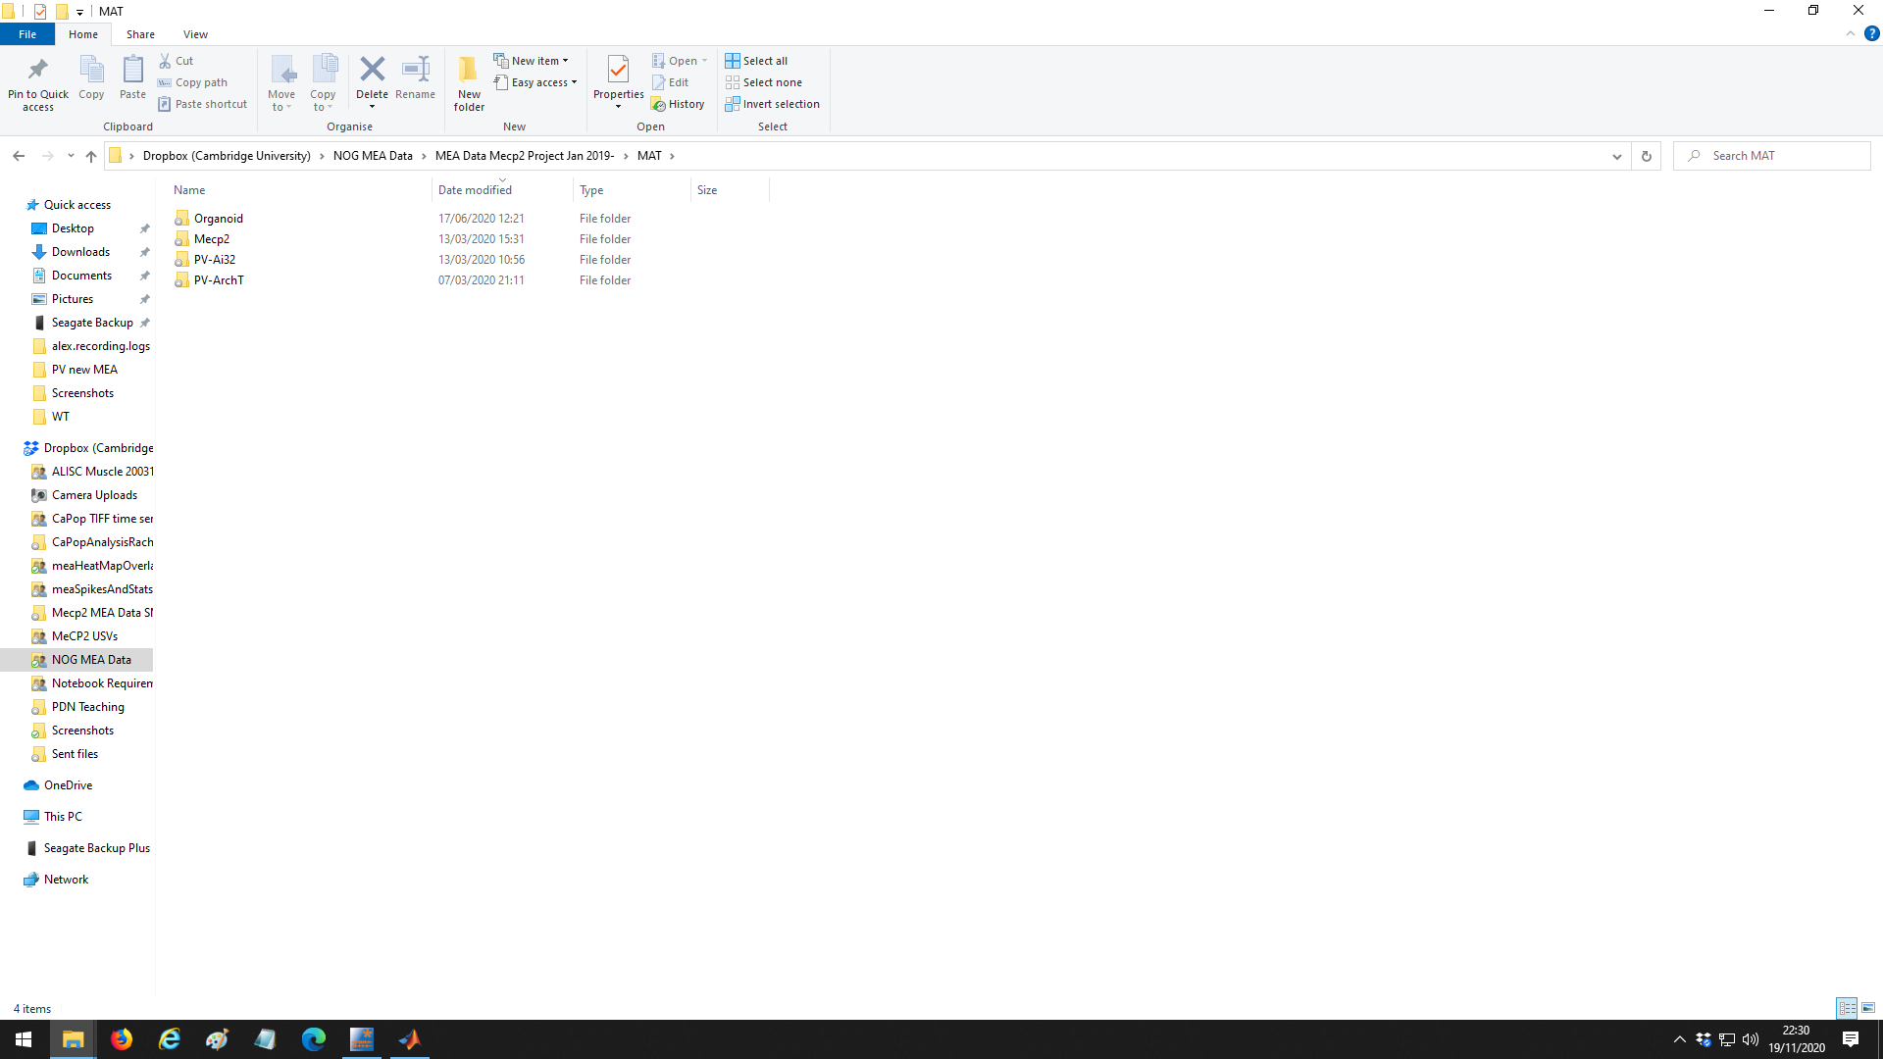

Image 10: The .mat files will be outputted to

*Dropbox>NOG MEA Data>MEA Data Mecp2Project Jan 2019>MAT.*

This is determined in the Matlab script.