INTEGRATION SPECIFICATION
Microsoft Dynamics 365 × PayPlus
Low-Code Billing, Collection & Payment Integration
Built on the Microsoft Power Platform — Power Automate & a PayPlus Custom Connector
Solution Design Document

Attribute | Value
Document type | Technical integration specification (solution design)
Systems in scope | Microsoft Dynamics 365 (system of record) · PayPlus (payments, collection, documents)
Integration platform | Microsoft Power Platform — Dataverse, Power Automate, Custom Connector
Version | 1.0 (Draft for review)
Status | For architecture review
Classification | Confidential — internal use
Primary reference | PayPlus API — https://docs.payplus.co.il/reference/introduction

Table of Contents
1. Executive Summary 1
2. Objectives & Scope 1
2.1 Business Objectives 1
2.2 In Scope 1
2.3 Out of Scope 1
2.4 Dynamics 365 Applicability 1
3. Solution Architecture 1
3.1 Component Responsibilities 1
3.2 Why Low-Code / Power Platform 1
4. System of Record & Data Ownership 1
5. Canonical Data Model & Field Mapping 1
5.1 Customer Mapping 1
5.2 Product & Line-Item Mapping 1
5.3 Billing / Invoice Mapping 1
5.4 Payment, Token & Document Mapping 1
6. PayPlus API Foundation 1
6.1 Environments 1
6.2 Authentication 1
6.3 Charge Methods 1
6.4 Key Endpoints 1
6.5 Callbacks (IPN) & Signature Verification 1
6.6 Idempotency, Currency & VAT 1
7. The PayPlus Custom Connector 1
7.1 Connector Definition 1
7.2 Actions to Expose 1
7.3 Build Steps (low-code) 1
7.4 Secrets & Environment Variables 1
8. Business Process Flows (Power Automate) 1
8.1 Customer Master Sync (D365 → PayPlus) 1
8.2 Product & Price Reference 1
8.3 Invoice-to-Cash — One-Time Collection 1
8.4 Recurring Billing & Dunning 1
8.5 Document Generation (Invoice / Receipt) 1
8.6 Refunds & Cancellations 1
8.7 Reconciliation & Exceptions 1
9. Billing & Collection Design 1
9.1 Billing Models Supported 1
9.2 Collection Lifecycle & Statuses 1
9.3 Dunning Policy 1
10. Document Management (Tax Invoices & Receipts) 1
11. Security, Compliance & PCI-DSS 1
11.1 Card Data & PCI Scope 1
11.2 Secrets & Access 1
11.3 Message Integrity & DLP 1
12. Error Handling, Idempotency & Observability 1
12.1 Retry & Idempotency 1
12.2 Exception Queue 1
12.3 Monitoring & Alerting 1
13. Environments, ALM & Deployment 1
14. Non-Functional Requirements 1
15. Testing Strategy 1
15.1 Sandbox Test Cards 1
15.2 Core Test Matrix 1
16. Implementation Roadmap 1
17. Roles & Responsibilities (RACI) 1
18. Risks & Mitigations 1
19. Assumptions & Open Questions 1
19.1 Assumptions 1
19.2 Open Questions (confirm before build) 1
20. Appendices 1
Appendix A — Representative GenerateLink Request (illustrative) 1
Appendix B — Field Dictionary (selected) 1
Appendix C — Glossary 1
Appendix D — References 1

1. Executive Summary
This document specifies a complete, production-grade integration between Microsoft Dynamics 365 and the PayPlus payment platform. Dynamics 365 is the organizational source of truth for customers, products, pricing, orders and receivables. PayPlus is the execution engine that collects money — generating hosted payment pages, charging cards (one-time and recurring), tokenizing payment methods, issuing refunds, and producing legally-compliant tax documents (invoices and receipts).
The integration is delivered with low-code Microsoft Power Platform tooling: Power Automate cloud flows for orchestration, a purpose-built PayPlus Custom Connector that wraps the PayPlus REST API, Microsoft Dataverse for mapping and audit data, and Azure Key Vault for secret management. No custom middleware server is required for the core scenarios, which shortens delivery time, lowers maintenance cost, and keeps the solution maintainable by a Power Platform team.
The design enforces four principles:
- Single source of truth. Dynamics 365 owns master and financial data; PayPlus never becomes an authoritative store of customer or invoice truth.
- Hosted, PCI-minimised payments. Card data is captured only on the PayPlus hosted page; the organization never stores or transmits primary card numbers.
- Deterministic write-back. Every PayPlus transaction carries the D365 key (invoice / customer id) so results reconcile back automatically and idempotently.
- Verifiable callbacks. Inbound PayPlus notifications (IPN) are cryptographically verified (HMAC-SHA256) before any financial write-back occurs.
Sections 3–8 define the architecture, data model, API foundation, the custom connector, and the end-to-end billing, collection, product and customer flows. Sections 9–20 cover billing/collection design, document management, security, error handling, deployment, testing, roadmap and governance.

2. Objectives & Scope

2.1 Business Objectives
- Automate billing and collection end-to-end, from an invoice raised in Dynamics 365 to cash confirmed against that invoice.
- Support one-time collection (payment links), recurring/subscription billing, and card-on-file (token) charging.
- Produce compliant tax documents (invoice / receipt) automatically at the moment of payment.
- Give finance a single, reconciled view of receivables inside Dynamics 365 — no manual re-keying of PayPlus results.
- Deliver and maintain the solution with low-code tooling owned by a Power Platform / business-applications team.

2.2 In Scope
- Customer master synchronization (D365 → PayPlus customer records).
- Product & price reference used to compose payment line items.
- Payment link generation, hosted checkout, and immediate charge (J4).
- Tokenization and recurring billing with a dunning (retry) policy.
- Refunds and cancellations initiated from Dynamics 365.
- Tax-document generation via the PayPlus Invoice+ / document module.
- Inbound IPN handling with signature verification and financial write-back.
- Daily reconciliation and an exception-handling workflow.

2.3 Out of Scope
- Replacing the Dynamics 365 general ledger or PayPlus acquiring/settlement functions.
- Storing raw card data (PAN/CVV) anywhere in Microsoft systems — this is deliberately avoided.
- PayPlus dashboard configuration that is a one-time administrative task (payment-page setup, invoice numbering, module subscriptions), except where referenced as a prerequisite.
- Point-of-sale / physical terminal flows (this specification covers card-not-present / online collection).

2.4 Dynamics 365 Applicability
The pattern applies to any Dynamics 365 line-of-business app that carries customers and receivables — Sales / Customer Engagement (Dataverse-native), Finance & Operations, or Business Central. Where an implementation detail depends on the specific app (trigger mechanism, entity names, native AR posting), it is called out. Dataverse-native apps use the Dataverse connector triggers directly; Finance & Operations and Business Central expose events and OData/APIs that Power Automate consumes.
Terminology: “Invoice”, “Account/Customer”, and “Product” are used generically. Map them to the exact table/entity names in your target D365 app during the design-confirmation phase (Section 19).

3. Solution Architecture
The solution is organised in three layers: the system of record (Dynamics 365), a low-code integration layer (Power Platform), and the payment execution engine (PayPlus). The integration layer is the only component that talks to PayPlus, and it does so exclusively server-side through the custom connector.
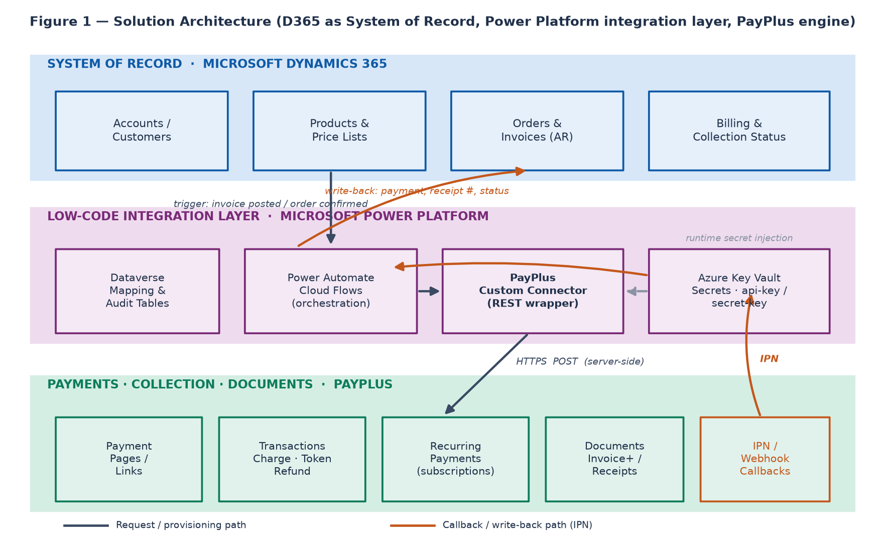
Figure 1 — Layered solution architecture and the request / callback paths.

3.1 Component Responsibilities
Component | Layer | Responsibility
Dynamics 365 | System of record | Owns customers, products, price lists, orders, invoices and billing status. Emits triggers when billable events occur; receives payment write-back.
Dataverse | Power Platform | Holds integration mapping tables (D365 ↔ PayPlus id cross-reference), a payment-transaction log, and an exception queue for audit and idempotency.
Power Automate | Power Platform | Cloud flows that orchestrate every process: build requests, call the connector, verify callbacks, and write results back to D365.
PayPlus Custom Connector | Power Platform | A reusable, typed wrapper over the PayPlus REST API. Centralises the base URL, authentication headers and action definitions.
Azure Key Vault | Power Platform | Stores api-key, secret-key and payment_page_uid. Secrets are referenced by environment variables, never hard-coded in flows.
PayPlus | Execution engine | Hosted payment pages, card charging (one-time/recurring), tokenization, refunds, tax documents, and outbound IPN notifications.

3.2 Why Low-Code / Power Platform
- Speed & ownership: business-application teams build and evolve flows without a dedicated backend deployment pipeline.
- Native D365 connectivity: Dataverse triggers/actions are first-class, removing custom polling code.
- Governance: Data Loss Prevention (DLP) policies, environment separation and managed solutions provide enterprise ALM.
- Reusability: the custom connector is authored once and reused across every flow and even canvas/model-driven apps.
Server-side rule: PayPlus requires all API calls to be made server-side. Power Automate cloud flows satisfy this; never call PayPlus from a browser, a canvas app client, or client-side JavaScript.

4. System of Record & Data Ownership
A clear ownership matrix prevents the two systems from disagreeing. The rule is simple: master and financial truth live in Dynamics 365; execution artefacts (payment attempts, tokens, tax-document PDFs) originate in PayPlus and are copied back to D365 as read-mostly references.
Data domain | Master owner | Executor | Write-back to D365
Customer identity | Dynamics 365 | PayPlus (mirror) | PayPlus customer_uid stored on the D365 account
Products & pricing | Dynamics 365 | PayPlus (line items) | None — line items are composed per transaction
Invoice / receivable | Dynamics 365 | — | Payment status, paid date, amount collected
Payment transaction | PayPlus | PayPlus | transaction_uid, status, method, approval no.
Stored card (token) | PayPlus | PayPlus | Token reference + card mask/expiry only
Tax document | PayPlus (Invoice+) | PayPlus | Document number + PDF link
Golden rule: Dynamics 365 decides what should be collected and from whom; PayPlus decides how the money moves and issues the document; the integration layer keeps the two in sync deterministically.

5. Canonical Data Model & Field Mapping
Each master object in Dynamics 365 maps to exactly one PayPlus counterpart. The D365 primary key is always carried into PayPlus (via the customer object and the more_info fields) so that every asynchronous callback can be matched back without ambiguity.
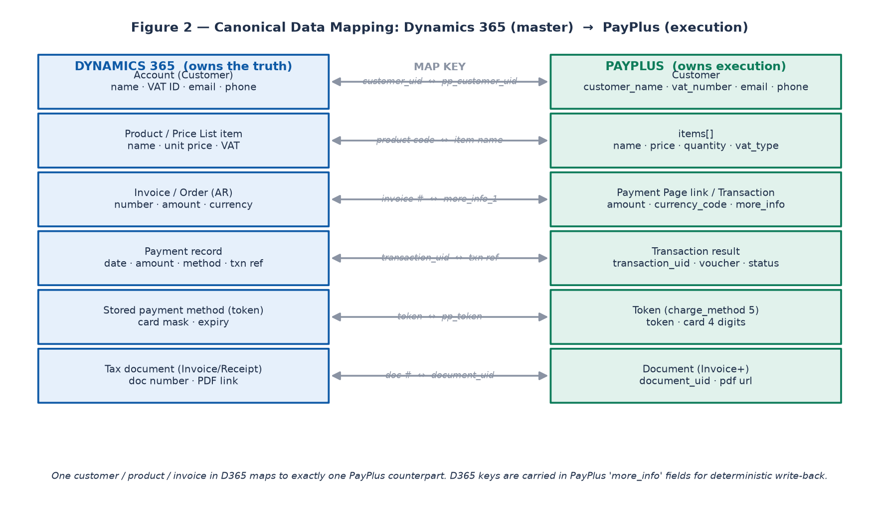
Figure 2 — Canonical mapping between D365 master data and PayPlus execution objects.

5.1 Customer Mapping
Dynamics 365 field | PayPlus field | Notes
Account / Contact name | customer.customer_name | Legal or display name shown on the document
VAT / Tax registration no. | customer.vat_number | Required for business tax documents in Israel
Primary email | customer.email | Receipt / invoice delivery and success emails
Primary phone | customer.phone | Optional SMS payment-link delivery
Account GUID | more_info_2 (carried) | Deterministic customer match on callback
PayPlus customer_uid | (returned by PayPlus) | Stored back on the D365 account as the cross-reference

5.2 Product & Line-Item Mapping
Dynamics 365 field | PayPlus items[] field | Notes
Product name / description | name | Appears as the invoice line description
Unit price | price | Net or gross depending on vat_type
Quantity | quantity | Line quantity
Tax treatment | vat_type | Controls VAT handling on the tax document
Product number | (reference in name / more_info) | For traceability to the D365 product
Note: PayPlus composes the document from the items array. Keep the sum of (price × quantity) consistent with the transaction amount to avoid document/settlement mismatches.

5.3 Billing / Invoice Mapping
Dynamics 365 field | PayPlus field | Notes
Invoice number | more_info (more_info_1) | The key used for reconciliation write-back
Invoice total | amount | Total to collect
Currency | currency_code | Defaults to ILS
Due / expiry policy | expiry_datetime | Minutes until the payment link expires
Installments allowed | payments | Number of installments for the charge
Issue tax document? | initial_invoice = true | Triggers automatic invoice/receipt generation

5.4 Payment, Token & Document Mapping
PayPlus result | Dynamics 365 target | Notes
transaction_uid | Payment.Transaction reference | Primary transaction identifier
status / code | Payment.Status | Drives invoice Paid / Failed state
approval number / voucher | Payment.Approval | Acquirer approval reference
token | Account.Payment token | Card-on-file for recurring; no PAN stored
document_uid + PDF url | Invoice.Document ref + link | Attached tax document
more_info echo | Match key | Echoed back on every callback/redirect

6. PayPlus API Foundation
This section captures the PayPlus REST API facts that the custom connector and flows depend on. Confirm exact request/response schemas against the live reference before build, as PayPlus versions its API.

6.1 Environments
Environment | Base URL | Use
Staging | https://restapidev.payplus.co.il/api/v1.0/ | Build & test
Production | https://restapi.payplus.co.il/api/v1.0/ | Live money

6.2 Authentication
PayPlus authenticates each request with two HTTP headers plus a payment-page identifier in the body:
Credential | Purpose
api-key | API key header identifying the merchant application
secret-key | Secret header; also the key used to verify inbound IPN signatures
payment_page_uid | Body parameter identifying the configured payment page
Security: store all three in Azure Key Vault and expose them to flows through environment variables. Never place them in flow definitions, canvas apps, or client code.

6.3 Charge Methods
Value | Method | Meaning
0 | Check (J2) | Validate card without holding funds
1 | Charge (J4) | Immediate payment — standard one-time collection
2 | Approval (J5) | Reserve/authorize funds for later capture
3 | Recurring | Automatic recurring billing (requires the recurring module)
4 | Refund | Immediate refund to the card
5 | Token (J2) | Create a reusable token for card-on-file / recurring charging

6.4 Key Endpoints
Endpoint (relative to base URL) | Method | Use in this design
PaymentPages/generateLink | POST | Create a hosted payment link for one-time or recurring collection
PaymentPages/ChargeMethods | GET | List the payment methods available on a page
PaymentPages/ipn-full | — | Richer inbound notification payload for a transaction
Customers/Add | POST | Create a PayPlus customer mirror of a D365 account
Refund by Transaction UID | POST | Refund a previous transaction by its uid
Refund by Credit Card | POST | Refund to a card where the original uid is not used
Recurring … | POST | Manage recurring/subscription charging (module-dependent)
SMS/SendSingleSMSMessage | POST | Optional: deliver a payment link by SMS
Note: Endpoint names above are taken from the PayPlus reference and update log. Treat the customer, recurring and refund route shapes as confirm-before-build items — validate the exact paths, required fields and response bodies in the live reference and in the sandbox.

6.5 Callbacks (IPN) & Signature Verification
PayPlus sends outbound notifications and browser redirects to URLs you provide on the payment link:
- refURL_callback — server-to-server IPN with the transaction result (this is the authoritative write-back trigger).
- refURL_success / refURL_failure / refURL_cancel — browser redirects for the payer’s experience.
- send_failure_callback = true — also receive callbacks for failed transactions, not only successful ones.
Every genuine PayPlus request carries a hash header and a user-agent: PayPlus header. The receiving flow must recompute an HMAC-SHA256 over the raw request body using the secret-key, Base64-encode it, and compare it to the hash header. Only on a match does the flow proceed to write back to Dynamics 365.
No verification, no write-back. A failed signature check routes the message to the exception queue and raises an alert — it is never posted to the ledger.

6.6 Idempotency, Currency & VAT
- Idempotency: use transaction_uid (and the D365 invoice key in more_info) to guarantee a payment is posted to D365 at most once, even if PayPlus retries the callback.
- Currency: currency_code defaults to ILS; set explicitly for multi-currency scenarios and store the currency on the D365 payment.
- VAT: vat_type on each line and the document-level VAT setting control the tax document; align these with the D365 tax configuration.

7. The PayPlus Custom Connector
A single custom connector is the reusable, typed interface to PayPlus for every flow. It centralises the host, base path, authentication and the set of actions, so credentials and endpoint changes are managed in one place.

7.1 Connector Definition
Setting | Value
Scheme / Host | https · restapi.payplus.co.il (prod) / restapidev.payplus.co.il (staging)
Base URL | /api/v1.0
Authentication type | API Key — two header parameters: api-key and secret-key
Content type | application/json
Environment strategy | Host driven by an environment variable so the same connector promotes Dev → Test → Prod
Note: The custom-connector API-key security type supports header keys. Where two headers are required, define both api-key and secret-key as policy/header parameters, or use a connection-parameter set. Confirm the exact header injection approach when authoring.

7.2 Actions to Expose
Action | Underlying endpoint | Consumed by
GeneratePaymentLink | POST PaymentPages/generateLink | Invoice-to-cash, recurring onboarding
CreateCustomer | POST Customers/Add | Customer master sync
GetChargeMethods | GET PaymentPages/ChargeMethods | Page capability checks
ChargeByToken | POST (recurring/charge route) | Recurring billing
RefundByTransaction | POST Refund by Transaction UID | Refunds & cancellations
GetTransaction / IPN-Full | PaymentPages/ipn-full | Reconciliation & enrichment

7.3 Build Steps (low-code)
- In the target Power Platform environment, create a new custom connector (from blank or by importing an OpenAPI/Postman definition of the PayPlus routes).
- Set scheme, host and base URL; drive the host from an environment variable for ALM.
- Define security as API Key with the api-key and secret-key header parameters.
- Add one operation per action in 7.2 with request/response schemas modelled from the reference and sandbox responses.
- Test each operation against staging using the sandbox test cards (Section 15).
- Package the connector into the managed solution and promote through environments.

7.4 Secrets & Environment Variables
- Store api-key, secret-key and payment_page_uid in Azure Key Vault.
- Reference them via Power Platform environment variables (Key Vault-backed) so no secret is embedded in a flow or connector export.
- Use separate credentials and payment pages per environment (staging vs production).

8. Business Process Flows (Power Automate)
Each business process is a Power Automate cloud flow. Flows are small and single-purpose, share the custom connector, and log every step to the Dataverse transaction log for audit and idempotency.

8.1 Customer Master Sync (D365 → PayPlus)
Trigger: a D365 account is created or its billing-relevant fields change.
- Check the Dataverse cross-reference; if a PayPlus customer_uid already exists, treat as update.
- Call CreateCustomer with name, VAT number, email and phone; carry the D365 account GUID in more_info.
- Store the returned customer_uid on the D365 account and in the Dataverse mapping table.
- On error, write to the exception queue and notify the data owner.

8.2 Product & Price Reference
Products and prices are not pushed to PayPlus as a catalogue; instead, at collection time the flow reads the D365 order/invoice lines and composes the PayPlus items array. This keeps pricing authority in D365 and avoids a second catalogue to maintain.

8.3 Invoice-to-Cash — One-Time Collection
Trigger: an invoice is posted / an order is confirmed in Dynamics 365 with a “collect via PayPlus” flag.
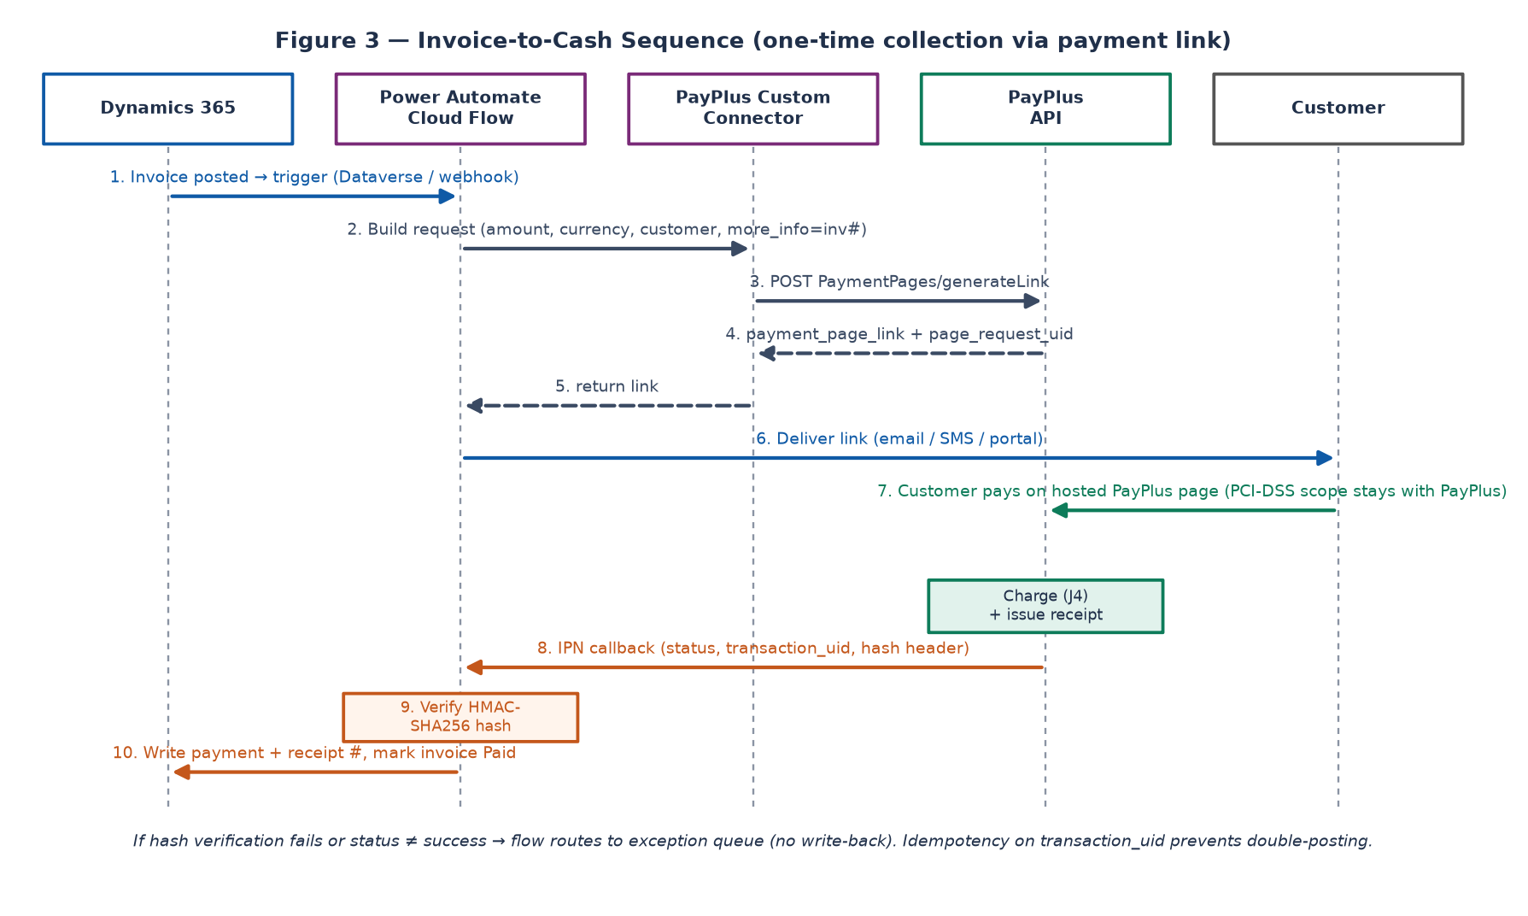
Figure 3 — Invoice-to-cash sequence for a one-time payment link.
- The flow reads the invoice header and lines and builds the request: amount, currency_code, customer object, items[], and more_info = invoice number.
- It sets the callback and redirect URLs and (optionally) initial_invoice = true to issue a tax document on success.
- It calls GeneratePaymentLink and receives payment_page_link and page_request_uid.
- It stores page_request_uid on the invoice and delivers the link to the customer (email, SMS, or a portal link).
- The customer pays on the PayPlus hosted page; PayPlus charges the card (J4) and issues the receipt/invoice.
- PayPlus sends the IPN callback; a second flow verifies the HMAC-SHA256 hash.
- On a verified success, the flow writes the payment, receipt number and paid status back to the invoice and closes it.
- On failure or a bad signature, it routes to the exception queue; idempotency on transaction_uid prevents double-posting.

8.4 Recurring Billing & Dunning
Trigger: a scheduled (daily) recurrence flow that reads subscriptions / recurring invoices due today.
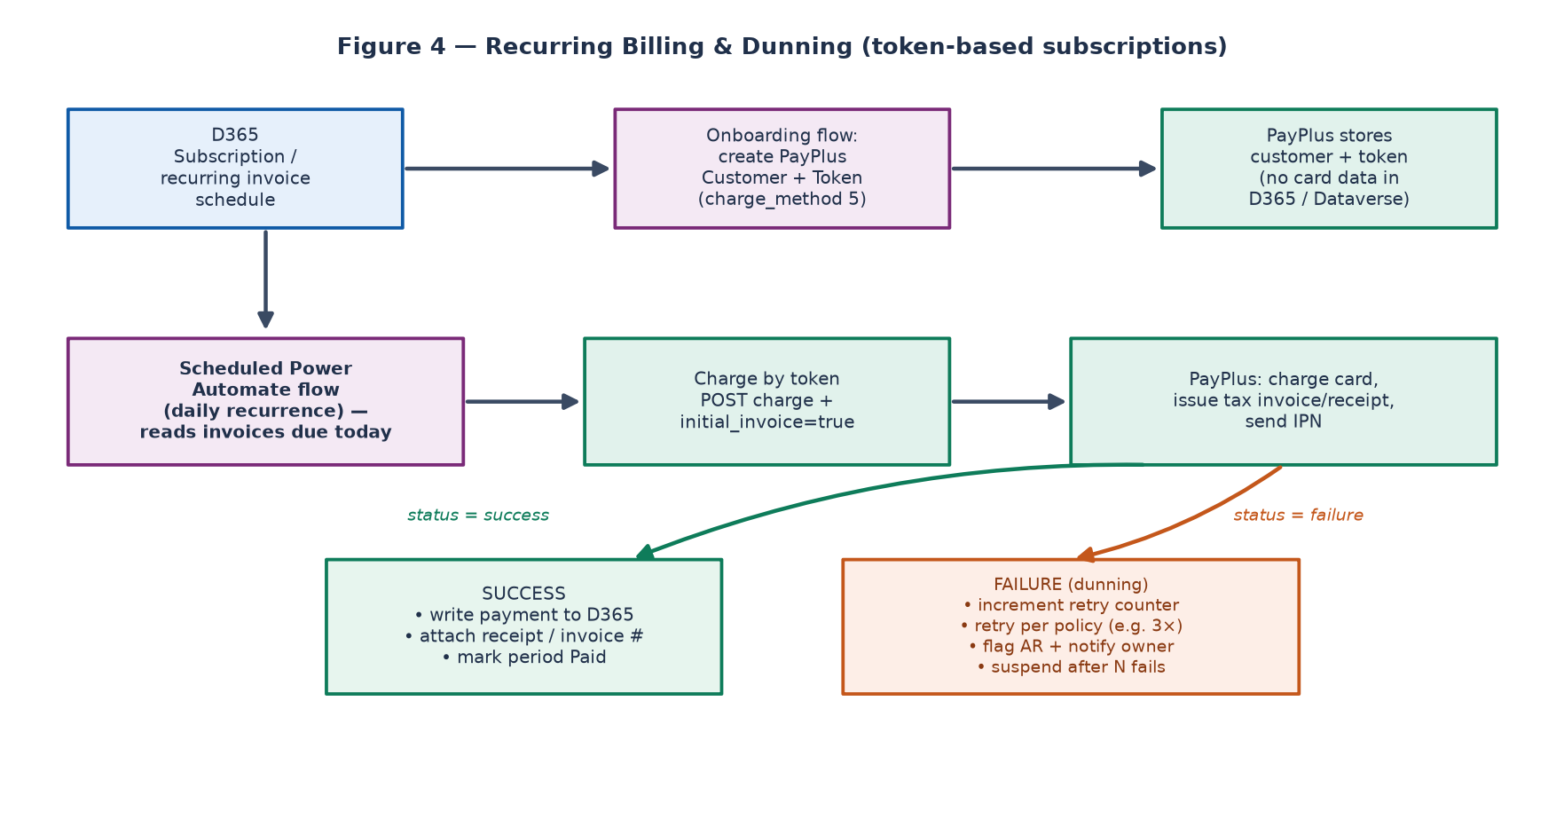
Figure 4 — Token-based recurring billing with a dunning (retry) policy.
- At subscription onboarding, an enrolment flow creates the PayPlus customer and a token (charge_method 5). No card data is stored in D365 or Dataverse — only the token reference and card mask.
- The daily flow selects invoices due today and charges each by token, setting initial_invoice = true to issue the period’s tax document.
- On success (verified IPN), it writes the payment and document reference to D365 and marks the period Paid.
- On failure, it increments a retry counter and re-attempts per the dunning policy (for example three attempts over several days).
- After the final failed attempt, it flags the receivable, notifies the account owner and optionally suspends the subscription.

8.5 Document Generation (Invoice / Receipt)
Tax documents are produced by the PayPlus Invoice+ / document module at the moment of a successful charge when initial_invoice = true is sent. The flow captures the returned document number and PDF link and attaches them to the D365 invoice. Where a document must be issued for an already-completed transaction, use the applicable close-document / document route rather than re-charging.

8.6 Refunds & Cancellations
Trigger: a refund/cancellation is approved in Dynamics 365.
- The flow calls RefundByTransaction with the original transaction_uid and the refund amount (full or partial).
- On success it writes a negative payment / credit reference to D365 and requests the corresponding credit document.
- It updates the invoice/receivable status and logs the action for audit.

8.7 Reconciliation & Exceptions
Trigger: a nightly scheduled flow.
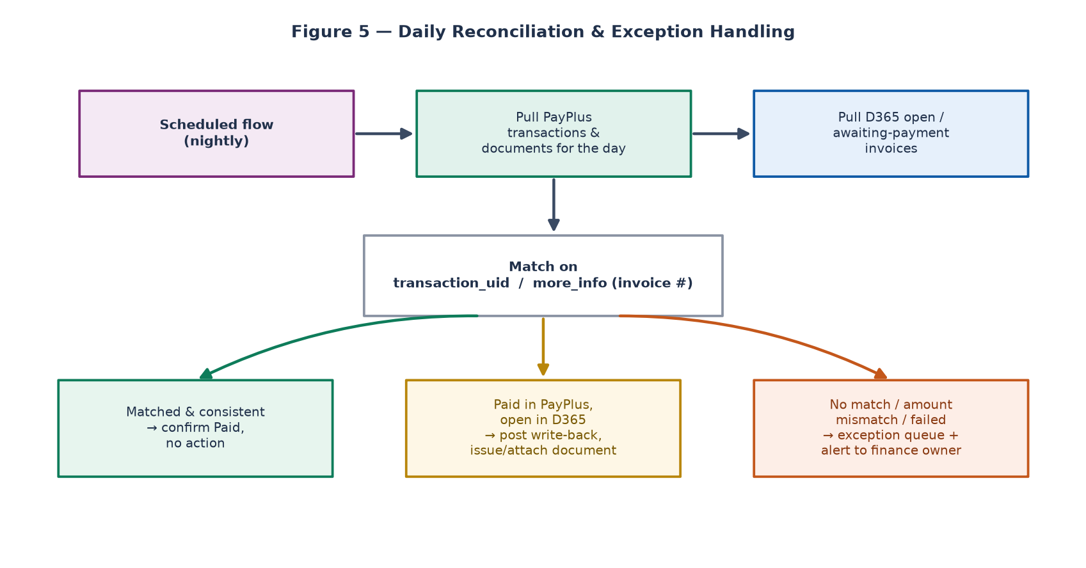
Figure 5 — Nightly reconciliation and exception routing.
- Pull PayPlus transactions and documents for the day and D365 open / awaiting-payment invoices.
- Match on transaction_uid and the invoice number carried in more_info.
- Matched & consistent: confirm Paid, no action.
- Paid in PayPlus but open in D365: post the missed write-back and attach the document.
- No match, amount mismatch, or failed: raise an exception-queue item and alert the finance owner.

9. Billing & Collection Design

9.1 Billing Models Supported
Model | How it works | PayPlus mechanism
One-time invoice | Single invoice → single payment link | generateLink + charge (J4)
Installments | One purchase split into N payments | payments parameter on the link
Recurring / subscription | Scheduled charges on a cadence | token (5) + scheduled charge / recurring module
Card on file | Charge a stored method on demand | token (5) then charge by token
Pre-auth then capture | Reserve then take funds later | approval (J5) then capture

9.2 Collection Lifecycle & Statuses
The invoice/receivable moves through a controlled set of states in Dynamics 365, driven by integration events:
D365 status | Set when
Awaiting payment | Payment link generated and delivered
Partially paid | An installment or partial amount is confirmed
Paid | A verified successful IPN covers the invoice total
Failed / retry | A verified failure callback (recurring dunning in progress)
Refunded / credited | A refund transaction is confirmed
In exception | Signature failure, mismatch, or unresolved reconciliation

9.3 Dunning Policy
- Define the retry count and interval (for example three attempts at day 0, +2, +5).
- Escalate after the final attempt: notify the owner, flag the receivable, optionally suspend service.
- Record every attempt in the transaction log for audit and customer communication.

10. Document Management (Tax Invoices & Receipts)
- Documents are generated by the PayPlus Invoice+ / document module; the module and numbering must be configured in the PayPlus dashboard as a prerequisite.
- Set initial_invoice = true on the charge to auto-issue the document at payment time.
- Use custom_invoice_name where the document name should differ from the payer name.
- Store the returned document number and PDF link on the D365 invoice; surface the link to finance and the customer.
- For refunds, request the corresponding credit document and link it to the original.
Note: Israeli tax-document rules (invoice vs. receipt vs. tax-invoice/receipt, VAT display, numbering continuity) are enforced by PayPlus configuration. Validate the document types and numbering with the finance/tax team before go-live.

11. Security, Compliance & PCI-DSS

11.1 Card Data & PCI Scope
- Card data (PAN/CVV) is entered only on the PayPlus hosted page — it never transits or rests in Dynamics 365, Dataverse, or Power Automate.
- For repeat charging, use PayPlus tokens; the organization stores only the token reference and a masked card, dramatically reducing PCI-DSS scope.
- All PayPlus calls are server-side from Power Automate; no payment call originates in a client app.

11.2 Secrets & Access
- api-key, secret-key and payment_page_uid live in Azure Key Vault, surfaced via environment variables.
- Apply least-privilege: connector connections and flows run under a dedicated service principal / service account.
- Restrict who can edit production flows and connections through environment security roles.

11.3 Message Integrity & DLP
- Verify HMAC-SHA256 on every inbound IPN before any write-back.
- Apply a Data Loss Prevention (DLP) policy that isolates the PayPlus connector to the finance environment and blocks it from non-business connectors.
- Log all requests/responses (with secrets and PAN redacted) to the Dataverse audit log.

12. Error Handling, Idempotency & Observability

12.1 Retry & Idempotency
- Outbound calls use bounded retries with exponential backoff for transient (network / 5xx) errors.
- Write-back is idempotent on transaction_uid; a repeated callback updates rather than duplicates.
- A duplicate payment-link request for the same invoice reuses the stored page_request_uid where still valid.

12.2 Exception Queue
- A Dataverse table captures every failure with context (flow, invoice, error, raw payload) and a resolution status.
- Signature failures, amount mismatches and unmatched transactions all land here.
- Finance owners work the queue; resolved items trigger a controlled re-processing flow.

12.3 Monitoring & Alerting
- Use Power Automate run history and analytics for flow health.
- Raise alerts (email / Teams) on exception-queue inserts and on repeated failures.
- Track KPIs: collection success rate, average time-to-cash, dunning recovery rate, exception ageing.

13. Environments, ALM & Deployment
Environment | Purpose | PayPlus target
Development | Build flows & connector | Staging + sandbox cards
Test / UAT | Business validation | Staging
Production | Live collection | Production credentials & page
- Package the connector, flows, Dataverse tables and environment variables into a single managed solution.
- Promote Dev → Test → Prod via Power Platform pipelines; bind environment variables to per-environment Key Vault secrets at import.
- Keep staging and production PayPlus credentials and payment pages strictly separate.

14. Non-Functional Requirements
Requirement | Target / approach
Availability | Rely on managed Power Platform + PayPlus SLAs; flows are stateless and resumable
Throughput | Batch recurring runs; respect PayPlus rate limits with paced loops
Latency | Payment-link generation is interactive (seconds); write-back is near-real-time on IPN
Auditability | Every request/result logged to Dataverse with correlation ids
Data retention | Retain the transaction log per finance/regulatory policy; purge PII on schedule
Recoverability | Reconciliation flow self-heals missed write-backs nightly

15. Testing Strategy

15.1 Sandbox Test Cards
Scenario | Card | Details
Successful transaction | 5326-1402-8077-9844 | EXP 05/26 · CVV 000
Rejected transaction | 5326-1402-0001-0120 | EXP 05/26 · CVV 000

15.2 Core Test Matrix
Test | Expected result
Generate link for a valid invoice | payment_page_link + page_request_uid returned; stored on invoice
Pay with success card | Verified IPN → invoice Paid, document attached
Pay with reject card | Verified failure IPN → status Failed, no write-back to ledger
Tamper with callback body | HMAC check fails → routed to exception queue
Duplicate IPN for one transaction | Single payment posted (idempotent)
Recurring charge by token | Period Paid; document issued
Failed recurring charge | Dunning retries; escalation after final attempt
Full & partial refund | Credit posted; credit document linked
Nightly reconciliation | Missed write-backs healed; mismatches flagged

16. Implementation Roadmap
Phase | Focus | Key deliverables
0 — Foundations | Access & config | PayPlus account, payment page, modules; Key Vault; environments
1 — Connector | Low-code interface | Custom connector with core actions, tested on staging
2 — Collect | Invoice-to-cash | Customer sync, link generation, IPN verification, write-back
3 — Documents | Tax documents | initial_invoice issuance, document linking, refunds
4 — Recurring | Subscriptions | Tokenization, scheduled billing, dunning
5 — Harden | Reconcile & monitor | Reconciliation flow, exception queue, alerting, UAT & go-live

17. Roles & Responsibilities (RACI)
Activity | Power Platform | Finance | Security | PayPlus
Connector & flows | R / A | C | C | I
Payment-page & module setup | C | C | I | R / A
Secrets & DLP policy | R | I | A | I
Reconciliation ownership | C | R / A | I | I
Go-live approval | C | A | C | I
Legend: R = Responsible, A = Accountable, C = Consulted, I = Informed.

18. Risks & Mitigations
Risk | Mitigation
API schema/version drift | Confirm schemas in sandbox; version the connector; monitor the PayPlus update log
Missed or duplicated callbacks | Idempotent write-back + nightly reconciliation as a safety net
Spoofed callbacks | Mandatory HMAC-SHA256 verification before any write-back
Secret leakage | Key Vault + environment variables + DLP; no secrets in exports
Rate limiting on bulk runs | Paced batch loops with backoff and continuation
Tax-document non-compliance | Validate document types/numbering with finance before go-live

19. Assumptions & Open Questions

19.1 Assumptions
- A PayPlus merchant account with the invoice/document and (if needed) recurring modules is available.
- The target D365 app can emit events/triggers Power Automate can consume.
- Azure Key Vault and Power Platform managed environments are available to the delivery team.

19.2 Open Questions (confirm before build)
- Exact request/response schemas for Customers, Recurring and Refund routes in the live reference.
- Which D365 app and entities are authoritative for invoices and payments.
- Required tax-document types and VAT presentation for the business.
- Dunning policy parameters (attempts, intervals, suspension rules).
- Multi-currency requirements, if any.

20. Appendices

Appendix A — Representative GenerateLink Request (illustrative)
Illustrative payload shape for a one-time collection. Field names follow the PayPlus reference; validate against the live schema before build.
POST https://restapi.payplus.co.il/api/v1.0/PaymentPages/generateLink
Headers: api-key: <key> secret-key: <secret> Content-Type: application/json
{
"payment_page_uid": "<page-uid>",
"charge_method": 1,
"amount": 1170,
"currency_code": "ILS",
"initial_invoice": true,
"more_info": "INV-100245",
"refURL_success": "https://<flow>/success",
"refURL_failure": "https://<flow>/failure",
"refURL_callback": "https://<flow>/ipn",
"send_failure_callback": true,
"customer": { "customer_name": "Contoso Ltd", "vat_number": "514999999",
"email": "ap@contoso.co.il", "phone": "03-0000000" },
"items": [ { "name": "Annual support", "quantity": 1, "price": 1000, "vat_type": 1 } ]
}

Appendix B — Field Dictionary (selected)
Field | Meaning
payment_page_uid | Identifies the configured PayPlus payment page
charge_method | 0 Check · 1 Charge · 2 Approval · 3 Recurring · 4 Refund · 5 Token
amount / currency_code | Total to collect and its currency (default ILS)
more_info…more_info_5 | Up to six metadata fields echoed back on callbacks (carry D365 keys here)
initial_invoice | When true, PayPlus issues the tax document on success
payments | Number of installments for the charge
refURL_callback / _success / _failure / _cancel | IPN and browser-redirect URLs
transaction_uid | PayPlus transaction identifier used for write-back & refunds
token | Reusable card-on-file reference for recurring charging

Appendix C — Glossary
Term | Definition
IPN | Instant Payment Notification — PayPlus’ server-to-server callback
HMAC-SHA256 | Keyed hash used to verify a callback truly came from PayPlus
Tokenization | Replacing card details with a reusable token to minimise PCI scope
Dunning | Structured retry/escalation process for failed recurring charges
System of record | The authoritative source for a data domain (here, Dynamics 365)
J2 / J4 / J5 | Acquirer transaction types: validate / charge / authorize

Appendix D — References
PayPlus API reference — https://docs.payplus.co.il/reference/introduction
- PayPlus environments — staging restapidev.payplus.co.il · production restapi.payplus.co.il
- Microsoft Power Platform — Power Automate, custom connectors, Dataverse, environment variables & pipelines
- Microsoft Dynamics 365 — Sales / Customer Engagement, Finance & Operations, or Business Central (as applicable)

End of document · Version 1.0 (Draft for review)

