Membership Card – Setup Instructions
- Shut the computer down completely
- Plug the Scanner into the keyboard port and then plug the keyboard into the scanner cord extension
- Turn the computer back on

SCANNER SETUP
- Set the Scanner settings:
- The default factory settings are all that is needed in order for the scanner to work. Out of the box the scanner should be ready to go, but if someone has been “experimenting” with the settings then to ensure that the scanner is properly configured all that needs to be done is to scan the “Factory Default” barcode at the top of Page 6.
- There are optional settings that are available as well
- Continuous Scan Mode Enable (Page 6): this setting will allow the scanner to work without having to “click the trigger” every time to scan a barcode. *Note: the only way to disable it is to rescan the “Factory Default” barcode which will obviously reset ANY/ALL settings that you may have changed.
- Beep Off (Page 7): this setting turns the “beep” off each time you scan. We recommend this option because when using the “Scan Membership Cards” interface the screen already plays sound files for confirmed and invalid membership cards.

WEB CAMERA SETUP
- Open email sent by EC Link.
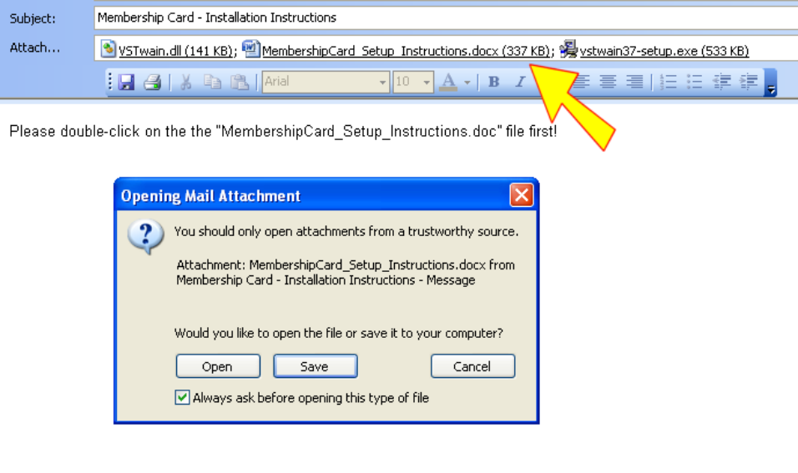
- Save all of the attachments to your machine. For example I saved the attachments in the following directory, “C:\My Documents”
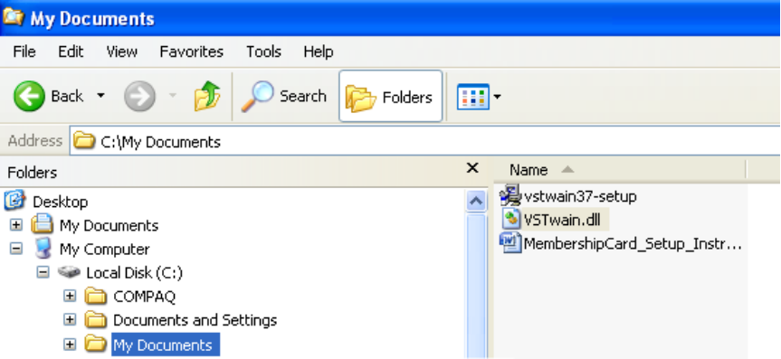
- Once you have done this then you will need to open/run the “vstwain37-setup.exe” file to start the installation.

- Click NEXT…
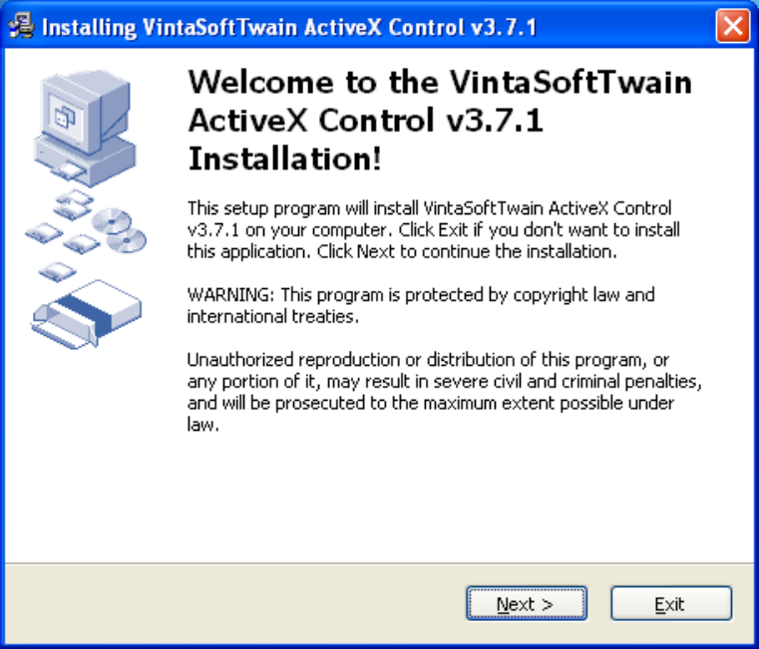
- When finished reading the terms and agreement documentation, click on the “I agree with the terms and conditions” checkbox, and then click NEXT…
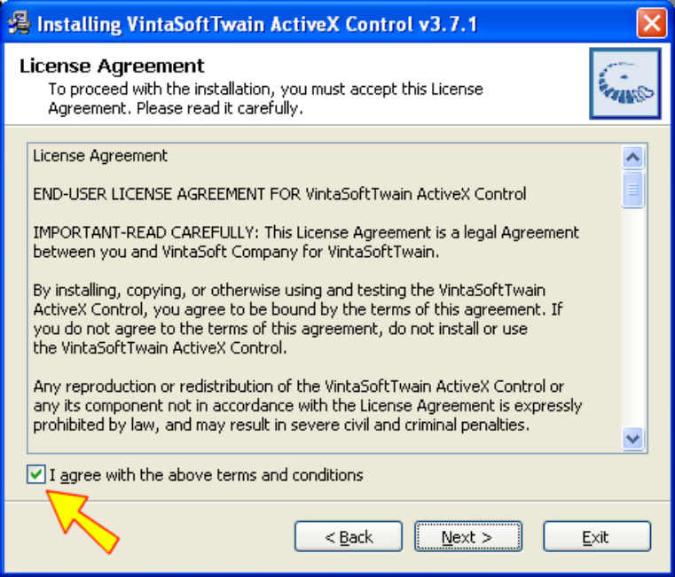

- Click NEXT…
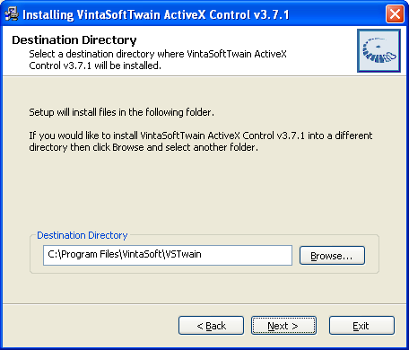
- <<< You should see that installation taking place >>>
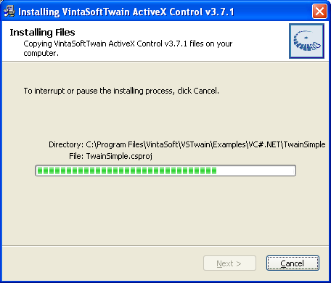

- Click FINISH…
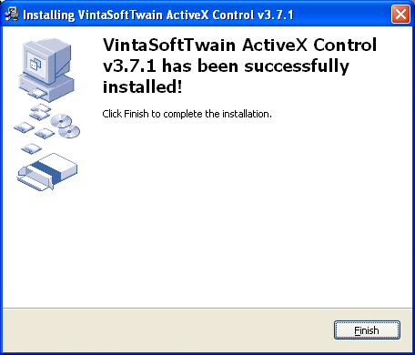

*Note: a popup may appear that shows all of the files that were included in the install. Simply close the popup.
- You need to copy the “VSTwain.dll” file to the “C:\Program Files\VintaSoft\VTwain” folder
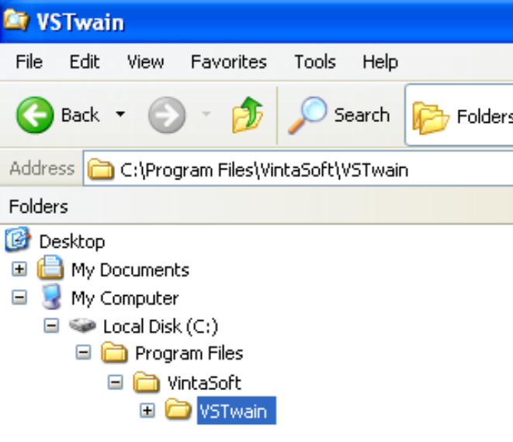
- After copying the file you will receive the following alert message:
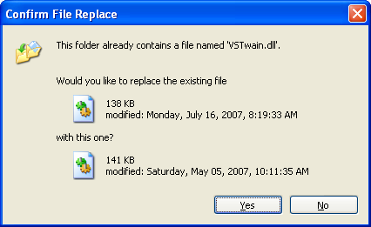
- Simply click the “Yes” button

PRINTER SETUP
- Follow the installation steps provided by the printer.

