Introduction to Route 53

Amazon Route 53 is a highly available and scalable **Domain Name System (DNS)** web service. Route 53 design is intended to provide a highly reliable and cost-effective approach to routing end-users to internet applications.

The name of Route 53 is a inspired by TCP or UDP port 53, where DNS server requests are addressed.

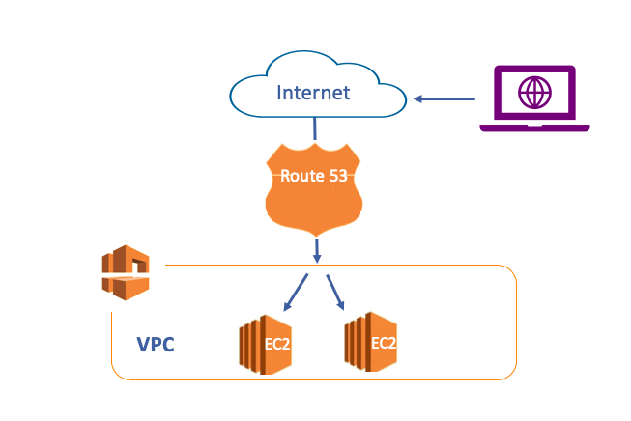

Amazon Route 53 effectively connects user requests to infrastructure running in AWS, such as Amazon EC2 instances, Elastic Load Balancer or Amazon S3 buckets. It can also be used to route users to infrastructure outside of AWS.

You can use Amazon Route 53 to configure DNS health checks to route traffic to healthy endpoints.

Thanks to Amazon Route 53 you can manage traffic globally through a variety of routing types, including Latency Based Routing and Weighted, etc.

Amazon Route 53 also offers Domain Name Registration. You can purchase and manage domain names such as **clarusway.com** and Amazon Route 53 will automatically configure DNS settings for your domains.

Domain Name System(DNS)

DNS stands for the **Domain Name System**. It is a system used for transferring human-readable domain names such as www.clarusway.com to a machine-readable IP address such as 1.2.3.45

**Domain Name** is the phrase given to the naming that corresponds to the IP address to which a device in the internet environment is connected.

Domain names consist of a set of words, letters, or numbers to describe a unique individual or company.

In fact, we can say the Domain Name System (DNS) is the phonebook of the Internet like in your home. All the IP numbers which correspond to domain names are listed in this phonebook.

Each device connected to the Internet has a unique IP address that other machines use to find the device. Computers communicate with each other over IP addresses, not names.

But the human brain using these computers has the ability to remember names rather than numbers. Therefore, in order to simplify the complex IP numbers, there was a need to match them with the names. We can say DNS is designed to make the connections easier for computer users.

### **Structure of DNS:**

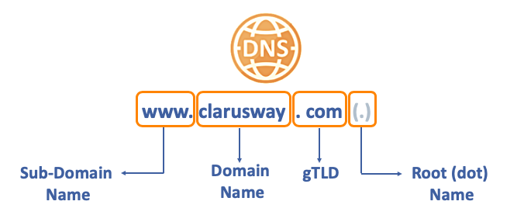

Let's examine the FQDN (Fully Qualified Domain Name) of **clarusway** to understand the structure of DNS.

* **Root (dot) Name:**

The basis of all naming is Root (dot) Name. It represents the beginning of the DNS query, although it is not visible. Also, the query for resolving the DNS depends on the Root (dot) Name.

* **gTLD:**

To the left of the route name are **gTLD** domains. **gTLD** stands for Generic Top-Level Domain. Management and responsibility for gTLDs are delegated to organizations by the Internet Corporation for Assigned Names and Numbers (ICANN) and the Internet Assigned Numbers Authority (IANA),

Generic Top-Level Domain was designed to help classify a feature of a website, such as its purpose. The most common TLDs are **com**, **net** and **org**.

* **Domain Names:**

**A Domain Name** is your website name. For example, **clarusway** is the domain name of our company where internet users can access our website. It represents to name of the firm, organization or foundation, etc.

Domain names are being sold and leased by organizations authorized by ICANN. AWS is one of these organizations and registers domain names via Route 53 Service.

* **Sub-domains:**

On the far left, there is a sub-domain. Sub-domains are commonly used to specify domains for communication purposes, device type, content type, or for other reasons.

**www**, **mobile**, **mail** and **info** are some of the most common subdomains.

### **DNS Servers**

To understand the process behind the DNS resolution, it's important to learn about the different hardware components that a DNS query needs to pass through.

There are 4 DNS servers involved in DNS;

* **DNS Recursor (Resolver):**

Clients typically do not make queries directly to authoritative DNS services. Instead, they generally connect to another type of DNS service known a resolver, or DNS Recursor.

If a Recursor has the DNS reference cached or stored for a period of time, then it answers the DNS query by providing the source or IP information. If not, it passes the query to one or more authoritative DNS servers to find the information.

* **Root(dat) Nameserver:**

The Root Nameserver is the first step in resolving the hostnames process. There are 13 different locations Root DNS server clusters in the world.

In this DNS server, there are IP addresses of authorized DNS servers where **all gTLD domains such as com, net, and org etc are kept.**

So the purpose of the Root Nameserver is to point out the gTLD Nameserver's IP

* **gTLD Nameserver:**

This nameserver is the next step in the search for a specific IP address, and it hosts the last portion of a hostname. It keeps the IP of all the Authoritative Nameserver.

For clarusway.com; gTLD Nameserver is **.com gTLD Nameserver** and it holds the Iist of Authoritative Nameserver's IP under this gTLD (com).

The responsibility of the **gTLD Nameserver** is to respond to the query with associated Authoritative Nameserver's IP.

* **Authoritative Nameserver:**

Authoritative Nameserver has the final authority over a domain and is responsible for providing answers to recursive DNS servers with the **IP address information**. Amazon **Route 53 is an Authoritative Nameserver**.

### **DNS Resolving:**

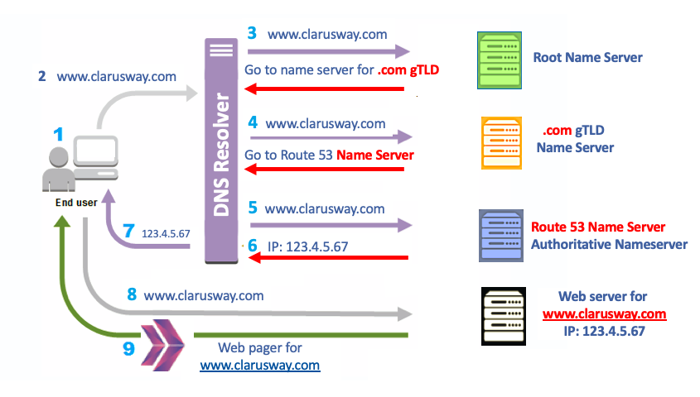

1. A user opens a web browser, enters www.clarusway.com in the address bar, and hit Enter.
2. The request for www.clarusway.com is routed to a DNS resolver, which is typically managed by the user's Internet service provider (ISP), such as a cable internet provider.
3. The DNS resolver for the ISP forwards the request for www.clarusway.com to a **DNS Root Name Server**.
4. The DNS resolver forwards the request for www.clarusway.com again, this time to one of the gTLD name servers for **.com** domains. The name server for **.com** domains responds to the request with the names of the **four Amazon Route 53 Name Servers** that are associated with the clarusway.com domain.
5. The DNS resolver chooses an Amazon Route 53 name server and forwards the request for www.clarusway.com to that name server.
6. The Amazon Route 53 name server looks in the clarusway.com hosted zone for the www.clarusway.com record, gets the associated value, such as the IP address for a web server 123.4.5.67 and returns the IP address to the DNS resolver.
7. The DNS resolver for the ISP finally has the IP address that the user needs. The resolver returns that value to the web browser.
8. The web browser sends a request for www.clarusway.com to the IP address that it got from the DNS resolver.
9. The web server or other resources at 123.4.5.67 return the web page for www.clarusway.com to the web browser, and the web browser displays the page.

### **Key Functions of Route 53**

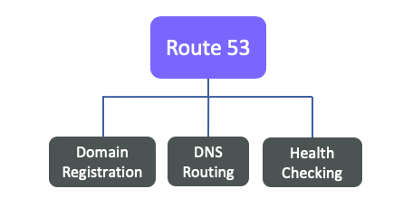

* **Domain Registration:**

Your website uses a name, such as clarusway.com. Route 53 one of the domain-name-provider lets you register a name for your website or web application, known as a domain name. After purchasing or leasing, the domain name will be dedicated only to you globally.

You can purchase or lease a domain name for the different timeframe via Route 53.

You can also transfer the registration for existing domains from other registrars to Route 53 or transfer the registration for domains that you register with Route 53 to another registrar.

* **DNS Routing:**

Route 53 route the internet traffic to the resources for your domain. When a user opens a web browser and enters your domain name (clarusway.com) or subdomain name (help.clarusway.com) into an address bar, Route 53 provides a connection between the browser and your website or web application.

After you register your domain name, Route 53 routes the web traffic of your domain with the help of the **DNS Record Sets** and **DNS Policies**.

Each DNS Record Set includes information about how you want to route traffic for your domain.

As for DNS Policies, they offer many scenario alternatives such as geographic, failover or weighted, etc.

We'll see more details about DNS Record Sets and DNS Policies in the following pages.

* **Health Checking:**

Health Checking, as the name suggests, is a function that checks whether our servers running with Route 53 are working properly. Then it allows mapping the traffic according to the information taken from this health check.

While Health Checking working, Route 53 sends automated requests over the internet to a resource, such as a web server, to verify that it's reachable, available, and functional.

You also can choose to receive notifications when a resource becomes unavailable and choose to route internet traffic away from unhealthy resources.

You can create three types of Amazon Route 53 Health Checks and you can use them while creating records:

* **Endpoint Health Checks:**

It is a health checking method that monitors an endpoint that you specify either by IP address or by the domain name.

* **Calculated Health Checks:**

In this option you can create a health check that considers the other health checks that may be healthy or unhealthy. Hence, health control criteria can be more personalized and produce composite results.

* **CloudWatch Health Checks:**

In this type of Health Check, you first create CloudWatch alarms that monitor and then create a health check that monitors the same data stream that CloudWatch monitors for the alarm.

### **Hosted Zones**

A hosted zone is a container for records, and records contain information about how you want to route traffic for a specific domain.

For example, if your domain is **clarusway.com**, you can reach also the same website corresponding to your domain with the help of the records inside these hosted zones when you enter its subdomains such as **info.clarusway.com**, or **mobile.clarusway.com** on the browser.

A domain and its hosted zone have the same name.

There are two types of hosted zones: **Public Hosted Zones** and **Private Hosted Zones**

**Public Hosted Zones**

A public hosted zone is a container that holds information (DNS Records) about how you want to route traffic on the internet for a specific domain. So, we can manage queries from the public internet through the DNS record sets and Policies that we create in the Public Hosted Zone.

Public Hosted Zones are accessible from the Public Internet.

If you want to create Public Hosted Zones, first of all, you need to have a domain name. You can purchase from AWS or you may migrate from another DNS registrar.

When you registered a domain name via Route 53, your Public Hosted Zone will be automatically created with the same name of your domain name.

**Private Hosted Zones:**

Private hosted zones contain records that specify how you want to route traffic in an Amazon VPC.

Private hosted Zone can only be accessed by our resources in VPC.

Unlike Public Hosted Zones, Private Hosted Zones are not created automatically when the domain name is registered with Route 53. So we can create it manually.

No domain name registration is required to create a Private Hosted Zone. Any name can be selected for the hosted zone. For example **team-clarusway.local**

### **DNS Record Sets**

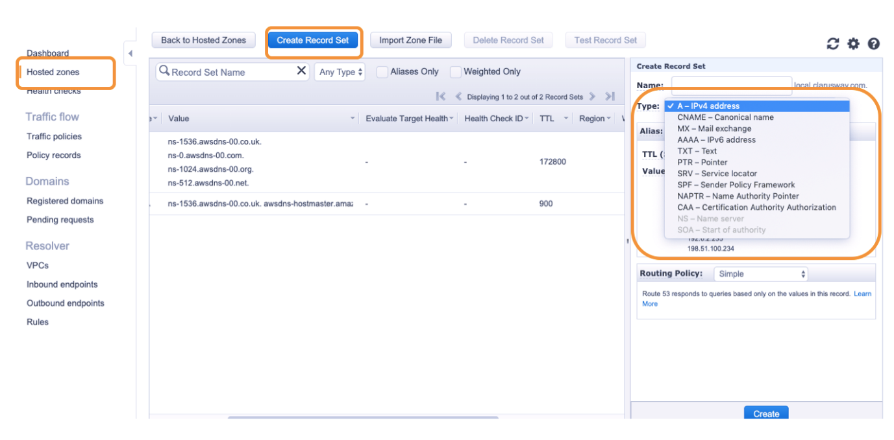

A DNS record sets are an information record used to map the domain names to an IP address in AWS Route 53. They provide you to manage user queries to an alternative web site.

Thanks to the DNS record we can associate our web site to one IP, multiple IP or any name. For example;

* **wwww.clarusway.com** is the hostname of your web site You can provide users to access this web site both from **public.clarusway.com** and **wwww.clarusway.com** via CNAME record.
* And also you can set your web site to be reachable from the IPs of 1.2.3.4.56 and IP: 7.8.9.10. thanks to the A or AAA records.

Amazon Route 53 currently supports 13 DNS record types (**most used in bold**) seen below:

* **NS (Name Server Record)**
* **SOA (Start of Authority Record)**
* **A (Address Record)**
* **CNAME (Canonical Name Record)**
* **PTR (Pointer Record)**
* **TXT (Text Record)**
* **ALIAS(Alias Record)**
* CAA (Certification Authority Authorization)
* MX (Mail Exchange Record)
* NAPTR (Name Authority Pointer Record)
* AAAA (IPv6 Address Record)
* SPF (Sender Policy Framework)
* SRV (Service Locator)

### **SOA and NS Records**

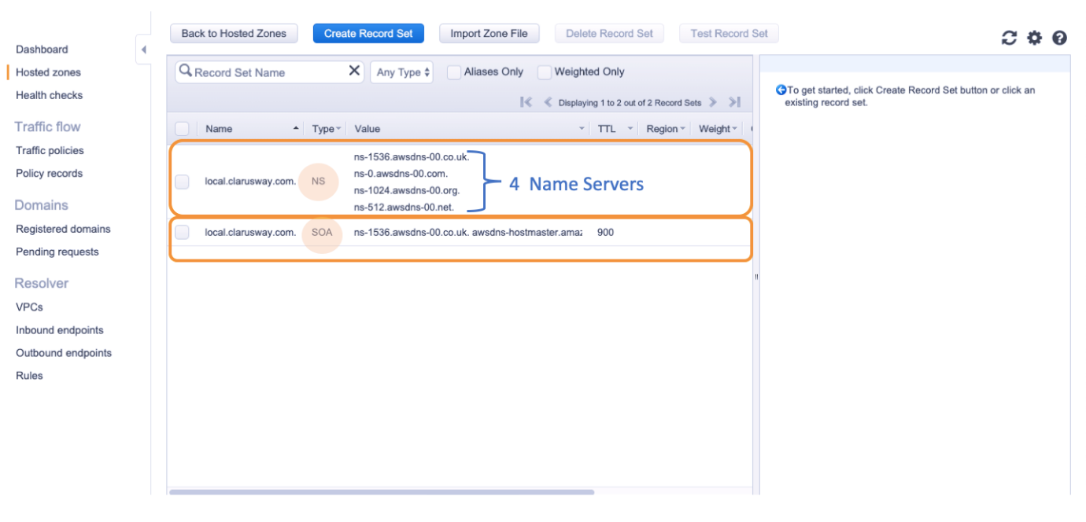

When we register a domain name or create a hosted zone in AWS Route 53, 2 records are created by default. These records are SOA (Start Of Authority) and NS (Name Server)

* **SOA (Start Of Authority):**

SOA (Start Of Authority) contains **administrative basic information** about the associated domain. It is the first record in all zones. It is the record that determines that a DNS Server is responsible for that zone. In other words, it is the **ID card of domain name**

It is used to define the parameters of the primary DNS server for a particular zone. Zone version, zone management, data in the zone and name server information are kept in SOA records.

It includes fields such as serial number, refreshes rate, retries timeout, expiration time, and negative cache time. In addition, how often information is shared among multiple DNS servers hosting the same zone, SOA record determines.

* **NS (Name Server):**

NS, as the name suggests, is a record that contains a list of servers authorized to host Name Server.

NS-records determine the DNS servers responsible (authoritative) for a zone.

Amazon Route 53 automatically creates a name server (NS) record that has the same name as your hosted zone. By default, it holds the **four** name servers that are the authoritative name servers for your hosted zone. You are not recommended to add, change, or delete name servers in these records.

* **A Record:**

It is the most basic DNS record. It is an important record type that we can match with the domain or subdomain to IPs. For example, we can point the sub-domain of **www.clarusway.com** to IP addresses such as 1.2.3.4

A record can only take an **IP address** as a Value.

You can assign multiple IPs to the same domain/subdomain.

You can also assign different sub-domains to the same IP via A records.

You'll see the sample of A Record listings of different types in the picture above.

* In the section marked as 1, **help.local.clarusway.com** and **www.local.clarusway.com** are assigned to the same IP of 1.2.3.45. So, thanks to the these A records you'll reach the same web server when you search both **www.local.clarusway.com** and **help.local.clarusway.com** in the web browser.
* In the section marked as 2, IP of 14.15.16.17 and 10.11.12.13 are assigned to **local.clarusway.com** as a value. When you enter **local.clarusway.com** in a web browser, Route 53 route the query to these IPs randomly.
* **CNAME(Canonical Name) Records:**

CNAME records are used to point a domain or subdomain to another hostname. It's a kind of alias for any hostname. If you want to provide a variety of associated services and subdomains (mail.clarusway.com, mobile.clarusway.com, etc.) on a single domain(clarusway.com) and, it is possible to define these subdomains record of each service to be directed to a single server with CNAME definitions.

Thus, when it is necessary to update the IP address record, instead of updating all the addresses one by one, we can only solve the problem with a change in the A Record.

As you see in the picture above, we have A record which points **www.local.clarusway.com** to the IP of **1.2.3.45** And we want to route also **info.local.clarusway.com** and **help.local.clarusway.com** to the same server. We have two options here:

* We can create **two more A Records** for **info.local.clarusway.com** and **help.local.clarusway.com** that point the IP of 1.2.3.45. But, in case of changing the IP address of the server, you need to change all IP values of these 3 A records, or
* In addition to **www.local.clarusway.com** A Record, we can create **two CNAME** records for **info.local.clarusway.com** and **help.local.clarusway.com** which point the A Record. So, in case of changing the IP address of the server, you'll just need to change the IP of A records and this automatically causes to change the CNAME record also.
* You can't create CNAME for the root/naked domain such as clarusway.com.

### **Alias Records**

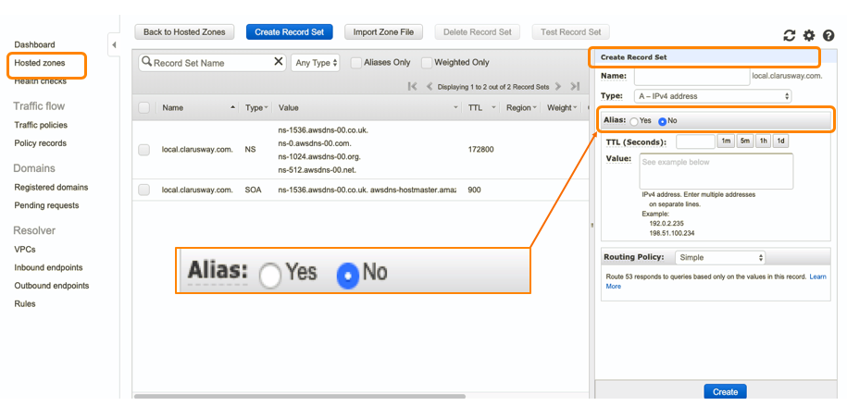

This is a DNS feature of Route 53 only. It is basically the same as the CNAME record, but instead of the IP address, we do DNS name mapping to the AWS resources like AWS Elastic Load Balancers, Amazon Cloud Front, AWS Elastic Beanstalk, or Amazon S3 Buckets.

Assume that you want to map your naked/root domain **clarusway.com** to your Amazon Elastic Load Balancers. As you remember from the previous lessons, Amazon Elastic Load Balancers only offers a DNS name, not IP addresses. Thus;

* If you create A record, it allows only IP addresses so it's not possible to create A record for the Amazon Elastic Load Balancers,
* As for CNAME records, although they offer name option, they cannot be used for a root or naked domain.

So you can only map your naked/root domain such as **clarusway.com**, to your Amazon Elastic Load Balancers by Alias ​​record. Because Alias both can be used with naked/root domain and DNS belonging to AWS services

* Alias ​​records are embedded in the other Route 53 records. So you can create an Alias record inside the other records.

### **Alias vs CNAME**

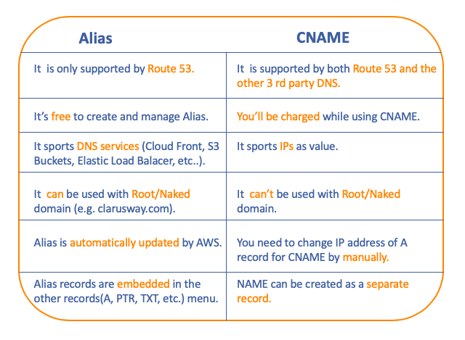

### **Other DNS Records**

* **MX Record (Mail Exchange Record):** Specifies the IP addresses of the servers that provide mail services related to the domain name.
* **TXT Record(Text Record):** As the name of the TXT record indicates, it allows you to keep the Text values ​​records.
* **PTR Records (Pointer Record):** These are records defined in reverse zone files for reverse DNS records. It is used to analyze the hostname against IP address. For example, to find the name of the server with the IP address 10.61.2.116, the DNS server responds by looking at the PTR records.
* **SRV Registration Record (Service Locator Record):** It is the type of registration we use when we want to send port information besides IP addresses.
* **SPF Record (Sender Policy Framework Record):** It is a record about sending spam and spoofing related to sending mail.
* **AAAA (IPv6 address record):** It is the IPv6 version of A Record designed for IPv4.
* **CAA Record (Certification Authority Authorization):** A CAA record specifies which certificate authorities (CAs) are allowed to issue certificates for a domain or subdomain.

If there is no CAA record, any CA is allowed to issue a certificate for the domain. If a CAA record is present, only the CAs existing in the record (s) are allowed to issue certificates for that hostname.

* **NAPTR Record (A Name Authority Pointer Record):** NAPTR Record Type is a type of record that is used by Dynamic Delegation Discovery System (DDDS) applications to convert one value to another or to replace one value with another. For example, one common use is to convert phone numbers into SIP URIs.

### **TTL(Time to Live)**

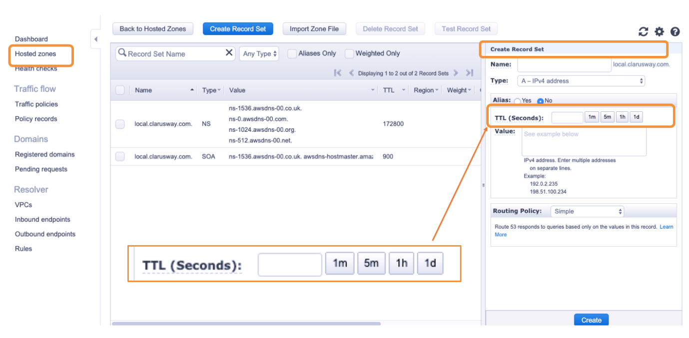

TTL(Time to Live) is a parameter that determines how long IPS (Internet Service Provider) will cache (store) the values for a record before submitting another request to Route 53 to get the current values for that record.

If the DNS resolver receives another request for the same domain before the TTL expires, the resolver returns the cached value.

Suppose there is a popular web site like www.google.com, so millions of devices are trying to enter this page and it will extremely increase the load of DNS servers. Instead, If we enter the TTL value as 1000 then IPS (Internet Service Provider) going to the DNS server again 1000 minutes after the first address is reached. Thus, the load of the DNS server will decrease.

TTL is set in seconds from the right-hand menu from the TTL section. You can manually enter a value as second or select **1 minute, 5 minutes, 1 hour and 1-day** options on the menu.

A longer TTL reduces your Route 53 charges, which are based in part on the number of DNS queries that Route 53 responds to. So this provides great convenience in a static environment where IP addresses do not change.

### **Routing Policies**

Routing Policy is a parameter that provides you to configure your traffic for different types of scenarios. When you create a record, you choose a routing policy, which determines how Amazon Route 53 responds to queries.

How the traffic is directed depends on which subject the policy based on. For example, While **Latency Routing Policy** takes action the distance/time, **Geolocation Routing Policy** considers the location of user and web-server.

Currently, Route 53 offers 7 types of policy seen below:

* **Simple Routing Policy:**

Used for a single resource that performs a given function for your domain, for example, a web server that serves content for the example.com website.

* **Failover Routing Policy:**

Use when you want to configure active-passive failover.

* **Weighted Routing Policy:**

Used for routing traffic to multiple resources in proportions that you specify(e.g proportions of 8/2, 10/90 or 1/5).

* **Latency Routing Policy:**

Use when you have resources in multiple AWS Regions and you want to route traffic to the region that provides the best latency.

* **Geolocation Routing Policy:**

Use when you want to route traffic based on the location of your users.

* **Geoproximity Routing Policy**

Use when you want to route traffic based on the location of your resources and, optionally, shift traffic from resources in one location to resources in another.

* **Multivalue Answer Routing Policy:**

Use when you want Route 53 to respond to DNS queries with up to eight healthy records selected at random.