Dr Antipov - Sitemap & Robots Audit
Date: 2026-08-05
Website audited: https://www.drantipov.com/
Platform detected: Custom / modern framework

What We Found - Quick Summary
The live sitemap currently lists 184 URLs and the cleanup pass keeps 184. The main risk is not robots syntax; it is sitemap quality and discovery governance. The audit found 0 indexable pages missing from the sitemap, 0 duplicate or overlapping page groups, and a section mix led by for-patients content.

Top Issues
- Fake lastmod signal (184)
- Sitemap dominated by supporting content (86)
- Mixed root-level URL strategy (6)
- Sitemap heavily weighted to deeper URLs (130)
- changefreq present (184)

Robots.txt
Verdict: Looks broadly clean
Current interpretation: The robots file should only be treated as a real issue if it is blocking indexable areas or missing a critical crawl/discovery rule. If it is technically valid, it should not distract from the larger sitemap strategy problems.
Current live robots.txt excerpt:
User-Agent: GPTBot
User-Agent: OAI-SearchBot
User-Agent: ChatGPT-User
User-Agent: ClaudeBot
User-Agent: anthropic-ai
User-Agent: PerplexityBot
User-Agent: Googlebot
User-Agent: Google-Extended
User-Agent: Bingbot
User-Agent: BingPreview
Allow: /
Allow: /api/llms
Disallow: /api/
Disallow: /admin/
User-Agent: AhrefsBot
User-Agent: SemrushBot
User-Agent: Screaming Frog SEO Spider
Allow: /
Allow: /api/llms
Disallow: /api/
Disallow: /admin/
User-Agent: *
Allow: /
Allow: /api/llms
Disallow: /api/
Disallow: /admin/
Sitemap: https://www.drantipov.com/sitemap.xml

Sitemap.xml
Verdict: Needs cleanup
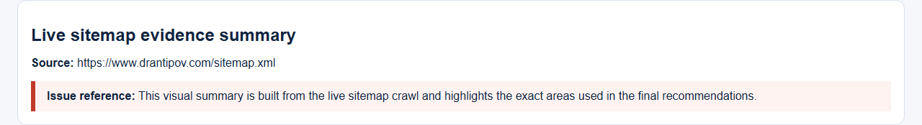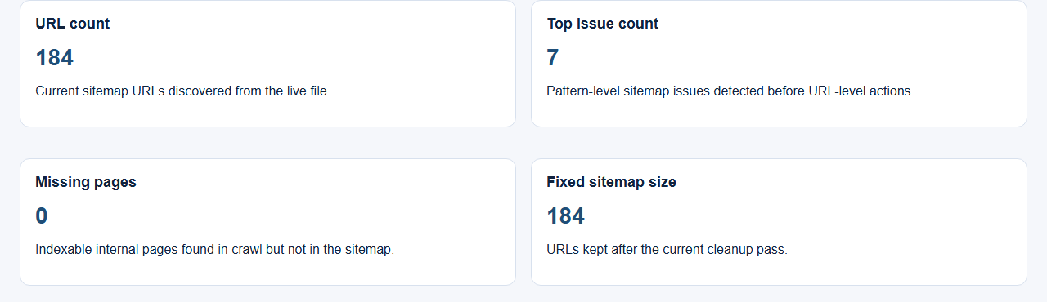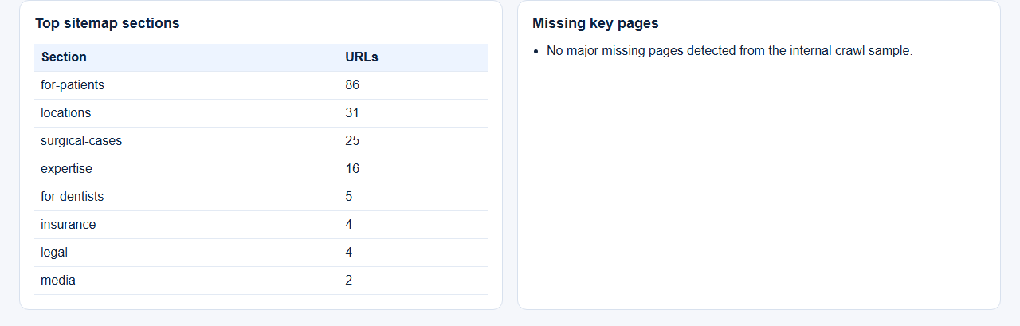
Current section weighting: for-patients 86, locations 31, surgical-cases 25, expertise 16, for-dentists 5

Recommended Fix Order
- Fake lastmod signal - Remove lastmod unless the CMS can output real page-level modified dates.
- Sitemap dominated by supporting content - Review whether the sitemap inventory is too broad. Make sure core commercial and location pages remain clearly prioritised and that thin or low-value supporting URLs are justified.
- Mixed root-level URL strategy - Review the standalone root-level landing pages and decide whether each one should remain a canonical root page, move under a structured section, or be consolidated with an existing service hub.
- Sitemap heavily weighted to deeper URLs - Review whether all deep supporting URLs need sitemap inclusion, especially if they add little unique search value.
- City-based location page set needs validation - Review the city pages one by one. Keep defensible pages that support the site’s real service footprint. If a page is weak or not needed, noindex it and remove it from the sitemap, or redirect it to the strongest relevant location or service page.
- changefreq present - Remove changefreq from the sitemap.
- priority present - Remove priority from the sitemap.

Example Fixed Files

Example fixed robots.txt
User-Agent: GPTBot
User-Agent: OAI-SearchBot
User-Agent: ChatGPT-User
User-Agent: ClaudeBot
User-Agent: anthropic-ai
User-Agent: PerplexityBot
User-Agent: Googlebot
User-Agent: Google-Extended
User-Agent: Bingbot
User-Agent: BingPreview
Allow: /
Allow: /api/llms
Disallow: /api/
Disallow: /admin/
User-Agent: AhrefsBot
User-Agent: SemrushBot
User-Agent: Screaming Frog SEO Spider
Allow: /
Allow: /api/llms
Disallow: /api/
Disallow: /admin/
User-Agent: *
Allow: /
Allow: /api/llms
Disallow: /api/
Disallow: /admin/
Sitemap: https://www.drantipov.com/sitemap.xml

Example fixed sitemap.xml
<?xml version="1.0" encoding="UTF-8"?>
<urlset xmlns="http://www.sitemaps.org/schemas/sitemap/0.9" xmlns:xhtml="http://www.w3.org/1999/xhtml">
<url>
<loc>https://www.drantipov.com</loc>
<xhtml:link rel="alternate" hreflang="en" href="https://www.drantipov.com" />
<xhtml:link rel="alternate" hreflang="x-default" href="https://www.drantipov.com" />
</url>
<url>
<loc>https://www.drantipov.com/expertise</loc>
<xhtml:link rel="alternate" hreflang="en" href="https://www.drantipov.com/expertise" />
<xhtml:link rel="alternate" hreflang="x-default" href="https://www.drantipov.com/expertise" />
</url>
<url>
<loc>https://www.drantipov.com/expertise/full-arch-implants</loc>
<xhtml:link rel="alternate" hreflang="en" href="https://www.drantipov.com/expertise/full-arch-implants" />
<xhtml:link rel="alternate" hreflang="x-default" href="https://www.drantipov.com/expertise/full-arch-implants" />
</url>
<url>
<loc>https://www.drantipov.com/expertise/single-tooth</loc>
<xhtml:link rel="alternate" hreflang="en" href="https://www.drantipov.com/expertise/single-tooth" />
<xhtml:link rel="alternate" hreflang="x-default" href="https://www.drantipov.com/expertise/single-tooth" />
</url>
<url>
<loc>https://www.drantipov.com/expertise/bone-grafting</loc>
<xhtml:link rel="alternate" hreflang="en" href="https://www.drantipov.com/expertise/bone-grafting" />
<xhtml:link rel="alternate" hreflang="x-default" href="https://www.drantipov.com/expertise/bone-grafting" />
</url>
<url>
<loc>https://www.drantipov.com/expertise/jaw-surgery</loc>
<xhtml:link rel="alternate" hreflang="en" href="https://www.drantipov.com/expertise/jaw-surgery" />
<xhtml:link rel="alternate" hreflang="x-default" href="https://www.drantipov.com/expertise/jaw-surgery" />
</url>
<url>
<loc>https://www.drantipov.com/expertise/sleep-apnea</loc>
<xhtml:link rel="alternate" hreflang="en" href="https://www.drantipov.com/expertise/sleep-apnea" />
<xhtml:link rel="alternate" hreflang="x-default" href="https://www.drantipov.com/expertise/sleep-apnea" />
</url>
<url>
<loc>https://www.drantipov.com/expertise/mole-removal</loc>
<xhtml:link rel="alternate" hreflang="en" href="https://www.drantipov.com/expertise/mole-removal" />
<xhtml:link rel="alternate" hreflang="x-default" href="https://www.drantipov.com/expertise/mole-removal" />
</url>
<url>
<loc>https://www.drantipov.com/expertise/tmj</loc>
<xhtml:link rel="alternate" hreflang="en" href="https://www.drantipov.com/expertise/tmj" />
<xhtml:link rel="alternate" hreflang="x-default" href="https://www.drantipov.com/expertise/tmj" />
</url>
<url>
<loc>https://www.drantipov.com/expertise/wisdom-teeth</loc>
<xhtml:link rel="alternate" hreflang="en" href="https://www.drantipov.com/expertise/wisdom-teeth" />
<xhtml:link rel="alternate" hreflang="x-default" href="https://www.drantipov.com/expertise/wisdom-teeth" />
</url>
<url>
<loc>https://www.drantipov.com/expertise/tooth-extractions</loc>
<xhtml:link rel="alternate" hreflang="en" href="https://www.drantipov.com/expertise/tooth-extractions" />
<xhtml:link rel="alternate" hreflang="x-default" href="https://www.drantipov.com/expertise/tooth-extractions" />
</url>
<url>
<loc>https://www.drantipov.com/expertise/sedation-anesthesia</loc>
<xhtml:link rel="alternate" hreflang="en" href="https://www.drantipov.com/expertise/sedation-anesthesia" />
<xhtml:link rel="alternate" hreflang="x-default" href="https://www.drantipov.com/expertise/sedation-anesthesia" />
</url>
<url>
<loc>https://www.drantipov.com/expertise/zygomatic-implants</loc>
<xhtml:link rel="alternate" hreflang="en" href="https://www.drantipov.com/expertise/zygomatic-implants" />
<xhtml:link rel="alternate" hreflang="x-default" href="https://www.drantipov.com/expertise/zygomatic-implants" />
</url>
<url>
<loc>https://www.drantipov.com/expertise/implant-rescue</loc>
<xhtml:link rel="alternate" hreflang="en" href="https://www.drantipov.com/expertise/implant-rescue" />
<xhtml:link rel="alternate" hreflang="x-default" href="https://www.drantipov.com/expertise/implant-rescue" />
</url>
<url>
<loc>https://www.drantipov.com/expertise/snap-on-dentures</loc>
<xhtml:link rel="alternate" hreflang="en" href="https://www.drantipov.com/expertise/snap-on-dentures" />
<xhtml:link rel="alternate" hreflang="x-default" href="https://www.drantipov.com/expertise/snap-on-dentures" />
</url>
<url>
<loc>https://www.drantipov.com/expertise/facial-cosmetic</loc>
<xhtml:link rel="alternate" hreflang="en" href="https://www.drantipov.com/expertise/facial-cosmetic" />
The full fixed sitemap is exported separately as the reference XML file.

