Assessment 3

Designing and implementing a network

# Part A: Task 1 (Solution)

**Analysis of the Existing LAN Topology**

1. The current LAN topology at AHI has several problems that cause slow network performance. These are:

* **Outdated Network Media and Technology**: The network uses 10Base-2 coaxial cables and Cat3 UTP cables, which are old and slow technologies. Coaxial cables are prone to interference and signal degradation, and Cat3 cables can only support up to 10 Mbps data transfer rates.
* **Bus Topology Issues**: The network uses a bus topology with coaxial cables, which is unreliable and inefficient. The network is vulnerable to disruptions; if one cable breaks or disconnects, it can affect the whole network. Also, the network has a limited bandwidth; as more users join the network, the data transmission becomes slower and more congested.
* **Hub Issues**: The network uses hubs to connect different floors, which are simple and passive devices. Hubs broadcast all data packets to every port, creating unnecessary traffic and noise on the network. Hubs also have a single point of failure; if one hub fails, it can disconnect multiple floors from the network.

**Recommendations for improving LAN Performance**

1. To improve the network performance at AHI, the following improvements are recommended:

* **Switch to Star Topology**: A star topology will provide a more reliable and efficient network. Each host on the network will connect to a central switch, which will manage data traffic intelligently and deliver data packets only to the intended recipients. A star topology will also reduce the impact of a single point of failure and make it easier to isolate and troubleshoot network problems.
* **Upgrade Cabling System**: Replace all existing 10Base-2 coaxial and Cat3 cables with Cat6 or higher Ethernet cables. This upgrade will support Gigabit Ethernet speeds (1000 Mbps), reducing latency and significantly improving data transfer capabilities across the network.
* **Use Network Switches**: Replace the existing hubs with network switches. Unlike hubs, switches can manage data traffic efficiently by delivering data packets only to the intended recipients, reducing unnecessary traffic and improving overall network performance.

1. **Recommended Network Components**

|  |  |  |  |  |
| --- | --- | --- | --- | --- |
| **Component** | **Specification (Number of ports, speed, connector type)** | **Quantity** | **Location** | **Compliant standards** |
| Cisco 2811 router | 2 built-in Gigabit Ethernet ports, additional slots for more ports | 1 unit | Level 1 | IEEE 802.3, IEEE 802.1Q (VLAN) |
| Network Switch | 24/48 ports, Gigabit Ethernet, RJ45 connector | 6 units | Each floor | IEEE 802.3ab |
| Cat6 Cable | UTP, support for up to 1000 Mbps | N/A | Everywhere | Cat6 |
| Wireless Access Points | Gigabit, dual-band | Optional | Selected areas | IEEE 802.11ac |

# Part B: Task 1(Solution)

**IP Addressing scheme for SMA**

|  |  |  |  |  |  |
| --- | --- | --- | --- | --- | --- |
| **LAN** | **Customised subnet mask (VLSM subnet mask)** | **Address prefix length (i.e., 130.10.0.0./?)** | **VLSM subnetted network address** | **First usable IP address** | **Last usable IP address** |
| LAN1 | 255.255.252.0 | /22 | 130.10.0.0 | 130.10.0.1 | 130.10.3.254 |
| LAN2 | 255.255.255.128 | /25 | 130.10.4.0 | 130.10.4.1 | 130.10.4.126 |
| LAN3 | 255.255.255.0 | /24 | 130.10.5.0 | 130.10.5.1 | 130.10.5.254 |
| LAN4 | 255.255.254.0 | /23 | 130.10.6.0 | 130.10.6.1 | 130.10.7.254 |
| LAN5 | 255.255.255.128 | /25 | 130.10.8.0 | 130.10.8.1 | 130.10.8.126 |
| LAN6 | 255.255.255.192 | /26 | 130.10.8.128 | 130.10.8.129 | 130.10.8.190 |
| WAN1 (Melbourne to Adelaide) | 255.255.255.252 | /30 | 130.10.8.192 | 130.10.8.193 (Melbourne router) | 130.10.8.194 (Adelaide router) |

**IP Addressing scheme for WAN1**

|  |  |  |  |  |  |
| --- | --- | --- | --- | --- | --- |
| WAN1 | **Customised subnet mask (VLSM subnet mask)** | **Address prefix length (i.e., 130.10.0.0./?)** | **VLSM subnetted network address** | **First usable IP address** | **Last usable IP address** |
| Melbourne to Adelaide (WAN1) | Serial interface on Melbourne (Serial0) | 255.255.255.252 | /30 | 130.10.8.192 | 130.10.8.193 |
| Melbourne to Adelaide (WAN1) | Serial interface on Adelaide (Serial0) | 255.255.255.252 | /30 | 130.10.8.192 | 130.10.8.194 |

# Task 2: Screenshot

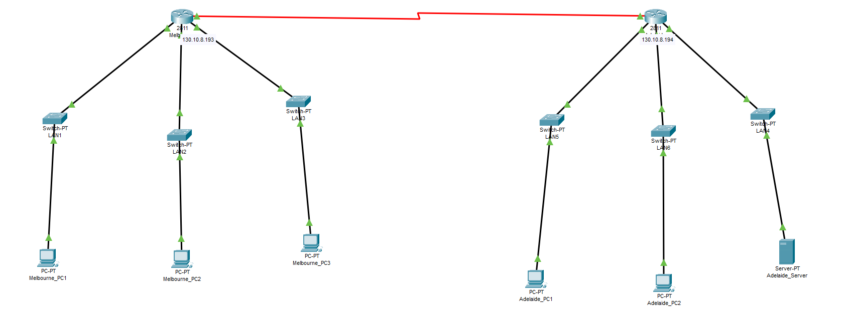

# Task 3: (Solution)

**IP address assignment**

**Table 6**

|  |  |  |  |
| --- | --- | --- | --- |
| **Network Device/interface** | **IP address (in dotted decimal notation)** | **Subnet mask (in dotted decimal notation)** | **Default gateway** |
| Melbourne router F0/0 interface | 130.10.0.1 | 255.255.252.0 | N/A |
| Melbourne router F0/1 interface | 130.10.4.1 | 255.255.255.128 | N/A |
| Melbourne router F1/0 interface | 130.10.5.1 | 255.255.255.0 | N/A |
| LAN1 Melbourne_PC1 | 130.10.0.2 | 255.255.252.0 | 130.10.0.1 |
| LAN2 Melbourne_PC2 | 130.10.4.2 | 255.255.255.128 | 130.10.4.1 |
| LAN3 Melbourne_PC3 | 130.10.5.2 | 255.255.255.0 | 130.10.5.1 |
| Adelaide router F0/0 interface | 130.10.61 | 255.255.254.0 | N/A |
| Adelaide router F0/1 interface | 130.10.8.1 | 255.255.255.128 | N/A |
| Adelaide router F1/0 interface | 130.10.8.129 | 255.255.255.192 | N/A |
| LAN4 Adelaide _Server | 130.10.6.2 | 255.255.254.0 | 130.10.6.1 |
| LAN5 Adelaide_PC1 | 130.10.8.2 | 255.255.255.128 | 130.10.8.1 |
| LAN6 Adelaide_ PC2 | 130.10.8.130 | 255.255.255.192 | 130.10.8.129 |

**Wan1 Link**

**Table 7**

|  |  |  |  |
| --- | --- | --- | --- |
| **Network Device/interface** | **IP address (in dotted decimal notation)** | **Subnet mask (in dotted decimal notation)** | **Default gateway** |
| WAN1 Serial interface on Melbourne (Serial0) | 130.10.8.193 | 255.255.255.252 | N/A |
| WAN1 Serial interface on Adelaide (Serial0) | 130.10.8.194 | 255.255.255.252 | N/A |

# Task 4: Screenshots

Melbourne_PC1

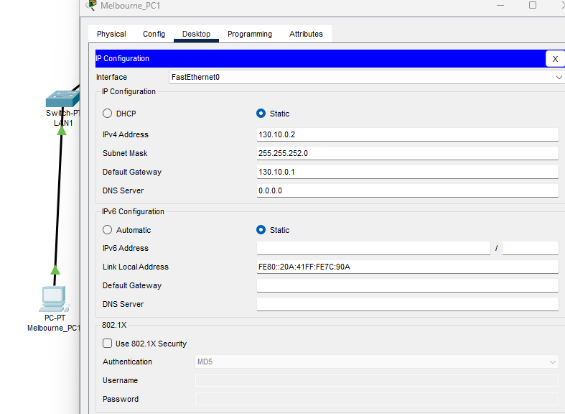

Melbourne_PC2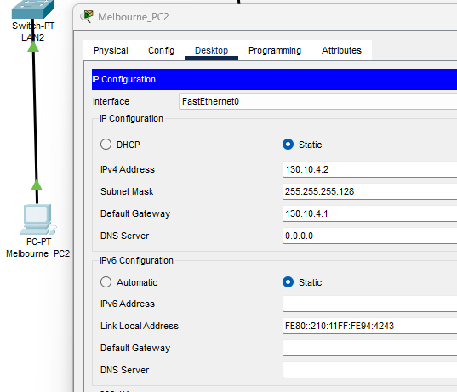

Adelaide_PC1

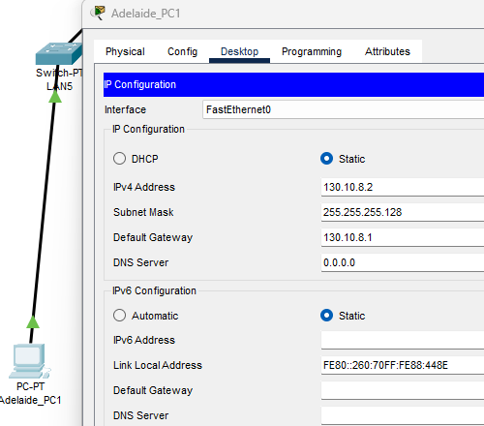

Adelaide Server

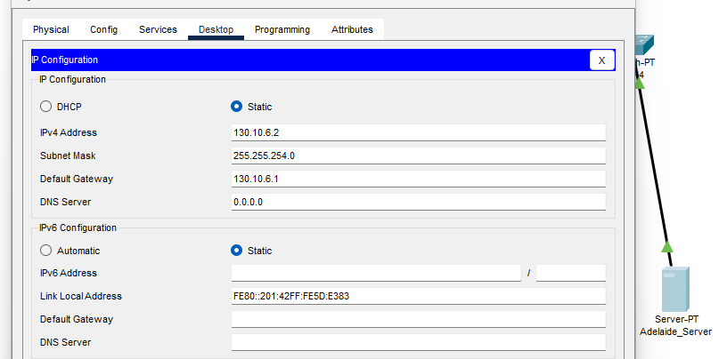

Serial interface_ Melbourne Router

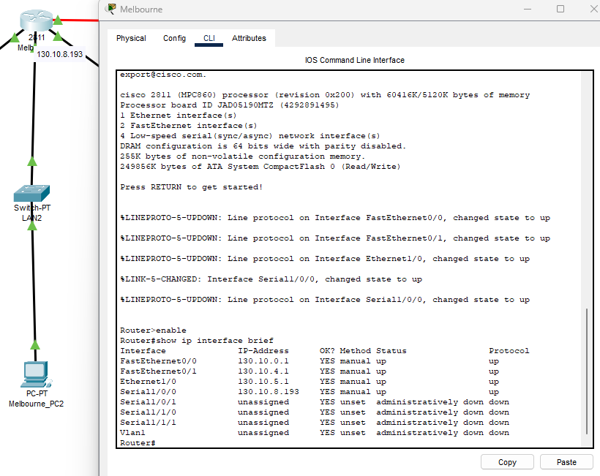

Serial interface_ Adelaide Router

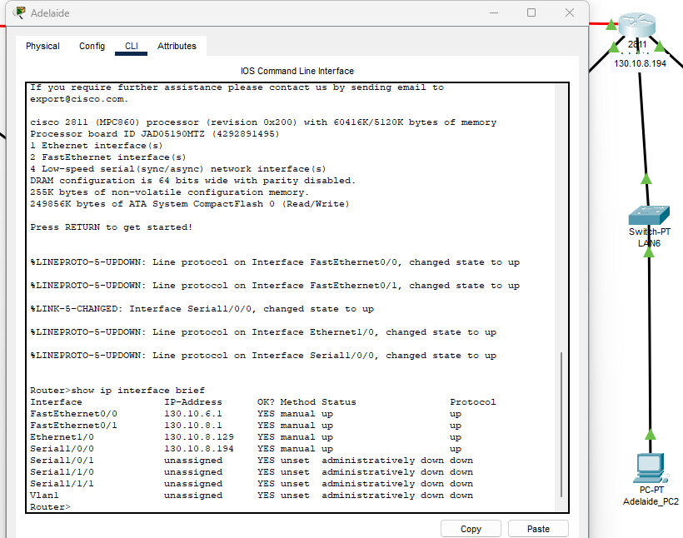

|  |  |
| --- | --- |
|  |  |
|  |  |
|  |  |
|  |  |
|  |  |
|  |  |
|  |  |
|  |  |

**Connectivity Test**

|  |  |
| --- | --- |
|  |  |
|  |  |
|  |  |

# Part C: (Answers)

Q1

The required device is a **Wireless Access Point (WAP)**. It allows Wi-Fi-enabled devices to connect to a wired network, providing coverage and flexibility for wireless connections within a specific area, like the 1st floor.

Q2

Without static routing on the routers, they won't know how to forward packets to non-directly connected networks. This means devices in one network (e.g., Melbourne) couldn't communicate with those in another network (e.g., Adelaide).

Q3

• **FLSM**: Divides IP addresses into subnets of the same size, leading to potential wastage. Useful for uniformity.

• **VLSM**: Allows subnets of different sizes based on host requirements, offering efficiency in IP address utilization. Best for tailored subnetting based on varying needs.