Overview
You are a mid-level bureaucrat who has just received an important promotion. Instead of reviewing hunting permits and filling out forms, you’re now in charge of an entire federal district. Your superiors have tasked you with gradually allowing hunting permits for geese due to the rising population, but there’s one problem: you’re a weregoose.
Game Diagram
Gameplay consists of the player approving/denying paperwork, as well as giving orders to the geese. They are trying to balance goose support (want to be high) with human awareness (want to be as low as possible). The player will approve/disapprove paperwork, rewarding them with a certain amount of goose orders, which can then be used to move the geese around the map, collecting supplies and intel. Every few rounds an event will come in the form of correspondance from the player’s superiors, which is a combination of the descisions made and random chance. The game either ends in the humans discovering the player’s secret, the geese revolting and overthrowing the player, or the player succsesfully saving all of the geese.

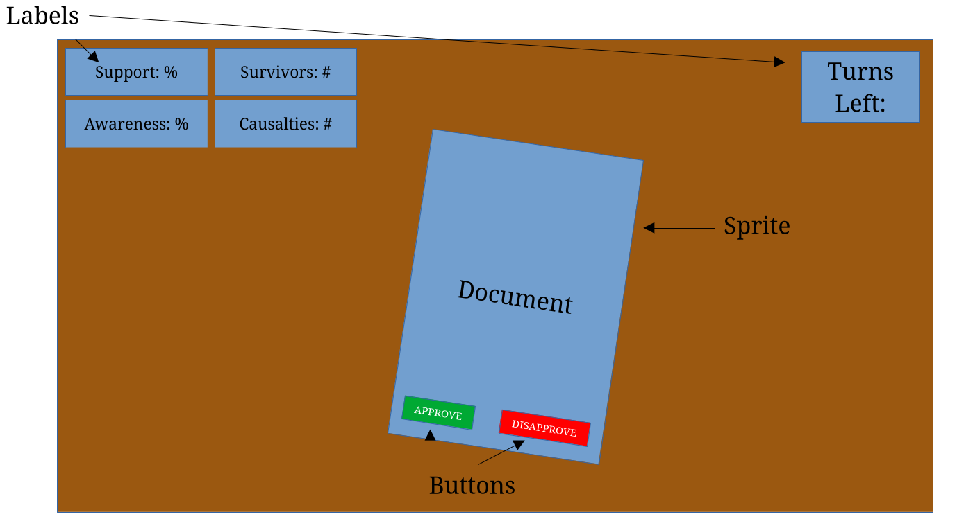
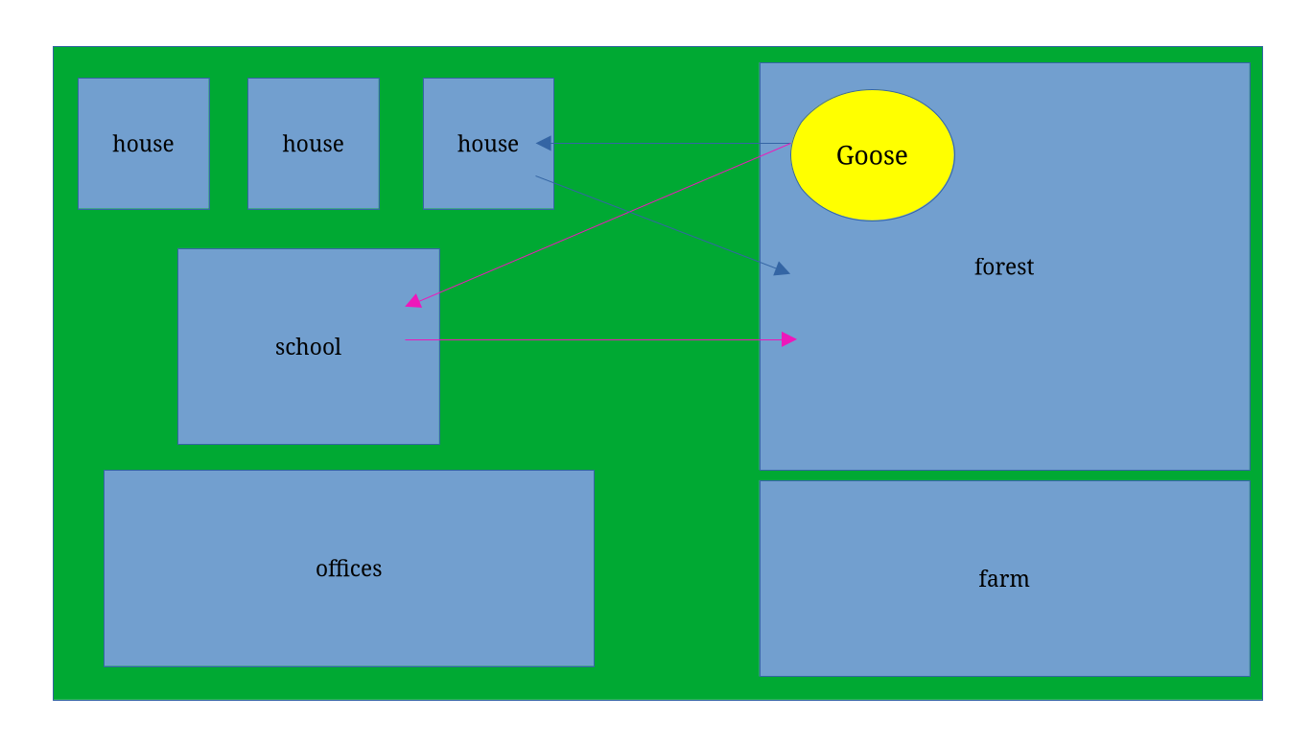
Game States
- Intro
  - title & dramatic intro paragraph
  - start / quit buttons
- Gameplay - “Desk”
  - sprites for paperwork
  - labels for:
    - goose support
    - human awareness
    - %geese remaining, hidden, & casualties
    - # of turns left
- Gameplay – “Map”
  - labels for:
    - remaining goose orders & supply levels
  - sprites:
    - houses, farm, forest, goose, school, offices
  - only able to move goose sprite on a click, using one of the player’s limited number of orders
Sprites
- event objects of document class
  - label with description
  - corresponding gameplay values
- houses, farm, forest, school, offices
  - each has an associated supply value, image, and size
- goose
  - movable via click on different hotboxes on the map
UI
- Backgrounds – wooden desktop, grass & paths for the map
- Title Screen – multilabel w/ start & quit buttons
- Labels:
  - LblSupport
    - shows the goose support percentage
    - always present
  - LblAwareness
    - shows the human awareness percentage
    - always present
  - LblSurvivors
    - shows the number of goose survivors
    - only appears at the end of a round
  - LblCasualties
    - shows the number of goose casualties
    - only appears at the end of a round
  - LblTurns
    - shows the number of rounds left for the player
    - always present in the “Desk” gamestate
  - LblOrders
    - shows the number of goose orders remaining
    - always present in the “Map” gamestate
- Buttons:
  - BtnStart
    - on intro screen, starts game when pressed
  - BtnQuit
    - on intro screen, stops game when pressed
  - BtnApprove
    - enacts associated value changes for the descision
    - removes the document sprite from view
  - BtnDenied
    - retains values for the associated descision
    - removes the document sprite from view
Sound
- click – when buttons are clicked
- transition – when the gamestate transitions between the “Desk” and the “Map”
Milestones
- create pseudocode
- create placeholders
- add goose class
- add class for documents
- add classes for farm & forest
- add classes for house, school, office
- add gamestate “Desk” & labels
- add gamestate “Map”
- add intro & buttons
Tuning Parameters
- # of turns
- descisions and # of goose orders
- supplies gained from each location & # of supplies needed to successfully flee
- # of locations on the map & possible travel cooldowns

