The Great Escape
Alexander Bell

A simple 2D game using pygame & simpleGE. The player is a space ship dodging obstacles while trying to escape unknown pursuers. The ship is at the bottom of the screen, with the player moving it left and right with the arrow keys, avoiding ‘asteroids’ (-1 point) and collecting ‘fuel pods’ (+1 point). Each of these objects will fall at a random speed between 4-10 pixels per frame, and from a random x position over a 15 second gameplay window.

State Transition
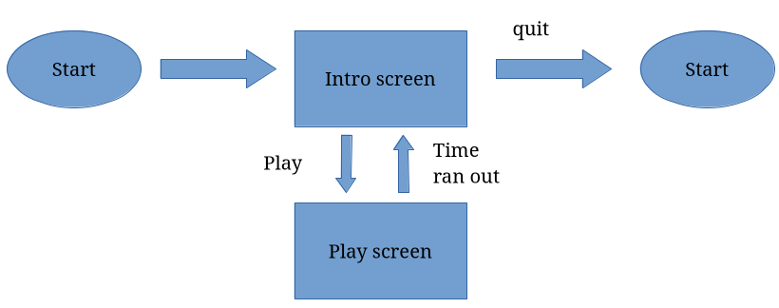
each state is a subclass of the simpleGE scene class. The player starts at the intro screen, and can either select play (which begins the game & transfers to the play screen state), or quit (closing the program)
Intro Screen
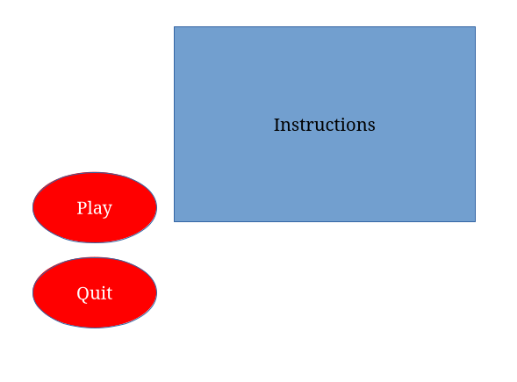
Visual elements:
- Instructions: simple GE multilabel w/ game instructions
- Play: button w/ “Play”
- Quit: button w/ “Quit”
Other elements:
- user_response: string for user response
init():
set background image to white
create ‘instructions’ w/ text’
set instructions size to (500,300), position to center of window

create btnPlay, set text “Play”, set position (100, 800)
create btnQuit, set text “Quit”, set position (100,400)

{lblInstructions, btnPlay, btnQuit}

process():
if quit pressed:
set response to “quit”
stop scene
if start pressed:
set response to “start”
stop scene

Game Screen

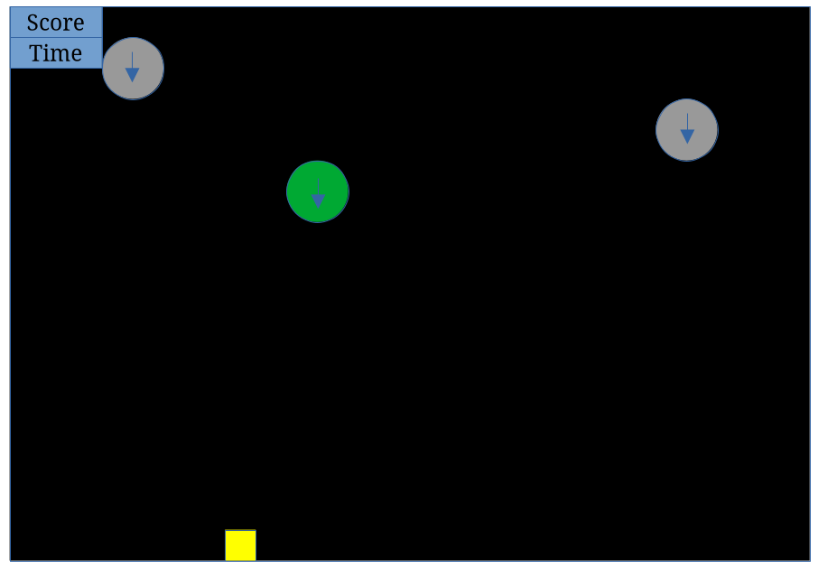
2 ‘asteroids’ and a ‘fuel cell’ fall from the top of the screen, with the ‘spaceship’ moving side to side at the bottom of the screen, with time left and currect score tracked at the top left of the screen
Visual elements:
- an instance of Ship class, ship
- instances of Asteroid class, asteroids
- instances of FuelCell class, fuel cells
- an instance of LblScore, lblScore
- an instance of Lbltime, lblTime
Other elements:
- instance of simpleGE Timer class, timer
- int holding current player score, score
init():
set background image to black
create timer & set to 15
set score to 0
create instance of Ship (ship)
create list of 3 Asteroid instances (asteroids)
create instance of FuelCell (fuel-cell)
create instance of LblScore (lblScore)
create instance of Lbltime (lblTime)

process():
for each coin in list:
if collides w/ ship:
reset coin
score + 1
update time
if time < 0:
print score
stop game

Ship
init():
set color to yellow, size to 50x50
position to (320,400)
set moveSpeed to 7

process():
if left key pressed:
x-moveSpeed
if right key pressed:
x+moveSpeed

Asteroid
init():
Set color gray, size to 25x25
call reset()

reset():
set y to 15
set x to random 0-screen width
set dy to random between 4-10

checkBounds():
if y > screen:
call reset()

FuelCell
init():
Set color green, size to 20x20
call reset()

reset():
reset():
set y to 15
set x to random 0-screen width
set dy to random between 8-15

checkBounds():
if y > screen:
call reset()

Lblscore
init():
text → “SCORE: 0”
set center to (100,30)

Lbltime
init():
text → “TIME LEFT: 15”
set center to (100,60)

