**SPEEDTEST MODULE**

# CONTENTS

## This module has the following files:

1. MODULE_SPEEDTEST.docx
2. MODULE_SPEEDTEST_MEDIA.zip

## A1. Table Pricing

Create a table pricing design consisting of 3 tables, title, price, description list, purchase button.

## A2. Landing News Page

Create a vacation landing page consisting of navigation bar, logo, menu, list of 3 destinations (title, picture, short description, total views, total comments, read more button).

## B1. Particle Button

Create an interactive animation using CSS only. When user click the “Click Me!” Button, many particles with diffusion effect will be displayed around the button.

You can only edit the style.css file.



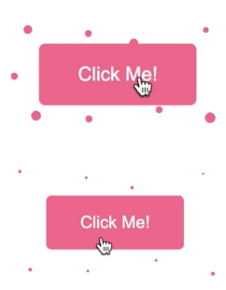



## B2. 5 Stars Rating Animation

Create a 5 Stars Rating UI using the provided "stars.png" image.

When you hover your mouse over a star, an animation that smoothly fills in from the left to the star's score proceeds.

Score 0.5 point unit: 0, 0.5, 1, 1.5, 2, 2.5, 3, 3.5, 4, 4.5, 5

Example.



Refer to **animation.mp4** for the star filling animation.

## C1. Mouse Style

Change the style of the mouse. When clicked, it should display an animation.

See **mouse.mp4** in the given folder to understand the functionality.



## C2. Canvas Hover

Draw a ball with border in a container of 400px height and 400px width using canvas. Make "ball" follow mouse on canvas.

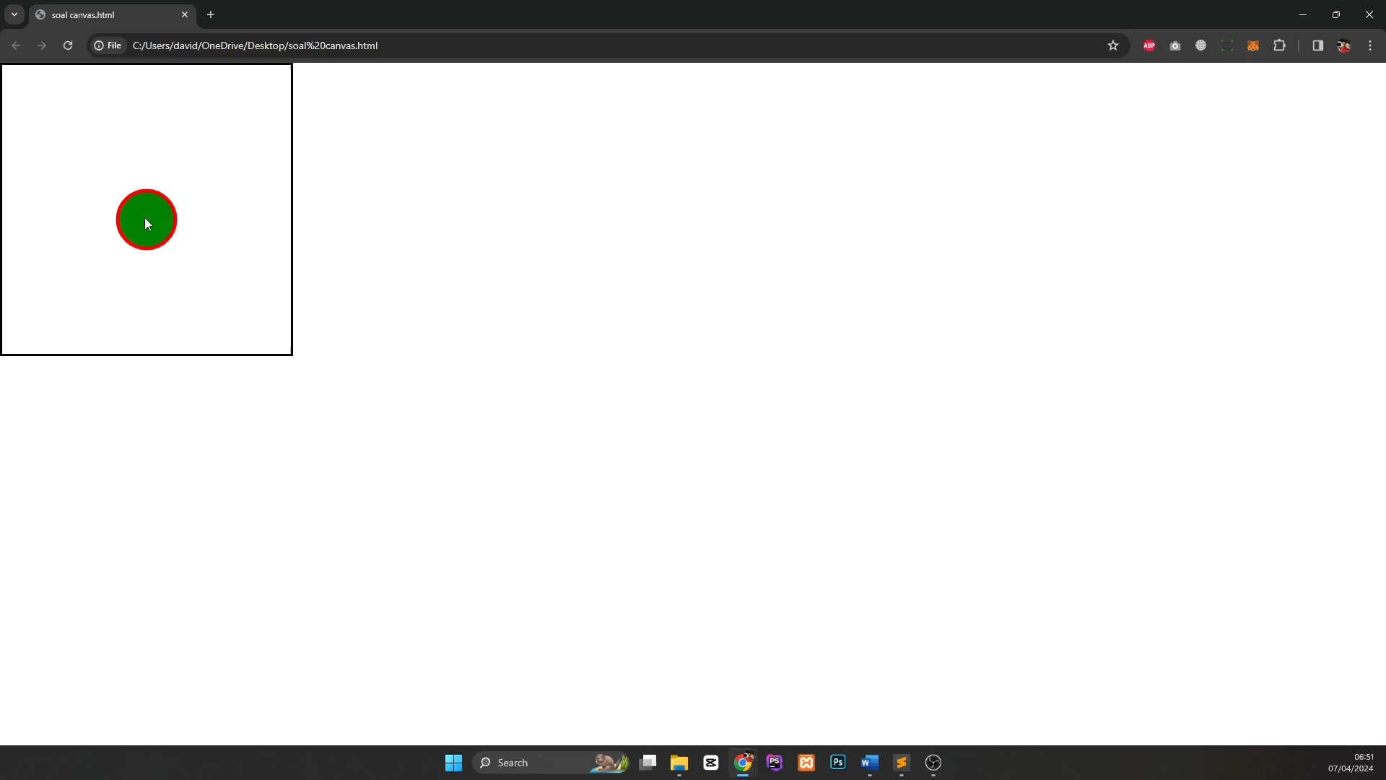 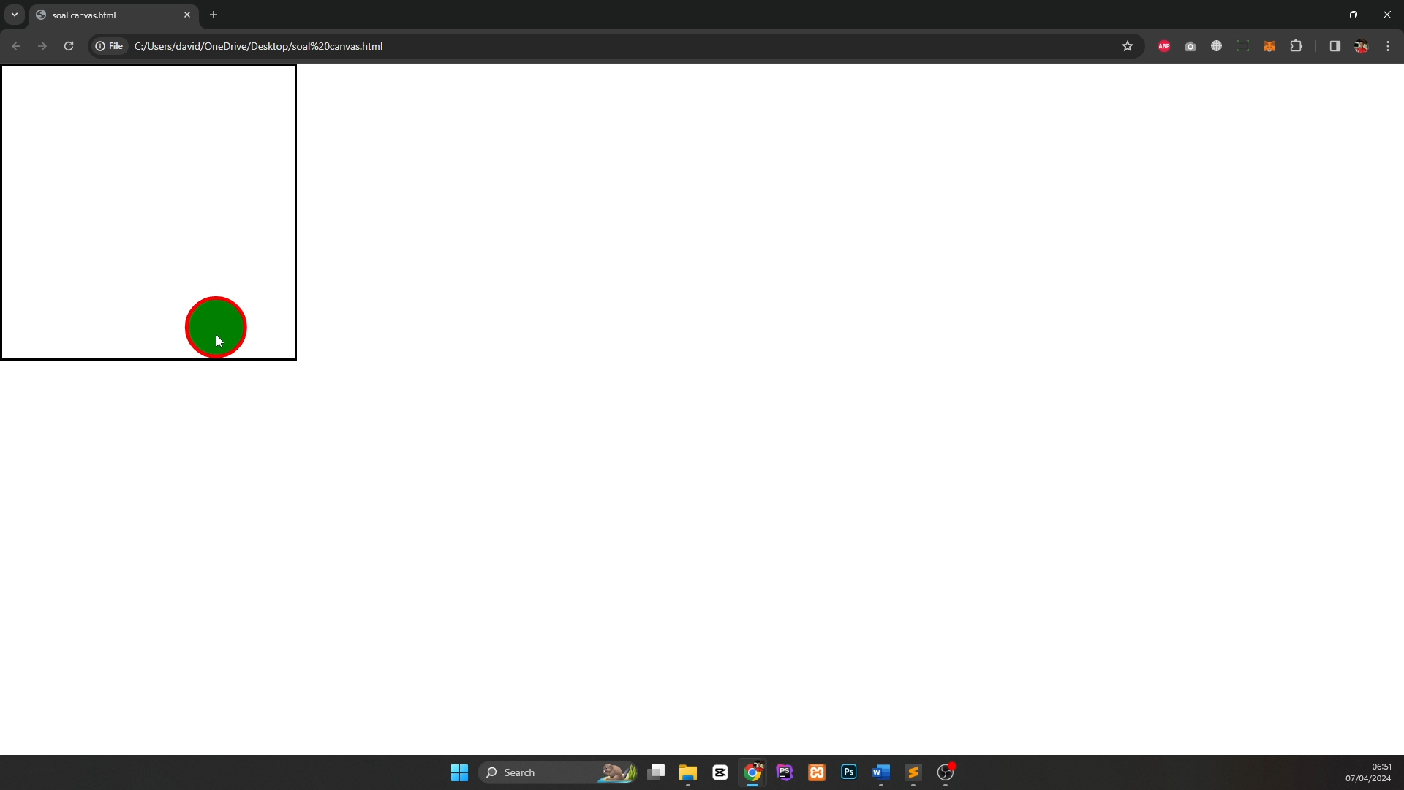

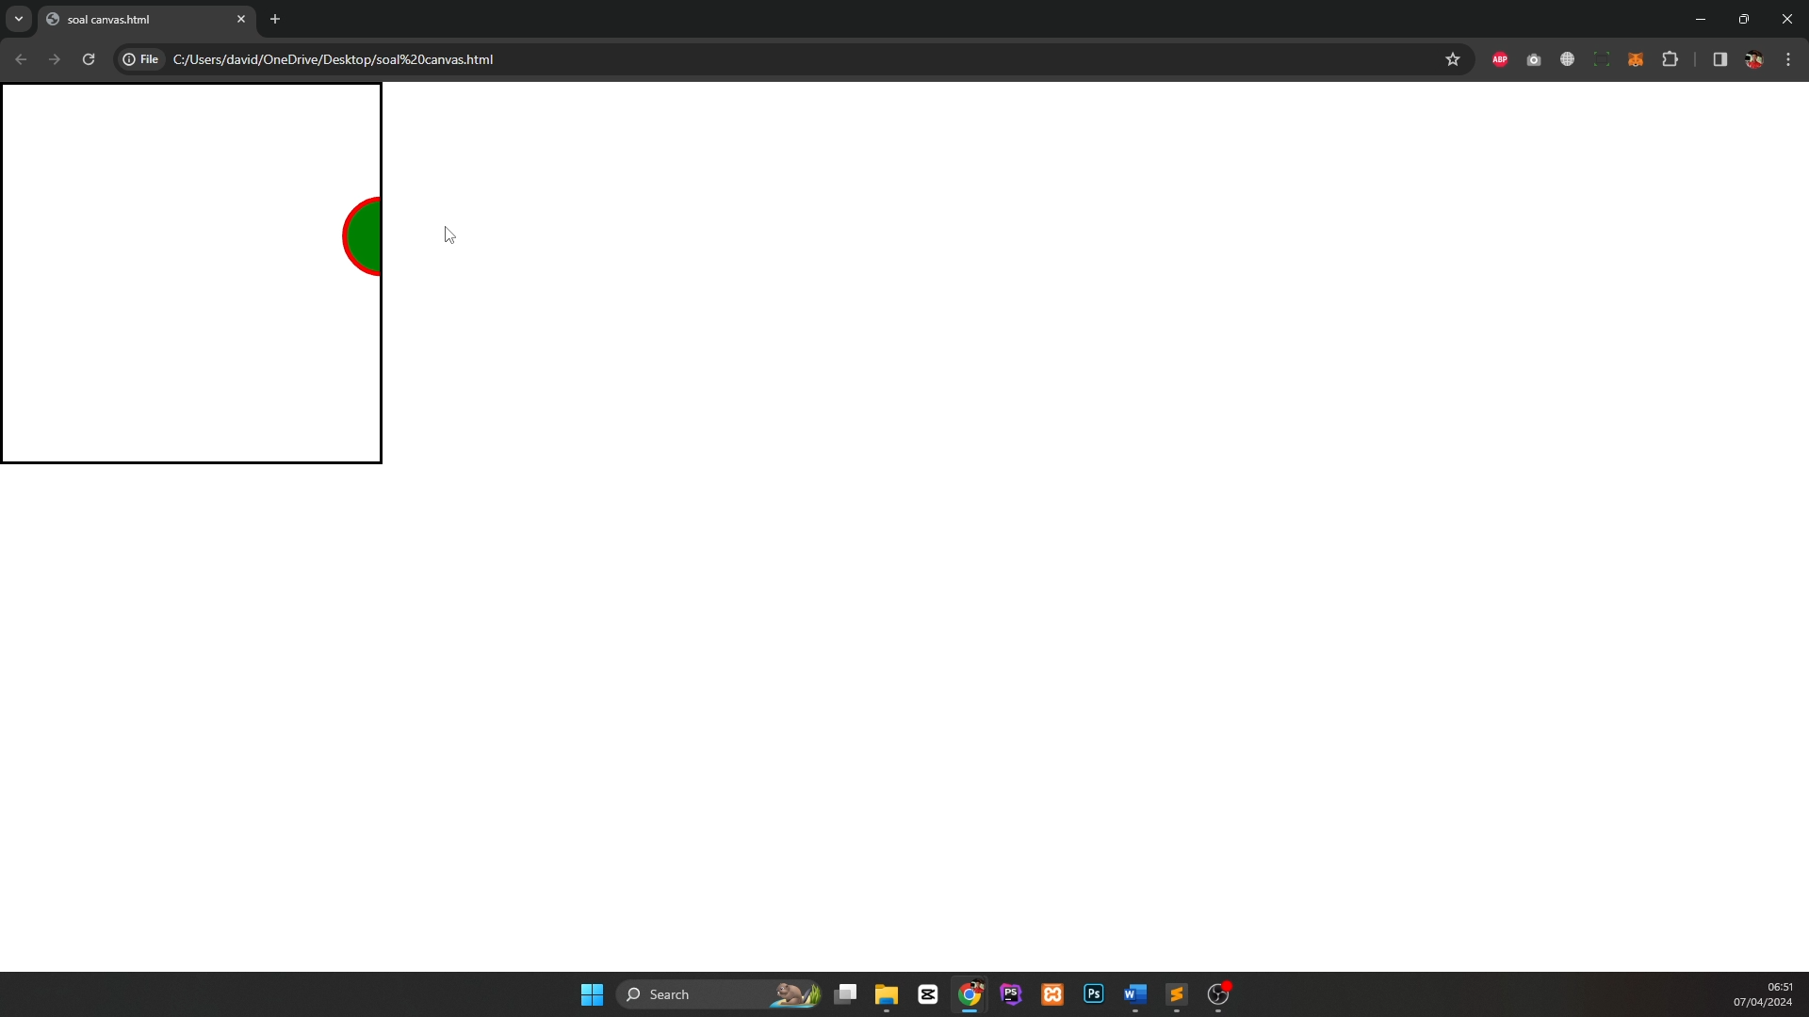

## D1. Bar Chart

"random.php" that generates random data to create charts is provided.

Draw a bar chart using all data from "random.php".

* Y tick labels (vertical axis number) must not have a decimal point, and there must be at least 5.
* The number of bars is randomly selected between 5 and 15.
* The color of the bars is applied randomly.
* For X Axis Data Labels, name must appear

**random.php data**

[ { name: "Charlotte", value: 380, }, ... ]

**Example**

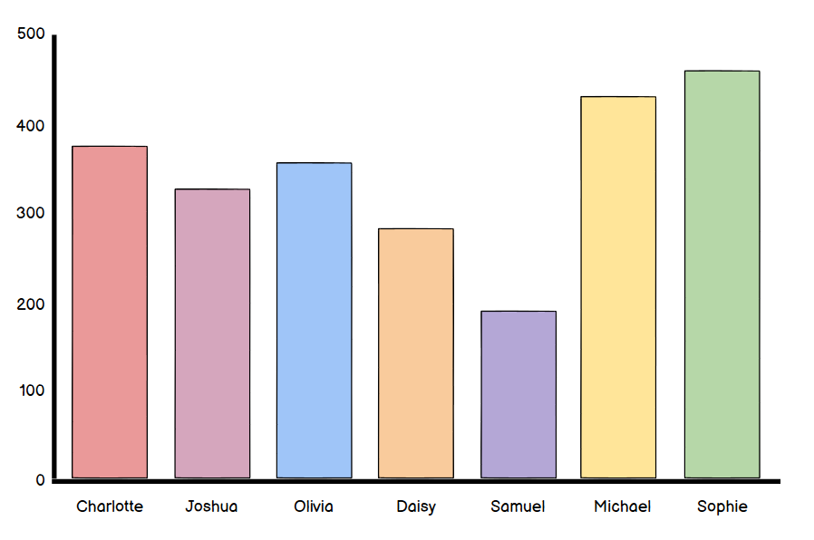

## D2. Generate File DOC

* In a form you must insert a title and then its content, when submitting the form you must download a DOC document where you can open it and view the content in the DOC file.
* The file must be called as the title of the form.
* The content must be included in the file with its respective title and paragraph.

Example video: **create_file.mp4**

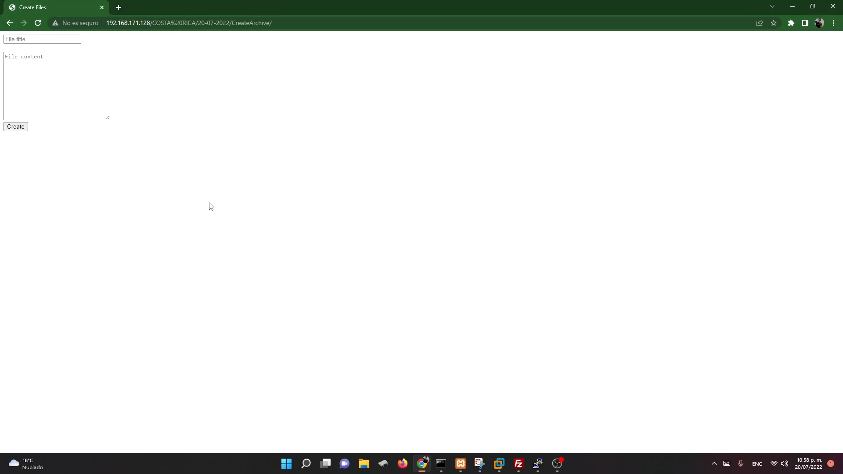  
An HTML_TO_DOC PHP class is provided.

## E1. Answer Checker

You are provided with two CSV files. One file contains the actual answers, and the other file contains the submitted answers. You are expected to develop a web page, displaying a table showing the question number, actual answer and submitted answer. At the bottom of the table, display the scores for this submission. Eg, if there are 8 correct answers and there are 10 questions. Display the score as “8/10”.

Screen shot:

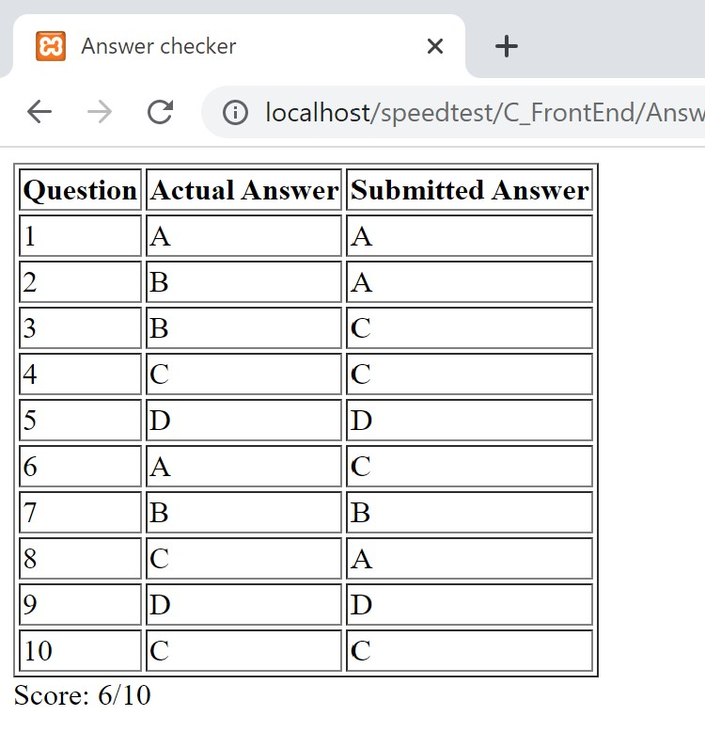

## E2. Array Manipulation

Create an array containing the numbers 1 to 40. When the file is run using index.php?factor=n, the content of the array changes to indicate which are the numbers that are multiple of n.

Example: For example index.php?factor=4

