Places Image Gallery 1.0.0

Software Needs Assessment

Prepared for
The World Wide Web

Prepared by
Alexander Fuller
Alexfuller60@gmail.com

Last Updated: | November 18, 2016
Document Version: | 1.0.0
Document: | 0000.doc

Table of Contents
Version History 1
1.0 Introduction 2
1.1 Purpose 2
1.2 Scope 2
1.3 References 2
1.4 Overview of Document 3
2.0 System Overview 3
2.1 Project Perspective 3
2.2 System Context 3
2.3 General Constraints 3
2.4 Assumptions and Dependencies 3
3.0 Domain Model 3
3.1 Class Diagrams 4
3.2 Class Specifications 4
4.0 Throw-Away Prototyping 4
5.0 Requirements 4
5.1 Use Case Requirements 4
5.1.1 Actor List 4
5.1.2 Use Case Diagrams 5
5.1.3 Use Case Specifications 6
5.1.4 Use Case Standard Template 7
5.2 Business Rules 7
5.3 Non-Functional Requirements 7
5.3.1 System Requirements 7
5.3.2 Usability Requirements 8
5.3.3 Performance Requirements 8
5.3.4 Security Requirements 8
5.3.5 Delivery Requirements 8
5.3.6 Legal Requirements 8
5.3.7 Interoperability Requirements 8
5.3.8 Scalability Requirements 8
5.3.9 Data Retention Requirements 8
5.4 Interface Requirements 8
5.4.1 Machine Interfaces 8
5.4.2 External System Interfaces 8
5.4.3 Human-Computer Interface Considerations 9
5.4.4 Input and Output Requirements 9
6.0 Project Issues 9
6.1 Projected Development Effort 9
6.2 Proposed Project Schedule 9
6.3 Conversion / Load Requirements 9
6.3.1 Data Population 9
6.3.2 Reference tables and Baseline Data 9
6.3.3 Data Conversion Strategy 9
6.3.4 Data Conversion Assumptions and Constraints 9
7.0 Appendices 9
Sign-Off 11

Version History
Document Version | Date | Author(s) | Details/Description
1.0.0 | 2016-11-18 | Alexander Fuller | Initial version; whole document

Introduction

Purpose
The purpose of this document is to give a detailed description of the requirements for the application software, both for the client and developer. It will also explain system constraints, interface and interactions with external hardware and software.

Scope
The purpose of this software is to allow the end user to view images of cool destinations. The end user has the ability to register and login to make comments about these destinations.

References
http://www.cse.chalmers.se/~feldt/courses/reqeng/examples/srs_example_2010_group2.pdf

Overview of Document
The remainder of this document includes 4 chapters and appendixes.

Chapter 2 will talk about how my application works and general constraints.

Chapter 3 will outline the class diagram for this software and explain different classes role and how they fit into the software to make it work.

Chapter 4 Prototype Throwaways - This will go through the different phases of my application design and structure

Chapter 5 will talk about different actors the software will need. Use cases will be presented for these actors. It will also talk about functional/non-functional requirements of the software and HCI concepts of the software.

Chapter 5 will mention any additional information or references.

System Overview

2.1 Project Perspective
This software will display locations through a JSON file and store users and comments in firebase.

System Context

This system is provided to allow the end user to share questions, thoughts, experiences of very cool places around the world.

General Constraints

Constraints

This Application must have JavaScript to work. We are using Angular JS which is the heart of the application and what makes it work.

Developer Constraints

Assumptions and Dependencies
Assumptions
- Users will find the destinations very cool and will want to leave a comment about it.

-Website will be accessed via desktop, tablet or phone.

-Most users will be using a modern browser and have JavaScript enabled.

Client Dependencies
JavaScript enabled

Modern web browser

Developer Dependencies
Firebase
Cloud storage of authenticated users and comments they post.

Angular
Enables routing for our application to render different template views inside the html. Also enables us to load our JSON data and push data to firebase.

Domain Model

Class Diagram
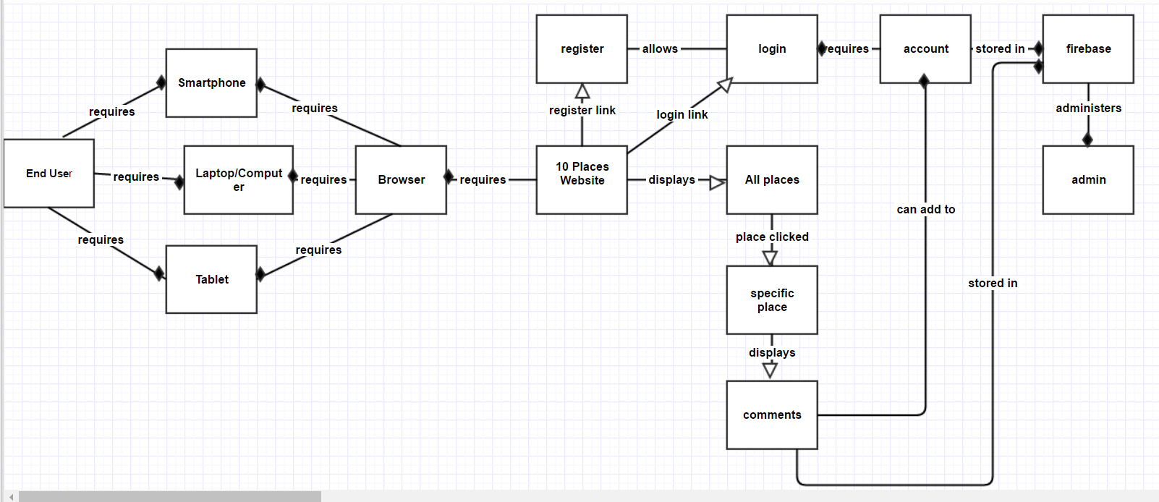

Class Specifications

End User – The end user who is going to use a browser

Smartphone – device the end user is going to use to a browser

Laptop/Computer – device the end user is going to use a browser

Tablet – device the end user is going to use a browser

Browser – system the end user will use to view my website

10 Places Website – the title of my website

Login – login page of my website

Register – register page of my website

All Places – default page of my website that displays all places

Specific Place – displays specific page with comments based on place clicked in ‘All Places’

Comments – comments authenticated users write on a specific place

Account – enables you to be authenticated and write comments, requires registration

Firebase – this is where end users and comments are stored

Admin – person who manages firebase

Throw-Away Prototyping
Below is an early version of my site. I threw this design away because I figured the gray color scheme was kind of boring for this gallery and I realized I don’t need to really have a ‘home’ link since the title of my website is the home link and tells you exactly what it is. Also, there is only 2 primary displays, so users shouldn’t have trouble getting to the home page. The specific page has a button that will take you back to the home page where all places are displayed.

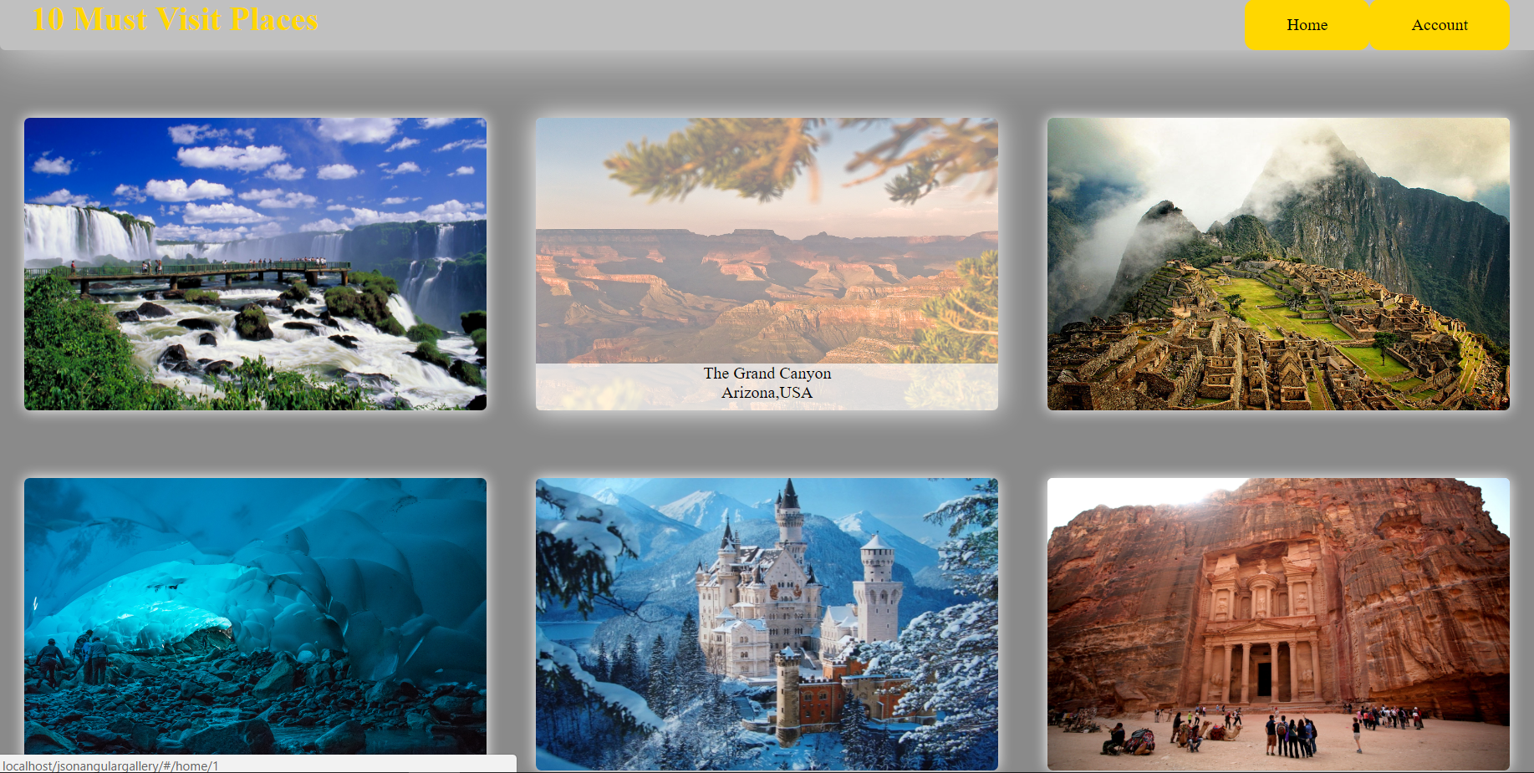

Requirements

Use Case Requirements

Actor List

Actor Goal Priority
Firebase Will store comments and users 3
Developer will configure application 1
Client Will be interacting with the application 4
Angular Will display content to the view with its functionality 2
Browser/Device Will display app 5
…

Use Case Diagrams

Use Case ID: PlacesGallery_00
Version: 1.0.0
Name: Developer
Description: configures applications functionality and UI

Level: Full Case

Primary Actor
- Developer

Preconditions
- Must have angular library
- Must have firebase account

Main Success Flow
# | Description
1 | Developer starts project
2 | Developer sets up project structure
3 | Developer sets up firebase
4 | Developer creates app

Use Case ID: PlaceGallery_02
Version: 1.0.0
Name: Firebase
Description: User will give the app storage for accounts and comments

Level: Full Case

Primary Actor
- Developer
- Firebase

Preconditions
- Must have an administrator (Developer)

Main Success Flow
# | Description
1 | Developer creates firebase account
2 | Developer creates and manages database

Use Case ID: PlaceGallery_03
Version: 1.0.0
Name: Client
Description: Will be interacting with the application

Level: Full Case

Primary Actor
- Client

Preconditions
- Must have a smartphone, tablet, or computer/laptop
- Must have internet
- Must be using a modern web browser

Main Success Flow
# | Description
1 | Client visits website
2 | Client registers and makes an account
3 | Client posts comments on places

Use Case ID: PlacesGallery_04
Version: 1.0.0
Name: Angular
Description: heart of the application that will make it work and display data
Level: Full Case

Primary Actor
- Angular

Preconditions
- Angular library

Main Success Flow
# | Description
1 | Angular generates dynamic content on web page
2 | Angular retrieves JSON data
3 | Angular configures routes for different views

Use Case ID: PlacesGallery_05
Version: 1.0.0
Name: Browser
Description: will display application
Level: Full Case

Primary Actor
- Browser

Preconditions
- Modern web browser
- Modern tablet or smartphone

Main Success Flow
# | Description
1 | URL is typed in the search bar or link to website is clicked
2 | Browser displays website

Business Rules
This Section is not required for the Software Needs Assessment.

Non-Functional Requirements
-The web site should be easy to use by all clients.

System Requirements

-Windows, Linux or Mac operating system

-smartphone

-Modern internet browser, ie9+

-Browser running JavaScript

Usability Requirements
 Public Checked

Performance Requirements
This Section is not required for the Software Needs Assessment.

Security Requirements
This section is not required for the Software Needs Assesment.

Delivery Requirements
This Section is not required for the Software Needs Assessment.

Legal Requirements
This Section is not required for the Software Needs Assessment.

Interoperability Requirements
This Section is not required for the Software Needs Assessment.

Scalability Requirements
This Section is not required for the Software Needs Assessment.

Data Retention Requirements
This Section is not required for the Software Needs Assessment.

Interface Requirements

Machine Interfaces
This Section is not required for the Software Needs Assessment.

External System Interfaces
 Yes
 No

User Interfaces

The places will be displayed in a 3-column grid structure for desktop/tablet view and a single column structure for mobile.

Human-Computer Interface Considerations

I decided to use a theme of dark green to represent an earthly color which can be associated with cool landscapes of earth, which is what a lot of my destination images are. A lot of images in my gallery has some shades of green from trees, etc.

In my navigation bar, I only have 2 links, the first link is the title of the website ’10 MUST VISIT PLACES’ is a link back to the home page that displays all of the destinations. I figured this was better then including a home link in addition to the title link. The title makes it obvious of where clicking it will take you too.

The second link is the account link that has a sub display of register/login if you hover over it. If you are logged in this account link will display as your login name and have a logout sub link on hover. This is better then having them all displayed as top level links and provides less clutter.

Input and Output Requirements

Input requirements:
Users will add comments to pictures of the destinations

Output requirements:
Users can click on images in the main display to show a larger version of the image.

Projected Development Effort
This project is projected to take a few days. I am already familiar with the technologies I am going to use to build this interactive gallery.

Conversion / Load Requirements

Data Population

This Section is not required for the Software Needs Assessment.

Reference tables and Baseline Data
This Section is not required for the Software Needs Assessment.

Data Conversion Strategy
This Section is not required for the Software Needs Assessment.

Data Conversion Assumptions and Constraints
This Section is not required for the Software Needs Assessment.

Appendices

Sign-Off

Name | Signature |  | Date
 | Business Area Representative
Name | Signature |  | Date
 | Ministry Project Manager, IMB
Name | Signature |  | Date
 | Vendor Project Manager
Name | Signature |  | Date
 | Architecture Group, IMB
Name | Signature |  | Date
 | Data Administration, IMB
Name | Signature |  | Date
 | Database and Middleware Services, IMB
Name | Signature |  | Date
 | Server Infrastructure, IMB
Name | Signature |  | Date
 | Workstation Infrastructure, IMB
Name | Signature |  | Date
 | Deliveries, IMB

