React-Redux Task List
Version 1.0.0

Software Needs Assessment

Prepared for
World Wide Web

Prepared by
Alexander Fuller
Alexfuller60@gmail.com

Last Updated: | November 25, 2016
Document Version: | 1.0.0
Document: | 0000.doc

Table of Contents
Version History 1
1.0 Introduction 2
1.1 Purpose 2
1.2 Scope 2
1.3 References 2
1.4 Overview of Document 3
2.0 System Overview 3
2.1 Project Perspective 3
2.2 System Context 3
2.3 General Constraints 3
2.4 Assumptions and Dependencies 3
3.0 Domain Model 3
3.1 Class Diagrams 4
3.2 Class Specifications 4
4.0 Throw-Away Prototyping 4
5.0 Requirements 4
5.1 Use Case Requirements 4
5.1.1 Actor List 4
5.1.2 Use Case Diagrams 5
5.1.3 Use Case Specifications 6
5.1.4 Use Case Standard Template 7
5.2 Business Rules 7
5.3 Non-Functional Requirements 7
5.3.1 System Requirements 7
5.3.2 Usability Requirements 8
5.3.3 Performance Requirements 8
5.3.4 Security Requirements 8
5.3.5 Delivery Requirements 8
5.3.6 Legal Requirements 8
5.3.7 Interoperability Requirements 8
5.3.8 Scalability Requirements 8
5.3.9 Data Retention Requirements 8
5.4 Interface Requirements 8
5.4.1 Machine Interfaces 8
5.4.2 External System Interfaces 8
5.4.3 Human-Computer Interface Considerations 9
5.4.4 Input and Output Requirements 9
6.0 Project Issues 9
6.1 Projected Development Effort 9
6.2 Proposed Project Schedule 9
6.3 Conversion / Load Requirements 9
6.3.1 Data Population 9
6.3.2 Reference tables and Baseline Data 9
6.3.3 Data Conversion Strategy 9
6.3.4 Data Conversion Assumptions and Constraints 9
7.0 Appendices 9
Sign-Off 11

Version History
Document Version | Date | Author(s) | Details/Description
1.0.0 | 2016-11-25 | Alexander Fuller | Initial version; whole document

Introduction

Purpose
The purpose of this document is to give a detailed description of the requirements for the application software, both for the client and developer. It will also explain system constraints, interface and interactions with external hardware and software.

Scope
The purpose of this software is to allow users to have a manageable list to add tasks that need to be completed with the ability to add new tasks or hide completed ones. Users can have the option to display all tasks or just tasks that are not completed yet. These tasks are stored in local storage so the data is persistent. Building this software also helped introduce me to using redux with react which is a way we can maintain state and actions of our components.

References
http://www.cse.chalmers.se/~feldt/courses/reqeng/examples/srs_example_2010_group2.pdf

Overview of Document
The remainder of this document includes 4 chapters and appendixes.

Chapter 2 will talk about how my application works, general constraints faced on both the client and developer side as well as assumptions and dependencies on the client and developer side

Chapter 3 will outline the class diagram for this software and explain different classes role and how they fit into the software to make it work. Once again, on the client and developer side.

Chapter 4 Prototype Throwaways - *not required for this Needs Assessment*.

Chapter 5 will talk about different actors the software will need. Use cases will be presented for these actors. It will also talk about functional/non-functional requirements of the software and HCI concepts of the software.

Chapter 5 will mention any additional information or references.

System Overview

2.1 Project Perspective
This software will only have client side functionality, but data is persistent with local storage. In this project, Redux is used with React which gives us another way to maintain state and actions for our components in React.

System Context

This system is provided to allow the end user to quickly jot down tasks with the ability to add or hide tasks.

General Constraints

Constraints

This Application must have JavaScript to work. With React JS, most of the content in the view/html is actually created through JavaScript with a virtual DOM including the functionality.

Assumptions and Dependencies
Assumptions

-Website will be accessed via desktop, tablet or phone.

-Most users will be using a modern browser and have JavaScript enabled.

Dependencies

-React
Allows us to build our interface in small manageable components that can change data and view.

-Babel
Babel will allow us to use ES6 and JSX in our JavaScript that will be interpreted into es5.

-JSX
Used to create components more easily by allowing us to use XML like syntax in our JavaScript.

-ES6
Newer JavaScript syntax that allows us to do common JavaScript functions more easily. Babel is required for ES6 to make sure it is compiled into ES5 so all browsers are able to read it.

-Webpack
Webpack will bundle our code into a single bundle.js file and help split up our project

-Redux
Redux is separate from React but it works really well with React. We can use Redux to create a store which will maintain the state of our components instead of maintaining state within the components.

3.0 Domain Model

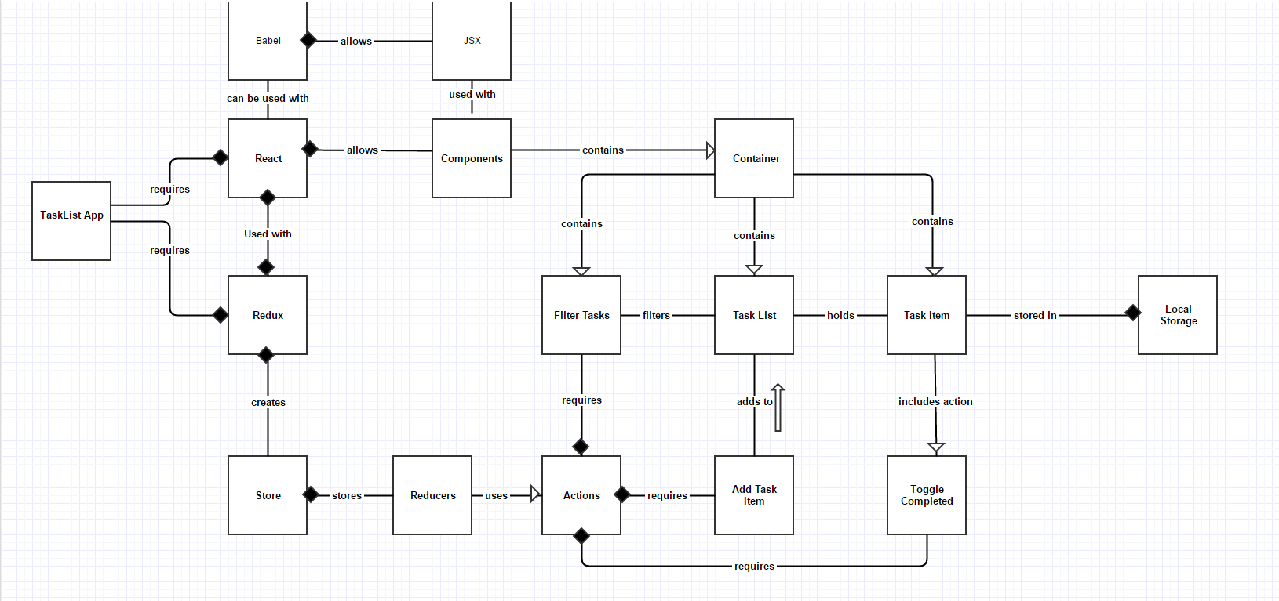

3.5 Class Specifications

Task List App – Our application that will mainly require react and redux

React - Allows us to build the application in components

JSX – Allows us to build components with XML like syntax. Requires Babel to use.

Components – Structure of our application. Requires React.

Babel – Allows us to use JSX with components and make sure browsers can read ES6 syntax.

Redux – Allows us to store the state and actions of our component in a store.

Store – Holds our components state and actions with reducers. Requires Redux.

Reducers – Used to process and run the state/actions we put in the store for the components.

Actions – Actions that will change the state of our components. Our reducers will use these actions to run the state in the components.

Add Task Item – One of the actions of the application that is defined in our store that will add a task to the list.

Toggle Completed – One of the actions of the application that is defined in our store that will enable us to toggle completed/uncompleted for individual task items.

Container – Parent component that holds all of our child components.

Task Item – Component that represents each task item

Task List - Component that holds our task items together

Filter Task – One of the actions of the application defined in our store that will allow us to filter out all completed tasks and vice versa. Also, a component.

Local Storage – Where our task items will be saved so data is persistent. Users can clear history > hosted app data to remove their task items.

4.0 Throw Away Prototyping

this section is not required

5.0 Requirements

Use Case Requirements

Actor List

Actor Goal Priority
Developer Will configure app 1
Webpack Will run local server to run app 2
React Will allow app to be split into components 3
Redux Will return state for components 4
Components Will display content to the view with its functionality 5
Browser/Device Will display app 6
Client Will use app to add tasks and delete them 7
…
Use Case ID: React-Redux_00
Version: 1.0.0
Name: Developer
Description: configures applications functionality and UI

Level: Full Case

Primary Actor
- Developer

Preconditions
- Must have node installed
- Must have react libraries
- React Tools Extension recommended

Main Success Flow
# | Description
1 | Developer starts project
2 | Developer sets up environment – webpack, react etc.
3 | Developer creates app

Use Case ID: React-Redux_01
Version: 1.0.0
Name: Webpack
Description: User will bundle code into a single bundle.js file and help modularize the project

Level: Full Case

Primary Actor
- Developer

Preconditions
- Must have node installed

Main Success Flow
# | Description
1 | Developer downloads node
2 | Developer opens up project folder
3 | Developer installs webpack

Use Case ID: React-Redux_02
Version: 1.0.0
Name: React
Description: Will allow app to be split into components

Level: Full Case

Primary Actor
- Developer

Preconditions
- Must include React Library
- Must include React-DOM Library

Main Success Flow
# | Description
1 | Developer includes React Libraries
2 | Developer starts making components

Use Case ID: React-Redux_03
Version: 1.0.0
Name: Redux
Description: Will allow state of components to be stored in a store

Level: Full Case

Primary Actor
- Developer

Preconditions
Node

Main Success Flow
# | Description
1 | Developer has node
2 | Developer installs redux
3 | Developer creates store

Use Case ID: React-Redux_04
Version: 1.0.0
Name: Components
Description: will split up app into logical pieces
Level: Full Case

Primary Actor
- Developer

Preconditions
- React library
- React-DOM library

Main Success Flow
# | Description
1 | Developer makes form-wrapper component
2 | Developer makes list-items component
3 | Developer makes list item component
4 | Developer makes add-item component

Use Case ID: React-Redux_05
Version: 1.0.0
Name: Client
Description: will view and interact with application
Level: Full Case

Primary Actor
- Client

Preconditions
- Modern web browser
- Modern tablet or smartphone

Main Success Flow
# | Description
1 | Client uses their device and searches for app
2 | User adds list items to app
3 | User checks off completed items

Use Case ID: React-Redux_06
Version: 1.0.0
Name: Display/Browser
Description: will display the application, whether in a web browser, smart phone or tablet.
Level: Full Case

Primary Actor
- Device/Browser

Preconditions
- IE9+, Modern web browsers
- Android, IOS, Windows smart phones
- smart tablets

Main Success Flow
# | Description
1 | Client searches for app in device
2 | device/browser displays app

Business Rules
This Section is not required for the Software Needs Assessment.

Non-Functional Requirements
-The web site should be easy to use by all clients and should be great for mobile.

-application should have good response time to user input.

System Requirements

-Windows, Linux or Mac OS

-Smart Phone

-Modern Internet Browser, IE9+

-Browser running JavaScript

Usability Requirements
 Public Checked

Performance Requirements
This Section is not required for the Software Needs Assessment.

Security Requirements
This section is not required for the Software Needs Assesment.

Delivery Requirements
This Section is not required for the Software Needs Assessment.

Legal Requirements
This Section is not required for the Software Needs Assessment.

Interoperability Requirements

This application will require react to generate components and their functionality to the view, such as add task bar, task list and form wrapper. It will require redux to call actions for these components.

Scalability Requirements
This Section is not required for the Software Needs Assessment.

Data Retention Requirements
This Section is not required for the Software Needs Assessment.

Interface Requirements

Machine Interfaces
This Section is not required for the Software Needs Assessment.

External System Interfaces
 Yes
 No

User Interfaces

The view for mobile and web, tablet will be similar. It will scale out full screen on any device.

Human-Computer Interface Considerations

This Task List app allows users to click on the task item to check it off as completed which will hide it. Users will have the option to show completed tasks if they want. This way users can always go back to see what they checked off and can un check it if it turns out they were not done with that task after all.

This app looks the same on all devices since it is responsive and the form input field is big enough to jot down a task with a lot of text even though most people wouldn’t use a lot of text to add a quick task.

Input and Output Requirements

Input requirements:
Users typing into the input bar to add a new task.

Output requirements:
Users can click on the task item to check it off as complete

Projected Development Effort
This project is projected to take a week. While I have a familiarity with React, Redux is new to me.

Conversion / Load Requirements

Data Population

This Section is not required for the Software Needs Assessment.

Reference tables and Baseline Data
This Section is not required for the Software Needs Assessment.

Data Conversion Strategy
This Section is not required for the Software Needs Assessment.

Data Conversion Assumptions and Constraints
This Section is not required for the Software Needs Assessment.

6.0 Appendences

Sign-Off

Name | Signature |  | Date
 | Business Area Representative
Name | Signature |  | Date
 | Ministry Project Manager, IMB
Name | Signature |  | Date
 | Vendor Project Manager
Name | Signature |  | Date
 | Architecture Group, IMB
Name | Signature |  | Date
 | Data Administration, IMB
Name | Signature |  | Date
 | Database and Middleware Services, IMB
Name | Signature |  | Date
 | Server Infrastructure, IMB
Name | Signature |  | Date
 | Workstation Infrastructure, IMB
Name | Signature |  | Date
 | Deliveries, IMB

