Task Tracker Design Package
Current application architecture and class design
CS341-01 Software Engineering | University of Redlands | Fall 2026
Professor Trish Cornez
Alexander Goda and Amanda Cabrera
November 7, 2026

1 Purpose scope and design basis
Task Tracker is a standalone collaborative to-do list application in Java. Multiple users are simulated through separate accounts in one local application. Users register, sign in, sign out, create and manage tasks, assign tasks to registered users, and view tasks they created or were assigned. SQLite accessed through JDBC stores account and task data in one local database file. No external database server or online service is required.
Our design follows the Project I requirements for Java 11 or later, MVC, SQLite/JDBC, JUnit 5, UML and project documentation. Optional deadlines and priority levels extend the core account and task features. Completed-task visibility and attention ordering support the task workspace.
This package documents our application architecture: one JFrame with reusable Swing panels. The Requirements Analysis defines capabilities and use cases; the Testing Report records execution results. The diagrams show the major classes and selected members.
Design choice | Reason and boundary
MVC with separate JDBC DAOs | Views collect input and display results; controllers validate session and permission rules; domain objects describe users and tasks; DAOs issue SQL. This follows the Project I MVC direction.
One local SQLite file | A local database supports account switching on the same computer without an external server. Separate computers do not share live data.
One window with inline forms | Keeps authentication, the dashboard, task editing and account actions inside a consistent application window.
Optional deadline and named priority | Supports planning while allowing tasks without a deadline or assignee. MEDIUM is the default priority.
Encapsulation and small responsibilities | Private domain data and controller permission checks separate business rules from visual helpers. Swing subclasses supply framework inheritance, while model and controller responsibilities remain encapsulated.

2 MVC architecture and responsibilities
Area | Current classes or packages | Responsibility
Bootstrap | tasktracker.Main; view.TaskTrackerUI | Initialize the local schema, construct DAOs and controllers, and launch the Swing UI on the Event Dispatch Thread.
Window and UI coordination | view.ApplicationWindow; view.AppWorkspace | Own the top-level window, prepare the login scene, bind UI actions, coordinate inline navigation, keep task selection by ID and guard unsaved task drafts.
Screens | view.screens.AuthSurface, DashboardSurface, InlineEditorSurface, PasswordChangeSurface, StartupSurface | Present sign-in/registration, the task list and focus panel, task fields, password fields, and startup state. AuthSurface holds a SunsetLoginPanel; it is not a Swing subclass itself.
Controllers | controller.AuthController; controller.TaskController | Maintain the current user, register and authenticate accounts, change a password, retrieve relevant tasks, and enforce task ownership and completion permissions.
Domain model | model.User; model.Task; model.Priority | Represent persistent user identity, task data and valid priority values independently of Swing.
Persistence | data.DatabaseManager; data.UserDAO; data.TaskDAO | Create the schema, open JDBC connections with foreign keys enabled, and perform parameterized account and task queries and updates.
View helpers | view.animation, view.components, view.presentation, view.theme | Provide transitions, controls, strict date presentation, attention ordering and scene rendering. These helpers do not own account or task persistence.

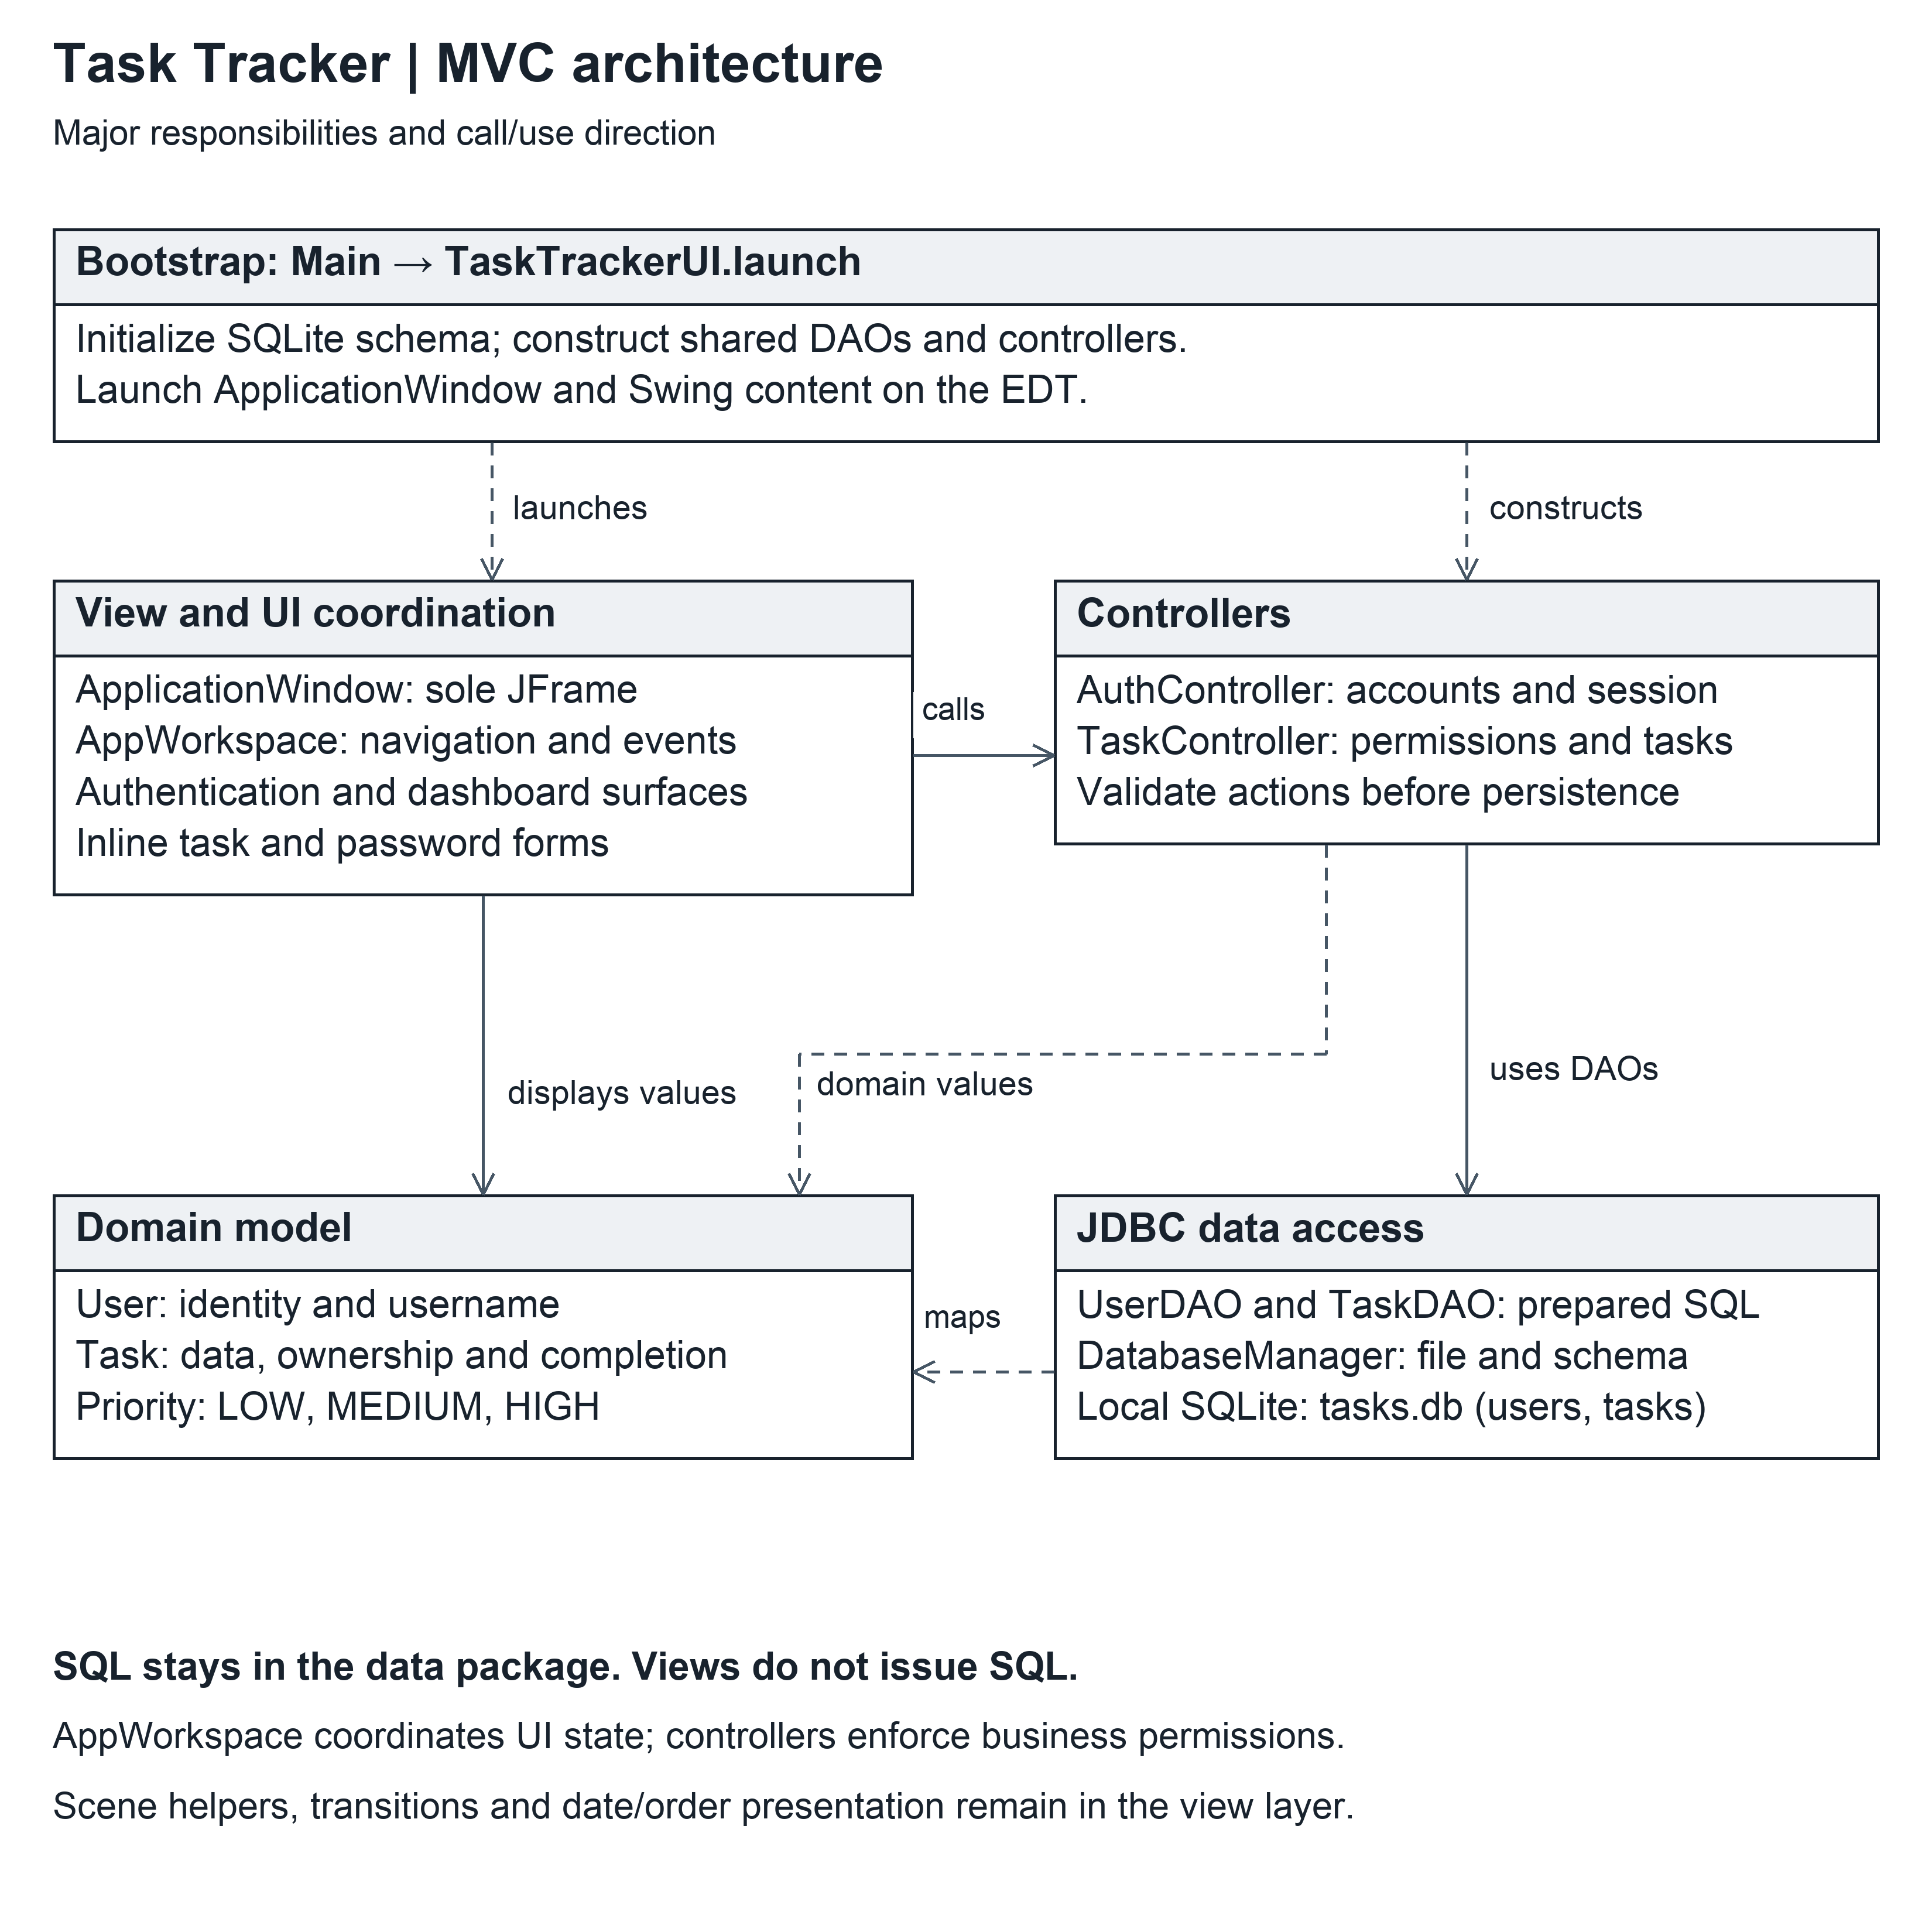
Figure 1. MVC architecture. The UI coordinator calls controllers, controllers use DAOs and domain objects, and DAOs access SQLite through DatabaseManager. Main constructs these dependencies.

Main initializes the database before creating the GUI. It constructs DatabaseManager, UserDAO, TaskDAO, AuthController and TaskController, then schedules UI launch. TaskTrackerUI creates ApplicationWindow, the only top-level JFrame. AppWorkspace is a JPanel installed through transition hosts. A SwingWorker prepares the startup scene, while Swing updates and navigation run on the Event Dispatch Thread. Database initialization errors are reported in the launch console and prevent UI launch; no graphical recovery workflow is provided for that startup failure.
AppWorkspace is a view-layer coordinator, not a replacement for the business controllers. It translates events into controller calls, displays feedback, manages the selected task ID, and decides which form occupies the dashboard focus panel. SQL remains in the data package. AuthController is the session authority; TaskController checks that a user is signed in before task actions and applies creator or assignee permissions before calling TaskDAO.
Interaction | Implemented sequence
Registration and sign-in | The shared authentication surface switches between sign-in and registration. Registration validates matching confirmation in the view and creates an account through AuthController. Creating an account does not sign the user in automatically. Successful sign-in establishes currentUser and opens the dashboard.
Create or edit | An inline editor collects title, notes, optional assignee, optional date and priority. AppWorkspace parses the date and calls TaskController. Domain and controller validation reject invalid data; SQL errors and validation feedback keep the form available for correction.
Task selection and display | The controller retrieves tasks created by OR assigned to the current user. The view applies attention ordering and, by default, hides completed tasks. Focus details show creator, assignee, deadline and named priority permanently.
Complete or reopen | The creator or assignee may change completion. The controller persists the change before the view animates it. The coordinator resolves the stable task ID after a guarded save so a reordered row cannot redirect the action.
Delete | The creator requests deletion and sees inline confirmation. The controller again checks creator ownership before deleting the row.
Unsaved task draft | Actions that would replace or leave a dirty task editor use Save and continue, Discard changes or Keep editing. Invalid saves retain the draft and permit correction. Keep editing preserves the prior selection, completed-filter state and visible list.
Password change | The account menu opens a password form in the focus area. Current password, replacement and confirmation are checked through AuthController; the DAO conditionally replaces the matching stored hash. The existing signed-in session remains active.
Sign out or close | A changed task draft is resolved before sign-out or closure. Sign-out clears the session and returns to authentication. The window closes only after the draft guard permits it.

The task-list display order differs intentionally from the DAO query order. TaskDAO returns incomplete tasks first and then task ID. TaskListOrder.BY_ATTENTION applies the presentation order: incomplete before completed, earliest dated tasks before undated tasks, higher priority before lower priority when the earlier keys tie, and task ID as the final tie breaker. Date groups distinguish Overdue, Today, Tomorrow, Upcoming, No date and Completed. The completed control changes between Show completed and Hide completed with a count.
The scene-based appearance is implemented in the view package. It supports six presets, manual selection and automatic selection based on local time. Appearance choices are session state rather than stored task data. Creator credit appears on startup, authentication and dashboard surfaces. Creator and named priority remain visible in the task focus panel.

3 Database design and persistence rules
The production database defaults to tasks.db relative to the application working directory. Starting Main with the project root as the working directory therefore selects the project’s local database. DatabaseManager also accepts a separate file path for tests. A first run creates missing tables with embedded CREATE TABLE IF NOT EXISTS statements. sql/schema.sql is a matching, human-readable schema reference; Main does not load that file at runtime.
users column | SQLite definition | Meaning
user_id | INTEGER PRIMARY KEY AUTOINCREMENT | Stable persistent user identity.
username | TEXT NOT NULL UNIQUE | Unique account name. The controller trims the supplied name.
password_hash | TEXT NOT NULL | Stored SHA-256 digest of the password; never included in the User domain object.

tasks column | SQLite definition | Meaning
task_id | INTEGER PRIMARY KEY AUTOINCREMENT | Stable task identity assigned on insert.
title | TEXT NOT NULL | Task title; Java validation also rejects blank titles.
description | TEXT | Optional notes. The Java Task model normalizes null notes to an empty string.
creator_id | INTEGER NOT NULL; FK users(user_id) | Exactly one creator; ownership is not changed by task editing.
assignee_id | INTEGER; FK users(user_id) | Zero or one assignee. SQL NULL represents unassigned.
due_date | TEXT | Optional ISO local date, yyyy-MM-dd. SQL NULL represents no date.
priority | TEXT NOT NULL DEFAULT 'MEDIUM'; CHECK IN ('LOW','MEDIUM','HIGH') | One named priority.
completed | INTEGER NOT NULL DEFAULT 0; CHECK IN (0,1) | 0 means open; 1 means completed.

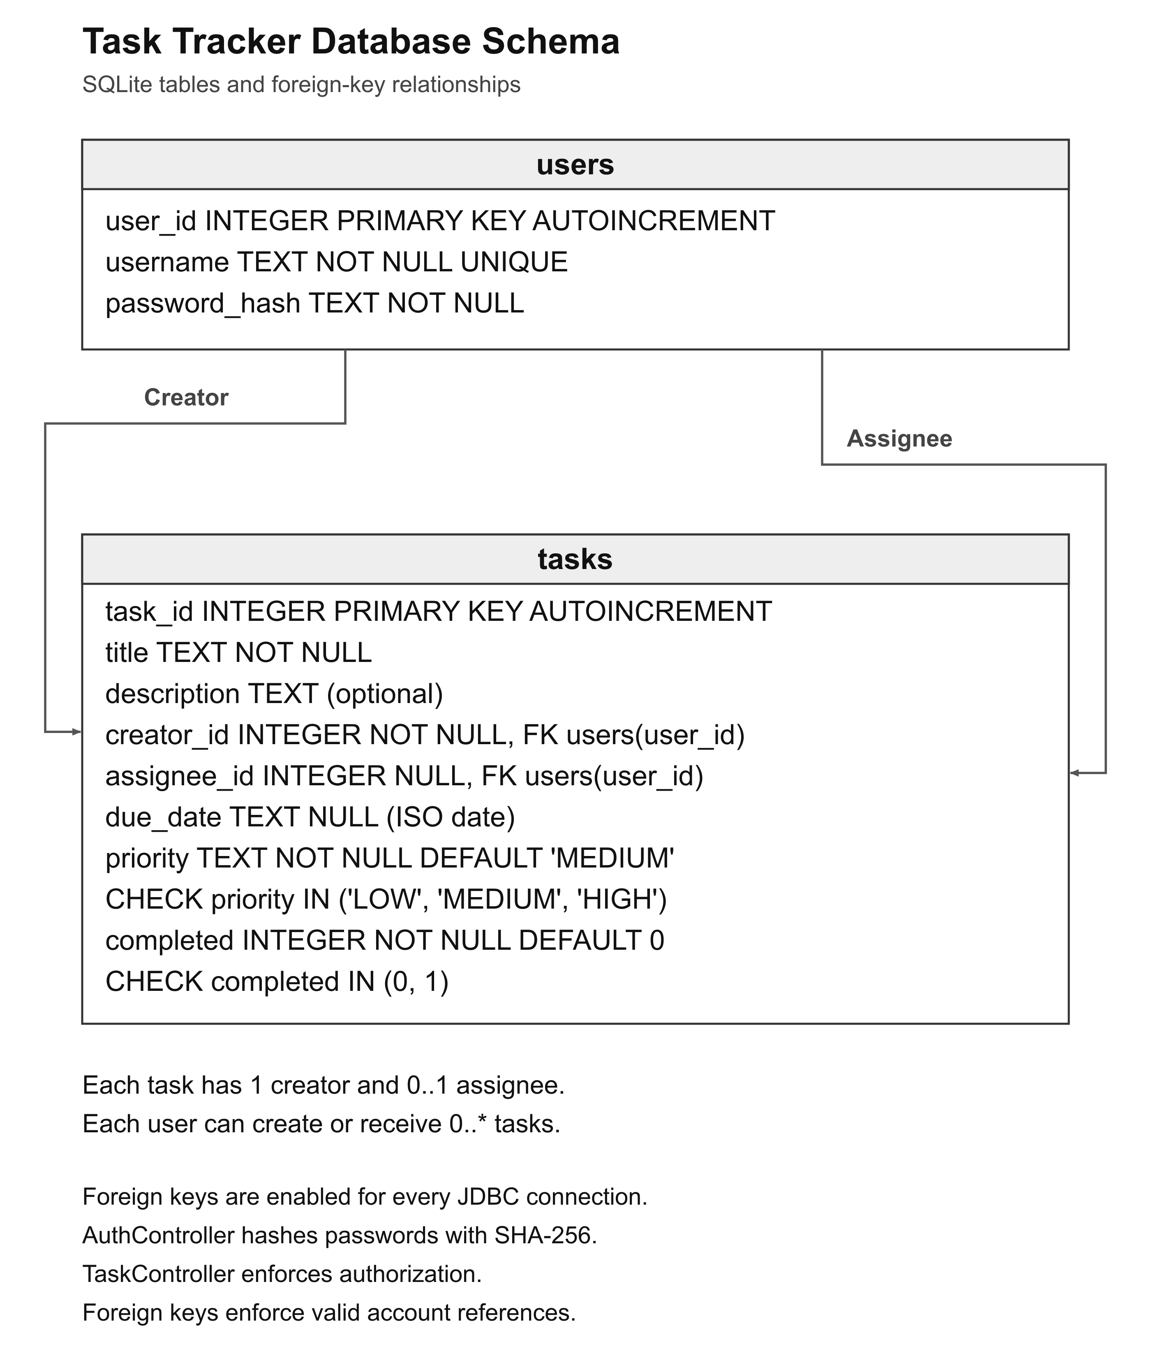
Figure 2. SQLite users and tasks schema. Each task has one creator and zero or one assignee; a user can create or be assigned zero or more tasks.

DatabaseManager enables PRAGMA foreign_keys = ON on every new connection. Creator and assignee references must therefore name existing users when non-null. JDBC statements bind values with PreparedStatement; DAO connections, statements and result sets normally use try-with-resources. Usernames are unique in the schema as well as checked during registration. There is no account-deletion feature, cascading account deletion, external database server or database migration system.
Rule | Enforcement location
A task has one creator and at most one assignee | Non-null creator foreign key and nullable assignee foreign key; Task stores creator as a final User reference.
Only the creator may edit, reassign or delete | TaskController ownership checks. The foreign keys alone do not enforce these permissions.
Creator or assignee may complete or reopen | TaskController creator-or-assignee check.
Relevant list is created-by OR assigned-to | TaskDAO parameterized OR query; a task created by and assigned to the same user appears once.
Optional date and assignee | Nullable columns plus LocalDate/null and User/null model values.
Valid priority and completion values | Priority enum, Task normalization and database CHECK constraints.
Password replacement checks the existing credential | AuthController verifies form input and UserDAO updates only the row matching user ID and current hash.

Dates are stored as ISO text and parsed as LocalDate. The UI accepts a strict US month/day/year date and displays MM/dd/yyyy; leaving the field blank means no deadline. The DAO reports malformed stored dates or priorities as SQL errors rather than silently changing them. The application stores passwords as unsalted SHA-256 hashes. It avoids plaintext storage but is not a production password-storage design and the SQLite file itself is not encrypted.
The application does not include a populated database as a prerequisite for first run. A clean installation should create its own local file and accounts. A personal working database must be kept separate from any fresh-install verification. Testing uses independent temporary database files rather than resetting an existing user database.

4 UML class design
Figures 3, 4A and 4B show selected members of the major classes. A plus sign means public and a minus sign means private. Solid directed associations represent stored object references; dashed dependencies represent use or construction without a stored field. Generalization uses a solid line with a hollow triangle pointing toward the superclass. Multiplicity describes domain associations. Rendering helpers, most Swing fields, serialVersionUID fields and routine accessors are omitted for readability.

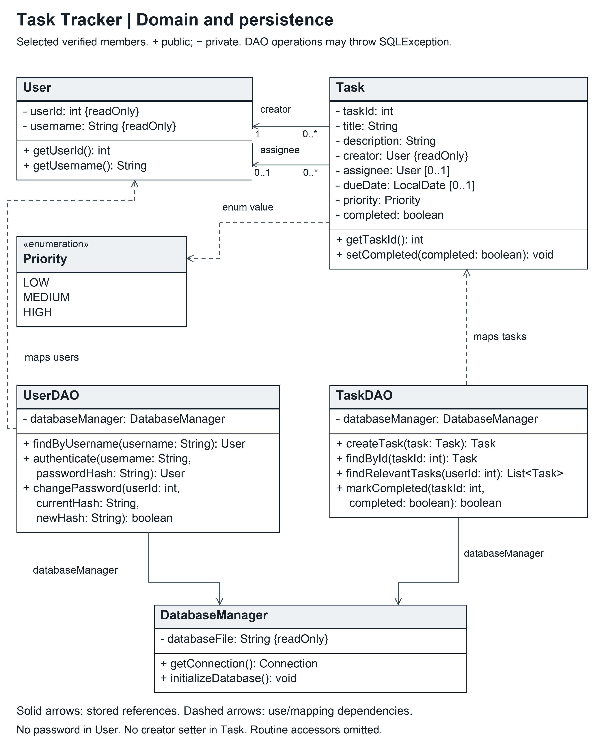
Figure 3. Domain and persistence class diagram, including the UserDAO password-change operation. Selected operations are shown.

Class | Responsibility
User | Immutable positive user ID and trimmed username; equality and hash code use user identity. Password data is excluded.
Task | Task ID, required title, notes, immutable creator, nullable assignee and due date, Priority and completion. New tasks begin with ID 0 until persistence assigns a positive ID.
Priority | LOW, MEDIUM and HIGH enum values. Null input is normalized to MEDIUM by Task.
DatabaseManager | Database file selection, connection creation and foreign-key configuration, and idempotent table creation.
UserDAO | Account creation, lookup, authentication by hash, registered-user listing and conditional password replacement.
TaskDAO | Insert, retrieve, update, assign, complete and delete persisted tasks. Joins reconstruct creator and optional assignee User values.
Class | Responsibility
AuthController | Owns the current session; validates registration and login, hashes passwords, exposes registered users, signs out and changes the current password.
TaskController | Requires a session for task operations, enforces ownership and completion rules, and delegates SQL persistence to TaskDAO.
ApplicationWindow | The sole JFrame; installs startup and workspace content and routes window closing through the workspace guard. It creates its AppWorkspace as a constructor-local value, not as a declared workspace field.
AppWorkspace | JPanel coordinating shared controllers, authentication surface, dashboard, active task editor, loaded tasks, selected ID and pending guarded navigation.
AuthSurface | Plain Java class exposing form controls and a SunsetLoginPanel. Presents the sign-in/registration transition and feedback.
DashboardSurface | JPanel containing the task list and focus area; presents task details, available actions, completed visibility and inline forms.
InlineEditorSurface | JPanel containing task fields, assignee and priority controls, dirty-state snapshot and leave-confirmation controls.
PasswordChangeSurface | JPanel containing current, new and confirmation password fields; clears password contents on cancellation/removal.
The shared AuthController and TaskController references are ordinary associations. TaskController uses AuthController for the session, and DAOs use DatabaseManager. Task has separate creator and assignee associations to User, with multiplicities 1 and 0..1. Figure 4A shows the Swing view inheritance.

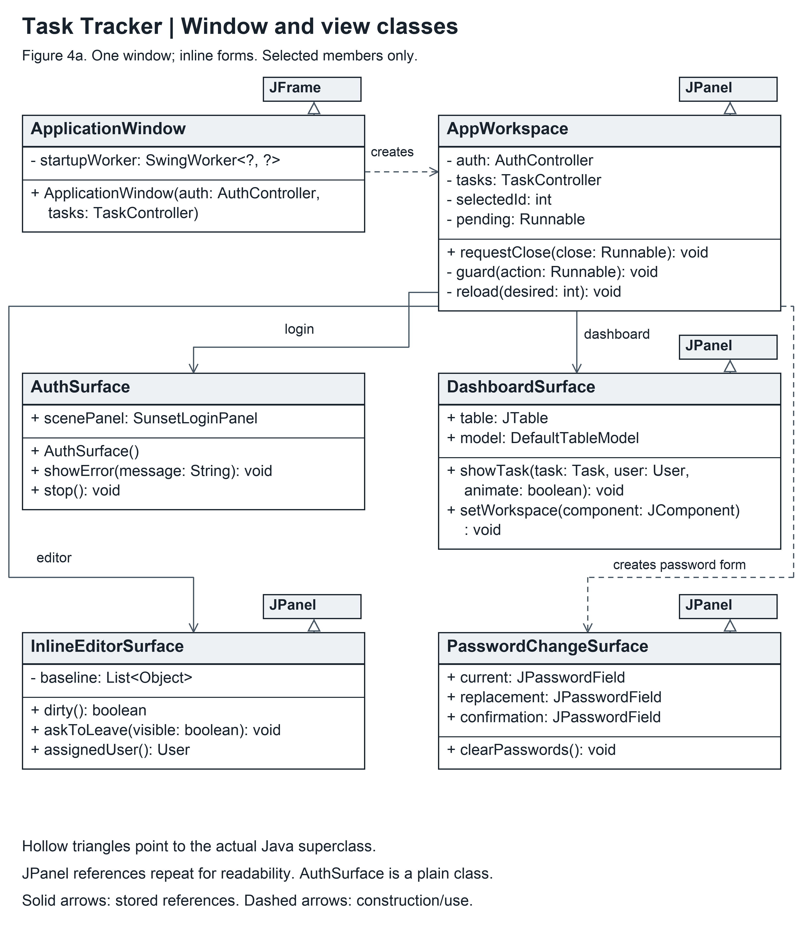
Figure 4A. Current controllers and single-window view design. ApplicationWindow extends JFrame. AppWorkspace and the three dashboard/form surfaces shown extend JPanel. AuthSurface is a plain class containing SunsetLoginPanel, not a JPanel or JFrame subclass.

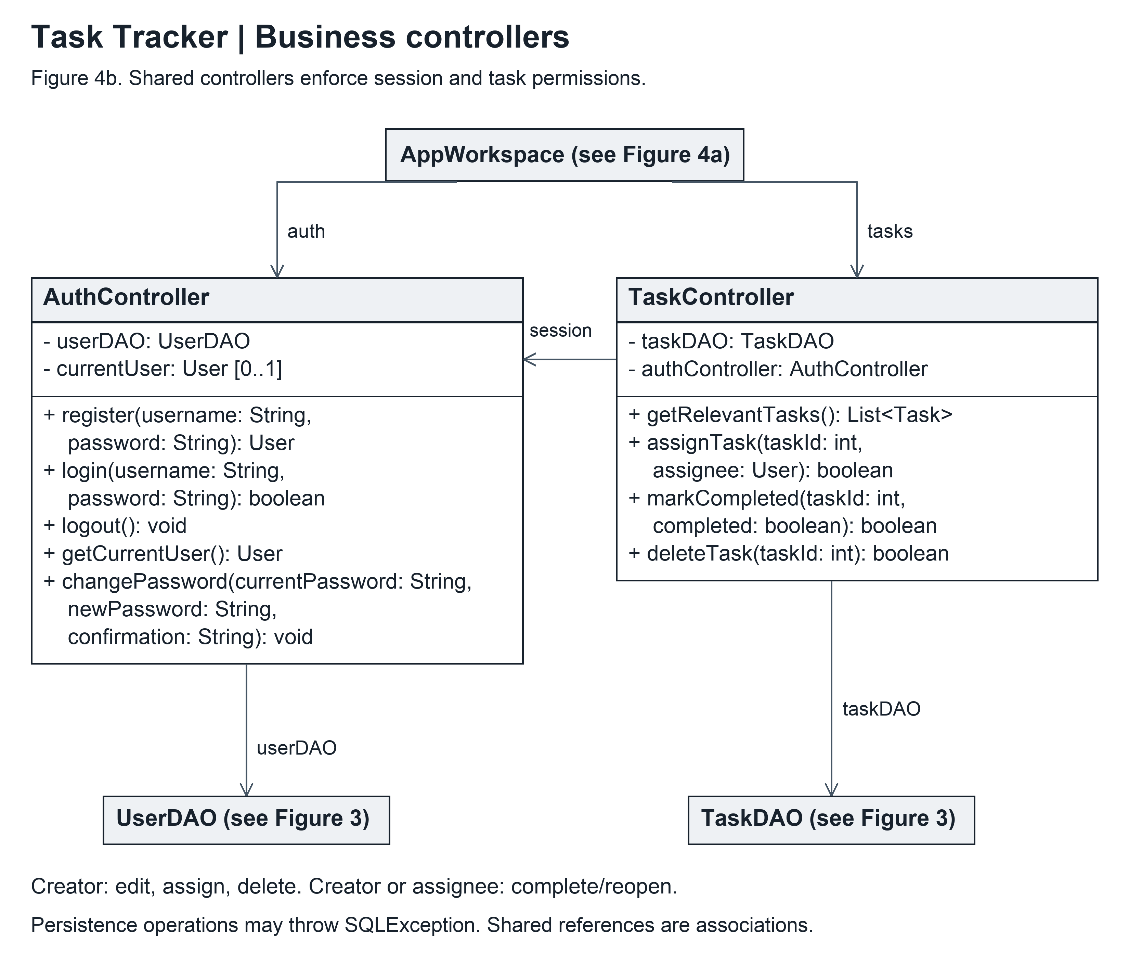
Figure 4B. Business controllers and shared dependencies. AppWorkspace holds AuthController and TaskController; TaskController uses AuthController for the session, and the controllers delegate persistence to DAOs. Selected members are shown.

5 Package structure and execution design
Path relative to the project root | Purpose
src/tasktracker/Main.java | Production entry point and dependency wiring.
src/tasktracker/model/ | User, Task and Priority.
src/tasktracker/controller/ | Authentication/session and task permission rules.
src/tasktracker/data/ | DatabaseManager and JDBC DAOs.
src/tasktracker/view/ | TaskTrackerUI, ApplicationWindow and AppWorkspace.
src/tasktracker/view/screens/ | Current authentication, dashboard, editor, password and startup surfaces.
src/tasktracker/view/components/, animation/, presentation/, theme/ | Controls, transitions, date/order helpers and scene rendering.
test/tester/ | The six JUnit 5 test classes in package tester.
test/tasktracker/view/ | Standalone main-based UI, interaction, rendering and asset checks, separate from JUnit.
assets/scenes/ | Classpath scene images used by the application.
lib/ | Local SQLite JDBC driver and setup instructions; Eclipse supplies JUnit 5 through its configured container.
sql/schema.sql | Readable schema reference matching DatabaseManager.
docs/Requirements/, docs/Design/, docs/ | Requirements, this design package with diagrams, and the testing report.

The project contains 55 production Java files and 31 test/check Java files: six JUnit classes and 25 standalone checks. Application and test sources are organized by package.
The project imports into Eclipse from its root directory and targets Java 11. The src and test source folders, assets resource root, SQLite driver and JUnit 5 container are configured through the project build path. Main is the application entry point. The working directory selects tasks.db. README.md provides the import, launch and test procedures.
New users register locally; no shared credentials or remote service are required at startup. Scene resources load from the classpath, so assets must be included as a runtime resource root. SQLite driver setup is documented in lib/README.txt.

6 JUnit and standalone verification design
JT01 through JT15 identify design scenarios mapped to test sources. Executed test-method counts appear in the Testing Report. JUnit tests use temporary databases for schema creation, persistence, authentication, authorization and password changes without changing the application’s working database.
Design ID | Scenario and current evidence area
JT01 | Database tables and foreign-key behavior: DatabaseManagerTest.
JT02 | Create and find a user: UserDAOTest.
JT03 | Reject a duplicate username: UserDAOTest and AuthControllerTest.
JT04 | Register and sign in successfully: AuthControllerTest.
JT05 | Reject invalid sign-in: AuthControllerTest.
JT06 | Persist task fields and relationships: TaskDAOTest.
JT07 | Update a task: TaskDAOTest and TaskControllerTest.
JT08 | Delete a task: TaskDAOTest and TaskControllerTest.
JT09 | Persist completion status: TaskDAOTest and TaskControllerTest.
JT10 | Retrieve tasks created by OR assigned to a user: TaskDAOTest.
JT11 | Permit creator edit/delete: TaskControllerTest.
JT12 | Reject another user’s edit/delete: TaskControllerTest.
JT13 | Permit assignee completion and reject an unrelated user: TaskControllerTest.
JT14 | Default null priority to MEDIUM: TaskControllerTest through Task creation.
JT15 | Reject a blank title: TaskControllerTest through Task validation.
Additional account coverage | PasswordChangeTest verifies successful password replacement. It also verifies that invalid current-password or replacement input is rejected without changing stored credentials.

Verification results November 7 2026 | Recorded result | What it establishes
JUnit 5, six classes | 33 tests; 0 failures; 0 errors; 0 ignored | Executed unit/integration assertions for model, persistence and controller behavior.
Standalone headless checks | 25 of 25 checks passed | Executed automated interaction, navigation, date, asset and rendering assertions. These are not JUnit tests.
Eclipse clean build | 0 errors; 0 warnings | Eclipse build with the project’s configured compiler and warning settings.
Java 11 compilation/lint and Javadoc | 0 errors and 0 warnings | Language/build compatibility and documentation lint for the checked source.
Application walkthrough | November 7 macOS walkthrough: no issues found. | Manual review of user-facing application workflows.

The Testing Report documents the automated checks and manual walkthrough, including their scope and results.
Relevant standalone checks include ActiveWorkspaceCheck and WorkspaceNavigationCheck for guarded draft navigation and selection, TaskListPresentationCheck for visible creator/priority and grouped rows, ScenePaletteDateCheck for strict dates and the actual editor path, and startup, appearance, menu, transition and completion checks. ActiveWorkspaceCheck injects a scene-preparation failure to verify fallback behavior.

7 Acceptance scenarios
The following acceptance scenarios define expected user-facing behavior.
ID | User scenario | Expected current behavior
AT01 | Register, sign in and sign out | Registration creates a local account, returns to sign-in, successful login opens the dashboard, and logout returns to authentication.
AT02 | Try an existing account name | Readable feedback rejects the duplicate without creating a second account.
AT03 | Create and assign a task | The created task retains title, notes, optional date, priority and registered assignee; it appears for creator and assignee after login/refresh.
AT04 | Edit a task as its creator | Saved fields persist and the list/focus details reflect them.
AT05 | Use a task as an assignee or unrelated user | Assignee cannot edit/reassign/delete; unrelated users do not gain task-management permission.
AT06 | Complete and reopen | Creator or assignee can change status; completed visibility and counts remain consistent.
AT07 | Confirm or cancel deletion | Cancel keeps the task; confirmed creator deletion removes it and clears or restores a valid focus selection.
AT08 | Switch between separate accounts | Only created-by or assigned-to tasks appear; a self-assigned task is not duplicated.
AT09 | Restart using the same intended database | Accounts, task fields and completion survive restart; startup does not reset existing data.
AT10 | Correct invalid input | Blank title, invalid date, bad credentials and invalid form values show feedback without silently discarding valid work.
Additional current scenarios | Unsaved task guard, password change, keyboard and appearance controls | Save, Discard and Keep editing across task selection, completed visibility, refresh, logout and close; password cancellation and replacement; native keyboard controls and scene behavior on macOS.

Fresh-install acceptance uses a separate project/database location and new local accounts. The setup must create the schema without existing credentials or task records. The launch working directory determines which database opens.

8 Requirements to design traceability
This table maps Project I capabilities to the implemented design using the identifiers in the Requirements Analysis. Appearance and keyboard support relate to NFR-01.
Capability | Design evidence | Verification area
Register, log in, log out: FR-01-05; UC-01-03 | AuthSurface; AppWorkspace; AuthController; UserDAO; users table | AuthControllerTest, UserDAOTest and authentication/navigation checks; AT01-AT02.
Create, edit and delete: FR-06-09; UC-04-06 | InlineEditorSurface; AppWorkspace; TaskController; Task; TaskDAO | TaskDAOTest, TaskControllerTest and guarded editor checks; AT03-AT05, AT07.
Assignment: FR-10; UC-07 | Registered-user choice; nullable Task.assignee; creator-only reassignment | TaskDAOTest, TaskControllerTest and actual editor checks; AT03, AT05.
Completion: FR-11; UC-08 | Dashboard action/checkbox; creator-or-assignee rule; persisted completed value | TaskControllerTest, TaskDAOTest and completion interaction checks; AT06.
Relevant viewing and metadata: FR-12-14; UC-09 | Relevant OR query; one record per task; stable task IDs; visible creator and named priority | TaskDAOTest plus workspace/list checks; AT08.
SQLite setup and persistence: FR-17-18; NFR-03,07 | DatabaseManager embedded schema; local tasks.db; parameterized DAOs | DatabaseManagerTest and DAO integration tests; fresh-install and restart acceptance.
Deadlines and priority: FR-15-16; UC-10 | LocalDate, Priority enum, date picker and strict DisplayDates | TaskControllerTest plus ScenePaletteDateCheck and TaskListPresentationCheck; AT03, AT10.
Completed visibility and ordering: FR-21-22; UC-13 | AppWorkspace completed filter; TaskListOrder.BY_ATTENTION; grouped dashboard rows | ActiveWorkspaceCheck and TaskListPresentationCheck; AT06 and the additional acceptance scenarios in Section 7.
Unsaved task draft: FR-23; UC-11 | InlineEditorSurface dirty snapshot; AppWorkspace pending-action guard | WorkspaceNavigationCheck and ActiveWorkspaceCheck; the additional acceptance scenarios in Section 7.
Password change: FR-24; UC-12 | PasswordChangeSurface; AuthController.changePassword; UserDAO.changePassword | PasswordChangeTest and account-form interactions.
Input and feedback: FR-19-20; NFR-01-02 | Domain/controller validation, strict date parser and inline feedback | JUnit invalid-input tests and actual-editor standalone checks; AT10.
MVC and UML | Figures 1-4; package and responsibility tables; no SQL in views | Source code, class relationships and diagrams.
JUnit and test report | Six JUnit classes and separate standalone check package | Current Testing Report with separate 33-test and 25-check results.
Git collaboration and team presentation | External project process and presentation materials | Repository history, individual contribution records and presentation materials.

9 Design tradeoffs and limitations
Choice or limitation | Consequence
Separate controllers and DAOs instead of a monolithic window | Keeps business permissions testable without the scene UI and limits SQL to the data package.
Custom Swing appearance and transitions | The custom appearance adds view helpers and rendering checks. The major-class diagrams show core responsibilities; the source tree provides the complete class inventory.
Single local database with account switching | Matches the course scope. Separate computers do not share live updates automatically.
Synchronous ordinary JDBC actions | Ordinary JDBC operations run synchronously and target the application’s small local workload. Startup scene preparation runs asynchronously.
Unsalted SHA-256 password hashing | Unsalted SHA-256 avoids plaintext storage but is weaker than a salted password-specific hash. The database file is not encrypted.
Session-only appearance state | Scene preferences are presentation choices; a restart need not restore a previous manual appearance.
No account deletion or password recovery | Account deletion and password recovery are outside scope. Tasks retain a required creator and an optional assignee.
Automated checks and manual walkthrough | Verification combined JUnit tests, standalone interface checks and a manual walkthrough on macOS. Test coverage and results are documented in the Testing Report.

10 Primary references
Source | Use in this package
Project I assignment | Core/extra features, Java/JDBC/JUnit, Week 2 MVC/UML/schema, documentation and organized presentation expectations.
Project I handout pages 1-5 | Primary specification for project scope and deliverables.
Lecture Wk5 Day 2a, UML Basics | Class compartments, public/private visibility, associations, multiplicity and the difference between class relationships and algorithmic behavior.
README.md and lib/README.txt | Current import, launch, tests and dependency instructions.
src/tasktracker/ and sql/schema.sql | Authoritative implementation and matching schema reference.
Requirements Analysis and Testing Report in docs/ | Detailed requirements, use cases, test procedures and results.

