CS341 SOFTWARE ENGINEERING
PROJECT I: TASK TRACKER
Week 2 Design Package
MVC Architecture | Database Schema | UML Class Diagrams | Test Outlines

Team: Alexander Goda and Amanda Cabrera
Instructor: Professor Trish Cornez
Course: CS341-01 Software Engineering
Date: October 16, 2026
Version: 1.1 | Final implementation reconciliation: October 16, 2026
Design baseline prepared after completion of the Week 1 Requirements Analysis and successful SQLite/JDBC rapid prototype.
Final reconciliation: October 16, 2026. This revision preserves Week 2 planning and the historical handoff while updating architecture/schema/UML to the finished code and explicitly distinguishing planned tests from recorded results.

1. Purpose and Design Basis
This package defines the Week 2 design baseline for Project I, Task Tracker. It translates the Week 1 requirements into a modular architecture before full implementation begins. The package covers the four items identified in the Project I development guideline for Week 2: MVC architecture, database schema, UML class diagrams, and outlines for JUnit and acceptance testing.
The design is based on the Project I specification, the team's Requirements Analysis, the verified SQLite/JDBC prototype, and Professor Cornez's class guidance to understand the problem first, identify object-oriented elements, compare design possibilities, keep code modular, and test incrementally.

1.1 Design Inputs
- Project I core features: registration, login/logout, task creation/editing/deletion/completion, task assignment, and viewing tasks created by or assigned to the logged-in user.
- Selected extra feature from the Requirements Analysis: optional due dates and priority levels.
- Required technologies: Java JDK 11+, SQLite through JDBC, JUnit 5, Git, and MVC.
- Verified Week 1 prototype result: Java successfully connected to SQLite, created the local database structure, inserted data, read the data back, and passed 2/2 JUnit tests with 0 errors and 0 failures.
- Professor-approved team: Alexander Goda and Amanda Cabrera. Both members will contribute to design, implementation, testing, documentation, Git commits, and the presentation.

1.2 Design Principles Used
- Separate responsibilities instead of placing database, GUI, and business logic in one large class or method.
- Keep the user interface independent from SQL so views can change without rewriting persistence logic.
- Keep database access in small data-access classes so persistence behavior is easier to test.
- Represent the main problem nouns as domain classes and the required actions as controller/data-access operations, consistent with the course UML analysis method.
- Design top-down, then implement and test bottom-up in small pieces.

2. MVC System Architecture
The Project I specification directs the team to use MVC. The selected architecture separates the desktop user interface (View), application decisions and coordination (Controller), and domain/persistence responsibilities (Model + Persistence). Views do not execute SQL directly. Controllers coordinate account/task operations and permissions. Views and Main manage navigation through callbacks. Data-access classes map User and Task objects to SQLite records.
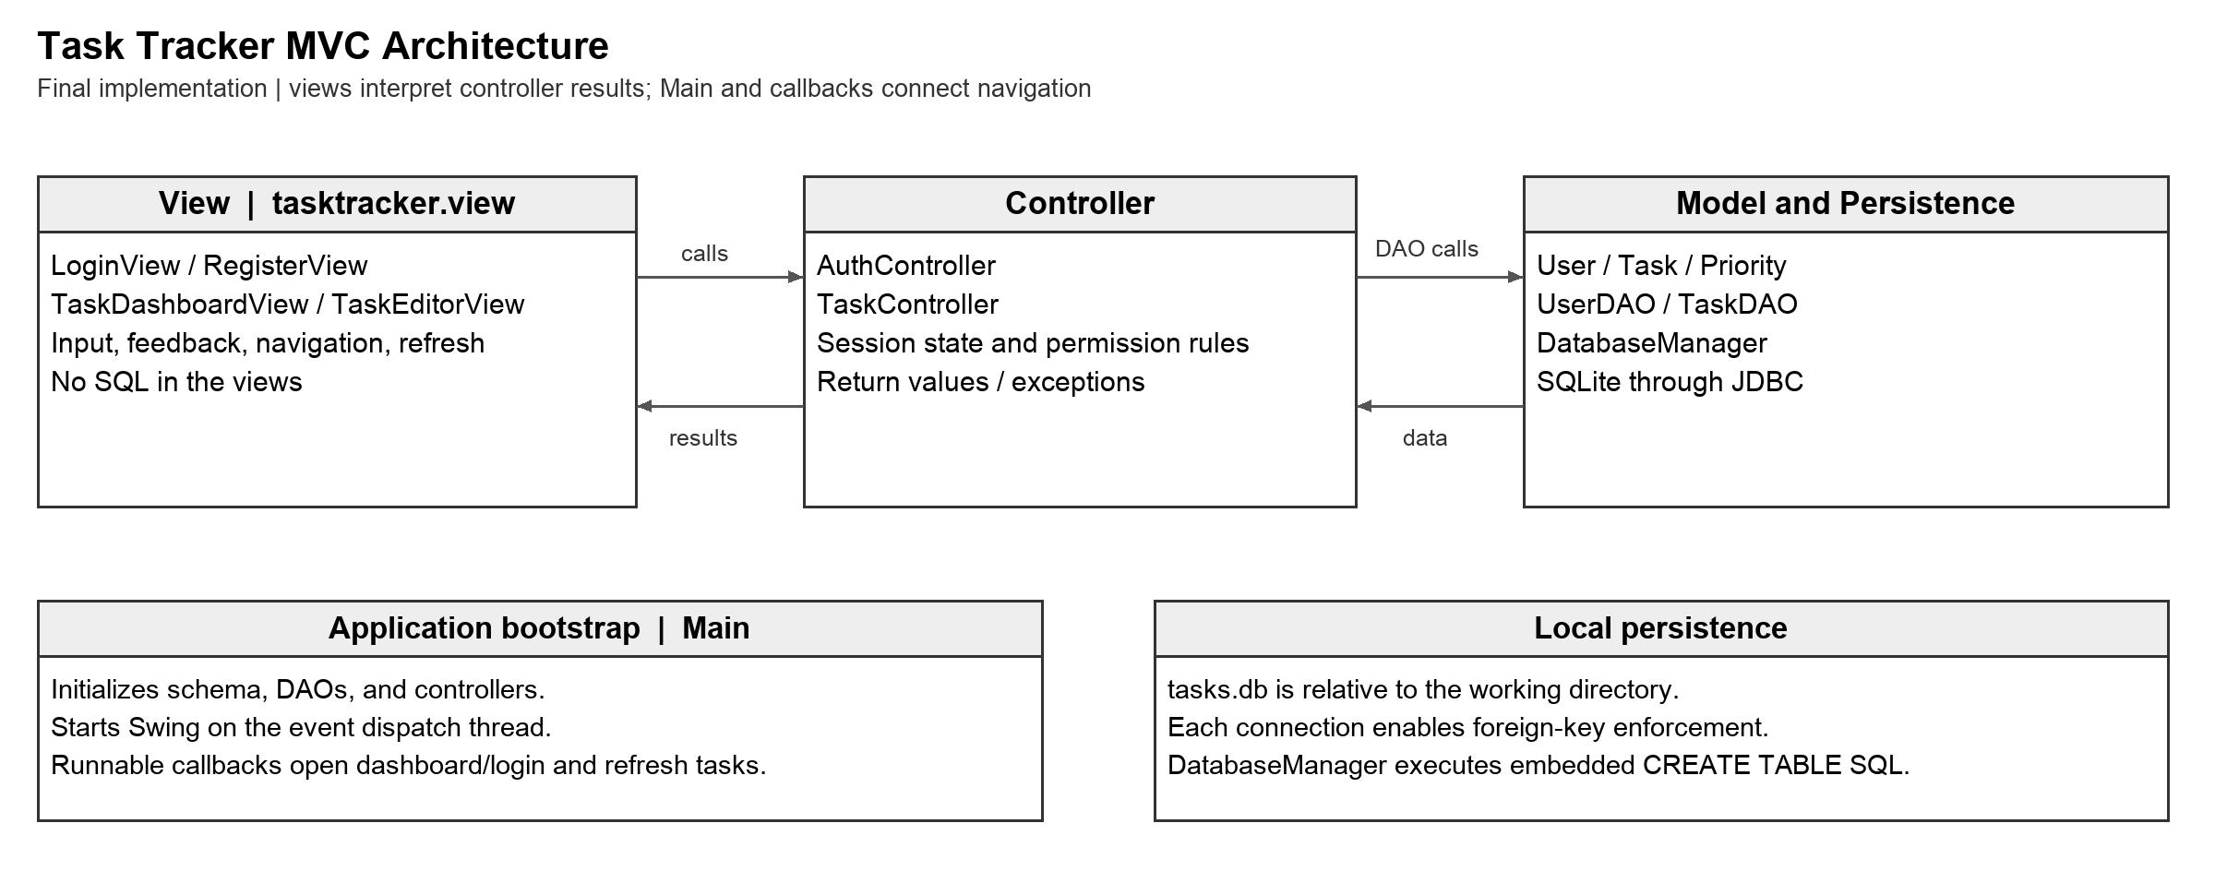
Figure 1. Final Task Tracker MVC architecture and data flow.
Layer / Package | Primary Classes | Responsibility
View | tasktracker.view | LoginView, RegisterView, TaskDashboardView, TaskEditorView | Display information, collect user input, raise UI events, and show validation/operation feedback. No SQL.
Controller | tasktracker.controller | AuthController, TaskController | Coordinate use cases, enforce current-user rules, validate requests, call data access, and return results or throw exceptions.
Model | tasktracker.model | User, Task, Priority | Represent account and task state used throughout the application.
Persistence | tasktracker.data | DatabaseManager, UserDAO, TaskDAO | Create/open the local database, initialize tables, execute parameterized SQL, and map records to model objects.
Application bootstrap | tasktracker | Main | Initialize database/data access, create controllers/views, and start at the login screen.

2.1 Primary Interaction Flow
1. A user performs an action in a view, such as submitting login credentials or selecting Create Task.
2. The view forwards the event/input to the appropriate controller.
3. The controller validates the request and applies the current-user permission rules defined in the requirements baseline.
4. The controller calls UserDAO or TaskDAO for persistent data access.
5. The DAO obtains a JDBC connection through DatabaseManager and performs the required SQLite operation.
6. The result is converted back to model objects or a success/failure result.
7. The controller returns data/results or throws an exception. The view displays feedback and invokes navigation or refresh callbacks; Main connects successful login and logout to the appropriate window.

Final implementation details: authentication and UI coordination
AuthController hashes passwords with unsalted SHA-256 before calling UserDAO. users.password_hash stores the hash; User contains only userId and username. Password confirmation and due-date parsing occur in views; authentication/permissions occur in controllers; model setters and database constraints also validate data.
TaskEditorView offers Unassigned plus all registered users, including the creator. Selecting Unassigned removes assignment. One dashboard combines created and assigned tasks, with Open before Complete and then task ID. The Complete control toggles state. Main initializes the database/DAOs/controllers and starts Swing on the event dispatch thread; Runnable callbacks connect login, logout, and dashboard refresh.

2.2 Architecture Alternatives Considered
Alternative | Decision | Reason
Put GUI, SQL, and task logic in one Main/window class | Rejected | Fast initially but creates a large coupled class that conflicts with MVC, modularity, maintainability, and testing goals.
Views call SQLite/JDBC directly | Rejected | Couples interface code to persistence and makes isolated controller/logic testing harder.
MVC with a small DAO persistence layer | Selected | Matches the required MVC architecture while keeping SQL localized, responsibilities clear, and test boundaries practical for a two-person team.

3. Database Schema
The production database is a single local SQLite file named tasks.db, resolved relative to the application working directory. DatabaseManager creates required tables automatically using embedded CREATE TABLE statements. sql/schema.sql mirrors this schema for reference; Main does not load that file.
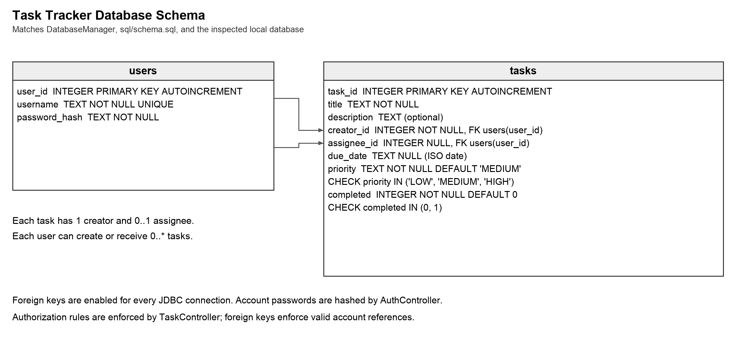
Figure 2. Implemented SQLite schema. assignee_id is optional; creator_id is required.
Table | Column | Type / Constraint | Purpose
users | user_id | INTEGER PRIMARY KEY AUTOINCREMENT | Internal account identifier.
users | username | TEXT UNIQUE NOT NULL | Unique login name.
users | password_hash | TEXT NOT NULL | Stored credential representation used for login verification.
tasks | task_id | INTEGER PRIMARY KEY AUTOINCREMENT | Internal task identifier.
tasks | title | TEXT NOT NULL | Required task title.
tasks | description | TEXT | Optional task details.
tasks | creator_id | INTEGER NOT NULL, FK users(user_id) | User who created and controls edit/delete/assignment.
tasks | assignee_id | INTEGER NULL, FK users(user_id) | Optional registered user assigned to the task.
tasks | due_date | TEXT NULL | Optional ISO date for the selected deadline feature.
tasks | priority | TEXT NOT NULL DEFAULT MEDIUM | LOW, MEDIUM, or HIGH.
tasks | completed | INTEGER NOT NULL DEFAULT 0 | SQLite boolean representation: 0 incomplete, 1 complete.

3.1 Implemented Table Creation SQL
CREATE TABLE IF NOT EXISTS users (
user_id INTEGER PRIMARY KEY AUTOINCREMENT,
username TEXT NOT NULL UNIQUE,
password_hash TEXT NOT NULL
);

CREATE TABLE IF NOT EXISTS tasks (
task_id INTEGER PRIMARY KEY AUTOINCREMENT,
title TEXT NOT NULL,
description TEXT,
creator_id INTEGER NOT NULL,
assignee_id INTEGER,
due_date TEXT,
priority TEXT NOT NULL DEFAULT 'MEDIUM'
CHECK (priority IN ('LOW','MEDIUM','HIGH')),
completed INTEGER NOT NULL DEFAULT 0
CHECK (completed IN (0,1)),
FOREIGN KEY (creator_id) REFERENCES users(user_id),
FOREIGN KEY (assignee_id) REFERENCES users(user_id)
);

3.2 Database Rules
- Usernames are unique.
- Every task has exactly one creator.
- A task may be unassigned or assigned to one registered user.
- The task creator can edit, delete, and assign that task. A creator or assignee can toggle it between Open and Complete, matching the reconciled FR-11 and UC-08.
- The relevant-task query returns tasks where the logged-in user is the creator OR the assignee.
- Due dates are optional and stored in an unambiguous ISO date format. Priority is LOW, MEDIUM, or HIGH with MEDIUM as the default.
- Foreign-key enforcement is enabled for each SQLite connection.

4. UML Class Design
The class design follows the course method of identifying classes, attributes, operations, and relationships, then refining the diagram iteratively. It intentionally shows responsibilities and relationships rather than algorithms. Visibility is shown with minus for private members and plus for public operations.
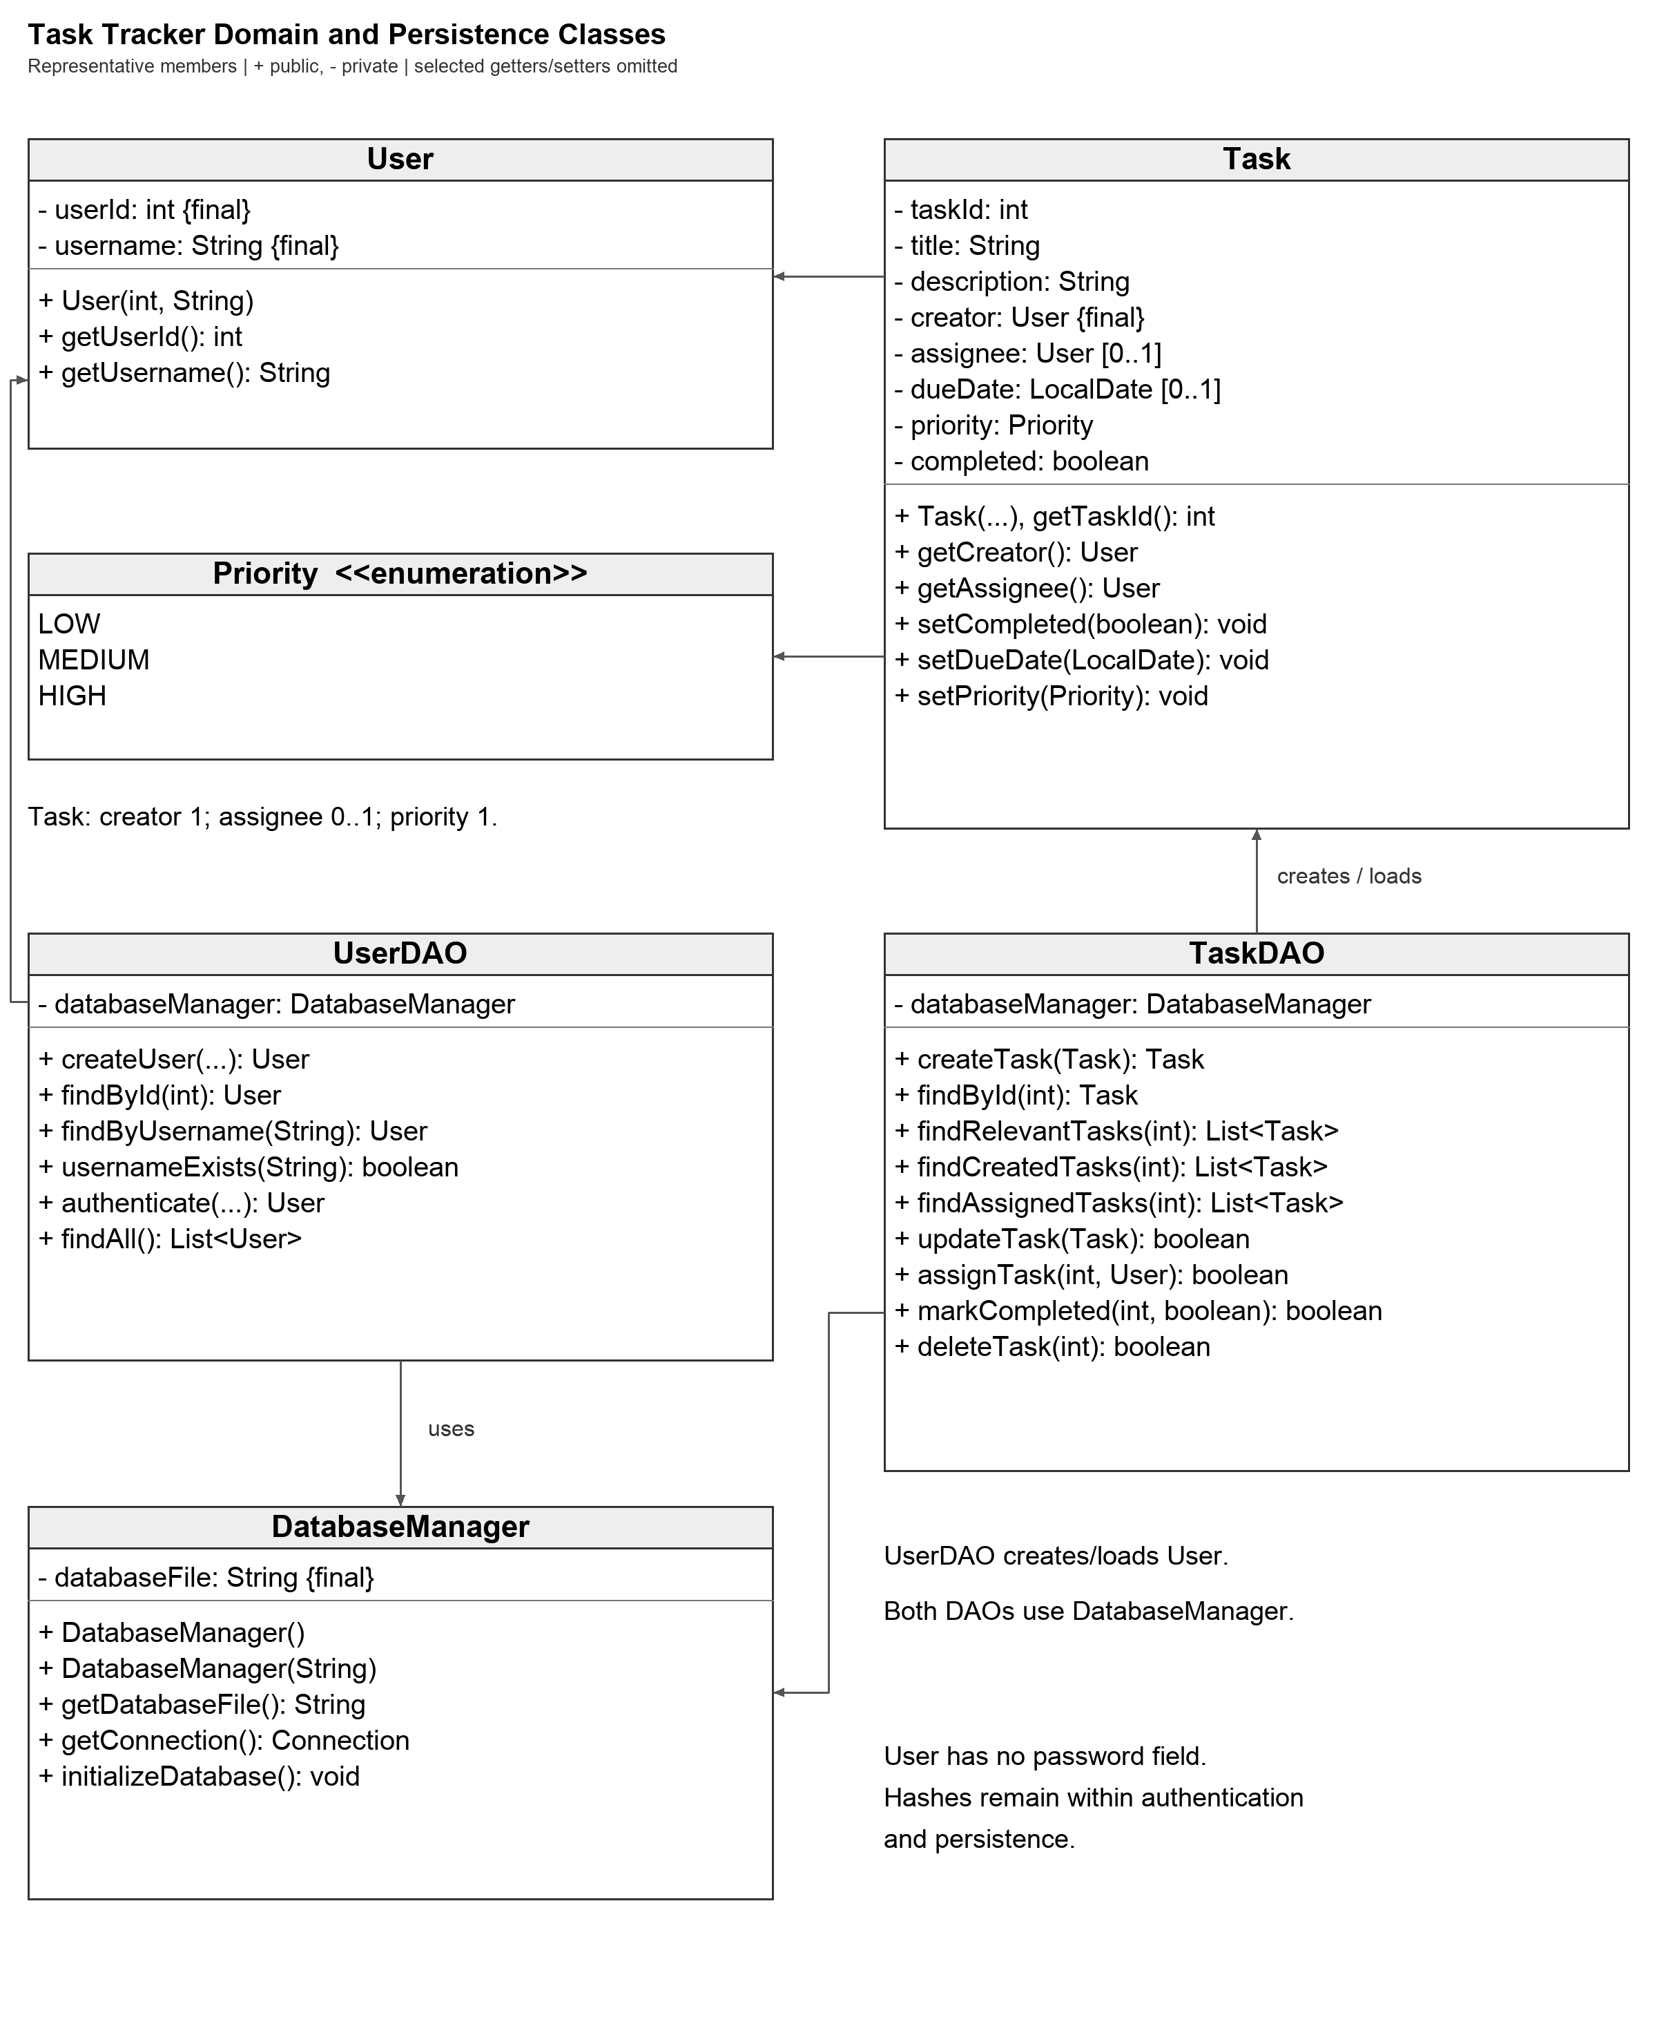
Figure 3. Domain and persistence UML class diagram.
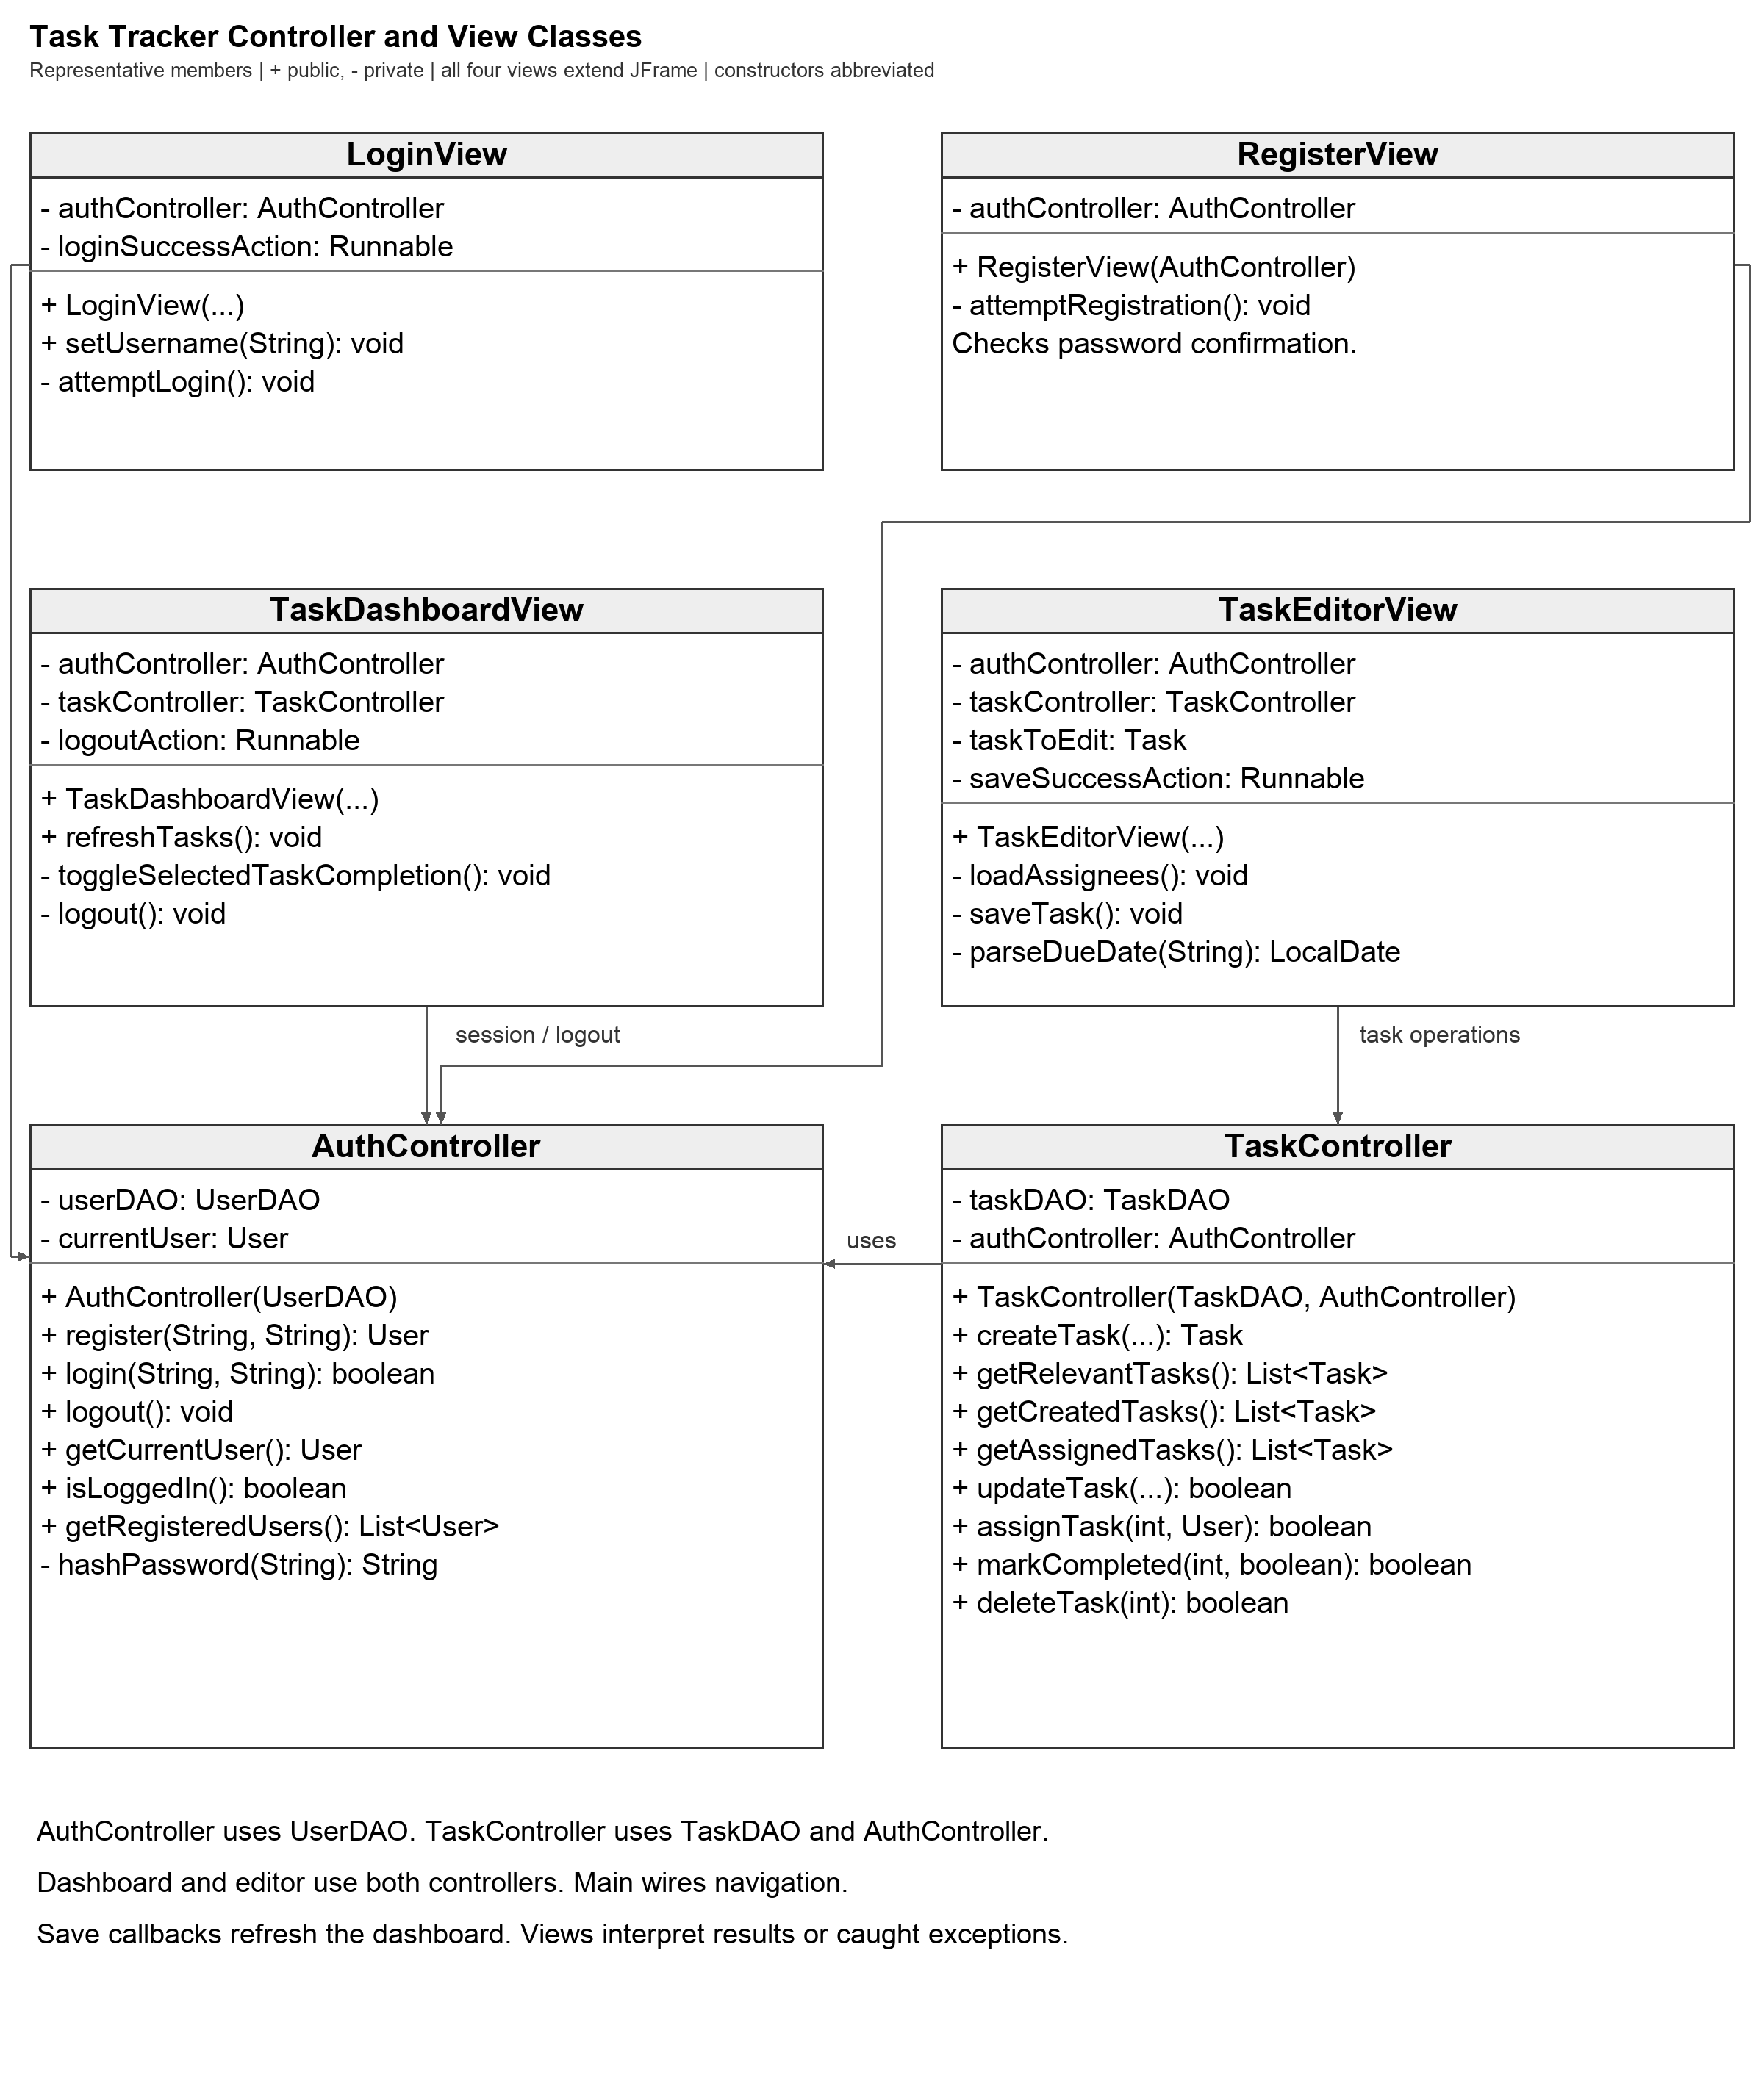
Figure 4. Controller and view UML class diagram.
Class | Responsibility | Key relationships
User | Represents a registered local account. | Referenced by Task as creator and optional assignee; created/loaded by UserDAO.
Task | Represents one task, including selected due-date/priority enhancement and completion state. | Has a creator User, optional assignee User, and Priority.
Priority | Defines the allowed priority values LOW, MEDIUM, HIGH. | Used by Task.
DatabaseManager | Owns SQLite connection setup and automatic schema initialization. | Used by UserDAO and TaskDAO.
UserDAO | Stores and retrieves user records and checks username uniqueness. | Uses DatabaseManager; maps database rows to User.
TaskDAO | Stores, updates, deletes, completes, and queries tasks. | Uses DatabaseManager; maps database rows to Task.
AuthController | Coordinates registration, login, logout, and current-user state. | Uses UserDAO; receives events from login/registration views.
TaskController | Coordinates task use cases and creator/assignee permission checks. | Uses TaskDAO and AuthController; receives events from dashboard/editor views.
Views | Present login/registration/task screens and collect user input. | Send events to controllers and display controller results; no direct database access.

5. Implemented Eclipse Package Structure
src/tasktracker/Main.java
src/tasktracker/model/User.java
src/tasktracker/model/Task.java
src/tasktracker/model/Priority.java
src/tasktracker/data/DatabaseManager.java
src/tasktracker/data/UserDAO.java
src/tasktracker/data/TaskDAO.java
src/tasktracker/controller/AuthController.java
src/tasktracker/controller/TaskController.java
src/tasktracker/view/LoginView.java
src/tasktracker/view/RegisterView.java
src/tasktracker/view/TaskDashboardView.java
src/tasktracker/view/TaskEditorView.java
test/tester/... JUnit 5 test classes
The implemented packages retain the Week 2 design boundaries. Figures 1 through 4 have been reconciled with the production implementation, consistent with Professor Cornez's guidance to refine UML through later iterations. Class diagrams show representative members rather than every helper or accessor.

6. JUnit 5 Test Outline
Professor Cornez asks for JUnit and acceptance-test outlines during Week 2. The tests below focus on small, representative behaviors. They are planned tests, not claims that the final implementation already exists or that these tests have already been executed.
ID | Target | Planned test | Expected result
JT-01 | DatabaseManager | initializeSchemaCreatesTables | A new test database contains users and tasks tables.
JT-02 | UserDAO | createAndFindUser | A valid new user is persisted and can be retrieved.
JT-03 | UserDAO | duplicateUsernameRejected | A duplicate username is not created.
JT-04 | AuthController | validLoginSetsCurrentUser | Valid credentials establish the authenticated user.
JT-05 | AuthController | invalidLoginNotAuthenticated | Invalid credentials leave the application unauthenticated.
JT-06 | TaskDAO | createTaskPersistsFields | Required and optional task values persist correctly.
JT-07 | TaskDAO | updateTaskPersistsChanges | Edited task values are saved and reloaded.
JT-08 | TaskDAO | deleteTaskRemovesTask | A deleted task no longer appears in the database.
JT-09 | TaskDAO | markCompletePersistsState | Completion changes to true and remains true when reloaded.
JT-10 | TaskDAO | findRelevantTasks | Only tasks created by or assigned to the requested user are returned.
JT-11 | TaskController | creatorCanEditDelete | Creator permissions allow edit/delete for that creator.
JT-12 | TaskController | nonCreatorCannotEditDelete | Another user is prevented from editing/deleting the creator's task.
JT-13 | TaskController | assigneeCanComplete | An assignee can complete a task assigned to that user.
JT-14 | Task model | priorityDefaultsToMedium | A task without an explicit priority uses MEDIUM.
JT-15 | Task validation | blankTitleRejected | A blank title is rejected before persistence.

Final automated test reconciliation
The final suite contains 25 test methods: DatabaseManagerTest 2, UserDAOTest 5, TaskDAOTest 6, AuthControllerTest 6, and TaskControllerTest 6. The testing report records the original passing run and a post-fix rerun of 25/25, 0 errors, 0 failures in 0.413 seconds. The JT identifiers below remain Week 2 planning identifiers, not final method names or a claim that every planned assertion was implemented.
JT-01 through JT-13 have corresponding behavior checks in the final five test classes, with some scenarios split or combined. JT-14 priorityDefaultsToMedium has no dedicated automated assertion. JT-15 blankTitleRejected has no automated assertion; blank-title rejection is recorded as manual acceptance check M07. Completion reopening and the editor/logout sequence remain outside the automated suite; the corrected logout sequence now has manual regression evidence in M10.

6.1 Unit-Test Data Strategy
- Use a separate temporary SQLite database for tests so automated tests never modify the production tasks.db file.
- Create only the small amount of test data needed for each test and keep tests independent.
- Reset or delete the test database between tests where needed.
- Use boundary/error cases such as duplicate usernames, blank task titles, unassigned tasks, and one-user/one-task scenarios.

7. Acceptance and Visual Test Outline
Acceptance tests verify the application from the user's point of view and will also provide the visual/manual testing evidence Professor Cornez discussed in class. Each test follows a real use case from beginning to observable result.
ID | Scenario | Steps / condition | Expected result
AT-01 | Register and log in | Register a unique account, then log in with it. | Account is created; valid credentials open the authenticated task view.
AT-02 | Reject duplicate user | Attempt to register an existing username. | No second account is created; clear feedback is shown.
AT-03 | Create and assign task | Alex creates a task and assigns it to Amanda Cabrera. | Task is saved and visible to Alex as creator and Amanda Cabrera as assignee.
AT-04 | Edit task as creator | Creator changes title, assignee, due date, and priority. | Updated values remain after refresh/reload.
AT-05 | Protect edit/delete ownership | Assignee attempts creator-only edit/delete action. | Action is unavailable or rejected with understandable feedback.
AT-06 | Complete assigned task | Amanda Cabrera logs in and marks her assigned task complete. | Completion state changes and persists.
AT-07 | Delete task with confirmation | Creator confirms deletion. | Task is removed from relevant views and database.
AT-08 | Relevant-task view | Log in as each account with unrelated tasks also present. | User sees only tasks created by or assigned to that account.
AT-09 | Persistence across restart | Create data, close the app normally, reopen, and log in. | Previously saved account/task data remains available.
AT-10 | Validation/error handling | Try blank title, invalid login, or invalid operation. | App remains usable and gives clear feedback without corrupting existing data.

Final acceptance-test reconciliation
The AT-01 through AT-10 entries are the historical Week 2 acceptance outline. The final report records M01 through M09 separately and adds post-fix manual regression check M10 for logout closing both editors. M01 corresponds to AT-02; M02/M03 to the task creation/visibility parts of AT-03 and AT-08; M04/M05 to AT-05; M06 to AT-06; M07/M08 to AT-10; and M09 to AT-09. These checks do not establish that every step of every AT scenario was manually executed.
Creator editing/deletion, logout, assignment removal, and unrelated-user completion denial have automated coverage; they are not separately recorded manual checks. See the final testing report for actual assertions and observations.

8. Requirements-to-Design Traceability
Requirement area | Design coverage | Schema coverage | Test coverage
Registration/login/logout | User, UserDAO, AuthController, LoginView, RegisterView | users table | JT-02 to JT-05; AT-01 to AT-02
Create/edit/delete task | Task, TaskDAO, TaskController, TaskEditorView | tasks table | JT-06 to JT-08, JT-11 to JT-12; AT-03 to AT-05, AT-07
Assign to registered user | Task, User, TaskDAO, TaskController | tasks.assignee_id FK users | JT-06, JT-10; AT-03
Mark complete | Task, TaskDAO, TaskController, TaskDashboardView | tasks.completed | JT-09, JT-13; AT-06
View created or assigned tasks | TaskDAO, TaskController, TaskDashboardView | creator_id / assignee_id | JT-10; AT-08
Deadline + priority feature | Task, Priority, TaskDAO, TaskEditorView | due_date / priority | JT-06; JT-14 remains planned (no dedicated assertion); AT-04 planned; M02/M09 recorded
Persistence/first-run setup | DatabaseManager, DAOs | tasks.db; users/tasks tables | JT-01; AT-09
Validation/feedback | Controllers + Views | Constraints support valid stored data | JT-03, JT-05, JT-12; JT-15 manual M07 only; AT entries planned; M01/M04/M05/M07/M08 recorded

9. Historical Week 2 Completion and Week 3 Handoff
With this design baseline complete, the team can enter Week 3 implementation without skipping the professor's required planning steps. The next implementation work should be incremental and testable rather than attempting the complete application in one pass.
1. Create the shared final Project I Git repository and Eclipse project with the agreed package structure.
2. Move the verified SQLite/JDBC knowledge from the rapid prototype into the production DatabaseManager and production tasks.db schema.
3. Implement model and persistence classes first and run small JUnit tests.
4. Implement AuthController and account views, then verify registration/login/logout.
5. Implement task persistence and TaskController operations, then task views.
6. Run JUnit tests frequently and perform visual/manual acceptance checks as features are integrated.
7. Keep meaningful Git commits from both Alexander Goda and Amanda Cabrera throughout implementation.
Historical Week 2 status: READY FOR WEEK 3 IMPLEMENTATION. Final implementation status: model, persistence, controllers, and Swing views implemented. The logout/editor correction is manually verified, and the post-fix JUnit rerun passed 25/25. See the final testing report for recorded results.

9.1 Verified Session Lifecycle Correction
TaskDashboardView tracks each task editor it opens, removes closed editors from its list, and disposes all remaining editors when the dashboard is disposed. Logout disposes the dashboard and its editors before clearing the authenticated session and invoking the login callback. The post-fix Eclipse JUnit rerun on October 16, 2026 completed 25/25 tests with 0 errors and 0 failures in 0.413 seconds, as shown in the 11:33 PM screenshot. The existing suite still contains 25 methods; no new automated GUI test was added. Manual regression check M10 passed: the user confirmed that both New Task and Edit Task windows closed automatically when Logout was clicked. The subsequent screenshot shows Amanda's dashboard without the old editors. This is manual GUI evidence, separate from the JUnit rerun. No dedicated automated editor/logout test has been added.

Final audit addendum
Final audit addendum dated October 16, 2026. This addendum supersedes current-suite counts and coverage-limit statements above while preserving historical results and Week 1/Week 2 plans. The expanded Eclipse JUnit 5 suite passed 28/28 tests with 0 errors and 0 failures in 0.444 seconds. Class counts are DatabaseManagerTest 2, UserDAOTest 5, TaskDAOTest 6, AuthControllerTest 6, and TaskControllerTest 9. Three new controller tests cover rejection of every public task operation while logged out, self-assignment without duplicate dashboard results with MEDIUM default and optional date, completion and reopening followed by unassignment, and blank-title create/edit rejection with saved data unchanged. These are automated controller/SQLite checks, not GUI passes. Editor-window cleanup remains covered by the previously recorded manual M10 only. The fresh Problems tab reported 0 items in its current configuration. Production sources compiled on JDK 11.0.30 with --release 11 and -Xlint:all without diagnostics. Eclipse launched Main and reported database initialization success, but native automation could not bind to the Java window; no new manual GUI pass is claimed. See docs/FINAL_AUDIT.md and docs/FINAL_SUBMISSION_CHECKLIST.md for delivery status and limitations.

