COMP 251 Assignment 1

Alex Hale

ID: 260672475

Definitions

Collisions = the number of slots visited before a key can be inserted or removed.

Task 1

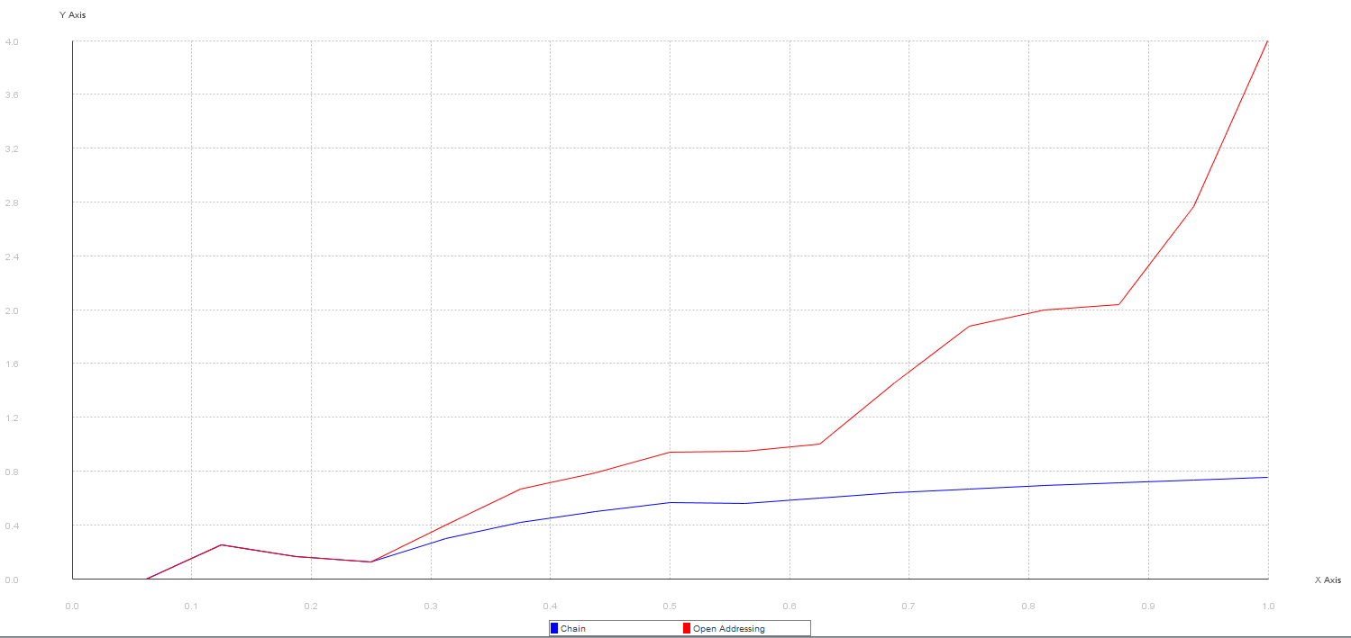

This graph plots the load factor (x-axis) against the number of collisions for an insertion (y-axis). For chaining, the number of collisions is (nearly) constant because the number of collisions is either 0 or 1. If the first slot that the key maps to is empty, the key is inserted there (no collisions). If the first slot that the key maps to already has one or more key in the chain in that slot, the key is inserted at the end of the chain (one collision). The average collisions increases slightly as the load factor increases because it’s more likely for there to be 1 collision instead of 0 as fewer slots are empty. For open addressing, the number of collisions as the load factor increases. This is because an insertion can result in multiple collisions, continuing until the insertion finds a slot or finds that the array is full.

Task 2

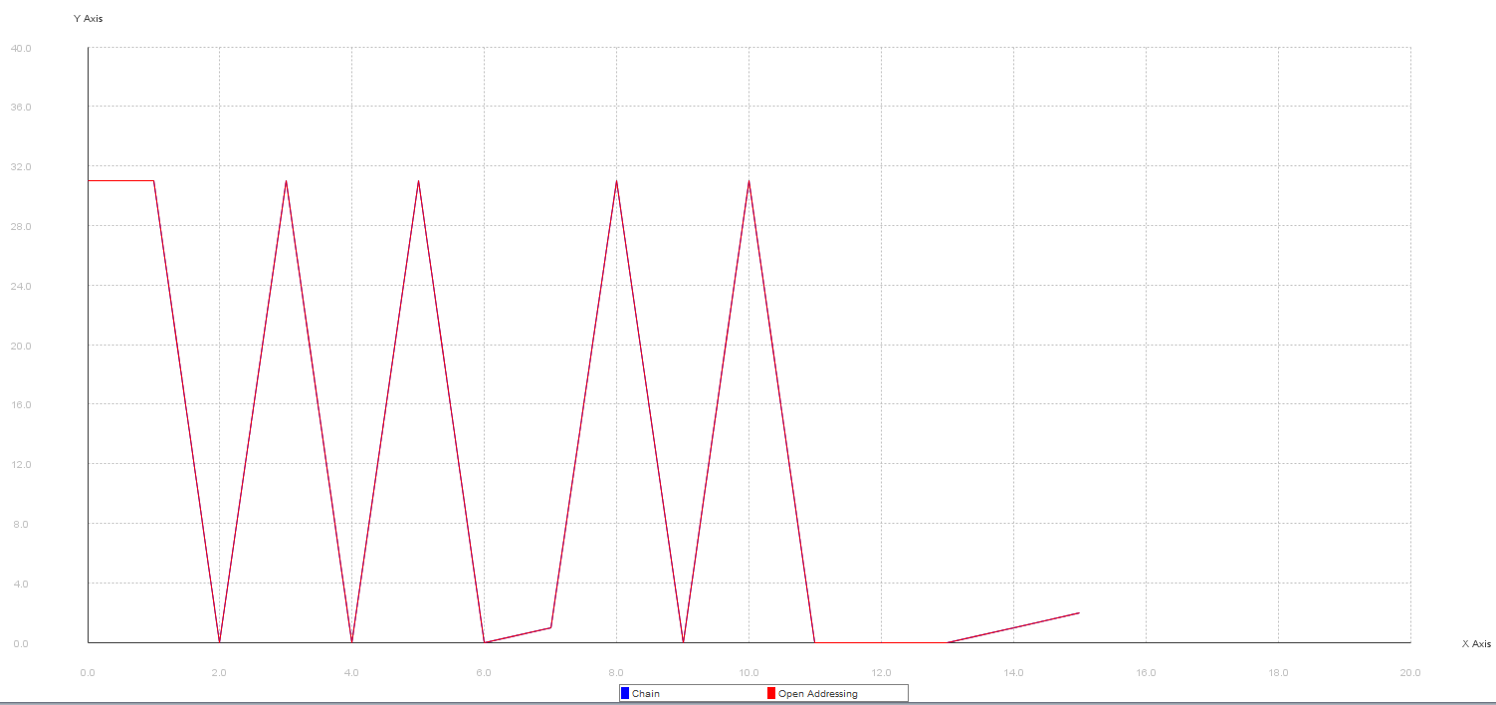

For values that are not in the hash table (and therefore not there to be removed), each removal returns 31 because there are 31 slots visited before realizing that the key is not present. For values that are in the hash table, a small number of collisions occurs (between 0 and 2) before the key is found and can be removed.

Task 3

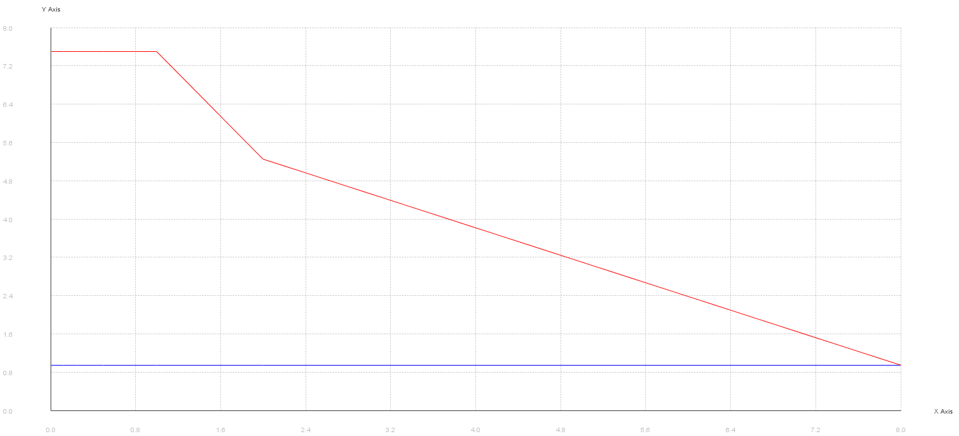

This graph shows the average collisions for various values of *w*. The number of collisions for open addressing drops dramatically as the load factor decreases because the number of open slots gets much higher. The number of collisions for chaining stays constant because no matter how many open slots there are, the collisions are at a maximum of 1 because the key can just be added onto the chain of that slot.