Alexander Hay
ME333 - Mechatronics
Chapter 24.1.2, 24.2.1 and 2,
24.3.1 and 2,
24.5, 24.7, and 24.8.

24.1.2 I chose R to be 333Ω by placing three (3) 10kΩ resistors in parallel. Using the materials provided a resistance of 303Ω by placing all resistors in parallel, but that’s hard to work with on a breadboard given the difference 30Ω made.

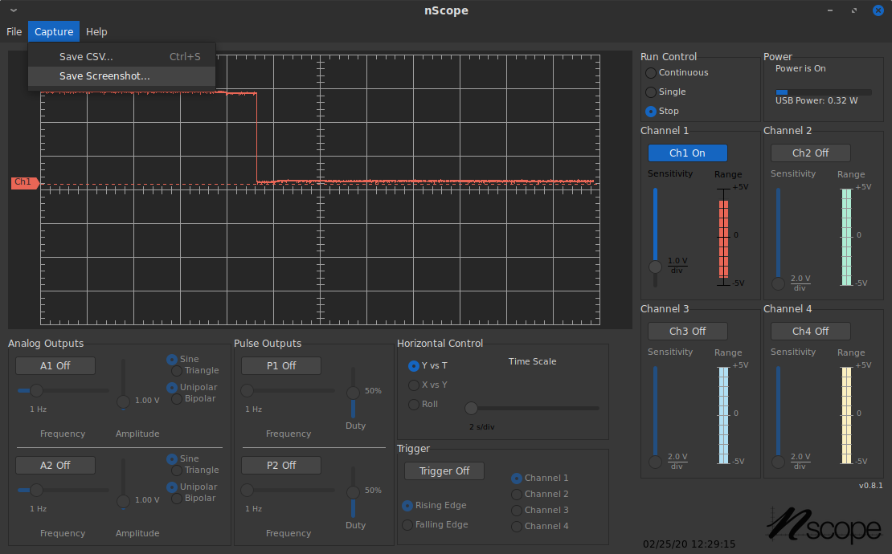Figure 1: Voltage resting at 3V when LED is on, 0V when the LED is off

24.2.1 (PR+1)*N*12.5 = period
N = 1
period = 50

PR = 3,999

24.2.2 a

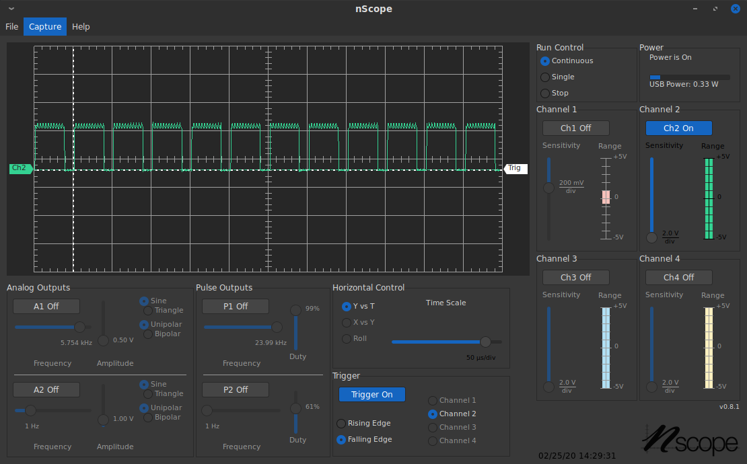Figure 2: nScope showing square 20kHz wave form at 75% duty cycle
b
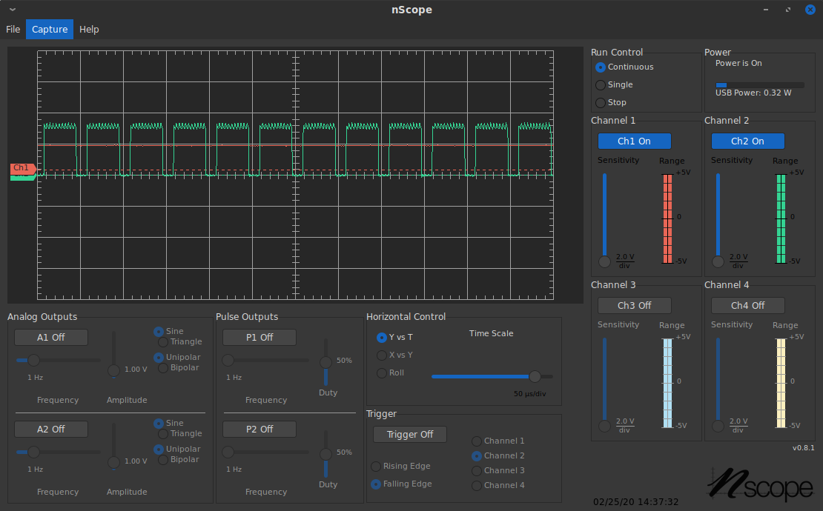Figure 3: nScope showing waveform and Vout voltage
24.2.2 c Capacitors resist change in voltage so during the low part of the duty cycle the capacitor discharges and has a stabilizing effect on V_{out}.

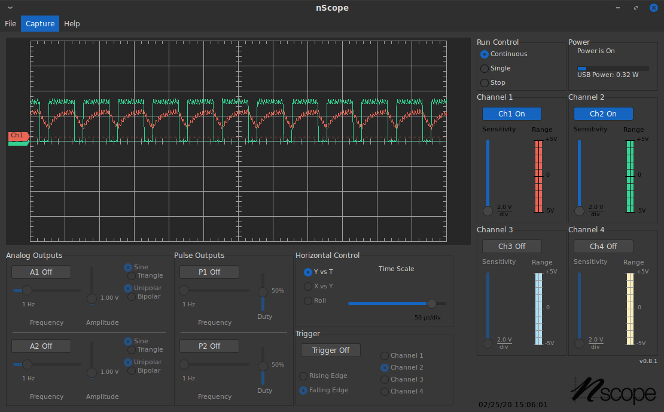Figure 4: nScope view qwith capacitor removed
24.3.1

