Alexander Hay
ME333 - Mechatronics
Chapter 28.4.1.7, 28.4.7.7, 28.4.9.8

28.4.1 1 SPI channel: 4
NU32 pins: F4, F5, B14

2 ADC input: AN3
NU32 pin: B3

3 D-out: RD0, RD1
PWM: OC1RS, Timer3

4 200Hz timer: Timer2
5kHz timer: Timer4

Priorities:
Timer2: 5
Timer4: 4

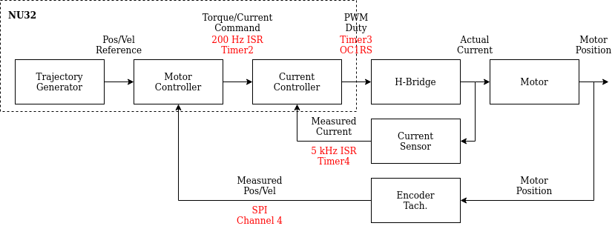
5

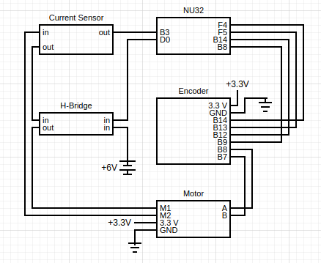
6

28.4.7 2

3

4

5

6
R0 | Expected I (mA) | Measured I (mA) | Sensor (V) | ADC counts
10 (to RS+) | 600 | 530 | 1.97
20 (to RS+) | 300 | 280 | 1.82
40 (to RS+) | 150 | 150 | 1.74
Open circuit | 0 | 0 | 1.65
40 (to RS-) | -150 | -140 | 1.59
20 (to RS-) | -300 | -270 | 1.53
10 (to RS-) | -600 | -530 | 1.44

28.4.9.8

