Alexander Hay
ME333 - Mechatronics
Chapter 24.5, 24.7, 24.8

24.5
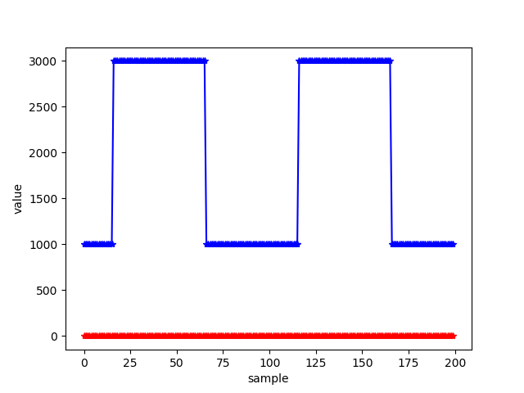Figure 1: Python communicating with the PIC32

24.7
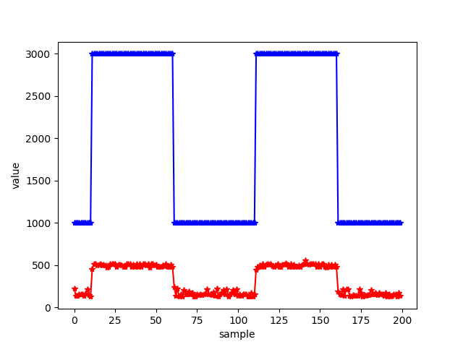Figure 2: Reading ADC values

24.8
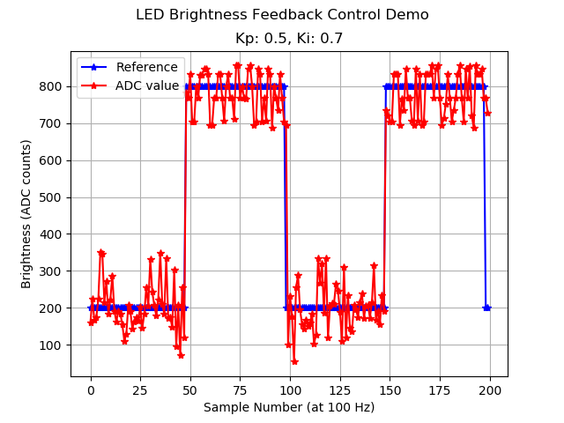Figure 3: ADC response

