Alexander Hay
NUIN 408
HW4

1. a. Threshold settings
14.98%
Upper bound: 65335
Lower bound: 1667

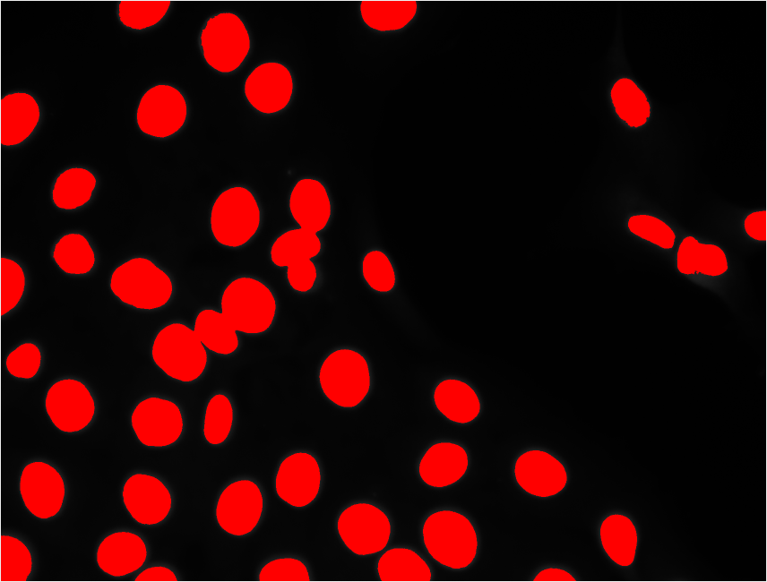Figure 1: Thresholded image

Nuclei: 45
Ave. size: 243.929 pixels
Intensity: 255

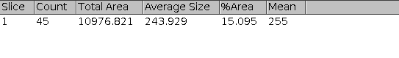Figure 2: Threshold report

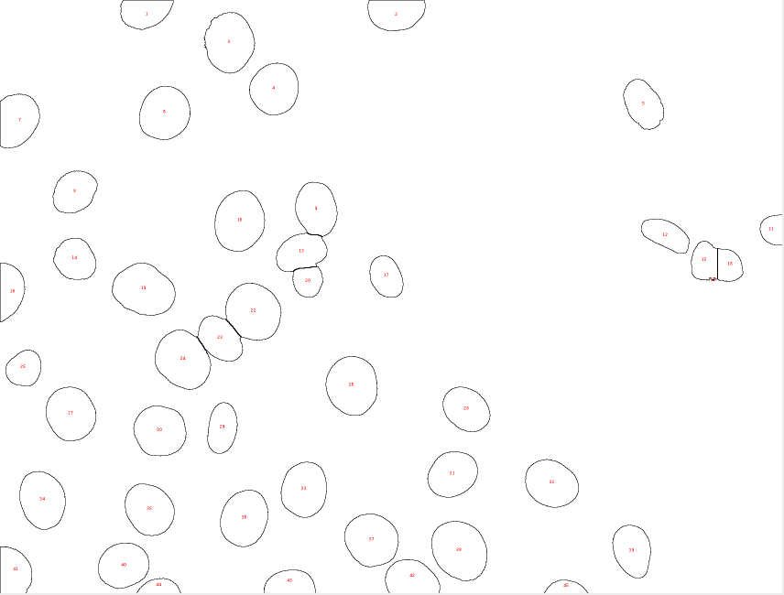Figure 3: Nuclei counted after watersheding

Thresholding merged some of the nuclei, making themm appear as one. Watershedding was done to re-separate the nuclei.

b.
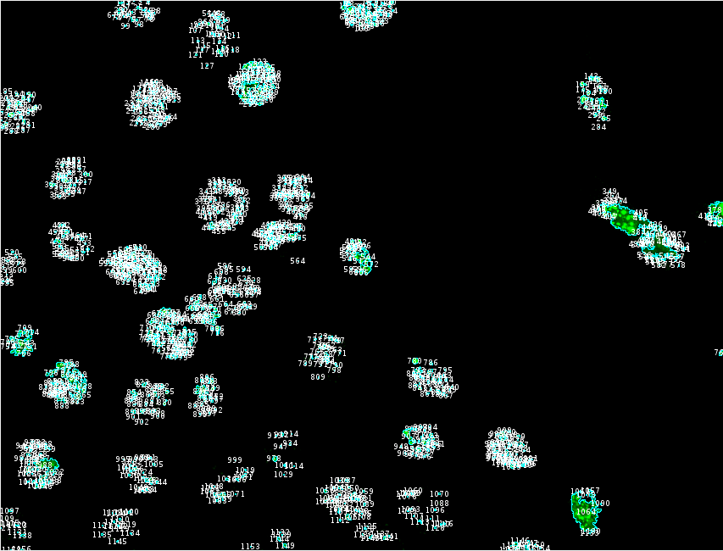Figure 4: Puncta filtered

Puncta: 1159
Puncta/nuc: 25.756
Mean: 88.518
Std dev: 32.178

The number of puncta is lower, the blobs in the right of the image was blurred into a bigger blob, reducing the number. Puncta/nucleus was calculated by dividing the puncta by the number of nuclei calculated in 1a. It served as a work-around for more robust filtering/counting.

2. a. Area, standard deviation, and mean gray value. This allows analysis of the muscle sizes and muscle types/subtypes.

b. First I changed the brightness and contrast to isolate the darker muscle fibers. I then thresholded (thresheld?) the image in order to analyze the image and create a mask. The mask was overlayed over a duplicate image, seen right in figure 5. Analyzing the results of that produced the data for part d. For light bundles the image was first inverted but the overall process was repeated.
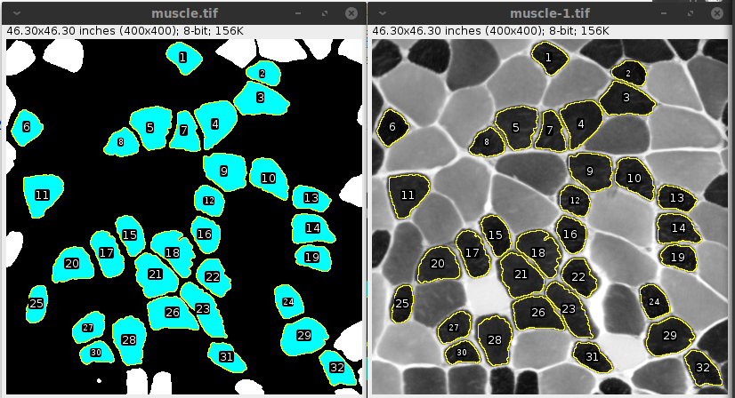Figure 5: Dark fibers isolated (left) and plotted against stock image (right)

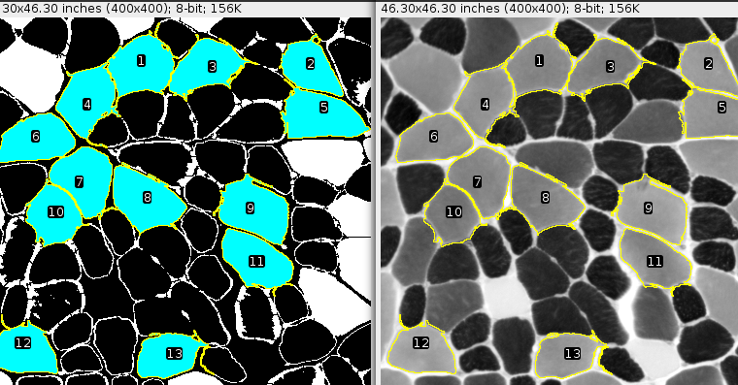Figure 6: Light fibers filtered (left) and plotted against stock image (right)
c. There were 32 dark bundles, average size was 16.244 pix., average intensity was 34.637.

There were 15 light bundles, average size was 39.282 pix., average intensity was 149.922.

13 bundles were identified, 2 were filtered into the background. Bundles on the edge were excluded to preserve size data.

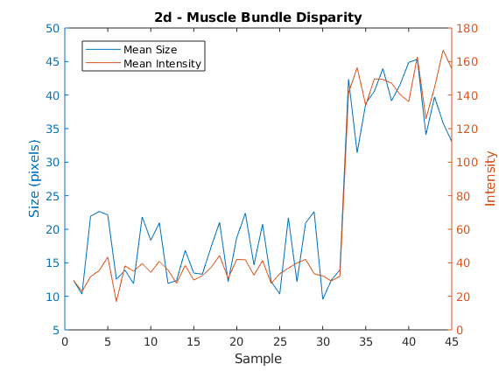
d.
e. there’s no part e

f. Dark fibers: 32
Mean area: 16.244
Mean intensity 34.637

Light fibers: 13
Mean area: 39.282
Mean intensity: 146.922

2-sample ttest results:
Area; h: 1, p: 3.662229719207060e-19

Int; h: 1, p: 1.361026324143152e-36

2-sample ttest rejects the null hypothesis that the samples come populations with equal means.

