Homework 6
Due 5/27/20

Problem 1
Match the signals below with their corresponding power spectra. Explain the rationale for your assignments. Each signal is shown on two different time scales, one zoomed in to 1 s. Power spectra are shown in both log-log and log-linear scales. Units are intentionally removed on the Y axes, so the actual numbers on all Y axes should be ignored, just consider them as relative.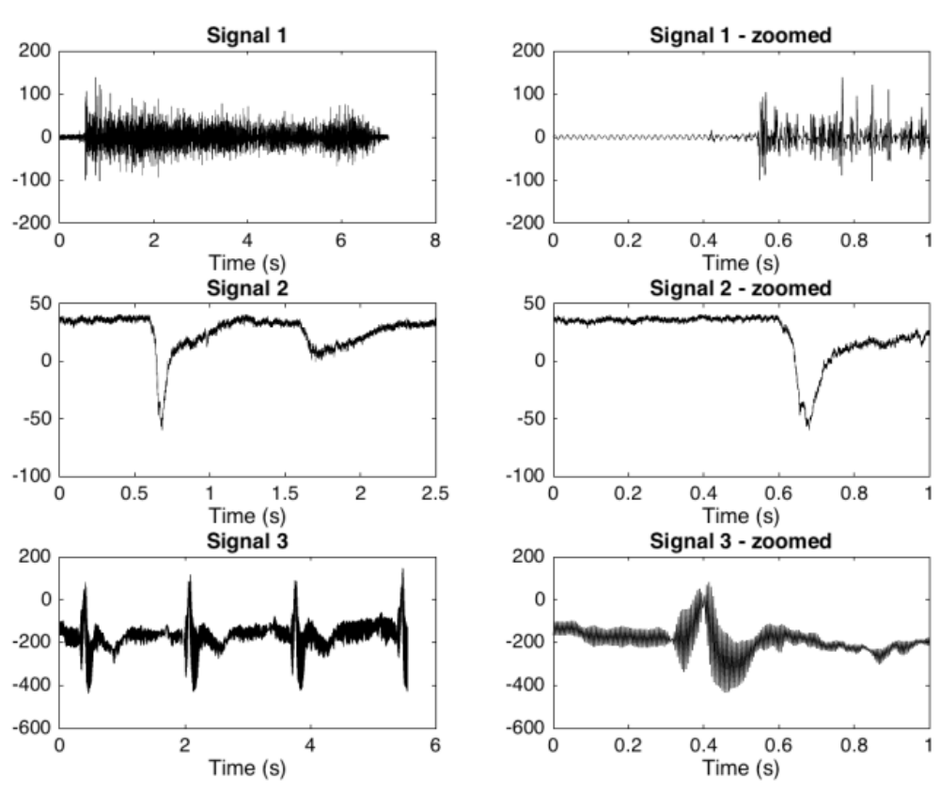

Log-Log scale
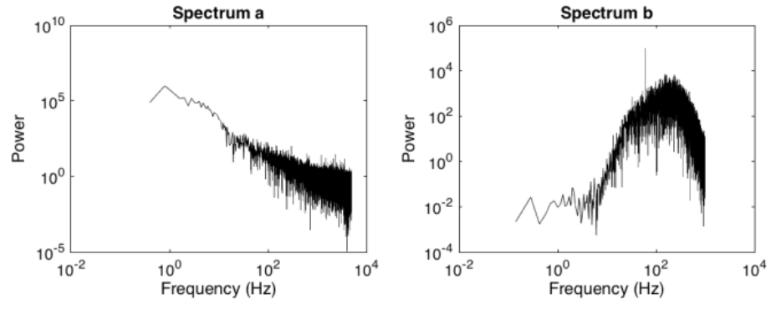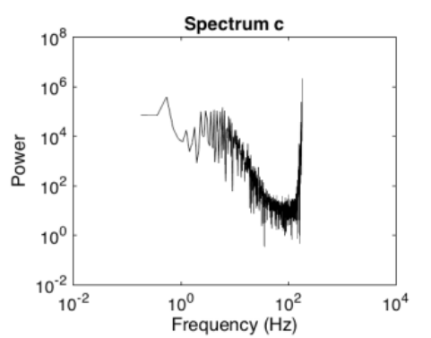

LogY-Linear X
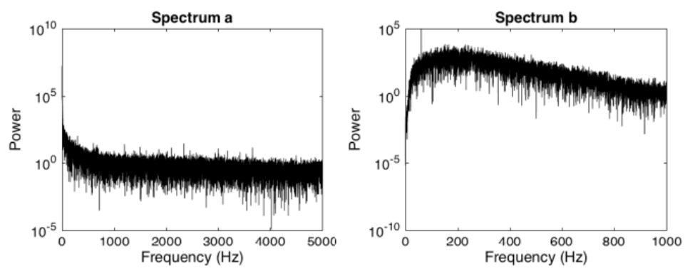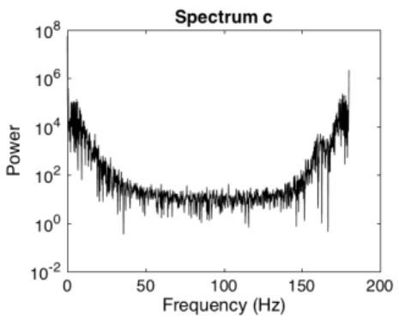

Problem 2
Load ‘HW6_prob2.mat’. You will find a variable called spikeTrace. This is a cell-attached recording from a retinal ganglion cell. The units are pA, and the sample rate is 10 kHz.
a. Detect spikes in the signal using a simple threshold. Plot the trace with a red ‘x’ on each detected spike. When plotting, zoom in to show that you identified all the spikes correctly.
b. Sample the trace at 1/5 of the original sample rate using the ‘downsample’ function in matlab. Plot the new trace and describe what has changed. Does your spike detection code still work? Why or why not?
c. Repeat part b, but now use the ‘resample’ function instead of ‘downsample’. How does this signal differ from the one in b? Why are ‘resample’ and ‘downsample’ different?

Problem 3
Load ‘HW6_prob3.mat’. You will find the original current clamp data set we have been looking at in class (CC_data) and two versions (A and B) corrupted by noise. The sampling rate is 10 kHz.
a. What frequency is the noise that corrupted CC_data_corrupted_A? How did you figure it out? Show the plot(s) that got you the answer.
b. What frequency is the noise that corrupted CC_data_corrupted_B? How did you figure it out? Show the plot(s) that got you the answer.
c. For each corrupted signal, use the FilterDesign app to design a filter to get rid of the noise while retaining as much signal as you can. Hint: look up online which frequencies carry signal in current-clamp data. Did you use the same type of filter in both cases? Why or why not?
d. Plot the original and filtered traces on the same axes for CC_data_corrupted_A. Do the same for CC_data_corrupted_B. Now plot the original and filtered power spectra for each.
e. Compute the level of attenuation (in dB) produced by your filter at each frequency and make a plot of it for each of the filters you made. Hint: think carefully about dB units to figure out how to get this value.

Problem 4
Load the file ‘HW6_prob4.mat’. This file contains the white noise responses we went over in class: data_repeatedSeedand data_nonRepeatedSeed. The sample rate for this data is 1 kHz.
a. On the same graph, plot the power spectrum of the average response to the repeated seed and the average power spectrum of the responses to the non-repeated seeds. What can you deduce from this plot about the frequency content of the signal (the part driven by the stimulus) and the noise (the part not driven by the stimulus)?
b. For the repeated seed data, plot a single trial and the mean data on the same graph. Given what you found in part a, design a filter using matlab’s filter design GUI (filterDesigner) to filter the noise out of the single trial. Is the filtered signal a better match to the mean? Did your filter distort the phase of the signal? Why or why not?

Problem 5
In this problem, you will be using your knowledge of signal processing to learn about the properties of 3 “black box” functions. These functions are .p files that will run in Matlab, but you will not be able to open them up in a text editor to see the code. The functions are sys1.p, sys2.p, and sys3.p. They are called as follows:
output_signal = sys1(input_signal, sampling_freq)
where sampling_freq is the sampling frequency of the input signal in Hz.
You must create input signals and study the outputs to investigate how the ‘sys’ functions work. Some guidance:
1. Explore a range of different frequencies at least from 0-100 Hz.
2. The relevant amplitudes of the input signal are -20 to 20 (arbitrary units, but call them Volts if you want to have a label on your graphs).
3. Reminder about linearity for functions:

If f is a linear function, f(a) + f(b) = f(a+b), for all a and b
If f is a nonlinear function, f(a) + f(b) ≠ f(a+b), for some a and b
a. Which (if any) of the ‘sys’ functions are linear and which (if any) are nonlinear? Show the figures and code you used to reach your answer.
b. For each ‘sys’ function, how (if at all) does it affect the frequency content of the signal? What kind of filter (of the types we learned in class) does it implement? Show power spectra to support your answer.
c. How does each ‘sys’ function affect the phase of the signal? How can you tell? Demonstrate your reasoning using either (1) power spectra or (2) the input and output signals in the time domain. Only one of (1) or (2) is a correct way to demonstrate this. Explain why.

