Alexander Hay
Problem Set 2

run.py will launch the code for each problem set.

1) Supervised Learning - Back Propagation

This problem proved to be difficult. I spent most of the time attempting to solve it using linear algebra before breaking down and using nested loops. The problem I was running into with linear algebra was that v, the second set of weights, would update as a group rather than individually. This was not a problem with the first set of weights as was indicated by the output from that layer. By breaking down the update step I was able to update the weights properly.

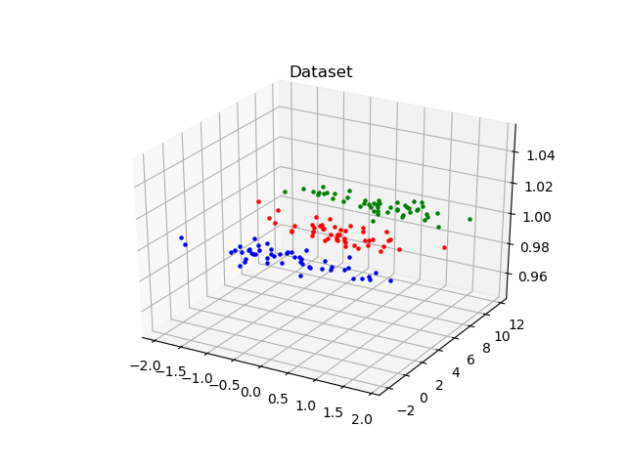
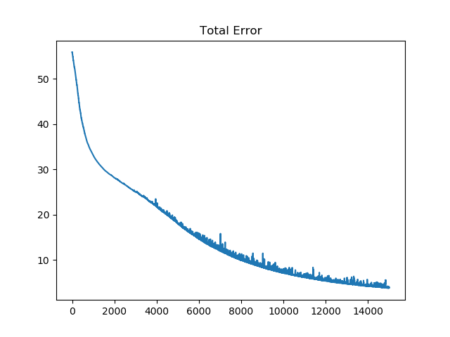
2) Unsupervised Learning – K-Means Clustering

Problem set and math was fairly straight forward. 2 means are initialized and “relocated” based upon the distance from a given sample. Means needed relatively few iterations before arriving at the intended location. The image below shows the route each mean takes and cluster circle. Multiple circles and lines are presented because the figure is animated
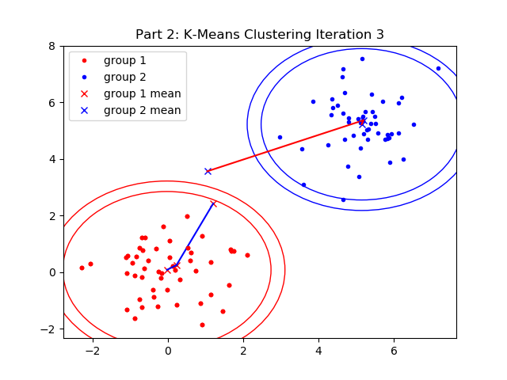

3) Unsupervised Learning – ML Gradient Descent

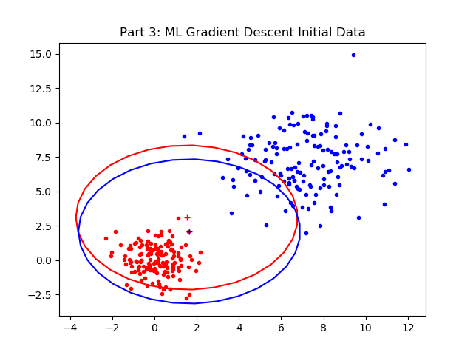
Because part 1 took as long as it did I could not give the time this problem needed. Piecing together a sketch algorithm proved to be difficult. I’m not sure if my notes are incomplete, wrong, or just cryptic; the notation of the equations and the looping is the most challenging aspect.

