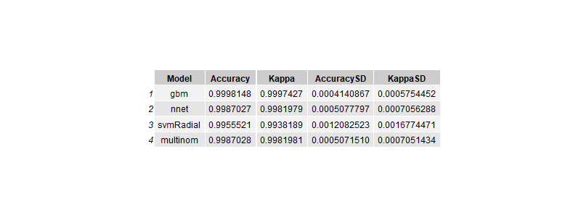

The nnet model, or neural network, is a type of machine learning algorithm that imitates how neurons in the human brain process information. In my code, I specified the **size** parameter in expanded_tune_grid_nnet, which controls the number of neurons in the “hidden layer,” with the diagram I found online below. From what I can tell, this lets the model capture more complex relationships in the data by letting a neuron take inputs, apply weights, sums them up, and then passes the result through an activation function, introducing non-linearity. I also used the **decay** parameter to add regularization, which I read helps [prevent overfitting](https://stackoverflow.com/questions/9390337/purpose-of-decay-parameter-in-nnet-function-in-r) by penalizing large weights. Overall, the nnet model seems like a good choice when I need to capture intricate patterns in data, but I want to get one of these models to work on the image data for my final project.

