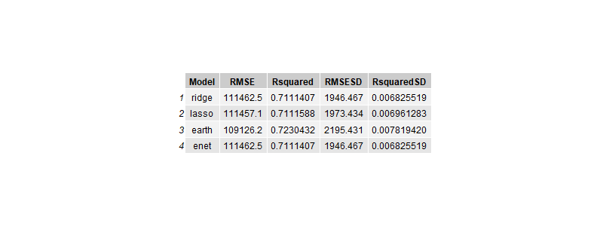

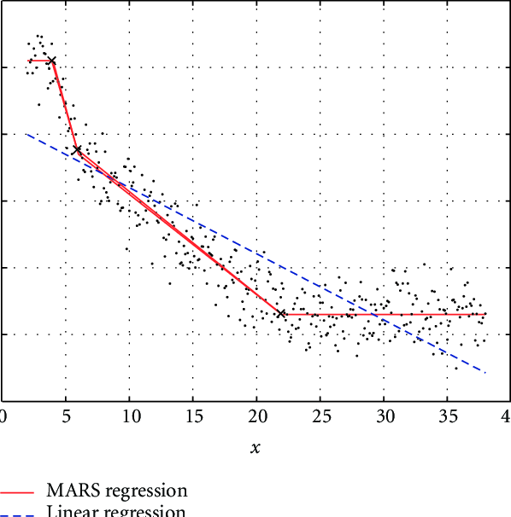picture of how MARS works I found online

I used the MARS (Multivariate Adaptive Regression Splines) model which is implemented in the earth package in R. In my code, I used degree and nprune parameters (expanded_tune_grid_earth) to control the complexity of the MARS model. From what I read online, **degree** specifies the interaction depth, allowing MARS to capture interactions between features, while **nprune** limits the number of terms in the model, helping prevent overfitting by controlling model complexity. MARS works by fitting piecewise linear regression functions across different ranges of the predictors, and you get something like above where the overall model can have differing slopes based off of where you are in the dataset. I like this visual representation, as it helped me understand how this model works, and the nprune and degree optimization seems like it didn’t change the actual hinge algorithms themselves, but makes the model choose the best placement of where to have those hinges. My dataset has a few variables that may correlate, like bedrooms and overall house size, thus these relationships of interacting variables ay be best captured in the MARS model.