Problem 1
- 200 blocks
5 memory buffer
$2N × \# parses$
$Total I/O cost = 2(200) × 4 = 1600$

$[200/4]=50 sorted runs, 4 blocks each (merge sort 1)$ $[50/4]=13 sorted runs. 12 having 16 blocks, last being 8 blocks (merge sort 2)$

- 200 blocks
8 memory blocks

$[200/7]=29 sorted runs, 28 having 7 blocks, last being 4 blocks (merge sort 1)$
$[29/7]=5 sorted runs, 4 having 49 blocks, last being 4 blocks (merge sort 2)$

$Total I/O cost = 1+[log_{7}(200/8)]=2.55=3 parses$
$2(200)×3=1200 I/O Cost$

Problem 2
- Yes, it is possible to construct a dense sequential index on $k1$
as dense indices can be used on sorted or unsorted columns.
This means there's a direct mapping of pointers in the file

$Pair =28 bytes$
$28*20*10^{6}=68360 blocks$

- Yes, it is possible to construct a sparse sequential index on $k1$ the column as it is sorted. The layout is that each index points to a block, which holds 20 records.

$28*10^{6}=3418 blocks$

- It is possible to construct a dense sequential index (1-level) $k2$ over R. Dense indexes can be used on unsorted columns like 1. The layout is direct mapping, and again, it would be:

$28*20*10^{6}=68360 blocks$

- No, it is not possible to construct a sparse sequential index (1-level) on $k2$ over R. This is because sparse indexes do not support unsorted columns.

- Yes, it is possible to build a sparse, second-level index on a. Basically, an abstraction of b. More expensive but applicable. First-level is 68360 blocks. Second-level size: $28*68360=234 blocks$

$Total index size: 234+68360=68594 blocks$

- Yes, it is possible to build a sparse, second-level index on 2. Even with Level-1 being sparse, we can further abstract each pointer by having one pointer block point to all Level-1 blocks.

Second-Level: $28*3418=12 blocks$
Total size: $12+3418=3430 blocks$

Problem 3
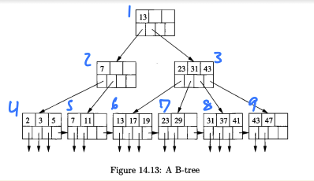

- $Finding key=35→ N1,N3,N8$

- $Finding records in range[9,20]→ N1,N2,N5,N6,N7$

- Insert record with key 4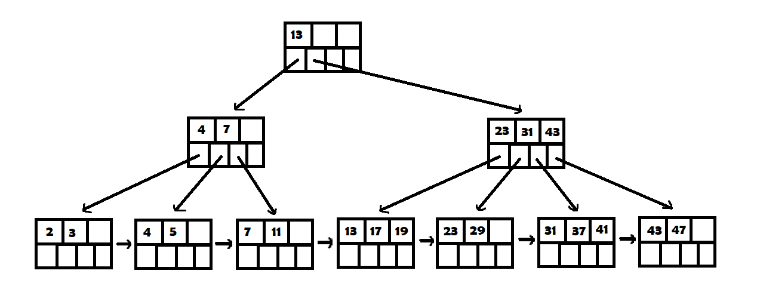
- Insert 14
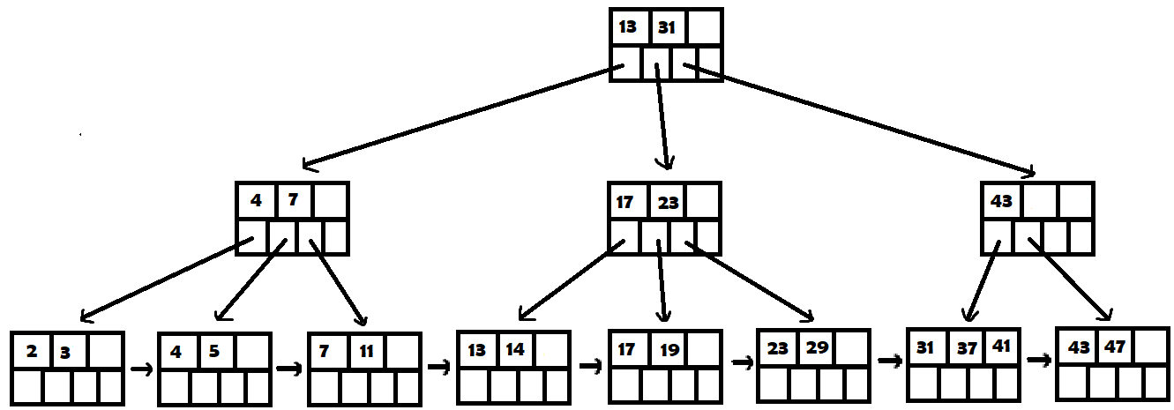

Insert 15

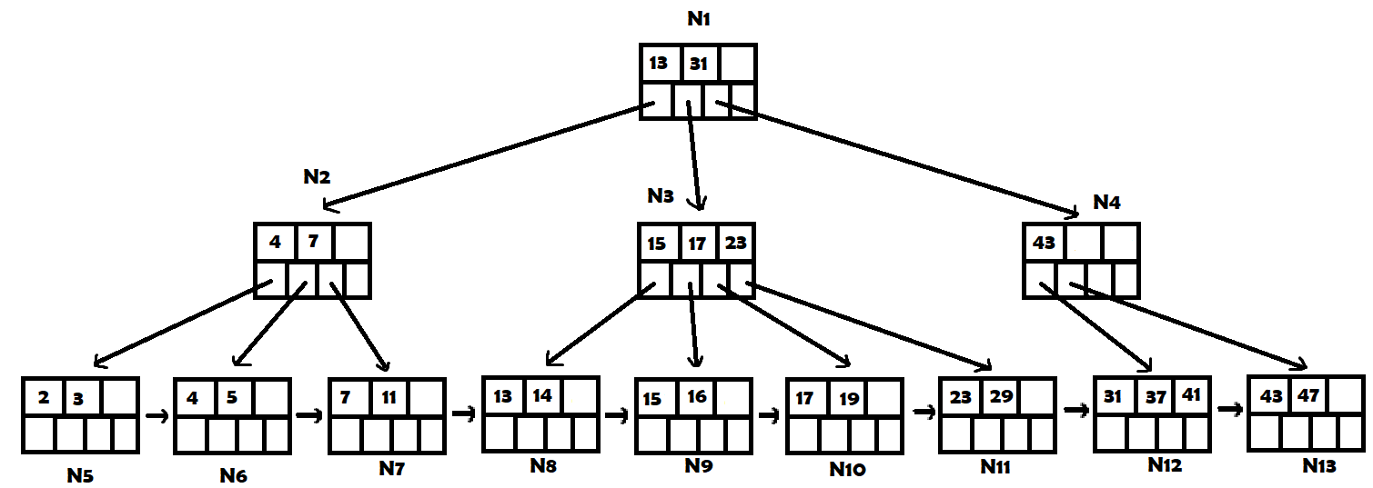

- $Lookup [6,13] -> N1,N2,N6,N7,N8$

- Deleting 23
