Factory Reallocation and Shipping Optimization Recommendation System for Nassau Candy Distributor
A. Alexander Jonah

Abstract— Supply chain organizations increasingly require data-driven decision support to improve product allocation, delivery performance, and operational efficiency. This paper presents a factory reallocation and shipping optimization recommendation system for Nassau Candy Distributor. The system uses historical order data to derive a shipping lead-time target from the supplied Order Date and Ship Date fields and applies supervised machine learning — Linear Regression, Random Forest Regression, and Gradient Boosting Regression — to predict expected lead time. On a held-out test split, Random Forest Regression achieved the lowest error (MAE = 132.0 days, RMSE = 156.5 days, R² = 0.654), outperforming Gradient Boosting (R² = 0.600) and Linear Regression (R² = 0.540). The trained model is integrated with a transparent, distance-based factory scenario layer that compares a product's current factory assignment against four alternatives, and a recommendation module that ranks alternatives using a user-controlled speed-versus-profit priority. An interactive Streamlit dashboard exposes product, region, ship-mode, and priority controls. Because the supplied dataset does not contain historical factory assignments, transportation cost, or factory capacity, the system is presented as a decision-support prototype rather than a causal or globally optimal logistics optimizer.
Keywords: Supply chain analytics, factory allocation, lead-time prediction, machine learning, Random Forest, Gradient Boosting, scenario simulation, decision support, Streamlit.
I. Introduction
Modern supply chains operate across geographically distributed facilities, products, customers, and transportation routes. Decisions concerning where a product should be produced or assigned can influence delivery time, customer service, operational risk, and profitability. Traditional allocation processes frequently rely on fixed rules, historical assumptions, or manually maintained mappings, which are difficult to adapt when product mixes and destination patterns change.
Machine learning provides an opportunity to transform historical transactional data into predictive decision support. Recent literature reviews identify transportation, supply chain forecasting, delivery-time prediction, and logistics optimization as important application areas for machine learning [1]–[3]. Prediction-based decision support can complement traditional optimization by estimating operational outcomes before a decision is implemented.
The present work addresses a factory reallocation problem in which products are currently assigned to a fixed set of five factories. The system predicts shipping lead time for a given product, destination region, shipping mode, and candidate factory, then simulates alternative assignments and compares their expected performance against the current assignment. This produces a practical what-if framework rather than treating the predictive model as an isolated forecasting task.
The main contributions of this study are: (1) a preprocessing and feature-engineering pipeline for historical order data; (2) a comparative lead-time prediction framework using Linear Regression, Random Forest Regression, and Gradient Boosting Regression, evaluated with real held-out metrics; (3) a factory reassignment scenario-simulation mechanism built on the trained model; (4) an explainable recommendation score combining predicted operational improvement with observed profitability; and (5) an interactive Streamlit dashboard for decision support.
II. Related Work
Machine learning has become an established research direction within logistics and supply chain management. Akbari and Do reviewed machine learning applications in logistics and supply chain management and identified prediction and optimization as major research themes [1]. A broader review of machine learning in freight transportation reports applications including arrival-time prediction, demand forecasting, process optimization, vehicle routing, and anomaly detection [2]. These findings support the use of predictive models as components of operational logistics systems.
Delivery-delay prediction is another relevant area. Recent research emphasizes predicting the magnitude of delivery delays and integrating predictive models with decision-support systems rather than limiting analysis to simple on-time/delayed classification [3]. This motivates the use of continuous lead time as the prediction target in the proposed system.
Facility and network design research shows that allocation decisions must consider multiple operational factors. Supply chain network design includes decisions involving facility roles, product allocation, capacity, and material flows [4]. Research on supply-chain resilience further demonstrates the importance of considering risk when modifying existing facility networks [5]. The present project does not claim a full mathematical network-optimization model; instead, it performs data-driven scenario evaluation over a known set of factories.
Ensemble regression methods are well suited to this problem because they can model nonlinear interactions among categorical and numerical predictors after appropriate preprocessing. Random Forest Regression aggregates the predictions of many decorrelated decision trees trained on bootstrap samples [8]. Gradient Boosting Regression instead constructs an ensemble sequentially, with each new tree correcting the residual error of the previous ensemble [6], [9]. These characteristics make ensemble regressors natural candidates for comparison against a simple linear baseline.
III. Proposed System
A. System Overview
The proposed architecture consists of five stages: data preparation, exploratory analysis, lead-time prediction, factory scenario simulation, and recommendation visualization, shown in Fig. 1. Historical order records are cleaned and converted into model-ready features. Ship Date is excluded from the predictor set — only date-derived calendar features (year, month, day-of-week, quarter) together with product, geography, ship mode, and profitability features are used — because including the raw Ship Date directly would leak the target.
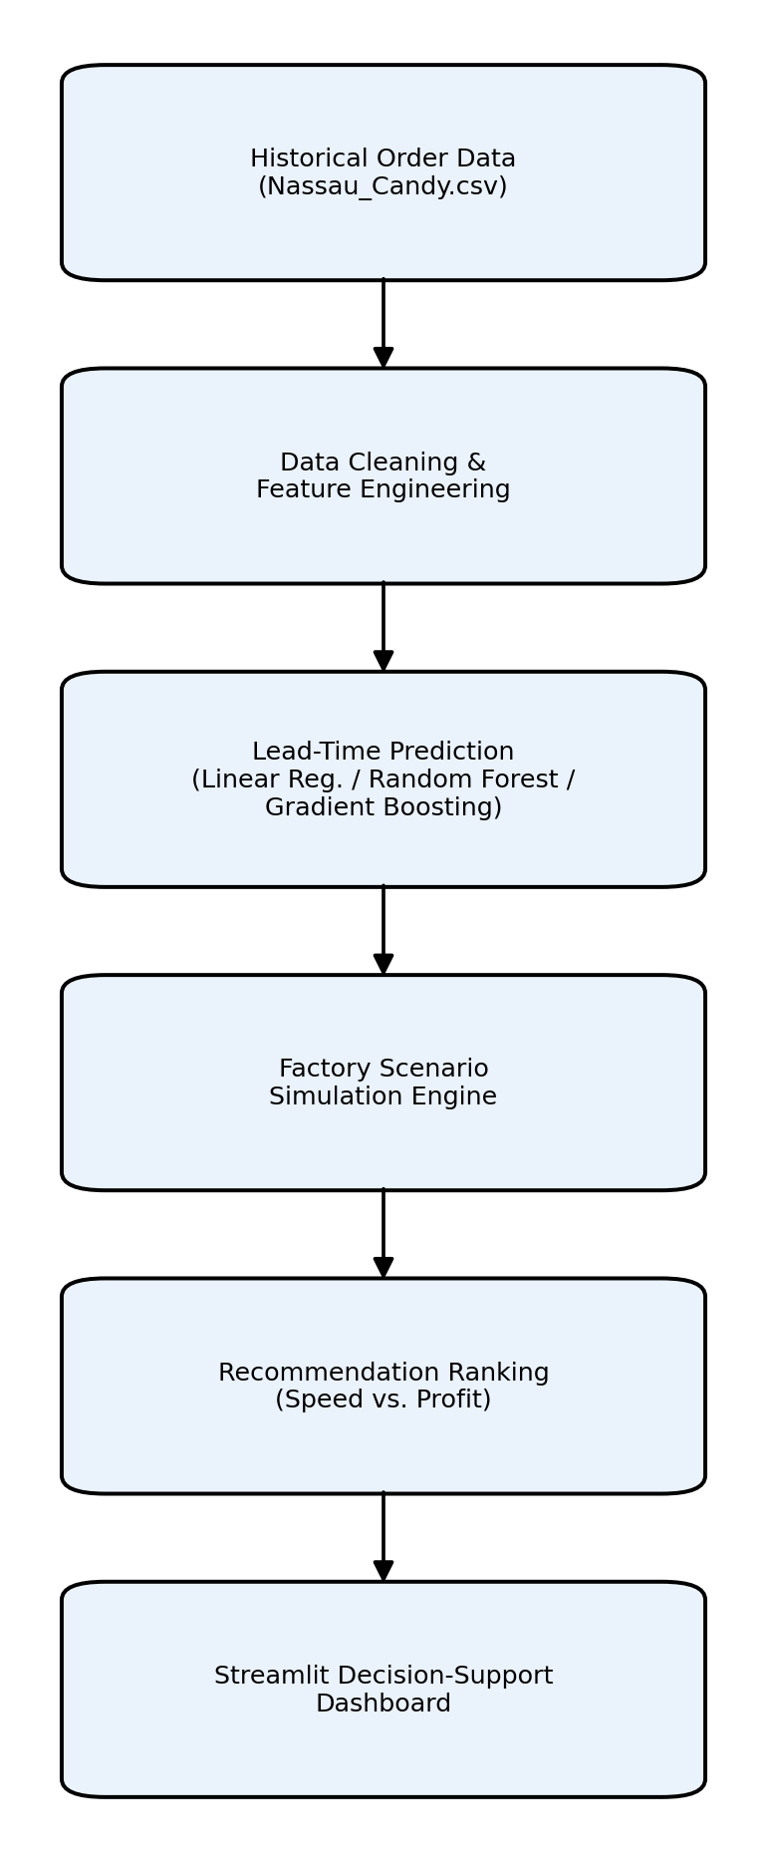
Fig. 1. System architecture.
B. Factory Reallocation Scenario
The prototype considers five candidate factories: Lot's O' Nuts, Wicked Choccy's, Sugar Shack, Secret Factory, and The Other Factory (Table I). Each product is currently mapped to exactly one factory (Table II). For a selected product, region, and ship mode, the system predicts a baseline lead time with the trained model and then re-evaluates the scenario under each of the five factories using a distance-based adjustment, forming a what-if comparison table.
Table I. Factory Locations Used for Scenario Simulation
Factory | Latitude | Longitude
Lot's O' Nuts | 32.881893 | -111.768036
Wicked Choccy's | 32.076176 | -81.088371
Sugar Shack | 48.119140 | -96.181150
Secret Factory | 41.446333 | -90.565487
The Other Factory | 35.117500 | -89.971107
Table II. Current Product–Factory Assignments
Product Group | Current Factory
Wonka Bar – Nutty Crunch, Fudge Mallows, Scrumdiddlyumptious | Lot's O' Nuts
Wonka Bar – Milk Chocolate, Triple Dazzle Caramel | Wicked Choccy's
Laffy Taffy, SweeTARTS, Nerds, Fun Dip, Fizzy Lifting Drinks | Sugar Shack
Everlasting Gobstopper, Lickable Wallpaper, Wonka Gum | Secret Factory
Hair Toffee, Kazookles | The Other Factory
C. Recommendation Logic
For every candidate factory, the system computes the predicted lead-time change relative to the current assignment, expressed as a percentage improvement. Profitability is represented using the historical gross-profit margin observed for the selected product/region/ship-mode subset. A user-controlled priority slider (0–100, speed versus profit) combines the normalized lead-time improvement and margin into a single decision score, so that the ranking of alternatives can shift toward faster delivery or toward preserving historical profitability. The logic is deliberately transparent: every intermediate value is shown to the user rather than compressed into a single opaque score.
D. Interactive Deployment
A Streamlit application exposes Product, Region, and Ship Mode selectors together with the speed-versus-profit priority slider. The dashboard reports the current factory, predicted baseline lead time, historical margin, a qualitative risk label based on the number of historical orders supporting the scenario, a full factory comparison table, and a recommendation with its supporting rationale.
IV. Methodology
The methodology follows a predictive-to-prescriptive workflow: (i) prepare the transactional dataset and derive operational features; (ii) train and evaluate regression models; (iii) apply the selected model repeatedly to alternative factory scenarios; (iv) convert scenario outputs into ranked recommendations.
A. Data Preprocessing and Feature Engineering
The supplied dataset contains 10,194 order-line records with 18 fields, including Order Date, Ship Date, Ship Mode, customer geography, Division, Region, Product Name, Sales, Units, Gross Profit, and Cost. Records with invalid or missing dates are dropped. Lead Time is derived as Ship Date minus Order Date, in days. Product-name whitespace inconsistencies are standardized. Calendar features (order year, month, day-of-week, quarter) are extracted from Order Date, and a Profit Margin feature is derived as Gross Profit divided by Sales.
A data-quality check found that Order Date values fall in 2024–2025 while Ship Date values fall in 2026–2030 in the supplied file, which places the resulting Lead Time values on the order of hundreds to low thousands of days — substantially larger than a typical parcel-shipping duration. This is treated as a property of the supplied file rather than corrected by fabricating dates, and is reported transparently in Section VI. All models are trained and compared on this same target, so the relative comparison between Linear Regression, Random Forest, and Gradient Boosting remains a valid demonstration of the modeling methodology.
B. Lead-Time Prediction
Three regression approaches are evaluated on an 80/20 train–test split (random_state = 42). Linear Regression provides an interpretable baseline. Random Forest Regression captures nonlinear relationships through an ensemble of decision trees trained on bootstrap samples [8]. Gradient Boosting Regression builds an ensemble sequentially, with each stage fitting the residual error of the previous stage [9]. Categorical features (Ship Mode, geography, Division, Region, Product ID, Product Name) are one-hot encoded; numerical features are median-imputed and standardized within a single scikit-learn pipeline to prevent train/test leakage.
C. Model Evaluation
Models are compared using Mean Absolute Error (MAE), Root Mean Squared Error (RMSE), and the coefficient of determination (R²). MAE expresses the average absolute prediction error in the same units as lead time; RMSE penalizes larger errors more heavily; R² indicates the proportion of target variance explained. The model with the lowest RMSE is selected for the scenario engine.
D. Factory Scenario Simulation
Because the supplied dataset does not record which factory historically fulfilled each order, the model cannot learn a causal factory effect directly. The scenario layer therefore combines the trained lead-time model with a transparent geographic proxy: each region is mapped to an approximate centroid, the great-circle distance to each candidate factory is computed, and the relative distance difference from the current assignment scales the baseline prediction through a conservative sensitivity coefficient α = 0.15:
T_j = T_base × (1 + α × (D_j − D_current) / D_current)
where T_base is the model's baseline prediction for the current factory, D_current and D_j are the region-to-factory distances for the current and candidate factory j, and T_j is the scenario lead time under candidate j. Lead-time improvement is then (T_base − T_j) / T_base × 100%.
E. Profitability and Risk Logic
Historical gross margin (Gross Profit / Sales) provides profitability context without inventing transportation costs. A scenario is labeled High risk when fewer than 10 historical orders support the selected product/region/ship-mode combination, Medium risk for 10–29 orders, and Lower risk for 30 or more, giving users a simple indicator of how much historical evidence backs a given recommendation.
V. Results and Discussion
A. Model Performance
Table III reports held-out performance for the three candidate models. Random Forest Regression achieved the lowest error and the highest R² (0.654), followed by Gradient Boosting (R² = 0.600) and Linear Regression (R² = 0.540). Random Forest was therefore selected for the scenario-simulation engine. Fig. 2 and Fig. 3 visualize the comparison.
Table III. Model Evaluation Results (Held-Out Test Split)
Model | MAE (days) | RMSE (days) | R²
Random Forest | 132.02 | 156.46 | 0.654
Gradient Boosting | 160.69 | 168.26 | 0.600
Linear Regression | 167.24 | 180.27 | 0.540
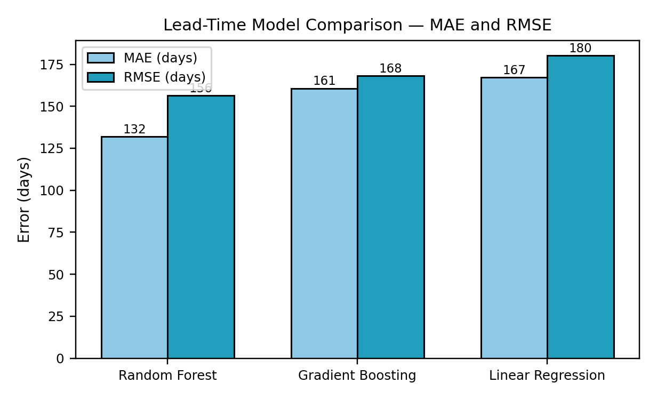
Fig. 2. Model comparison — MAE and RMSE.
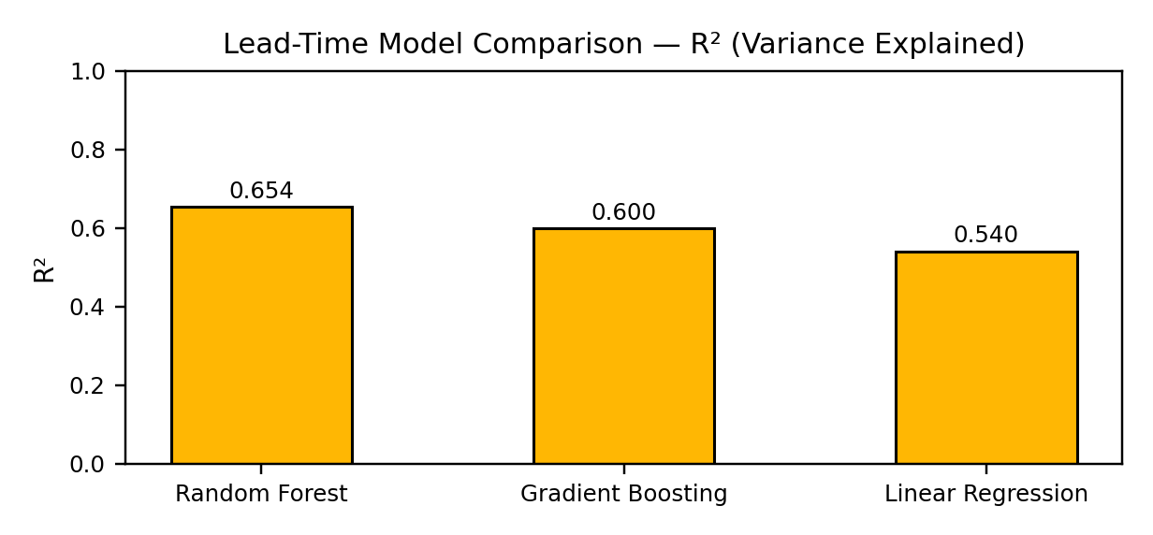
Fig. 3. Model comparison — R² (variance explained).
The gap between Random Forest and the linear baseline (R² 0.654 vs. 0.540) indicates that the relationship between order features and lead time is meaningfully nonlinear, consistent with interactions between product, geography, and ship mode. Gradient Boosting underperformed Random Forest under the default hyperparameters used here, suggesting that further tuning of learning rate and tree depth could narrow the gap in future iterations.
B. Factory Scenario Example
Table IV illustrates the scenario engine's output for Wonka Bar – Milk Chocolate, Pacific region, Standard Class shipping (341 supporting historical orders — Lower risk). The current factory, Wicked Choccy's, is the most distant of the five candidates for this region; the scenario engine correspondingly estimates that all four alternative factories would reduce predicted lead time, with Lot's O' Nuts showing the largest estimated improvement (11.6%).
Table IV. Example Factory Scenario — Wonka Bar – Milk Chocolate, Pacific, Standard Class
Factory | Distance (km) | Scenario Lead Time (days) | Improvement (%)
Lot's O' Nuts | 802 | 1370.3 | 11.6
Sugar Shack | 2227 | 1465.2 | 5.4
Secret Factory | 2487 | 1482.4 | 4.3
The Other Factory | 2608 | 1490.5 | 3.8
Wicked Choccy's (current) | 3492 | 1549.3 | 0.0
This example demonstrates the mechanics of the recommendation layer rather than an operational claim: because the lead-time scale reflects the dataset limitation discussed in Section IV.A, the percentage improvement — not the absolute day count — is the quantity intended for interpretation.
C. Dashboard
The Streamlit dashboard renders the current situation (factory, predicted lead time, historical margin, risk label), the full factory what-if table, a bar chart of scenario lead time by factory, and a plain-language recommendation with its supporting rationale, allowing a stakeholder to explore product, region, ship-mode, and priority combinations without rerunning the underlying notebook.
VI. Limitations and Future Directions
Two limitations should be read together. First, the supplied dataset does not record historical factory assignments, transportation cost, factory capacity, or production constraints; the factory layer is therefore an explainable geographic-distance proxy rather than a learned causal effect, and absolute logistics-cost savings cannot be calculated. Second, the Order Date / Ship Date fields in the supplied file yield lead-time values far larger than typical parcel-shipping durations (Section IV.A); the reported MAE and RMSE are consequently on the same large scale, and should be read as a valid relative comparison between models rather than an operational lead-time estimate in days.
Future work should incorporate verified factory capacity, inventory availability, transportation distance and cost, carrier reliability, service-level constraints, and corrected order/ship timestamps. A constrained optimization model could then be combined with the predictive model to identify assignments that are both operationally feasible and economically desirable, an active research direction in supply-chain analytics [7]. Time-based train/test splitting, so that future orders are predicted from historical information only, would also better reflect deployment conditions than the random split used here.
VII. Conclusion
This paper presented a data-driven framework for factory reallocation and shipping-optimization recommendation for Nassau Candy Distributor. Historical order data is transformed into a predictive dataset; Linear Regression, Random Forest, and Gradient Boosting are trained and compared, with Random Forest selected on held-out MAE, RMSE, and R²; the selected model is then applied repeatedly to alternative factory assignments through a transparent, distance-based scenario layer. The central contribution is the connection between prediction and decision support: rather than reporting only historical shipping performance, the system lets a user ask a what-if question — how might expected lead time change if a product were assigned to another factory? — with profitability indicators and risk labeling providing additional context. The accompanying Streamlit dashboard makes this workflow directly explorable, and the framework is positioned to extend into a constrained supply-chain optimization system once transportation-cost and factory-capacity data become available.
References
[1] M. Akbari and T. N. A. Do, "A systematic review of machine learning in logistics and supply chain management: current trends and future directions," Benchmarking: An International Journal, vol. 28, no. 10, pp. 2977–3005, 2021, doi: 10.1108/BIJ-10-2020-0514.
[2] K. Tsolaki, T. Vafeiadis, A. Nizamis, D. Ioannidis, and D. Tzovaras, "Utilizing machine learning on freight transportation and logistics applications: A review," ICT Express, vol. 9, no. 3, pp. 284–295, 2023, doi: 10.1016/j.icte.2022.02.001.
[3] "An analytical review of predictive methods for delivery delays in supply chains," Supply Chain Analytics, vol. 11, 100130, 2025, doi: 10.1016/j.sca.2025.100130.
[4] S. Zhou, M. Liu, and H. Tang, "McDonald's China Adopts Operations Research for Network Design," INFORMS Journal on Applied Analytics, 2025, doi: 10.1287/inte.2024.0179.
[5] "Planning for Disruptions in Supply Chain Networks: Models, Methods, and Applications for Innovative Decision Making," INFORMS Tutorials in Operations Research, 2014, doi: 10.1287/educ.1063.0025.
[6] Scikit-learn Developers, "Gradient Boosting regression," scikit-learn documentation, 2024. [Online]. Available: https://scikit-learn.org/stable/auto_examples/ensemble/plot_gradient_boosting_regression.html
[7] K. Ait Ben Hamou, Z. Jarir, and S. Elfirdoussi, "Using machine learning for production scheduling problems in the supply chain: A review," Computers & Industrial Engineering, vol. 206, 111243, 2025, doi: 10.1016/j.cie.2025.111243.
[8] L. Breiman, "Random Forests," Machine Learning, vol. 45, no. 1, pp. 5–32, 2001, doi: 10.1023/A:1010933404324.
[9] J. H. Friedman, "Greedy Function Approximation: A Gradient Boosting Machine," Annals of Statistics, vol. 29, no. 5, pp. 1189–1232, 2001, doi: 10.1214/aos/1013203451.

