**Prompts**

**Simple/Funny**

Explain 2024 tax law changes relevant for individual returns in the style of a star wars title crawl.

**Tax Examples/Context**

Doug and Pam Prospect are retired and ages 79 and 78 respectively. Doug was a former executive and Pam historically stayed at home with their children. Today, they spend most of their time traveling to see their three adult children and eight grandchildren. When not traveling, they are very engaged and active with their local church.

Doug and Pam have approximately $5,000,000 in investable assets at a large investment advisory firm and a home valued at $1,000,000 with no debt. Their assets are invested exclusively in public markets with approximately 70% in equities and 30% in fixed income securities; all of which are either mutual funds or exchange traded funds (ETFs). A further breakdown of the investable assets indicates that $1,000,0000 is held in a Traditional IRA and the balance in non-qualified accounts, which have a net unrealized long-term capital gain of approximately $250,000.

Doug and Pam are leery of any investment that is not liquid and would prefer securities that can be converted into cash quickly due to a “bad experience” in a private REIT. They consistently talk about cash flow and worry about how to fund their lifestyle expenses as a result of a volatile 2022 market. They have estimated their annual expenses to be approximately $250,000 (after-tax).

During the prospecting discussions, Doug repeatedly shared his fear about the current administration’s focus on potential tax increases and the potential of a recession. They were concerned that these potential events could jeopardize their future and the wealth that they’ve worked so hard to accumulate.

Doug and Pam are losing trust in their current financial advisor, although they have glowing reviews about their “Dividend Stock Strategy” and the support team at the brokerage firm. They felt like their advisor was not addressing their questions or concerns and often received the “canned” company response. After CLA reviewed the performance of this strategy, the strategy has underperformed compared to corresponding benchmarks.

The prospect has their taxes prepared by a well-known regional CPA firm and is expecting a tax liability of $300,000 due to a large capital gain event in the current year. Doug and Pam shared this is a one-time event and is not expected to repeat in the future. Although the prospect believes in paying their fair share of taxes, they would like to understand if they can minimize their tax liabilities. Historically, Doug and Pam are made aware of their tax liabilities when they pick up their tax return in April each year.

The prospect is charitably inclined. In the past year, Doug and Pam donated $20,000 in cash donations writing multiple checks to their church and other 501(c)(3) organizations.

You are a tax accountant and wealth advisor.

Adapt your response to this scenario.

Compare and contrast different approaches.

Provide specific strategies.

Doug and Pam would like to reduce their income tax liability in the current year given the large capital gain, how can they do so?

**HR Data**

Tell me about this data.

Show me a useful visual so that I can better understand this dataset.

Now create a random forest model to predict churn.

Generate a report that's a downloadable word document that I can present to leadership later today. It should be nicely formatted and explain all of this analysis.

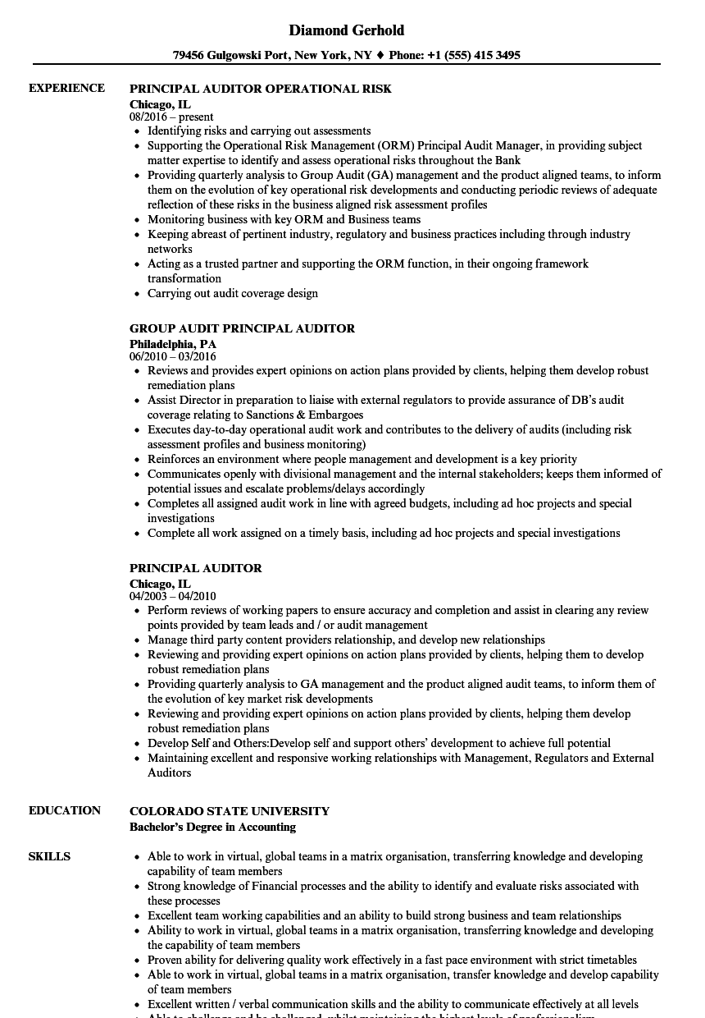

**Hiring**

You are an expert at talent acquisition. Write a short guide to hiring an accountant for a professional services firm with 200 employees. Be sure to include ways to make sure that the culture is a great fit.

Write the qualifications and role

How does this resume look to fit this job?